­­

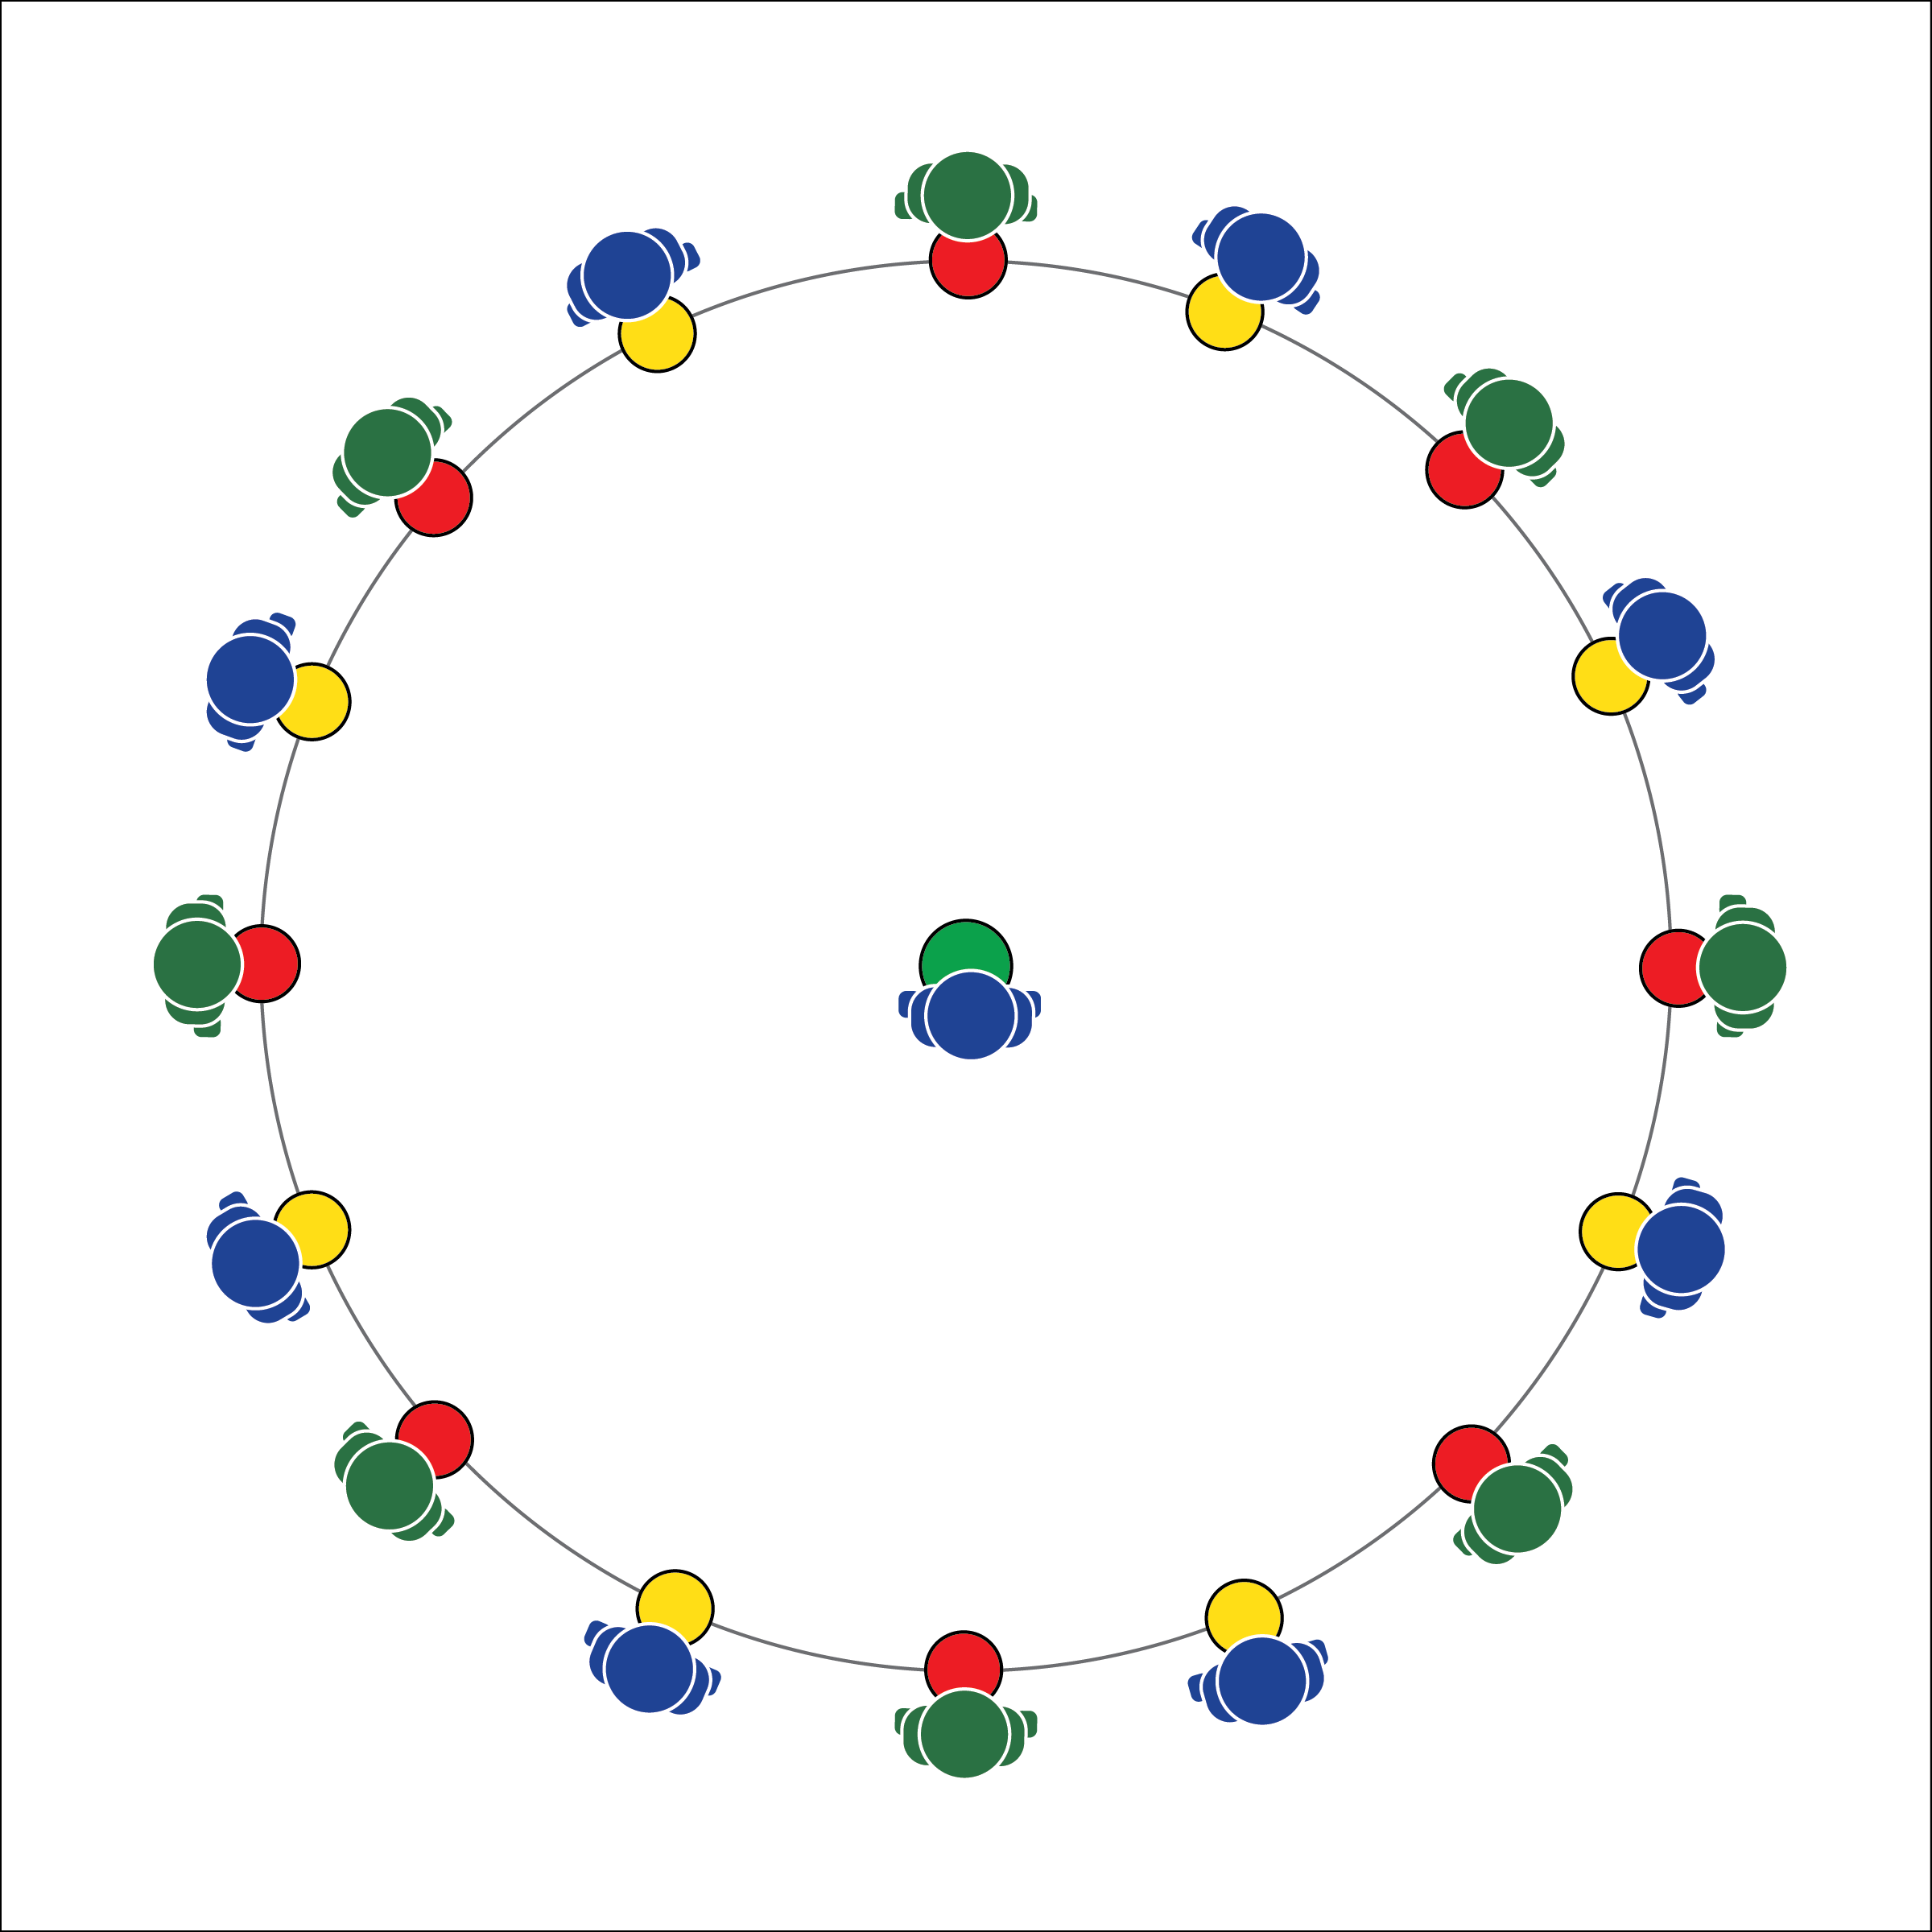

**LIFE ON THE ICE**

* **Skill:** I will safely demonstrate locomotor movements through general space.
* **Cognitive:** I will explain and discuss the importance of nonverbal communication.
* **Fitness:** I will actively engage in the Life of Ice challenge.
* **Personal & Social Responsibility:** I will demonstrate focus by working to complete the Life on the Ice challenge.
* Be Quiet
* Be Patient
* Focus on Your Classmates
* Move Safely

**Equipment:**

* 1 spot marker per student

**Set-Up:**

1. Arrange spot markers in a large circle with 1 spot in the center.
2. Each student stands on a poly spot, with 1 student in the center.

**Activity Procedures:**

1. This is the Life on the Ice challenge. We’ve traveled to Northern Canada where people live on 2 meters of ice during the long winter in Yellowknife Bay. However, it’s the spring breakup and the ice is getting thin. Any loud noise could cause it to break. It is important that you communicate with classmates using only nonverbal methods.
2. The object of this activity is to swap spots with a classmate without the Abominable Snow Monster taking your spot. To do this, make eye-contact or another type of nonverbal communication with another classmate standing on a spot marker. After making eye contact, use nonverbal communication to coordinate movement to quickly exchange places while safely traveling through open space.
3. As 2 players are changing places, the center player (the Abominable Snow Monster) tries to get to an open spot marker first. If she/he is successful, the player left without a spot marker becomes the new Snow Monster.
4. When the teacher calls, “Iceberg!!” ALL students must quickly move to a new spot marker while the Snow Monster also tries to secure a spot.

**Grade Level Progression:**

**6:** The students can use all forms of nonverbal communication.

**7:** The students can only use hands and feet for communication.

**8:** The students can only use facial expressions for communication.

**LIFE ON THE ICE**



Actively Engage, Cooperate, Nonverbal Communication, Responsibility, Safe, Teamwork



* **Standard** **4 [M5.6-8]:** Cooperates with a small group of classmates during adventure activities, game play, or team-building activities (6); Problem-solves with a small group of classmates during adventure activities, small-group initiatives, or game play (7); Cooperates with multiple classmates on problem-solving initiatives including adventure activities, large-group initiatives, and game play (8).



* **DOK 1:** What would you include on a list about nonverbal communication?
* **DOK 2:** What did you notice about the nonverbal communication used by classmates in the Life on the Ice challenge?
* **DOK 3:** How is nonverbal communication related to cooperation?



**Organize students to interact with content:** Positive communication and creative gestures play a key role in student success if this activity. The challenge for teachers is to create an environment in which students interact with members of different social groups. One modification that may help with this task is to limit communication to students on spots of the same color. This will force students to interact with students that they may otherwise ignore.



* **Adaptation:** Students change locomotor movements when passing through open space. Begin with walking and increase to more vigorous movements.
* **Extension:** Each time students make it to a new spot, perform a fitness activity. Break the class into smaller groups throughout the gym with space for movement between groups. Every circle has a Snow Monster in the middle. Students can move from 1 group to another.