­­

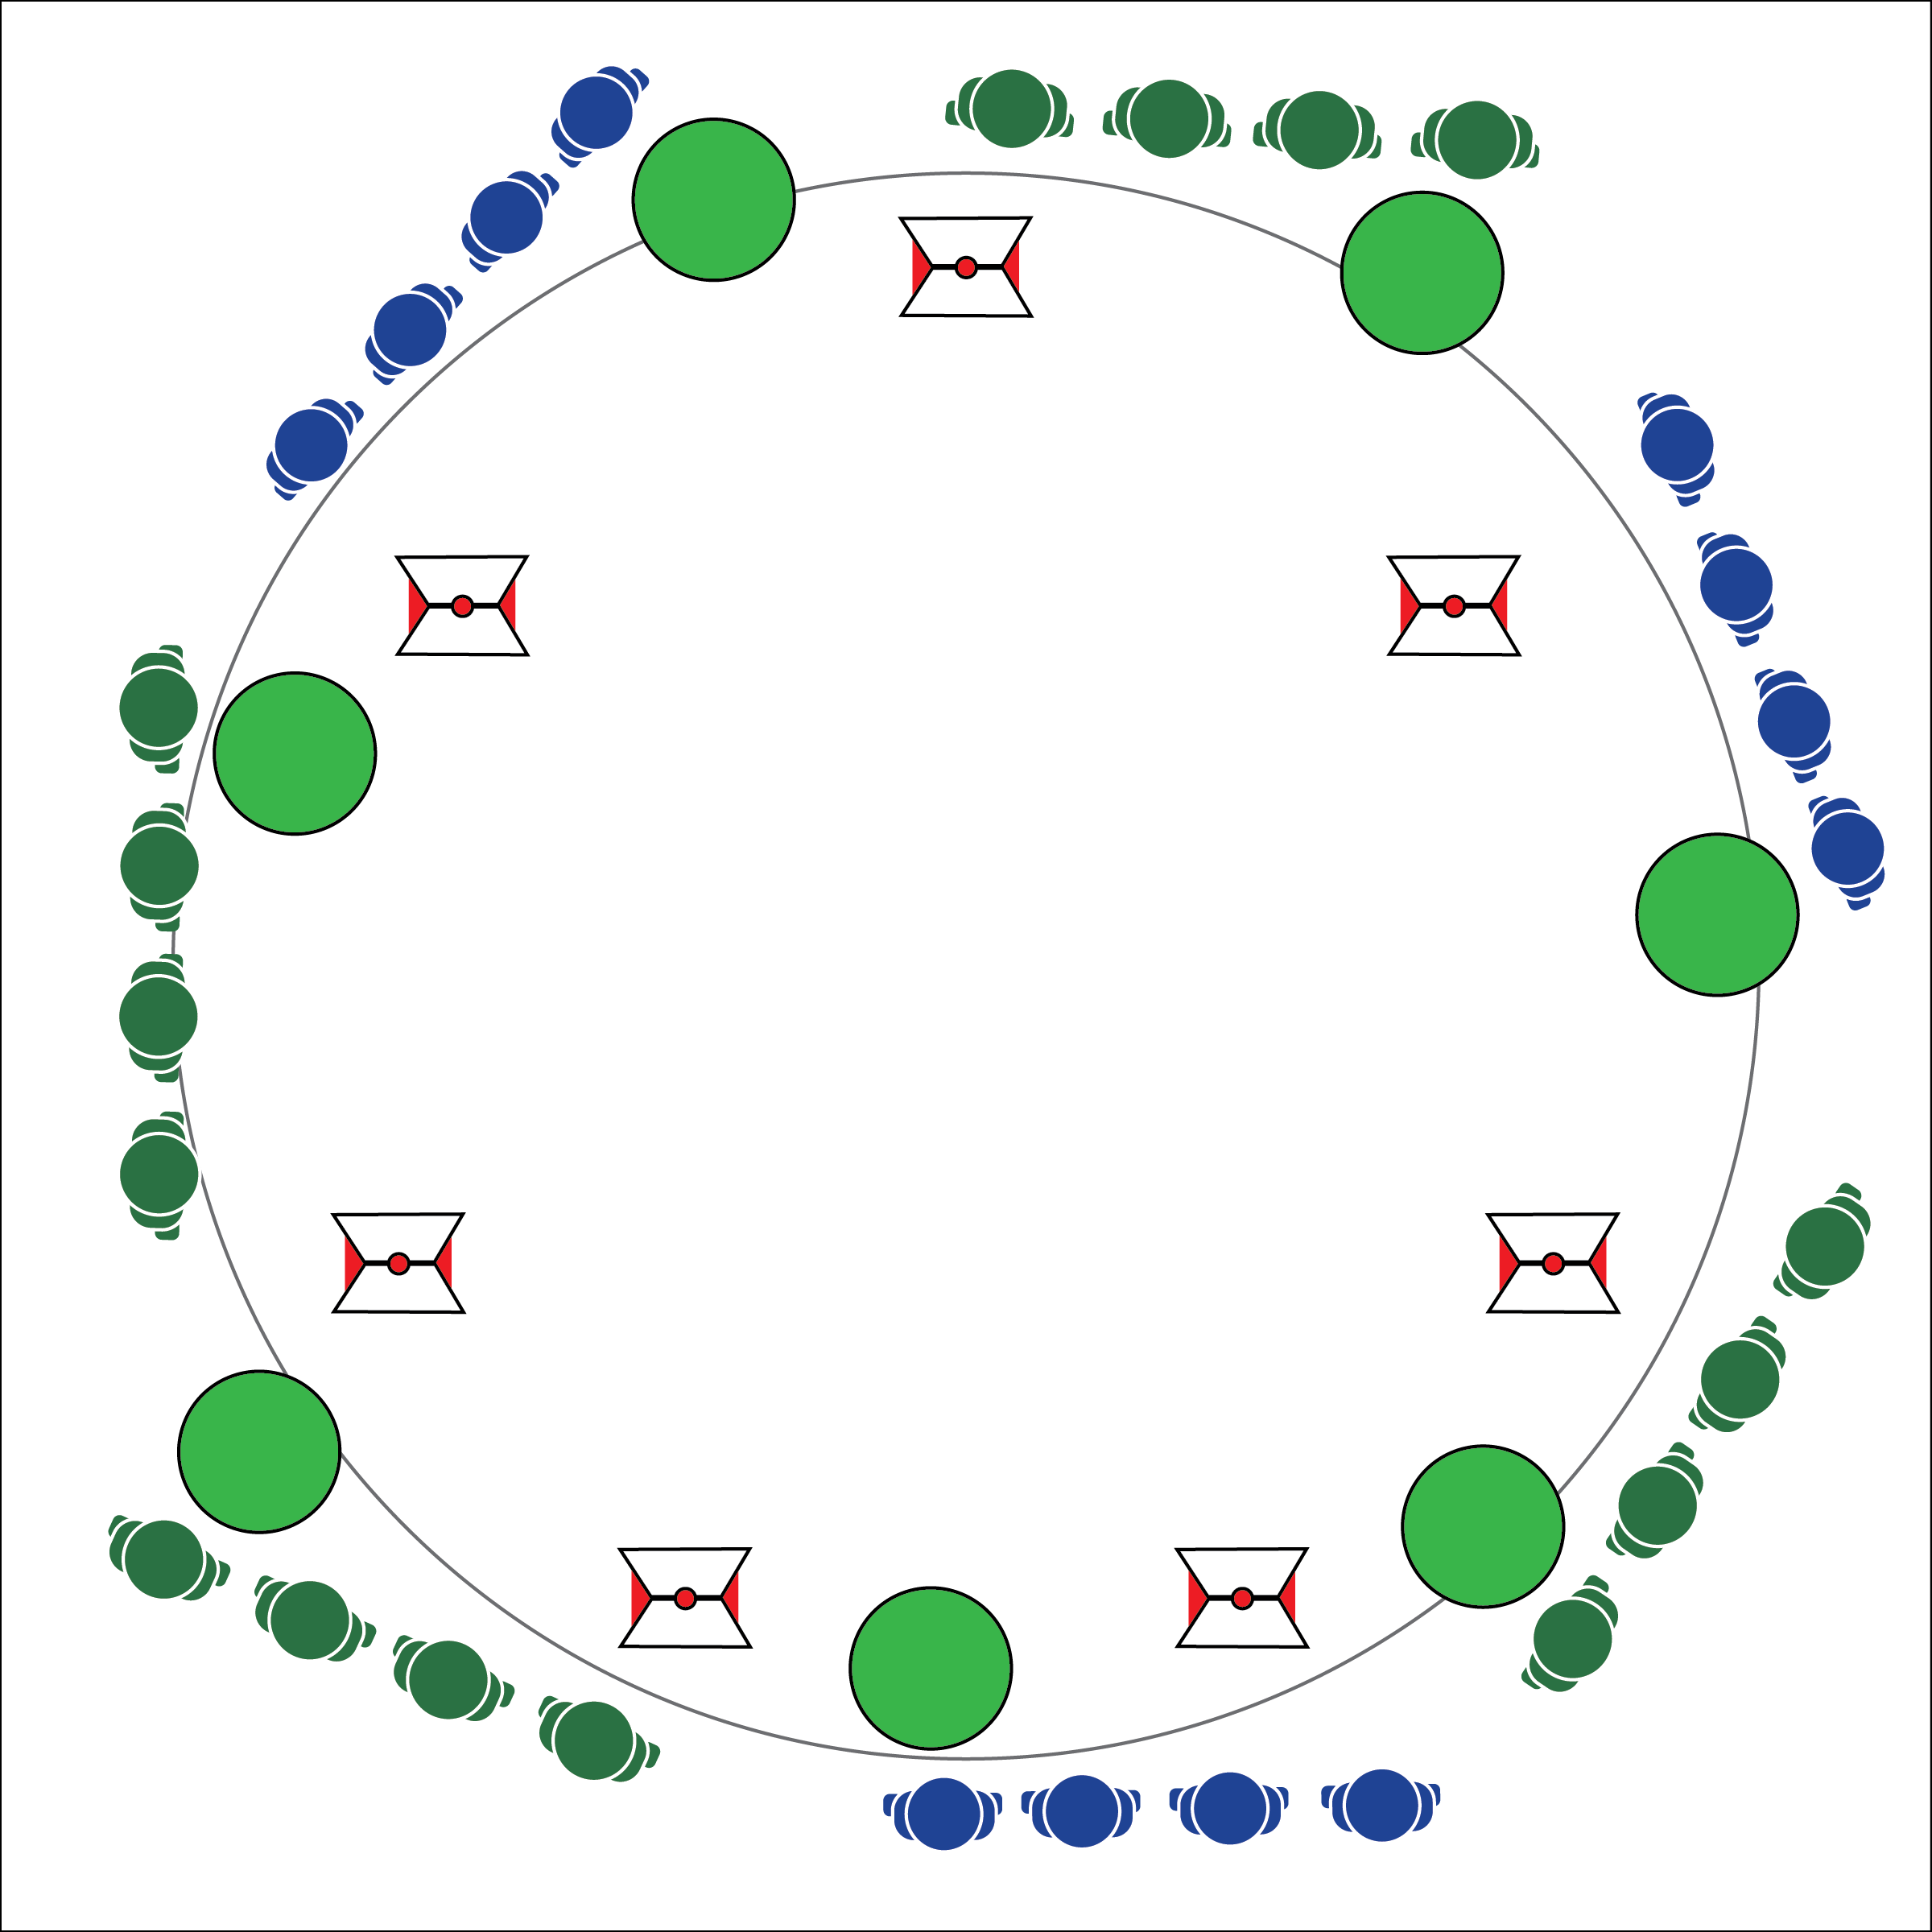

**ACT OF ULTIMATE COURAGE**

* **Skill:** I will demonstrate coordinated movements, motor control, and balance.
* **Cognitive:** I will discuss the importance of courage to personal development and a growth mindset.
* **Fitness:** I will actively engage in the Act of Ultimate Courage.
* **Personal & Social Responsibility:** I will demonstrate focus by working with classmates to successfully complete the final OPEN 8 Adventure Challenge.
* Focus on Safe Movement
* Communicate and Cooperate
* Be Kind and Respectful

**Equipment:**

* 7 cones (any size)
* 1 large fitness ball (or other ball) per group
* Courage Creation Cards

**Set-Up:**

1. Create an activity perimeter using 7 cones.
2. Divide classes into 7 equal groups. Each group at a cone with a ball.
3. Use Courage Creation Card as described in the Grade Level Progressions below.

**Activity Procedures:**

1. We’ve made it to the final OPEN 8 Adventure Challenge, which is called the Act of Ultimate Courage. Each group will start at 1 of the 7 continents with a Sphere of Courage (ball). The objective is for each team to carry a Sphere of Courage to each continent as a service to humanity, providing bravery to all people.
2. Start in a line behind your continent cone. Lay on your backs, shoulder to shoulder. The last person in line holds the ball.
3. On the start signal, the player with the ball hands it to the next player and then stands up to quickly move to the front of the line. The ball is passed forward, from player to player, and each passer quickly moves to the front of the line to keep the line moving ahead.
4. Teams continue in this pattern around the cones until they return to their original continent cone. If the ball is dropped, retrieve it and continue to move ahead.
5. Teams may safely pass other teams while inside the cones.

**Grade Level Progression:**

**6:** Implement the activity as written above.

**7:** Use Courage Creation Cards to provide an additional movement challenge.

**8:** Place a Courage Creation Card at each cone. As teams pass a continent cone, they must begin the movement challenge posted on the Courage Creation Card.

**ACT OF ULTIMATE COURAGE**



Courage, Communicate, Cooperate, Grit, Growth Mindset, Kindness, Respect, Service



* **Standard** **4 [M5.6-8]:** Cooperates with a small group of classmates during adventure activities, game play, or team-building activities (6); Problem-solves with a small group of classmates during adventure activities, small-group initiatives, or game play (7); Cooperates with multiple classmates on problem-solving initiatives including adventure activities, large-group initiatives, and game play (8).
* **Standard 5 [M6.6-8]:** Demonstrates respect for self and others in activities and games by following the rules, encouraging others, and playing within the spirit of the game or activity (6); Demonstrates the importance of social interaction by helping and encouraging others, avoiding trash talk, and providing support to classmates (7); Demonstrates respect for self by asking for help and helping others in various physical activities (8).



* **DOK 1:** What would you include on a list about the growth mindset?
* **DOK 2:** What do you know about grit? How does grit apply to the growth mindset?
* **DOK 3:** How is courage related to grit?
* **DOK 4:** Use the Grit Builder Reflection Sheet to gather information to support your ideas about courage and grit.

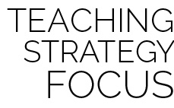

**Help students process content:** As the OPEN 8 Adventure Challenge comes to a conclusion, student will benefit from using the Grit Builder Reflection Sheet as a tool for processing their experiences. It critical that teachers create space and opportunity for students to work with, summarize and elaborate on how their personal interaction with the class content relates directly to their lives.



* **Adaptation:** Use a smaller/lighter object for passing. Allow students to stand and walk as they hand the ball off.
* **Extension:** Allow students to create their own Courage Creation challenges.