­­

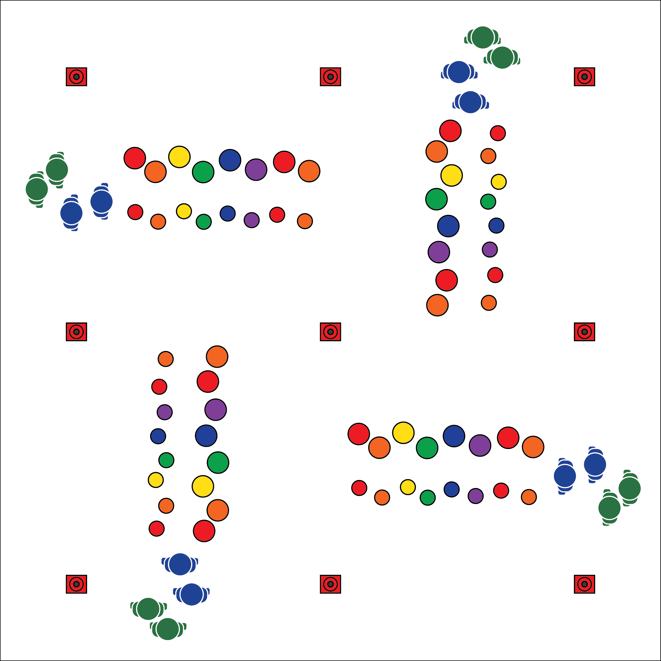

**Equipment:**

* 50 (or more) 5-inch spot markers per 15 students
* 50 (or more) 10-inch spot markers per 15 students
* Cones to mark area boundaries
* 1 blindfold per 4 students
* 3 long jump ropes per 4 students

**Set-Up:**

1. Create a grid with 4 to 6 activity areas (depending on number of students).
2. Use spot markers to create 2 close parallel lines across each area: 1 line of smaller spots for hands, another line of larger spots for feet. (Use floor tape or painter's tape if you don’t have enough spot markers.)
3. Create groups of 2 to 6 students. 1 group per activity area.

* **Skill:** I will demonstrate coordination while applying movement skills.
* **Cognitive:** I will discuss the role of communication in cooperative activities.
* **Fitness:** I will actively engage with classmates in Urban Plane Climbing.
* **Personal & Social Responsibility:** I will demonstrate focus by working with classmates to successfully complete the Birth of Sky challenges.
* Use Positive Communication
* Demonstrate Teamwork
* Be Respectful to Others

**BIRTH OF SKY**

**Activity Procedures:**

1. Activity This is the Birth of Sky Challenge. It will be our mode of transportation to each of the other OPEN 8 Adventure Challenges. You’ll flex and extend your muscles as you climb across the gym, using the spots as hand and foot holds. The object is for all students to move safety through the sky, using the holds to reach the other side.
2. **Practice Challenge:** Students use hands on small spots and feet on large spots while traversing.
3. **Intermediate Challenges:** 1) One student guides a blindfolded partner as they walk upright through the urban climbing plane; 2) One partner guides a blindfolded partner across the sky using hands/feet on spots.
4. **Advanced Cooperative Challenges:** 1) Teams of 2-4 students move together while connected with a soft jump rope. All team members must touch only the poly spots; 2) Students design their own climbing routes with spot markers/floor tape. Designs must work to improve muscular strength and endurance.

**Grade Level Progression:**

**6:** Practice challenge only.

**7:** Practice challenge and intermediate challenge.

**8:** Complete all challenges across 2 classes; students design challenges for day 2.

**BIRTH OF SKY**



* **DOK** **1:** What does positive communication sound like? look like?
* **DOK 2:** How can communication (both positive and negative) affect a cooperative performance?
* **DOK 3:** How is positive communication related to respect?
* **DOK 1:** What is coordination?
* **DOK 2:** How would you summarize the way coordination relates to climbing/traversing?
* **DOK 3:** How would you adapt the Birth of Sky challenge to help further develop coordination?



* **Standard 3 [M5.6-7]:** Participates in a variety of lifetime recreational team sports, outdoor pursuits, or dance activities (6); Participates in a variety of lifetime dual and individual sports, martial arts, or aquatic activities (7).
* **Standard 4 [M5.6-8]:** Cooperates with a small group of classmates during adventure activities, game play or team-building activities (6); Problem-solves with a small group of classmates during adventure activities, small-group initiatives or game play (7); Cooperates with multiple classmates on problem-solving initiatives including adventure activities, large-group initiatives and game play (8).



Challenging, Cooperate, Grit, Respect, Teamwork, Traverse



* **Adaptation:** Place spots/tape on a horizontal wall. Students use their hands to move from one side of the course to the other. Add sequential numbers to the spots to increase the difficulty.
* **Extension:** Allow the group to use nonverbal communication only.

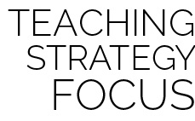

**Organize students to interact with content:** The “Birth of Sky” activity challenges students to manipulate their body in a non-traditional environment. Most students have played traditional recreation games such as twister and party dances, but what happens when students are exposed to outdoor adventure activities? Will they be prepared to be physically literate in an outdoor environment? This activity allows them to apply skills taught in the physical education classroom to real-world, lifetime activity settings.

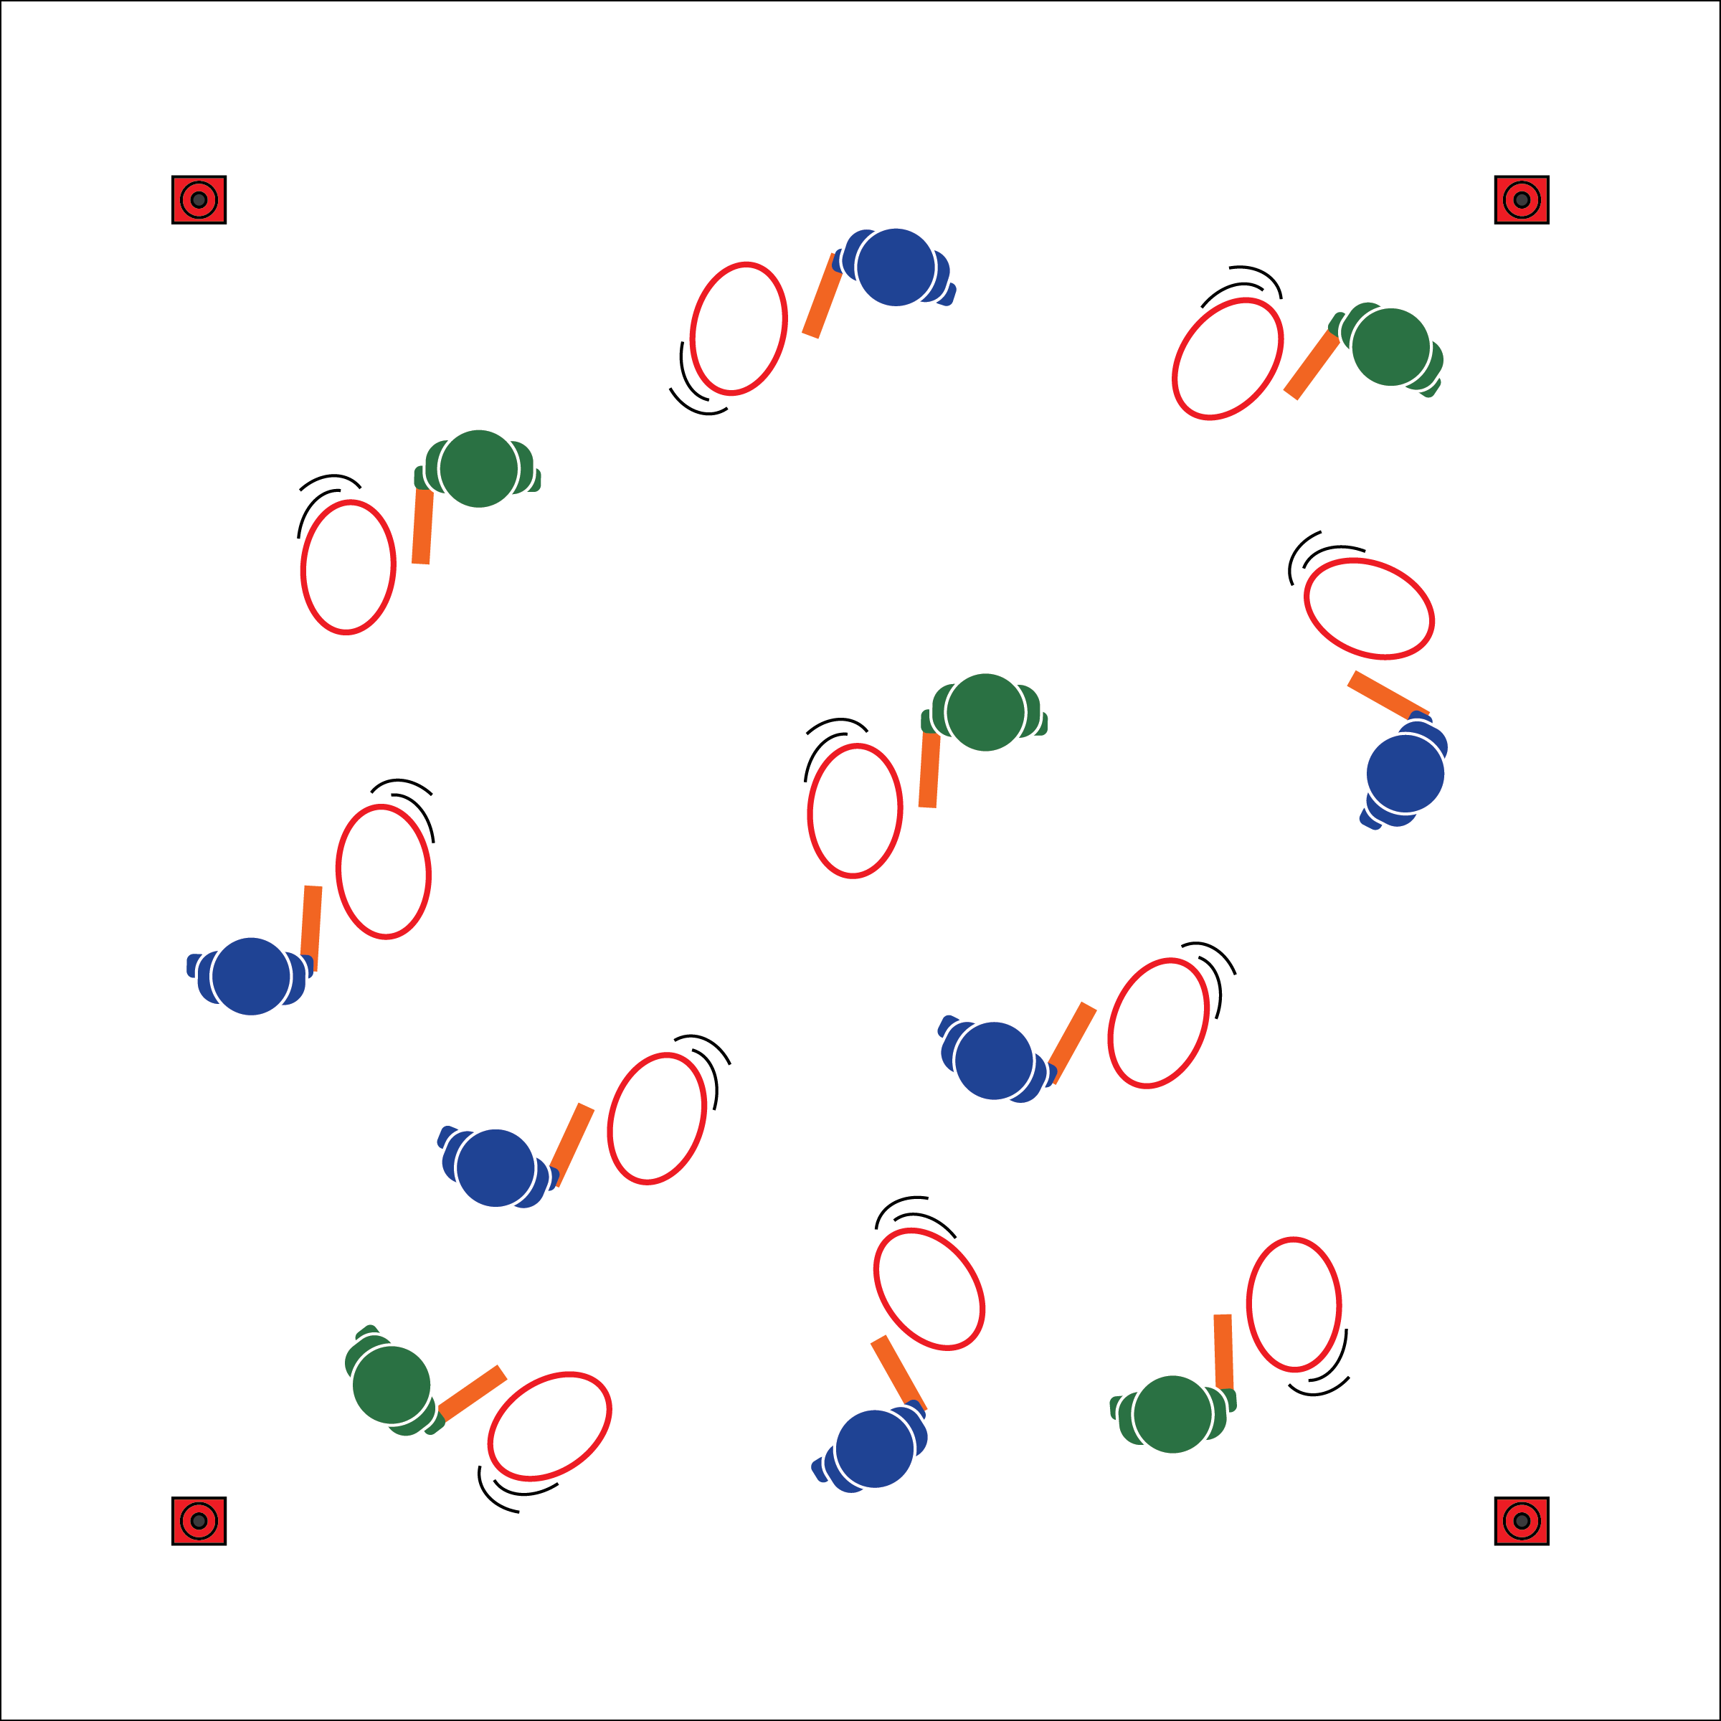

**Equipment:**

* 1 Hula Hoop per student
* 1 two-foot foam noodle per student
* 4 large cones to create boundaries
* 2 half-cones per group to create relay lines
* A variety of obstacles (e.g., cones, pins, ropes)
* One pinnie or colored wrist band per student
* Fitness Challenge Posters

**Set-Up:**

1. Create a large activity area using cones.
2. Each student with a hoop and a foam noodle.
3. Post or project the Emerging Force Fitness Challenges on a wall.
4. Use additional equipment as described in each challenge.

**Activity Procedures:**

1. Today’s activity is called Emerging Force. We are traveling to Africa to continue The OPEN 8 Adventure Challenge. These challenges are adaptations of traditional African hoop-rolling games.
2. We will begin with all students practicing their Hoop Rolling techniques. On the start signal, use your stick (foam noodle) to safety complete the challenge. If your hoop falls or is out of control, stop & restart.
3. **Practice:** 1) Forward roll to stop; 2) Forward w/direction changes; 3) Forward, stop, then backward.
4. **Individual Challenges:** 1) Longest roll: keep your hoop rolling through space for as long as you can. When hoop stops/falls, move to sidelines and complete a fitness challenge. 2) Hoop tag: choose 3 to 5 taggers. Taggers use a stick (noodle) to tap other hoops to make them fall. If tagged, move to the side, complete a fitness challenge, then return.
5. **Team Challenges:** 1) Hoop-rolling relays: teams in relay lines with 2 cones set up. Be the first team to roll all hoops to the cone and back in relay format. If a hoop drops or is out of control, stop, regain control, then continue. 2) Team longest roll with obstacles: as individuals, roll your hoop while navigating obstacles (e.g., cones, pins). If hoop drops or goes out of bounds, walk the perimeter while watching the game. The challenge is over when 1 team remains. 3) Team hoop hackers: format is the same as the longest roll challenge, but players use their hoops/noodles to disrupt other hoops. If your hoop drops or goes out of bounds, walk the perimeter while watching the game. Continue until 1 team remains.

**Grade Level Progression:**

**6:** Practice & individual challenges. **7:** All individual & 1 team challenge. **8:** All challenges.

**EMERGING FORCE**

* **Skill:** I will demonstrate control while striking the hoop.
* **Cognitive:** I will discuss striking as a skill used in lifelong physical activities.
* **Fitness:** I will actively engage in Hoop Rolling challenges.
* **Personal & Social Responsibility:** I will demonstrate focus by working with classmates to successfully complete all Emerging Force challenges.
* Appropriate Force
* Move to Open Space
* Travel Safely

**EMERGING FORCE**



* **Standard** **1 [M6.6-8]:** Performs pivots, fakes, and jab steps designed to create open space during practice tasks (6); Executes at least one of the following designed to create open space during small-sided game play: pivots, fakes, jab steps (7); Executes at least two of the following to create open space during modified game play: pivots, fakes, jab steps, screens (8).
* **Standard 2 [M1.6-8]:** Creates open space by using locomotor movements in combination with movement (e.g., varying pathways; change of speed, direction, or pace) (6); Reduces open space by using locomotor movements (e.g., walking, running, jumping & landing, changing size and shape of the body) in combination with movement concepts (e.g., reducing the angle in the space, reducing distance between player and goal) (7); Opens and closes space during small-sided game play by combining locomotor movements with movement concepts (8).
* **Standard 5 [M4.6-8]** Describes how moving competently in a physical activity setting creates enjoyment (6); Identifies why self-selected physical activities create enjoyment (7); Discusses how enjoyment could be increased in self-selected physical activities (8).



* **DOK 1:** What is striking?
* **DOK 2:** What physical activities require skilled striking? Which of those activities could you play throughout your lifetime?
* **DOK 3:** How is hand-eye coordination related to success when striking and rolling the hula hoop?
* **DOK 1:** What is a cultural experience?
* **DOK 2:** How would you compare/contrast Hoop Rolling from Africa to games that come from American cultures?
* **DOK 3:** How is enjoyment related to cultural activities? Explain your answer.



**Help students examine similarities and differences:** Physical activity for personal and social enjoyment is found in most cultures across the globe. Prompting students to compare, classify, and draw conclusions as they examine physical activity from a cultural perspective can allow them to deepen their thinking and respect all people living in an increasingly global society.



Culture, Force, General Space, Locomotor, Manipulative Skill, Striking



* **Adaptation:** Allow students to use a hand, rather than a noodle, to control the hoop.
* **Extension:** Allow students to create their own challenges with the equipment and skills used in class.

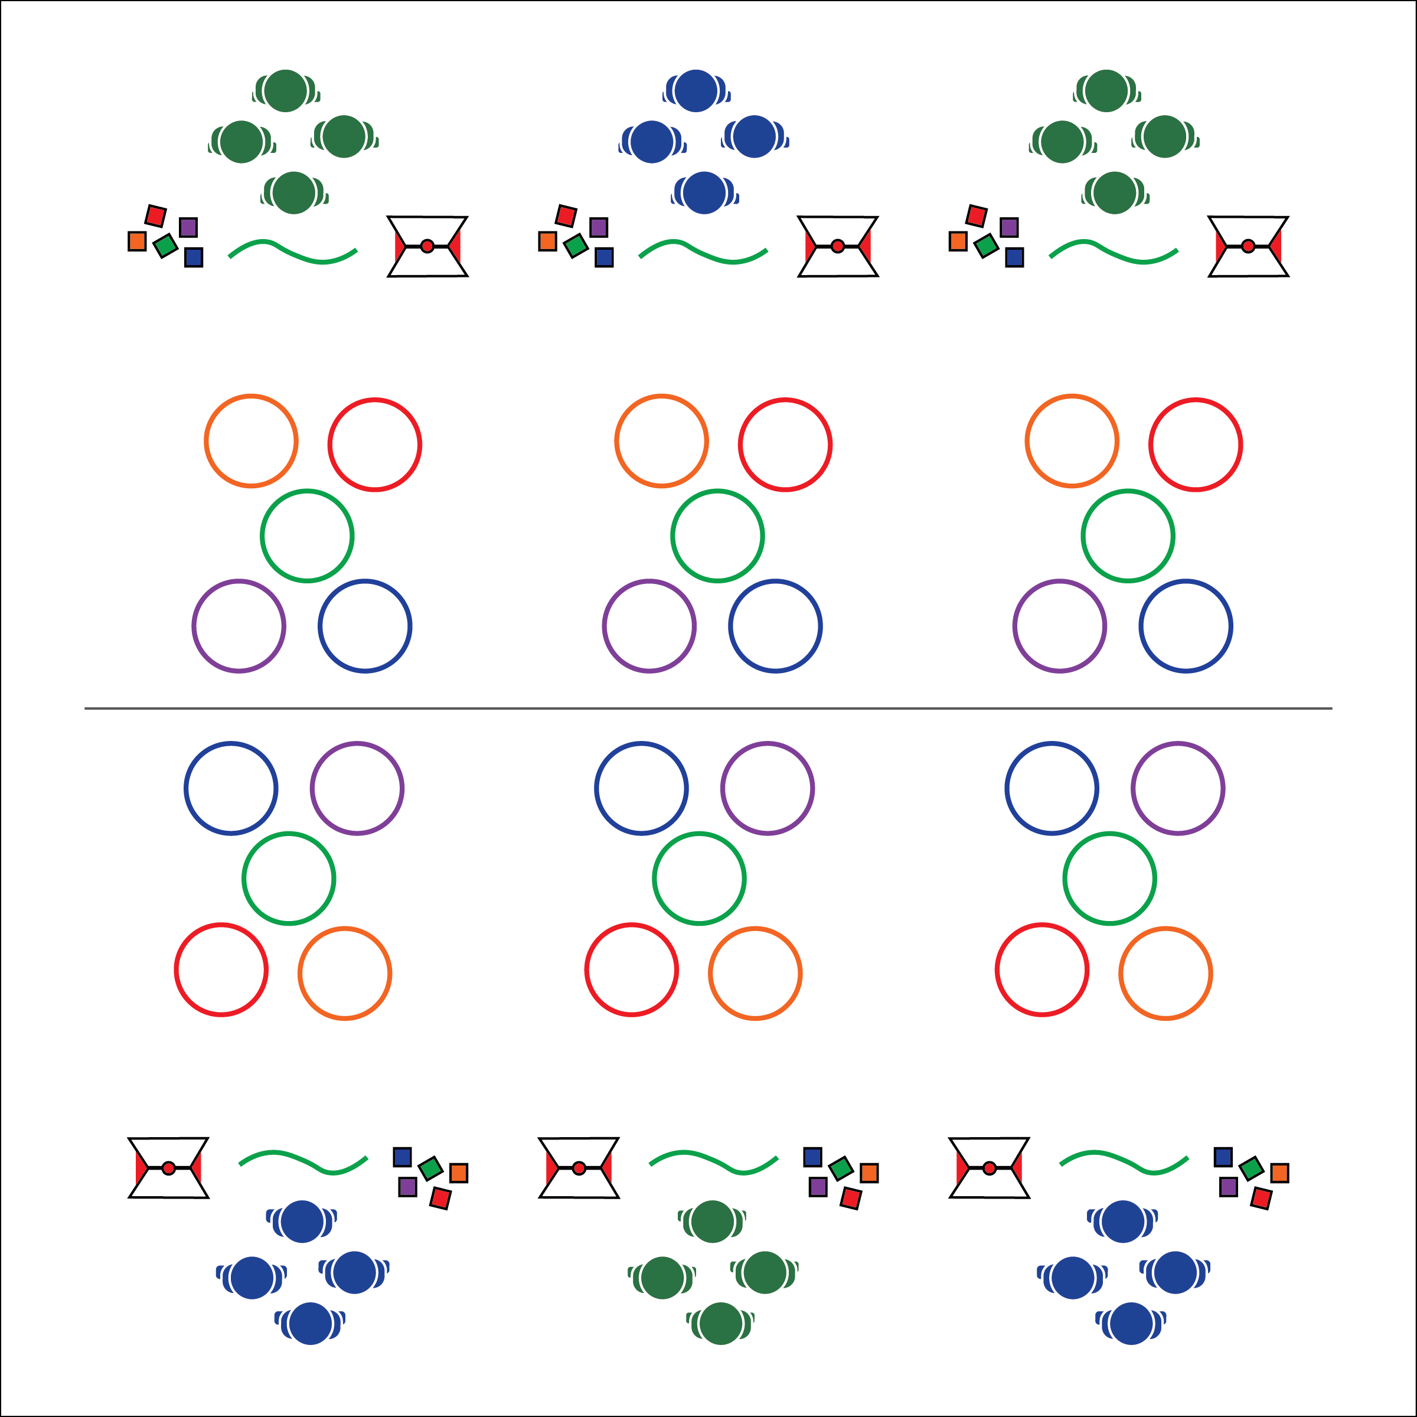

* Eyes on Target
* Focus on Form
* Be Kind

**Activity Procedures:**

1. Today’s challenge is called Awakening the Earth. We have travelled to Cambodia to complete the OPEN 8 Adventure Challenge and will play a traditional Cambodian game called *Ang-Konnh*. The game is commonly played on New Year’s Day with fruit seeds. We’ll use bean bags instead of fruit seeds.
2. The object of the game is to throw a bean bag into each of the 5 hoops.
3. Each student takes 5 throws per turn and must use correct technique for each: 1st: underhand with right hand; 2nd: underhand with left hand; 3rd: underhand under right knee; 4th: underhand under left knee; 5th: back to the target, throw over their shoulder.
4. After all players have thrown, the player with the most bean bags in the hoops wins the round. Players track how many rounds they win. Continue playing additional rounds until the teacher calls out “AWAKEN THE EARTH!”
5. On that signal, all students perform the designated fitness activity (jumping jacks, burpees, etc.), and then quickly move to find a new group to play against.

**Grade Level Progression:**

**6:** Students throw to stationary targets.

**7:** Students modify the hoop patterns and/or types of throws used.

**8:** Students modify the activity to create a new backyard game that could be played at home with friends.

**Equipment:**

* 5 four-inch bean bags per student
* 5 hula hoops per group of 3-4 students
* 1 jump rope per group of 3-4 students
* 1 toss technique poster per group of 3-4 students

**Set-Up:**

1. Create groups of 3-4 students.
2. Create a boundary line with each team’s jump rope. Stagger 5 hoops 15-25 feet from the line.
3. Each player will need 5 bean bags. Students can share bean bags if necessary.

* **Skill:** I will demonstrate hand-eye coordination while throwing.
* **Cognitive:** I will discuss throwing skill used in lifelong activity.
* **Fitness:** I will actively engage with classmates in a cultural game called Ang-Konnh (Cambodia).
* **Personal & Social Responsibility:** I will demonstrate focus by working with classmates to successful complete the Awaken the Earth challenge.

**AWAKEN THE EARTH**

**AWAKEN THE EARTH**



**Help students examine their reasoning:** Prompt students to reflect on their performance and behavior with an emphasis on logic and proof. Challenge them to explore the day’s lesson in order to identify proof of their reasoning, and then prompt them to examine and defend that reasoning. The resulting discussion will reflect an analysis of perspective for errors and fallacies, and a critique of the overall logic of their thinking.



* **DOK 1:** How would you perform an accurate throw/toss?
* **DOK 2:** How does a focus on accuracy affect your throwing performance?
* **DOK 3:** How is technique related to accuracy when throwing at a target?
* **DOK 1:** What does Spirit of the Game mean?
* **DOK 2:** How did/can you apply Spirit of the Game to Ang-Konnh?
* **DOK 3:** What evidence from today’s class would you select to support the importance of Spirit of the Game? Can you elaborate on why you chose those facts?



* **Standard** **1 [M18.6-8]:** Executes consistently (70% of the time) a mature underhand pattern for target games such as bowling, bocce, or horseshoes (6-7); Performs consistently (70% of the time) a mature underhand pattern with accuracy and control for one target game such as bowling or bocce (8).
* **Standard 2 [M9.6-8]:** Selects appropriate shot/club based on location of the object in relation to the target (6); Varies the speed and/or trajectory of the shot based on location of the object in relation to the target (7); Varies the speed, force, and trajectory of the shot based on location of the object in relation to the target (8).
* **Standard 5 [M6.6-8]:** Demonstrates respect for self and others in activities and games by following the rules, encouraging others and playing within the spirit of the game or activity (6); Demonstrates the importance of social interaction by helping and encouraging others, avoiding trash talk and providing support to classmates (7); Demonstrates respect for self by asking for help and helping others in various physical activities (8).



Accurate, Cooperate, Challenging, Sequence, Spirit of the Game, Throwing



* **Adaptation:** Use yarn balls or another object of the student’s choosing. Simplify the types of throws required.
* **Extension:** Allow students to choose between more challenging objects to throw (e.g., balls of different materials, Critters, etc.).

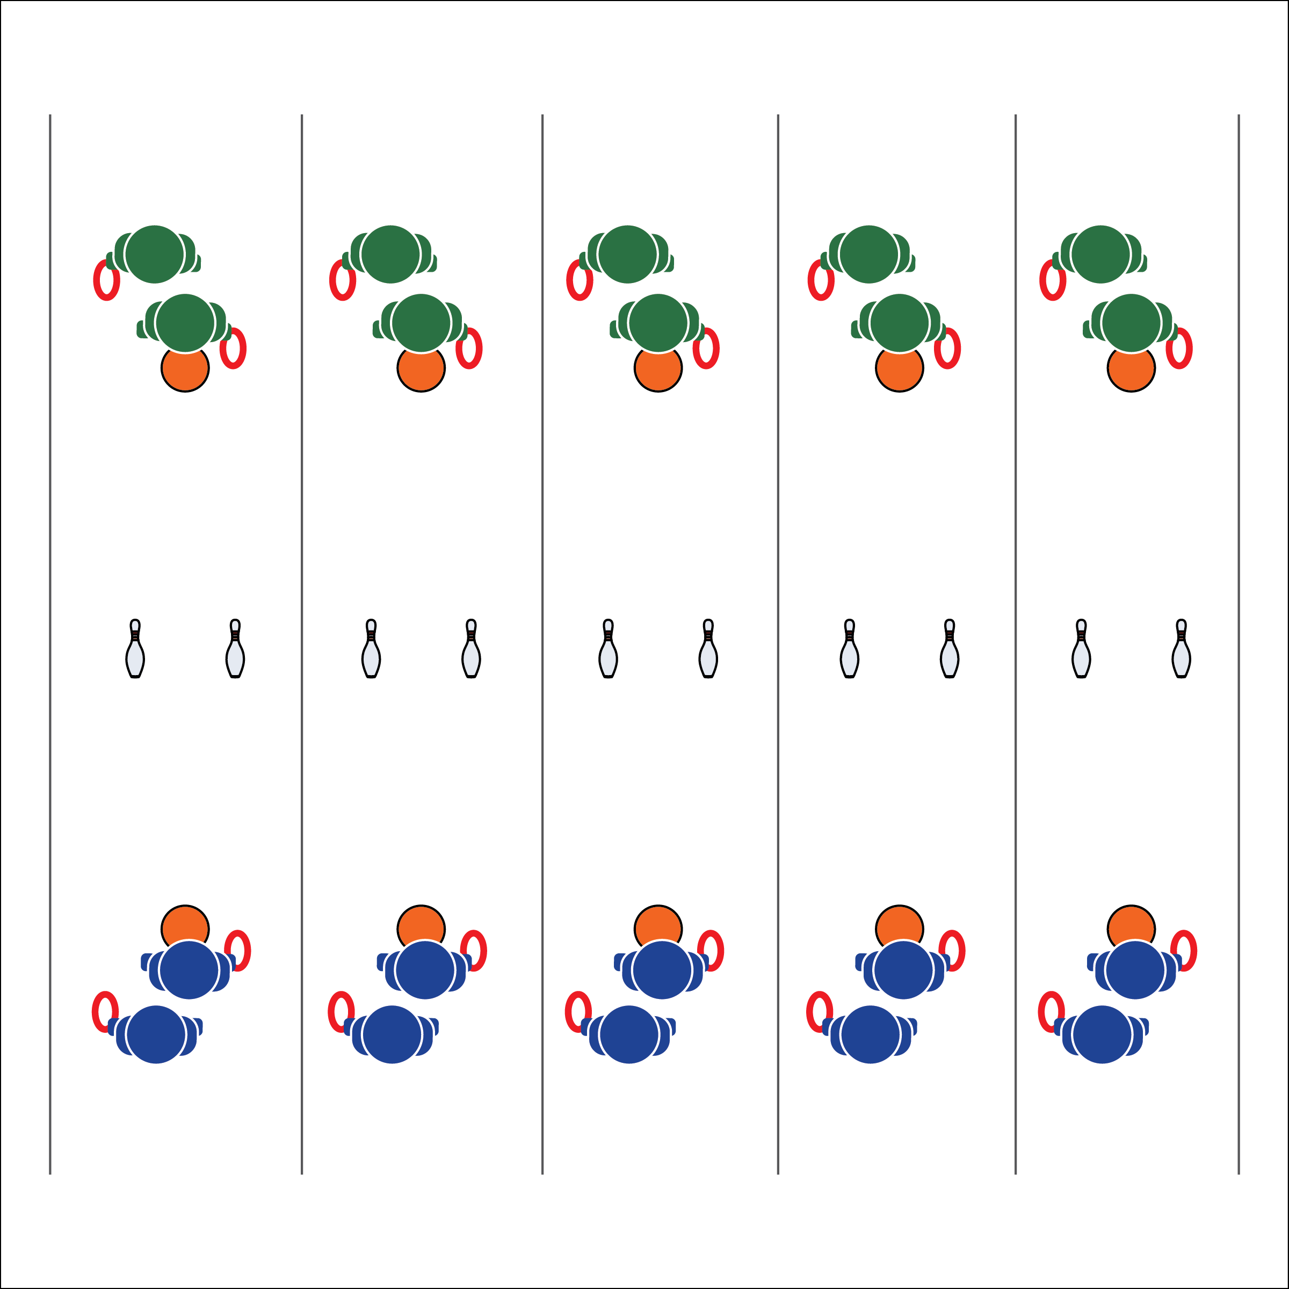

**Activity Procedures:**

1. This is the Life of Water challenge. We are in Hawaii to continue The OPEN 8 Adventure Challenge by playing a traditional Hawaiian game called *Ulu Maika*. It was played during the Makahiki celebration honoring Lono, the god of rain.
2. The object of the activity is to roll a deck ring between the 2 pins without touching either of them. The game was traditionally played with a stone disc.
3. Teams of 2 stand on opposite sides of the court. Each student with 1 deck ring.
4. Teams take turns trying to roll the deck ring between the 2 pins. Teams receive 1 point for every ring that rolls through the pins.
5. The team that scores 21 points first is the Big Kahuna.

**Grade Level Progression:**

**6:** Play the game with no modifications.

**7:** Students can use both underhand rolling or a modified Frisbee toss with the ring sliding across the floor. If successful with a “Frisbee toss,” the throw counts as 2 points.

**8:** Allow students to modify the activity with a new piece of equipment. For example, use a hockey stick to push the ring through the bowling pins for 1 point.

**Equipment:**

* 2 deck rings or small balls per 2 students
* 2 bowling pins (or cones) per 2 students
* 4 spot markers per 2 students

**Set-Up:**

1. Create 1 playing court for every 4 students. Each court should have 2 bowling pins in the middle of the area, about 6-12 inches apart (depending skill level).
2. Place two poly spots 25-30 feet away from both sides of each cone.
3. Divide the class into pairs. Two pairs per court.

* **Skill:** I will demonstrate hand-eye coordination while rolling the deck ring.
* **Cognitive:** I will discuss the importance of preserving culture through physical activity.
* **Fitness:** I will actively engage with classmates in a cultural game called *Ulu Maika* (Hawaii).
* **Personal & Social Responsibility:** I will demonstrate focus by working with classmates to successful complete the Life of Water challenge.

**LIFE OF WATER**

* Face to Target
* Arm Back
* Step with Opposite Foot
* Release & Follow Through

**LIFE OF WATER**



* **DOK 1:** What does the word culture mean?
* **DOK 2:** What do you know about the different cultures that can be found in different areas of the United States? North America? The world?
* **DOK 3:** How is physical activity and sport related to culture?
* **DOK 4:** Create a series of interview questions that you might ask a native Hawaiian about the game *Ulu Maika*.



* **Standard 1 [M18.6-8]:** Executes consistently (70% of the time) a mature underhand pattern for target games such as bowling, bocce, or horseshoes (6-7); Performs consistently (70% of the time) a mature underhand pattern with accuracy and control for one target game such as bowling or bocce (8).
* **Standard 2 [M9.6-8]:** Selects appropriate shot/club based on location of the object in relation to the target (6); Varies the speed and/or trajectory of the shot based on location of the object in relation to the target (7); Varies the speed, force, and trajectory of the shot based on location of the object in relation to the target (8).
* **Standard 5 [M5.6-9]** Identifies how self-expression and physical activity are related (6); Explains the relationship between self-expression and lifelong enjoyment through physical activity (7); Identifies and participates in an enjoyable activity that prompts individual self-expression (8).



Accurate, Challenging, Cooperate, Culture, Persevere



* **Adaptation:** Play with larger balls and/or a wider distance between the bowling pins.
* **Extension:** Allow the students to pick their tossing equipment before attempting the challenge.



**Help students engage in cognitively complex tasks:** Prompt students to think abstractly by connecting their game-play experience to the larger concept of a global community. As students create interview questions that they might as a native Hawaiian they must apply this abstract process in a way that creates a cognitively complex environment.

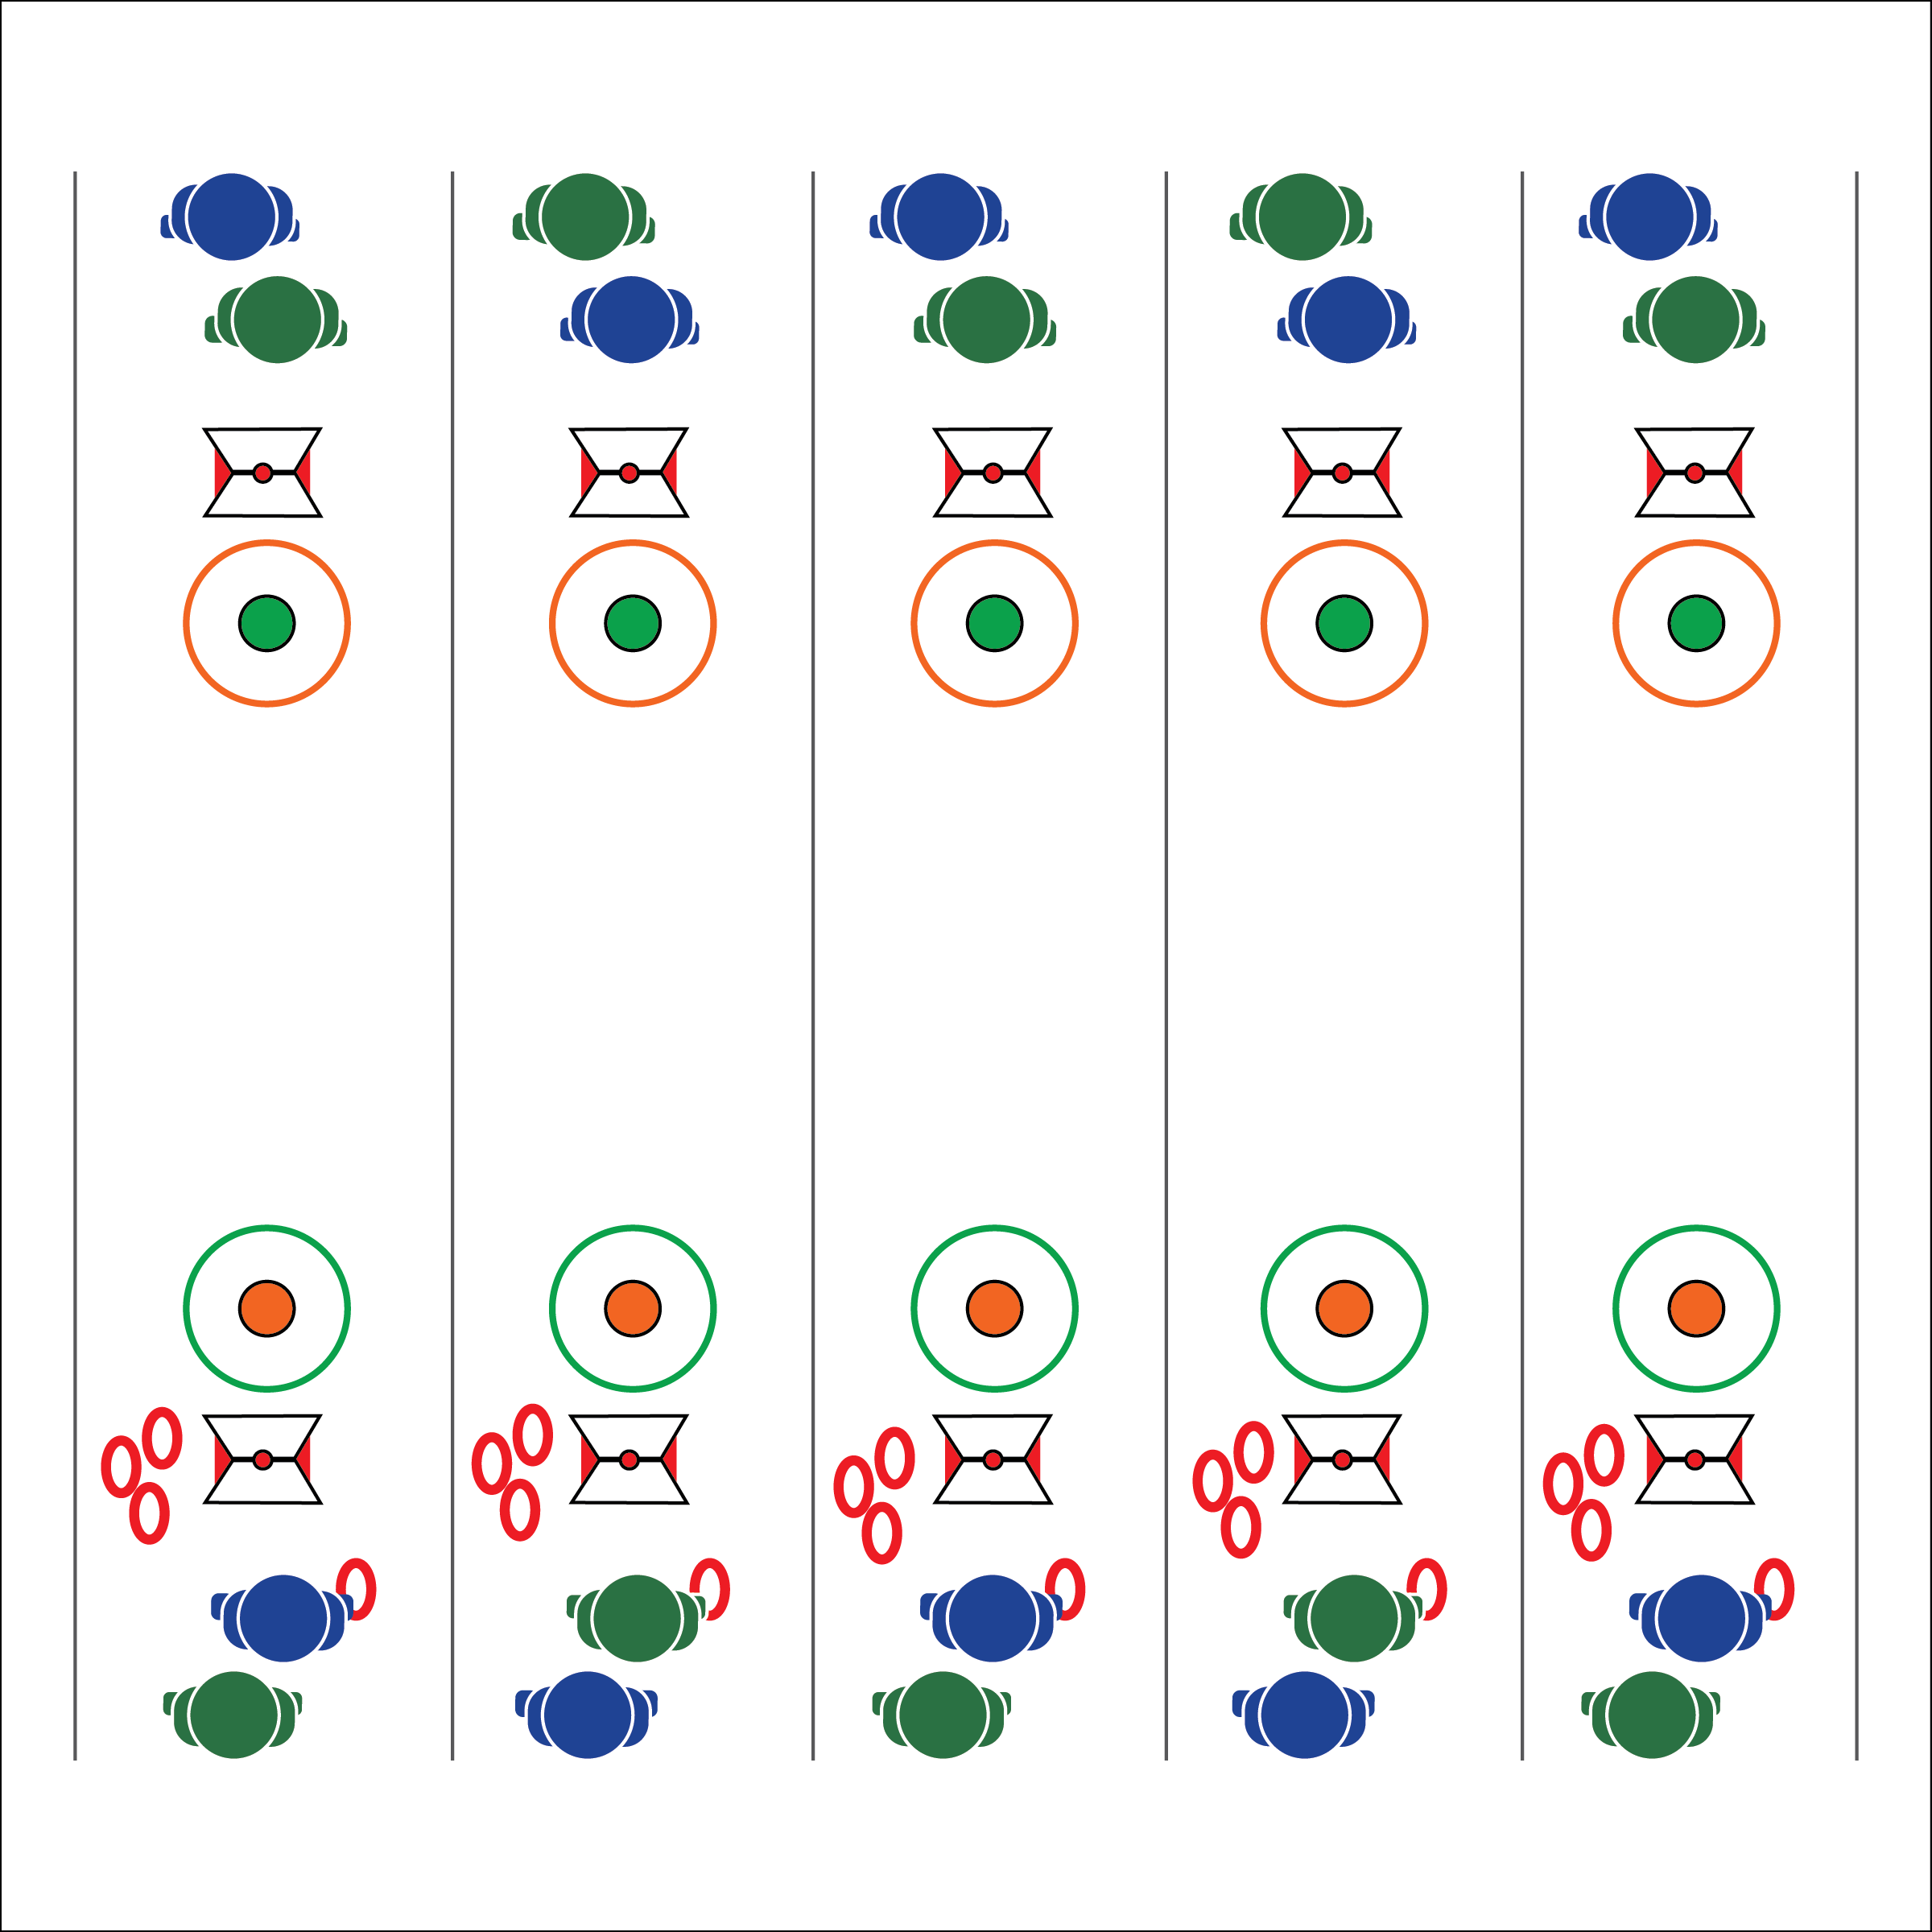

**Equipment:**

* 2 spot markers per group of 4 students
* 2 hula hoops per group of 4 students
* 4 deck rings per group of 4 students
* 1 Life of Wind Exercise Card per 2 students

**Set-Up:**

1. Create 1 playing court for every 4 students. Each court with 2 hoops, 20-40 feet apart (depending on space/skill), and a spot marker in the center of each hoop.
2. Place 4 deck rings at each court.
3. Place 2 Life of Wind Exercise Cards at each court (1 at each end of the court).
4. Divide the class into pairs. 2 pairs per court.

**Activity Procedures:**

1. This is the Life of Wind Challenge. We’ve landed on the Island of Wight in the English Channel. There are ancient records of Roman occupiers in the British Isles playing an ancient game called Quoits. It’s the earliest known version of Horseshoes.
2. The object is to use proper underhand throwing form to place the ring nearest to the spot marker. Traditionally, the game is played with a stake in the ground.
3. If 1 ring is closest to the spot, 1 point is scored. If 2 rings are closest to the spot, 2 points are scored. The game is played to 21 points.
4. In order to “bank” the points scored, the team with the rings closest to the spot must complete 1 Life of Wind Exercise Challenge.
5. Play Rock, Paper, Scissors to determine which team is first. A member of each team alternates throws from 1 side. After points are scored, players on the other side have a turn.
6. Remind students the importance of safety while throwing and of watching others throw. Students stand 5-10 feet to the side of the spot while watching the activity.

**Grade Level Progression:**

**6:** Play the game as described above.

**7 & 8:** Score only the rings that land on the spot marker or within the hula hoop.

* Eyes on Target
* Proper Form
* Good Sportsmanship
* **Skill:** I will demonstrate hand-eye coordination while tossing.
* **Cognitive:** I will discuss the important connection between social interaction and physical activity.
* **Fitness:** I will actively engage with classmates in cultural game called *Quoits (Greece)*.
* **Personal & Social Responsibility:** I will demonstrate focus by working to complete the Life of Wind challenge.

**LIFE OF WIND**

**LIFE OF WIND**



* **DOK 1:** How would you describe encouragement in a physical activity setting? How would you describe respect?
* **DOK 2:** What did you notice about the social interactions that took place during our game play today?
* **DOK 3:** How are encouragement and respect related to social interaction?
* **DOK 4:** Can we identify any areas that need improvement with respect to our class social interaction? Let’s create a plan for improving those areas.



**Help students elaborate on content:** After asking students what they noticed about the class social interactions, challenge them to provide evidence and support for their claims. Allowing students to respond with one or two work answers does not help to extend their thinking beyond a surface reply. Ask probing questions and work to develop their ability to draw inferences from their personal experiences as well as from the experiences of their classmates.



* **Standard 1 [M18.6-8]:** Executes consistently (70% of the time) a mature underhand pattern for target games such as bowling, bocce, or horseshoes (6-7); Performs consistently (70% of the time) a mature underhand pattern with accuracy and control for one target game such as bowling or bocce (8).
* **Standard 2 [M9.6-8]:** Selects appropriate shot/club based on location of the object in relation to the target (6); Varies the speed and/or trajectory of the shot based on location of the object in relation to the target (7); Varies the speed, force, and trajectory of the shot based on location of the object in relation to the target (8).
* **Standard 5 [M6.6-8]** Demonstrates respect for self and others in activities and games by following the rules, encouraging others and playing within the spirit of the game or activity (6); Demonstrates the importance of social interaction by helping and encouraging others, avoiding trash talk and providing support to classmates (7); Demonstrates respect for self by asking for help and helping others in various physical activities (8).



Accurate, Encouragement, Respect, Social Interaction



* **Adaptation:** Modify the distance and size of the target to meet the needs of each student. Deck rings can be replaced with bean bags.
* **Extension:** Add cross-curricular lesson components, integrating geography, history, language arts, and science (Laws of Motion or Physiology). This could be co-taught with science teachers.

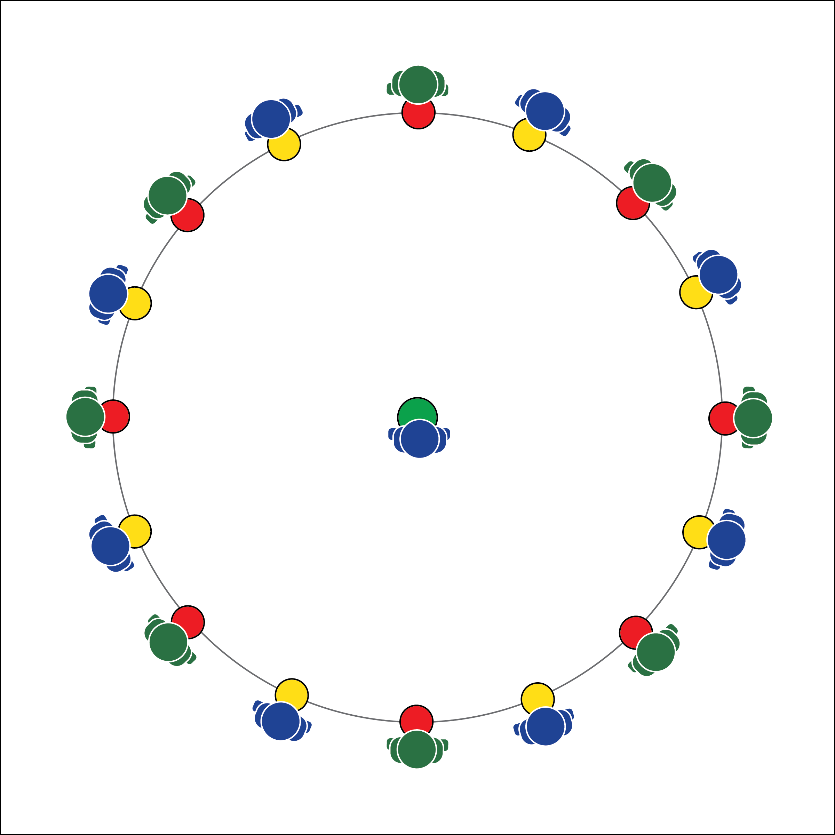

**Equipment:**

* 1 spot marker per student

**Set-Up:**

1. Arrange spot markers in a large circle with 1 spot in the center.
2. Each student stands on a poly spot, with 1 student in the center.

* **Skill:** I will safely demonstrate locomotor movements through general space.
* **Cognitive:** I will explain and discuss the importance of nonverbal communication.
* **Fitness:** I will actively engage in the Life of Ice challenge.
* **Personal & Social Responsibility:** I will demonstrate focus by working to complete the Life on the Ice challenge.

**Activity Procedures:**

1. This is the Life on the Ice challenge. We’ve traveled to Northern Canada where people live on 2 meters of ice during the long winter in Yellowknife Bay. However, it’s the spring breakup and the ice is getting thin. Any loud noise could cause it to break. It is important that you communicate with classmates using only nonverbal methods.
2. The object of this activity is to swap spots with a classmate without the Abominable Snow Monster taking your spot. To do this, make eye-contact or another type of nonverbal communication with another classmate standing on a spot marker. After making eye contact, use nonverbal communication to coordinate movement to quickly exchange places while safely traveling through open space.
3. As 2 players are changing places, the center player (the Abominable Snow Monster) tries to get to an open spot marker first. If she/he is successful, the player left without a spot marker becomes the new Snow Monster.
4. When the teacher calls, “Iceberg!!” ALL students must quickly move to a new spot marker while the Snow Monster also tries to secure a spot.

**Grade Level Progression:**

**6:** The students can use all forms of nonverbal communication.

**7:** The students can only use hands and feet for communication.

**8:** The students can only use facial expressions for communication.

* Be Quiet
* Be Patient
* Focus on Your Classmates
* Move Safely

**LIFE ON THE ICE**

**LIFE ON THE ICE**



* **DOK 1:** What would you include on a list about nonverbal communication?
* **DOK 2:** What did you notice about the nonverbal communication used by classmates in the Life on the Ice challenge?
* **DOK 3:** How is nonverbal communication related to cooperation?



* **Standard** **4 [M5.6-8]:** Cooperates with a small group of classmates during adventure activities, game play, or team-building activities (6); Problem-solves with a small group of classmates during adventure activities, small-group initiatives, or game play (7); Cooperates with multiple classmates on problem-solving initiatives including adventure activities, large-group initiatives, and game play (8).



* **Adaptation:** Students change locomotor movements when passing through open space. Begin with walking and increase to more vigorous movements.
* **Extension:** Each time students make it to a new spot, perform a fitness activity. Break the class into smaller groups throughout the gym with space for movement between groups. Every circle has a Snow Monster in the middle. Students can move from 1 group to another.



Actively Engage, Cooperate, Nonverbal Communication, Responsibility, Safe, Teamwork



**Organize students to interact with content:** Positive communication and creative gestures play a key role in student success if this activity. The challenge for teachers is to create an environment in which students interact with members of different social groups. One modification that may help with this task is to limit communication to students on spots of the same color. This will force students to interact with students that they may otherwise ignore.

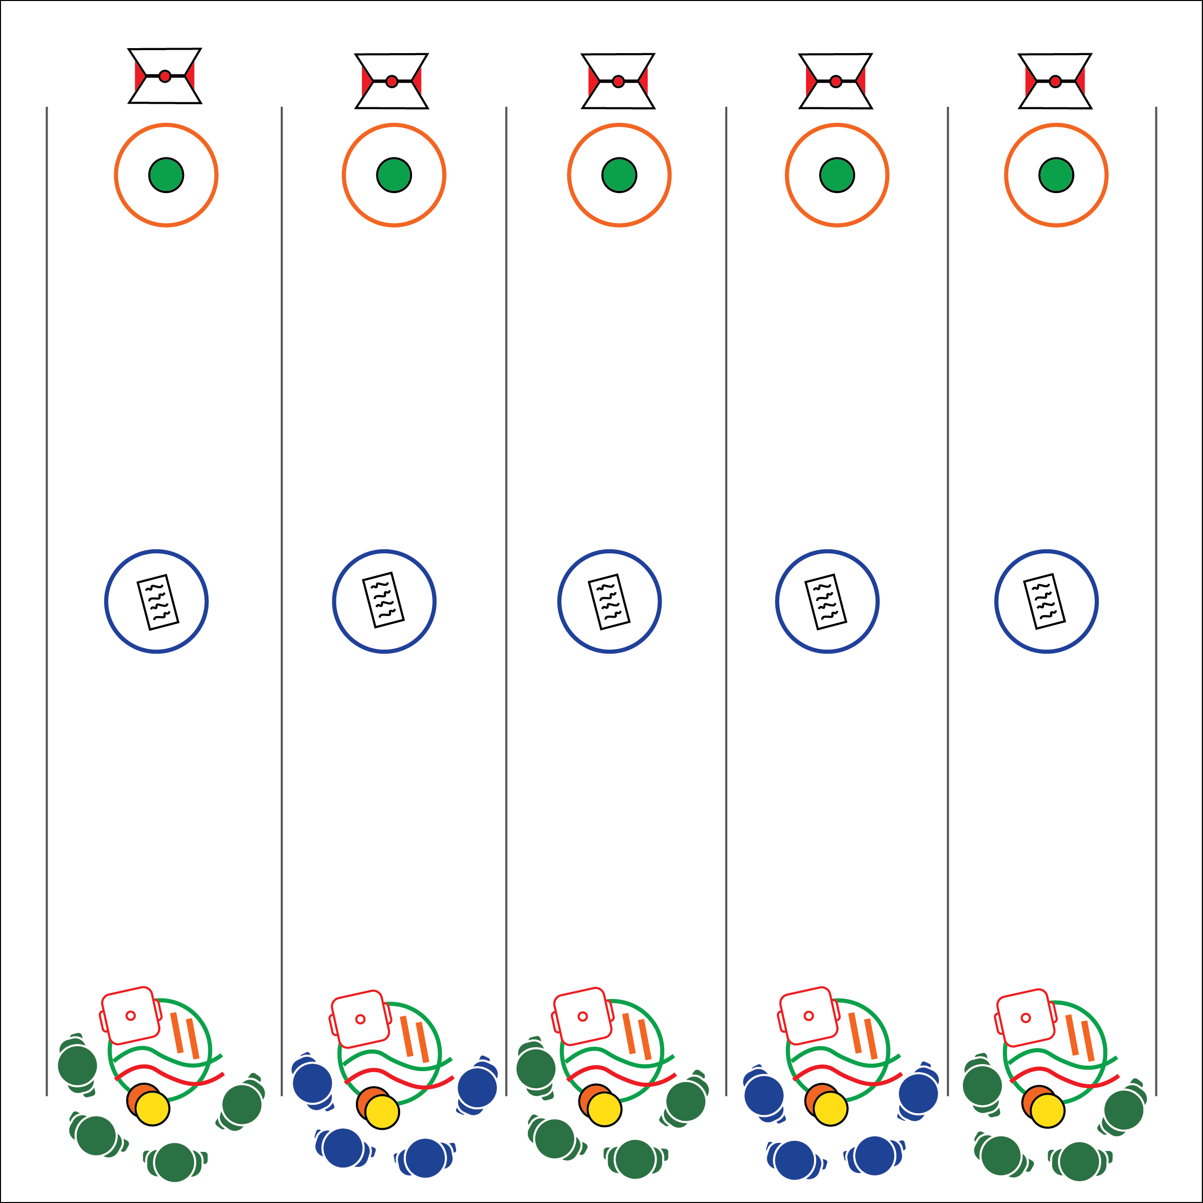

* Communicate
* Listen to All Ideas
* Be Patient with Teammates
* **Skill:** I will demonstrate cooperation by solving problems with my team.
* **Cognitive:** I will discuss the relationship between physical activity and cognitive function.
* **Fitness:** I will actively engage in the Master of Life challenge.
* **Personal & Social Responsibility:** I will demonstrate responsible behaviors related to safety and cooperation.

**Equipment:**

* 3 hoops per group
* 2 jump ropes per group
* 2 spot markers per group
* 1 cone per group
* 1 scooter per group
* 2 pool noodles per group
* 1 ASCII Code Hacker Guide per group
* 1 Master of Life Scramble Card per group

**Set-Up:**

1. Create 3 parallel lines with hoops. 1 line of hoops on one side of the activity area, 1 across on the other side, and 1 in the center of the other 2.
2. Inside hoop 1, place the equipment listed above.
3. Create groups of 3 to 5 students; 1 group per set of hoops.

**Activity Procedures:**

1. We’ve traveled to Silicon Valley in the San Francisco Bay Area to complete the Master of Life challenge. This is one of the most important challenges in the OPEN 8 Adventure Challenge.
2. Your team must navigate an electrified security area, capture the ASCII Code Hacker Guide, and then continue to the Master of Life Scramble Card, where you’ll crack the binary code to unlock essential ingredients for saving humanity.
3. Here’s the rules for navigation: at least 2 players must be tied together with ropes at all times; only players tied safely together can navigate the secure area; no player may touch the floor of the secure area – use spots, hoops, noodles, and the scooter to navigate the area; hoops can be used as islands, but cannot be moved; if any player touches the floor, all members of the team must go back to the starting hoop.

**Grade Level Progression:**

**6:** Implement the activity as written above.

**7:** Students cannot speak. Nonverbal communication only.

**8:** One member of the team is blindfolded or has suffered a mock injury.

**MASTER OF LIFE**

**MASTER OF LIFE**



**Help students practice skills, strategies, and processes:** Group dynamics play a key role in success of each team. Even though students are required to sit and discuss ideas as a team prior to starting the activity, many students typically set out on their own, sometimes with limited success, before realizing that they will not be successful until all group members become involved. The teacher must move from group to group, offering guidance while also allowing each group to discover their own process to complete the challenge. Monitor student behavior throughout the activity with a careful watch for the unsafe use of equipment and the use of disrespectful language.



* **DOK 1:** What is cognitive function?
* **DOK 2:** What do you know about how physical activity affects cognitive function?
* **DOK 3:** What facts can you provide to support the statement that physical activity can improve cognitive function? Elaborate on why you chose those facts.



* **Standard** **4 [M1.6-7]:** Exhibits personal responsibility by using appropriate etiquette, demonstrating respect for facilities, and exhibiting safe behaviors (6); Exhibits responsible social behaviors by cooperating with classmates, demonstrating inclusive behaviors, and supporting classmates (7).
* **Standard 4 [M4.6-8]:** Accepts differences among classmates in physical development, maturation, and varying skill levels by providing encouragement and positive feedback (6); Demonstrates cooperation skills by establishing rules and guidelines for resolving conflicts (7); Responds appropriately to participants’ ethical and unethical behavior during physical activity by using rules and guidelines for resolving conflicts (8).
* **Standard 4 [M5.6-8]:** Cooperates with a small group of classmates during adventure activities, game play, or team-building activities (6); Problem-solves with a small group of classmates during adventure activities, small-group initiatives, or game play (7); Cooperates with multiple classmates on problem-solving initiatives including adventure activities, large-group initiatives, and game play (8).



Binary Code, Cognitive Function, Communicate, Cooperate, Grit, Responsibility, Safe, Teamwork, 21st Century Learning Skills (each skill is defined on the ASCII Key & Glossary)



* **Adaptation:** Add more hoops and spot markers to each group’s equipment options. Do not require students to be tied safely together.
* **Extension:** Double the size of teams. Provide each group with 1 spot maker per team member, plus 1 additional spot. Do not provide a scooter. Require teams to use only spot markers to navigate. All teammates must also remain holding on to the safety ropes, linking the team together.

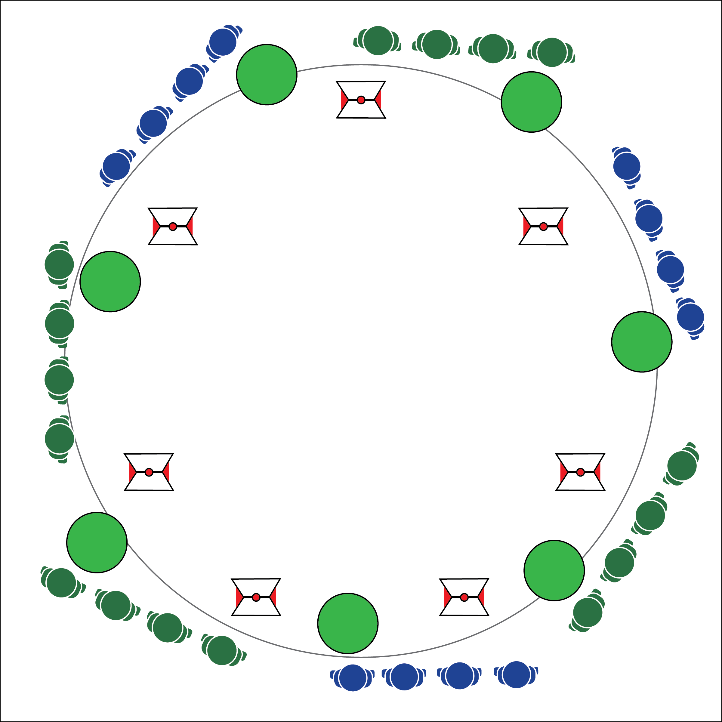

* Focus on Safe Movement
* Communicate and Cooperate
* Be Kind and Respectful

**Equipment:**

* 7 cones (any size)
* 1 large fitness ball (or other ball) per group
* Courage Creation Cards

**Set-Up:**

1. Create an activity perimeter using 7 cones.
2. Divide classes into 7 equal groups. Each group at a cone with a ball.
3. Use Courage Creation Card as described in the Grade Level Progressions below.

**Activity Procedures:**

1. We’ve made it to the final OPEN 8 Adventure Challenge, which is called the Act of Ultimate Courage. Each group will start at 1 of the 7 continents with a Sphere of Courage (ball). The objective is for each team to carry a Sphere of Courage to each continent as a service to humanity, providing bravery to all people.
2. Start in a line behind your continent cone. Lay on your backs, shoulder to shoulder. The last person in line holds the ball.
3. On the start signal, the player with the ball hands it to the next player and then stands up to quickly move to the front of the line. The ball is passed forward, from player to player, and each passer quickly moves to the front of the line to keep the line moving ahead.
4. Teams continue in this pattern around the cones until they return to their original continent cone. If the ball is dropped, retrieve it and continue to move ahead.
5. Teams may safely pass other teams while inside the cones.

**Grade Level Progression:**

**6:** Implement the activity as written above.

**7:** Use Courage Creation Cards to provide an additional movement challenge.

**8:** Place a Courage Creation Card at each cone. As teams pass a continent cone, they must begin the movement challenge posted on the Courage Creation Card.

* **Skill:** I will demonstrate coordinated movements, motor control, and balance.
* **Cognitive:** I will discuss the importance of courage to personal development and a growth mindset.
* **Fitness:** I will actively engage in the Act of Ultimate Courage.
* **Personal & Social Responsibility:** I will demonstrate focus by working with classmates to successfully complete the final OPEN 8 Adventure Challenge.

**ACT OF ULTIMATE COURAGE**

**ACT OF ULTIMATE COURAGE**



* **Standard** **4 [M5.6-8]:** Cooperates with a small group of classmates during adventure activities, game play, or team-building activities (6); Problem-solves with a small group of classmates during adventure activities, small-group initiatives, or game play (7); Cooperates with multiple classmates on problem-solving initiatives including adventure activities, large-group initiatives, and game play (8).
* **Standard 5 [M6.6-8]:** Demonstrates respect for self and others in activities and games by following the rules, encouraging others, and playing within the spirit of the game or activity (6); Demonstrates the importance of social interaction by helping and encouraging others, avoiding trash talk, and providing support to classmates (7); Demonstrates respect for self by asking for help and helping others in various physical activities (8).



Courage, Communicate, Cooperate, Grit, Growth Mindset, Kindness, Respect, Service



* **Adaptation:** Use a smaller/lighter object for passing. Allow students to stand and walk as they hand the ball off.
* **Extension:** Allow students to create their own Courage Creation challenges.



* **DOK 1:** What would you include on a list about the growth mindset?
* **DOK 2:** What do you know about grit? How does grit apply to the growth mindset?
* **DOK 3:** How is courage related to grit?
* **DOK 4:** Use the Grit Builder Reflection Sheet to gather information to support your ideas about courage and grit.



**Help students process content:** As the OPEN 8 Adventure Challenge comes to a conclusion, student will benefit from using the Grit Builder Reflection Sheet as a tool for processing their experiences. It critical that teachers create space and opportunity for students to work with, summarize and elaborate on how their personal interaction with the class content relates directly to their lives.