­­­

­

* Challenge
* Cooperate
* Coordination
* Grit
* Respect
* Traverse
* Culture
* Force
* **Standard 2 [M1.6-8]:** Creates open space by using locomotor movements in combination with movement (e.g., varying pathways; change of speed, direction, or pace) (6).
* **Standard 5 [M4.6-8]** Describes how moving competently in a physical activity setting creates enjoyment (6); Identifies why self-selected physical activities create enjoyment (7); Discusses how enjoyment could be increased in self-selected physical activities (8).
* **Standard 5 [M6.6-8]:** Demonstrates respect for self and others in activities and games by following the rules, encouraging others and playing within the spirit of the game or activity (6); Demonstrates the importance of social interaction by helping and encouraging others, avoiding trash talk and providing support to classmates (7); Demonstrates respect for self by asking for help and helping others in various physical activities (8).
* **Skill:** I will demonstrate coordination while applying movement skills.
* **Cognitive:** I will discuss the role of communication in cooperative activities.
* **Fitness:** I will actively engage in all OPEN 8 challenges.
* **Personal & Social Responsibility:** I will demonstrate focus by working with classmates to successful complete the OPEN 8 challenges.
* Academic Language Exit Slip

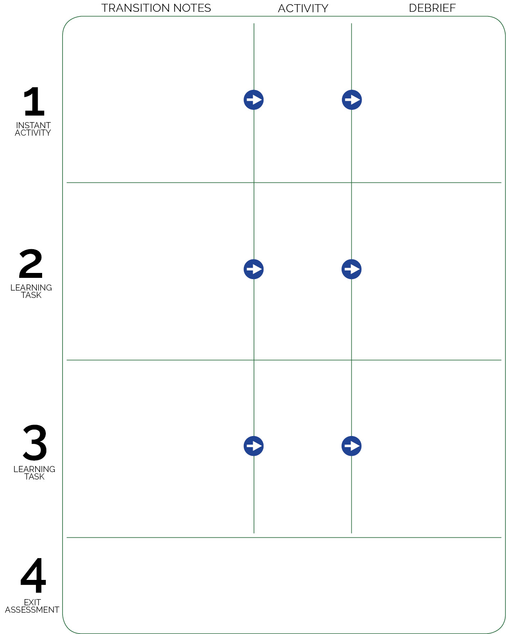

There are 6 traversing areas. Students in groups of 4. One group per area, 2 blindfolds per group. Introduce this challenge as the mode of transportation that will take the class from their homes/school to the OPEN 8 challenge location.

Birth of Sky

Emerging Force

Students quickly help clean the traversing areas. Perimeter cones are left in place. Each student gets 1 hoop and a short pool noodle. Scatter all students in personal space standing in their hoop with noodle on the floor in the hoop. Students stand, ready to listen.

Students put hoops and pool noodles away, pick up an academic language exit slip and pencil, and then sit in personal space. They choose 1 academic language word from the day’s list of words, then define in their own words with a new contextual sentence.

**DOK 1:** What is a cultural experience?

**DOK 2:** How would you compare/contrast Hoop Rolling from Africa to games that come from American cultures?

**DOK 3:** How is enjoyment related to cultural activities? Explain your answer.

**DOK 1:** What is coordination?

**DOK 2:** How would you summarize the way coordination relates to climbing/traversing?

**DOK 3:** How would you adapt the Birth of Sky challenge to help further develop coordination?

OPEN 8 Introduction

As students enter, the walk the perimeter (marked with cones) while looking at and discussing the day’s selected academic language words.

**DOK** **1:** What does positive communication sound like? look like?

**DOK 2:** How can communication (both positive and negative) affect a cooperative performance?

**DOK 3:** How is positive communication related to respect?