­­­

­

* Word
* Word
* Word
* **Standard # [Code]:** Text
* **Standard # [Code]:** Text
* **Standard # [Code]:** Text
* **Skill:** I will…
* **Cognitive:** I will…
* **Fitness:** I will…
* **Personal & Social Responsibility:** I will…
* Assessment Name

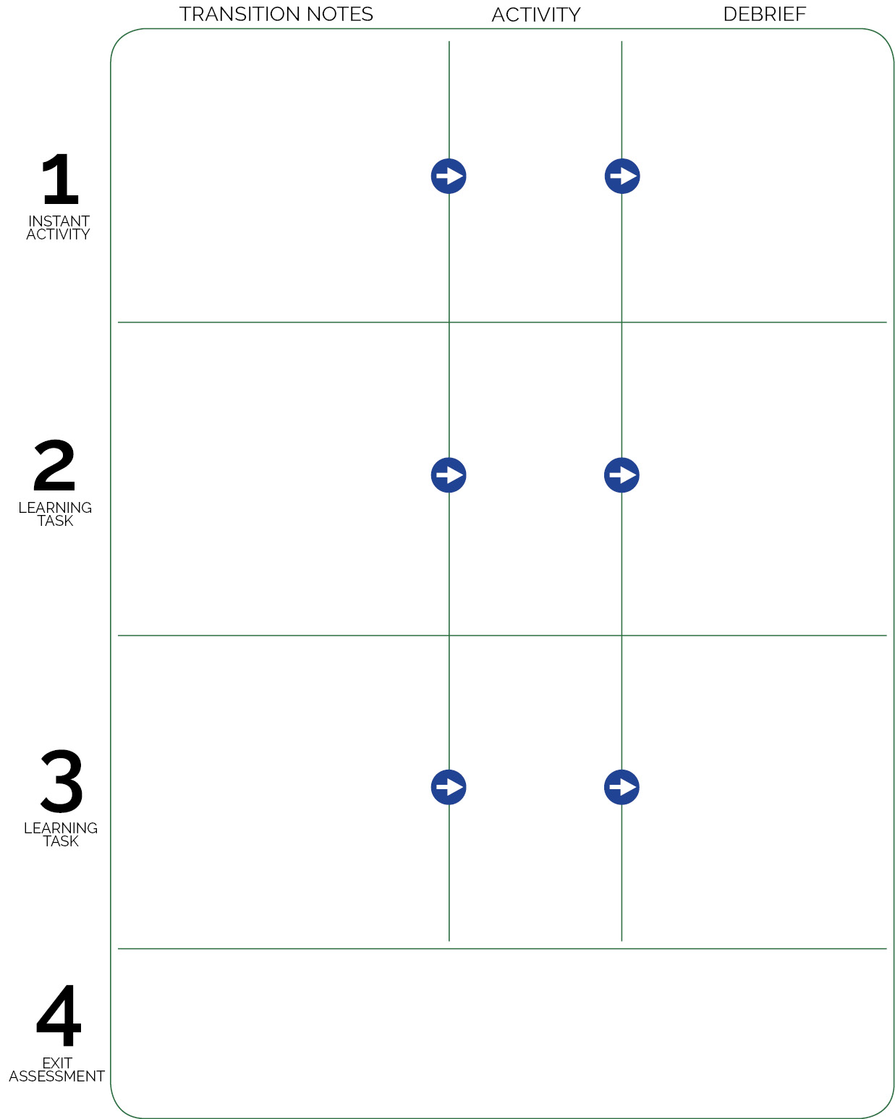

Activity Name

Transition to next activity…

Activity Name

Transition to next activity…

Exit assessment logistics…

**DOK** **1:** Question

**DOK 2:** Question

**DOK 3:** Question

**DOK** **1:** Question

**DOK 2:** Question

**DOK 3:** Question

Activity Name

Transition into class…

**DOK** **1:** Question

**DOK 2:** Question

**DOK 3:** Question