­­­

|  |  |  |
| --- | --- | --- |
| **RESOURCES** | **FOCUS STANDARDS** | **PAGE** |
| Module Overview |  | **1** |
| Required Materials List |  | **5** |
| **Activity Plans** |  |  |
| The Basics | Standards 1, 2, 4 | **6** |
| Ball Fun | Standards, 2, 4 | **8** |
| Under the ‘Chute | Standard 4 | **10** |
| Parachute Games | Standard 1, 2, 4 | **12** |
| Parachute Fitness | Standard 2, 4 | **14** |
| Sample First Lesson Plan |  | **16** |
| Academic Language Posters |  | **26 pages** |
| Universal Design Modifications |  | **1 page** |
| Parachute Activity Cards |  | **5 pages** |
| Parachute Rules Poster |  | **1 page** |
| Elementary Anatomy Chart |  | **1 page** |
| **Student Assessment Tools** |  |  |
| Self-Assessment Worksheet |  |  |
| Holistic Performance Rubrics |  |  |
| Teacher Self-Reflection Guide |  |  |

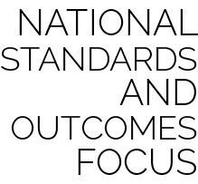

**Standard 1.** Demonstrates competency in a variety of motor skills and movement patterns.

* **E1.K-2.** Performs locomotor skills (hopping, galloping, running, sliding, skipping) while maintaining balance (K); Hops, gallops, jogs, and slides using a mature pattern (1); Skips using a mature pattern (2).

**Standard 2.** Applies knowledge of concepts, principles, strategies and tactics related to movement and performance.

* **E3.K-2.** Travels in general space with different speeds (K); Differentiates between fast and slow speeds (1a); Differentiates between strong and light force (1b); Varies time and force with gradual increases and decreases (2).

**Standard 4.** Exhibits responsible personal and social behavior that respects self and others.

* **E4.K-1,2b.** Follows teacher directions for safe participation and proper use of equipment with minimal reminders (K); Follows teacher directions for safe participation and proper use of equipment without teacher reminders (1); Works safely with physical education equipment (2b).

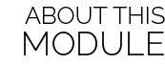

**Written by:** Lisa Kushner, Amanda Welch, Nick Kline & Aaron Hart

**Special Contributions:** Deedi Brown **Design:** Jennifer Truong

Parachute activities are among the most memorable physical education experiences of a young child’s life. Just seeing the ‘chute creates excitement and joy for most students. It is also an important opportunity to reinforce critical personal responsibility skills, as well as introduce movement concepts and early muscular anatomy.

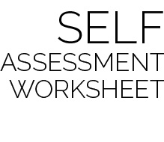

This simple self-assessment provides each student with a structure for reflecting on current knowledge and skill level, setting a goal for growth and development, and then reassessing progress toward that goal.

The authors recommend that students complete this form as a pre-assessment on the day that skills and concepts are first introduced. For example, during the module’s first lesson, students participate in the activity The Basics. At the end of this activity, students would complete the Pre and Goal columns for Start/Stop Signals. Cooperation, and Muscle Names would not be completed until a future lesson introduces those concepts. A post-assessment for all skills would then be completed during the Module’s final lesson.

Introduce the self-assessment tool and process to K-1 students by completing the worksheet as a class, rating the entire group’s performance. Next, set a group goal for improvement and complete the post assessment together. Young students will most likely need too much guidance to complete this type of assessment independently. We recommend attempting an independent self-assessment at the end of grade 1 and then throughout grade 2.



Two types of assessment are provided as a part of this module. However, there are many different ways for teachers and students to assess and evaluate student learning and skill development.

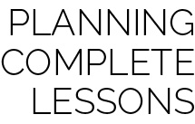

Each skill-building activity in this module is meant to be one part of a complete lesson. The authors recommend the following formula for creating a 30 to 45 minute lesson:

Instant Activity (not on block plan) *5-10 minutes*

+ ‘Chute Activity with Debrief *10-15 minutes*

+ ‘Chute Activity with Debrief *10-15 minutes*

+ Check for Understanding *5 minutes*

**Important:** Suggestions are what they say they are – *suggestions*. All OPEN materials are offered in MS Word format so that you can easily modify our suggestions to meet the needs of your students.

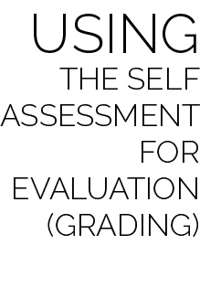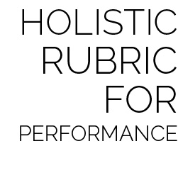

The Holistic Rubric can be used as both a formative and summative assessment within the module. Providing students with the rubric’s criteria early in the module will allow for discussion and formative evaluation throughout activities and lessons.

Two rubrics are given for teachers to choose from based completely on preference. The Single Holistic Rubric provides one set of criteria including both skill and personal and social responsibility (PSR) characteristics. The Dual Holistic Rubric separates skill and PSR characteristics providing two sets of criteria to be evaluated separately. Either rubric can be completed in full during the Module’s final lesson, providing a final holistic evaluation of each student’s performance.

When evaluating a student’s performance in using the Self-Assessment Worksheet, the student’s score should be based on the process and quality of self-reflection, not the student’s ability to score a full column of smiles or stars. Here is a sample rating scale for Self-Assessment evaluation:

* Well Below Competence (1): Was present, but refused to complete Self-Assessment.
* Lacks Competence (2): Completed each assessment with little effort. Student pre- and post-assessments do not match teacher-observed skill performance.
* Competent (3): Most skill assessments match the student’s skill level with a goal for improvement and an accurate post-assessment. Evidence of reflection is present.
* Proficient (4): All skill assessments match the student’s skill level with a goal for improvement and an accurate post-assessment. Evidence of reflection and a regard for quality of work is present.

*NOTE: The evaluation scale suggested for the Self-Assessment is consistent with the scale used for the Holistic Rubrics discussed below. This consistency allows teachers to average several scores for the sake of a final evaluation or grade.*



|  |  |  |
| --- | --- | --- |
| **Lesson** | **Skill Activity** | **Suggested Academic Language** |
| 1 | The Basics | Appropriate, Overhand Grip, Underhand Grip, Mixed Grip, Clockwise, Counter-Clockwise, Cooperate, Muscle, Teamwork |
| 2 | The Basics,  Ball Fun | Control, Cooperation, Direction, Force, Muscle, Muscular Endurance, Muscular Strength, Teamwork |
| 3 | The Basics,  Under the ‘Chute | Cooperation, Coordination, Muscular Endurance, Muscular Strength, Personal Responsibility, Trust |
| 4 | The Basics, Parachute Games | Control, Etiquette, Mindful, Relaxation |
| 5 | Parachute Fitness, Parachute Games | Challenge, Control, Fitness, Muscular Endurance, Muscular Strength |
| 6 | Parachute Fitness, Parachute Games | Challenge, Control, Fitness, Muscular Endurance, Muscular Strength |