­­

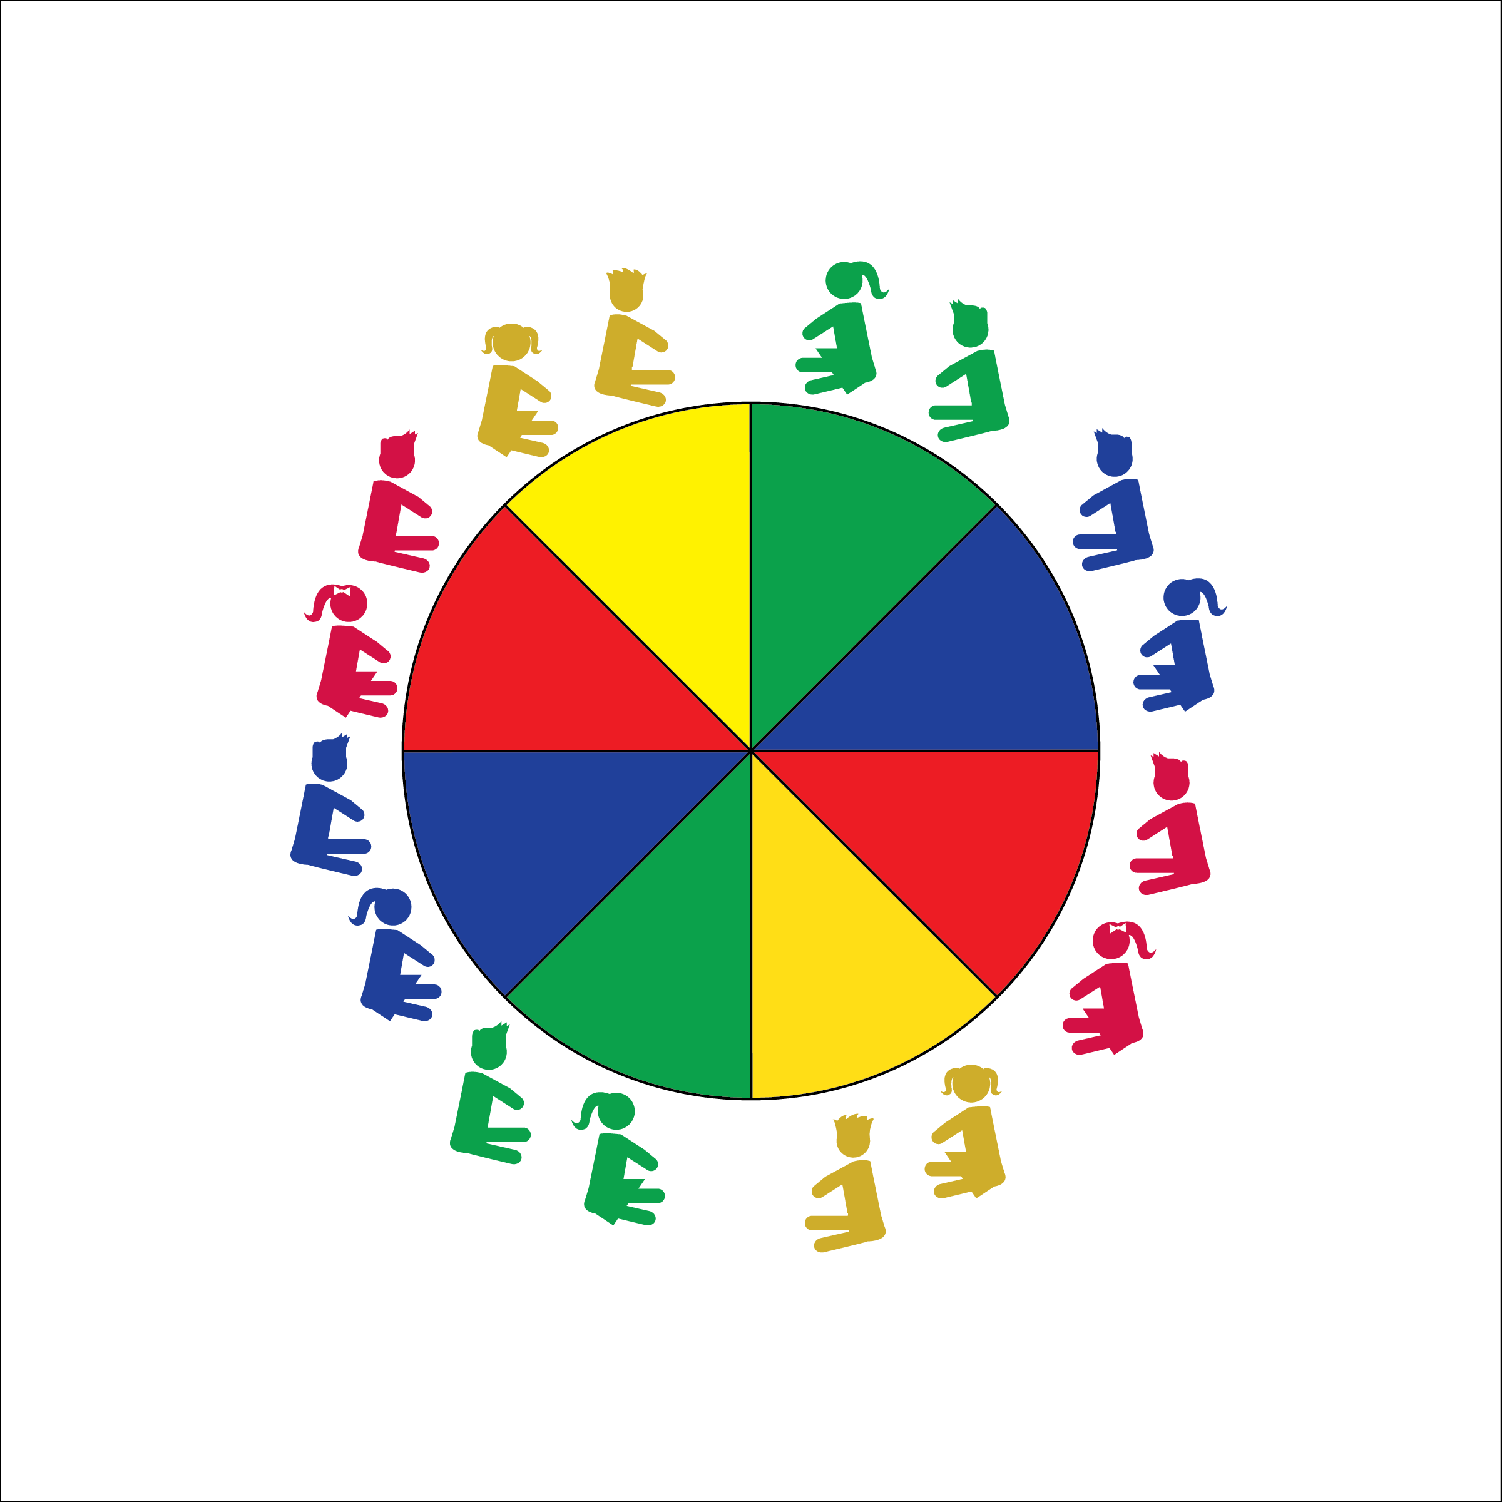

**Equipment:**

* Large Parachute
* Parachute Rules
* Parachute Activity Card: “The Basics”

**Set-Up:**

1. Students begin by siting around the outside of the parachute.
2. Teacher has easy access to the Parachute Activity Card.

* **Skill:** I will demonstrate the basic overhand, underhand, and mixed grips.
* **Cognitive:** I will discuss parachute safety rules.
* **Fitness:** I will stay actively engaged during all activities.
* **Personal & Social Responsibility:** I will work cooperatively with my classmates and use the parachute appropriately.
* Work Safely
* Listen for Teacher Cues
* Respect Self-Space
* Respect Equipment
* Actively Engage

**Activity Procedures:**

1. Today we are going to have fun exploring different grips used during parachute activities. Then, we’ll cooperate during a series of parachute activities.
2. One of the most important rules to follow during parachute activities is to listen for and follow my start and stop signals. When I say, “GO!” it’s okay to start moving with the parachute. When I say, “FREEZE!” it’s important to stop immediately and freeze your body.
3. Teachers, use the following activity sequence from the Parachute Activity Cards (this may take more than one class period): 1) Get a Grip; 2) Storm Bringer; 3) Merry Go Round; 4) One-Hand Run; 5) Color Race; 6) The Wave; 7) Follow the Leader 8); Mountain Climber; 9) Hot Air Balloon; 10) Balloon Ride; 11) Submarine.

**Grade Level Progression:**

**K:** Begin movement around the chute with basic locomotor skills such as a walk, march, or jog.

**1st:** Progress to more complex locomotor skills such as a gallop or slide. Some students will be able to skip while maintaining balance.

**2nd:** Add a skip to locomotor skills.

**THE BASICS**

**THE BASICS**



* **DOK 1:** Can you remember all of the parachute rules?
* **DOK 2:** How does following rules affect safety during parachute activities?
* **DOK 3:** How is safety related to learning?



* **Standard 1** **[E1.K-2]** Performs locomotor skills (hopping, galloping, running, sliding, skipping) while maintaining balance (K); Hops, gallops, jogs, and slides using a mature pattern (1); Skips using a mature pattern (2).
* **Standard 2 [E3.K-2]** Travels in general space with different speeds (K); Differentiates between fast and slow speeds (1a); Differentiates between strong and light force (1b); Varies time and force with gradual increases and decreases (2).
* **Standard 3 [E2.K-2]** Actively participates in physical education class (K); Actively engages in physical education class (1); Actively engages in physical education class in response to instruction and practice (2).
* **Standard 4 [E1.K-2]** Follows directions in group settings (e.g., safe behaviors, following rules, taking turns) (K); Accepts personal responsibility by using equipment and space appropriately (1); Practices skills with minimal teacher prompting (2).
* **Standard 4 [E4.K-1, 2b]** Follows teacher directions for safe participation and proper use of equipment with minimal reminders (K); Follows teacher directions for safe participation and proper use of equipment without teacher reminders (1); Works safely with physical education equipment (2b).



Appropriate, Overhand Grip, Underhand Grip, Mixed Grip, Clockwise, Counter-Clockwise, Cooperate, Muscle, Teamwork



* Use smaller ‘chutes with fewer students working together.
* Use two smaller ‘chutes with one group acting as a model/demonstration ‘chute.
* Provide video demonstrations of each activity.



**Help students practice skills, strategies, and processes**: Students will be learning the three different parachute grips and applying each during different activities. They’ll also learn the rules of the parachute. Practice and repeat a variety of basic activities in order to build students’ understanding of why each grip and each rule is necessary.



**Activity Procedures:**

1. Today we’re going to add foam or yarn balls to our parachute. Again, it will be very important for everyone’s safety that we all listen to and follow start and stop signals.
2. Some of the activities will require us to move at just the right time, in a sequence or pattern. Teamwork, cooperation, and control will be very important. The amount of force that we use – either hard or soft – will determine whether or not we will be successful. All parachute activities help us build our muscular strength and endurance.
3. Teachers, use the following activity sequence: 1) Popcorn; 2) Microwave Popcorn; 3) Bounce-Off; 4) Catapult; 5) Roller Ball.

**Grade Level Progression:**

**K:** Reinforce start and stop signals with popcorn activities.

**1st:** Introduce the catapult activity. As student cooperation and coordination increase, add height challenges. Start with an easy challenge (e.g., ball flies over students’ heads). Work toward the ultimate challenge (e.g., ball hits the ceiling).

**2nd:** Roller ball is an advanced activity that requires sequential movement and a lot of teamwork.

**Equipment:**

* Large Parachute
* Yarn Balls
* Foam Balls
* Parachute Activity Card: “Ball Fun”

**Set-Up:**

1. Students begin by siting around the outside of the parachute.
2. Teacher has easy access to the Parachute Activity Card.

* **Skill:** I will demonstrate control and move the parachute at high, medium, and low levels.
* **Cognitive:** I will describe the difference between using hard or soft force during parachute activities.
* **Fitness:** I will use muscular strength and endurance to perform parachute activities.
* **Personal & Social Responsibility:** I will demonstrate safe and cooperative play during all parachute activities.
* Work Safely
* Listen for Teacher Cues
* Respect Self-Space
* Respect Equipment
* Actively Engage

**BALL FUN**

**BALL FUN**



* **DOK 1:** How do you recognize hard force? How do you recognize soft force?
* **DOK 2:** What do you know about how to control the force you apply to the parachute?
* **DOK 1:** What is muscular strength?
* **DOK 2:** How does muscular strength affect force?
* **DOK 3:** How is muscular strength related to activities like Catapult?



* **Standard 3 [E2.K-2]** Actively participates in physical education class (K); Actively engages in physical education class (1); Actively engages in physical education class in response to instruction and practice (2).
* **Standard 4 [E1.K-2]** Follows directions in group settings (e.g., safe behaviors, following rules, taking turns) (K); Accepts personal responsibility by using equipment and space appropriately (1); Practices skills with minimal teacher prompting (2).
* **Standard 4 [E4.K-1]** Shares equipment and space with others (K); Works independently with others in a variety of class environments (e.g., small & large groups) (1); Works independently with others in partner environments (2).
* **Standard 4 [E6.K-1, 2b]** Follows teacher directions for safe participation and proper use of equipment with minimal reminders (K); Follows teacher directions for safe participation and proper use of equipment without teacher reminders (1); Works safely with physical education equipment (2b).



Control, Cooperation, Direction, Force, Muscle, Muscular Endurance, Muscular Strength, Teamwork



* Use smaller ‘chutes with fewer students working together.
* Use two smaller ‘chutes with one group acting as a model/demonstration ‘chute.
* Provide video demonstrations of each activity.



**Review content**: Review the rules and grips from last class and now practice with objects on the parachute. The review will reinforce the importance of following teacher cues and it will highlight the cumulative nature of each lesson. Students are building up to more complex, and often more interesting activities.



**Equipment:**

* Large Parachute
* Parachute Activity Card: “Under the ‘Chute”

**Set-Up:**

1. Students begin by siting around the outside of the parachute.
2. Teacher has easy access to the Parachute Activity Card.

* **Skill:** I will use the different grips to perform activities underneath the parachute.
* **Cognitive:** I will discuss the different muscles used during parachute activities.
* **Fitness:** I will use muscular strength and endurance to perform parachute activities.
* **Personal & Social Responsibility:** I will keep my body under control while I’m moving underneath the parachute.

**Activity Procedures:**

1. Today we’re going to work cooperatively while safely exploring space underneath the parachute. We will need to demonstrate teamwork in order to do some really fun activities. Listen carefully for my movement cues.
2. Teachers, use the following activity sequence: 1) Place Change; 2) Windy Day; 3) The Tent; 4) Washing Machine; 5) Igloo; 6) Bear in the Woods; 7) Big Turtle; 8) Headless Horseman

**Grade Level Progression:**

**K through 1st:** Perform the activities as listed on the Activity Card.

**2nd:** Choose students who have demonstrated excellent behavior to be activity leaders. She/he will call out the commands to complete tent formations.

* Work Safely
* Listen for Teacher Cues
* Respect Self-Space
* Respect Equipment
* Actively Engage

**UNDER THE ‘CHUTE**

**UNDER THE ‘CHUTE**



* Use smaller ‘chutes with fewer students working together.
* Use two smaller ‘chutes with one group acting as a model/demonstration ‘chute.
* Provide video demonstrations of each activity.



Cooperation, Coordination, Muscular Endurance, Muscular Strength, Personal Responsibility, Trust



* **Standard 3 [E2.K-2]** Actively participates in physical education class (K); Actively engages in physical education class (1); Actively engages in physical education class in response to instruction and practice (2).
* **Standard 4 [E1.K-2]** Follows directions in group settings (e.g., safe behaviors, following rules, taking turns) (K); Accepts personal responsibility by using equipment and space appropriately (1); Practices skills with minimal teacher prompting (2).
* **Standard 4 [E4.K]** Follows teacher directions for safe participation and proper use of equipment with minimal reminders (K).



* **DOK 1:** How many muscles can you name?
* **DOK 2:** What do you know about how muscles work?
* **DOK 1:** What does control mean?
* **DOK 2:** What are different ways to apply control to parachute games?
* **DOK 3:** How is control related to safety?



**Help students engage in cognitively complex tasks:** Under ‘Chute activities require careful following of teacher instructions and cues. Each student must listen to and follow cues in a cooperative manner. Be patient and take time to discuss and process successful and unsuccessful performances. Each performance is an opportunity to learn and gain valuable experience toward increasing complex activities.



**Equipment:**

* Parachute
* 1 Foam Ball
* 12 or more bean bags or yarn balls
* Parachute Activity Card: “Parachute Games”

**Set-Up:**

1. Students begin by siting around the outside of the parachute.
2. Teacher has easy access to the Parachute Activity Card.

* **Skill:** I will practice a variety of parachute skills using the teacher’s cues.
* **Cognitive:** I will discuss why it’s important to follow the rules of each parachute game.
* **Fitness:** I will stay actively engaged during all activities.
* **Personal & Social Responsibility:** I will demonstrate proper etiquette by following the rules for each game.
* Work Safely
* Listen for Teacher Cues
* Respect Self-Space
* Respect Equipment
* Actively Engage

**Activity Procedures:**

1. During this class and the next we are going to play fun cooperative games with the parachute. It will be important for everyone in the class to follow all rules and directions.
2. Teachers, use as many classes as necessary to teach and participate in each of the following games:  
   Hot Potato, Mousetrap, Shark Attack, Superman’s Cape, Mindfully Floating on Clouds.
3. Important note: some students may not feel comfortable working under the parachute during games like Mousetrap and Shark Attack. Working under the parachute should be voluntary.

**Grade Level Progression:**

**K through 1st:** Try all activities with the exception of Superman’s Cape.

**2nd:** Add Superman’s cape.

**PARACHUTE GAMES**

**PARACHUTE GAMES**



* **Standard 3 [E2.K-2]** Actively participates in physical education class (K); Actively engages in physical education class (1); Actively engages in physical education class in response to instruction and practice (2).
* **Standard 4 [E1.K-2]** Follows directions in group settings (e.g., safe behaviors, following rules, taking turns) (K); Accepts personal responsibility by using equipment and space appropriately (1); Practices skills with minimal teacher prompting (2).
* **Standard 4 [E2.K-2]** Acknowledges responsibility for behavior when prompted (K); Follows the rules/ parameters of the learning environment (1); Accepts responsibility for class protocols with behavior and performance actions (2).
* **Standard 4 [E4.K-2]** Shares equipment and space with others (K); Works independently with others in a variety of class environments (e.g., small & large groups) (1); Works independently with others in partner environments (2);
* **Standard 4 [E6.K-1, 2b]** Follows teacher directions for safe participation and proper use of equipment with minimal reminders (K); Follows teacher directions for safe participation and proper use of equipment without teacher reminders (1); Works safely with physical education equipment (2b).



Control, Etiquette, Mindful, Relaxation



* Use smaller ‘chutes with fewer students working together.
* Use two smaller ‘chutes with one group acting as a model/demonstration ‘chute.
* Provide video demonstrations of each activity.



* **DOK 1:** Can you remember the parachute rules?
* **DOK 1:** What does the word mindful mean?
* **DOK 2:** How does being mindful affect your ability to follow rules?
* **DOK 3:** How is being mindful related to safety?



**Help students elaborate on content:** The excitement of the parachute can often override a child’s desire to please the teacher and follow behavior rules. Take time to pause the action, ask guiding questions, and allow students to elaborate on their thinking.



**Equipment:**

* Large Parachute
* Parachute Activity Card: “Parachute Fitness”
* Elementary Anatomy Chart

**Set-Up:**

1. Students begin by siting around the outside of the parachute.
2. Teacher has easy access to the Parachute Activity Card.

* **Skill:** I will properly demonstrate each fitness activity using the cues the teacher provides.
* **Cognitive:** I will point to and identify different muscles when asked by the teacher.
* **Fitness:** I will actively engage in all fitness activities.
* **Personal & Social Responsibility:** I will understand and discuss that some activities are more challenging than others.

**PARACHUTE FITNESS**

* Work Safely
* Listen for Teacher Cues
* Respect Self-Space
* Respect Equipment
* Actively Engage

**Activity Procedures:**

1. This activity is called Parachute Fitness.
2. The object of the activity is to focus on building muscular strength and endurance while playing with the parachute. During each activity we’ll talk about and identify the muscles that we’re using.
3. Teachers, use the following activity sequence: 1) Hands on the Wheel; 2) Parachute Sit-ups; 3) Squat Washers; 4) Biceps Curl; 5) Plank to T Workout.

**Grade Level Progression:**

**K through 1st:** Reinforce controlled movements.

**2nd:** Create and practice a variety of plank-based exercises. Allow students to explore muscular tension created during different body positions.

**PARACHUTE FITNESS**



* **Standard 3 [E2.K-2]** Actively participates in physical education class (K); Actively engages in physical education class (1); Actively engages in physical education class in response to instruction and practice (2).
* **Standard 4 [E1.K-2]** Follows directions in group settings (e.g., safe behaviors, following rules, taking turns) (K); Accepts personal responsibility by using equipment and space appropriately (1);Practices skills with minimal teacher prompting (2).
* **Standard 4 [E4.K-2]** Shares equipment and space with others (K); Works independently with others in a variety of class environments (e.g., small & large groups). (1); Works independently with others in partner environments (2).



Challenge, Fitness, Muscular Endurance, Muscular Strength



* Use smaller ‘chutes with fewer students working together.
* Use two smaller ‘chutes with one group acting as a model/demonstration ‘chute.
* Provide video demonstrations of each activity.



* **DOK 1:** Point to the correct muscle as I call out muscle names.
* **DOK 2:** What do you notice about your muscles during parachute fitness activities?
* **DOK 3:** How is muscular endurance related to parachute activities?



**Help students process content**: Parachute activities provide students with a relatable experience with respect to the way that their muscles work. They can feel and see their muscles in action. Engage students in discussion about what they’re seeing and feeling.