­­

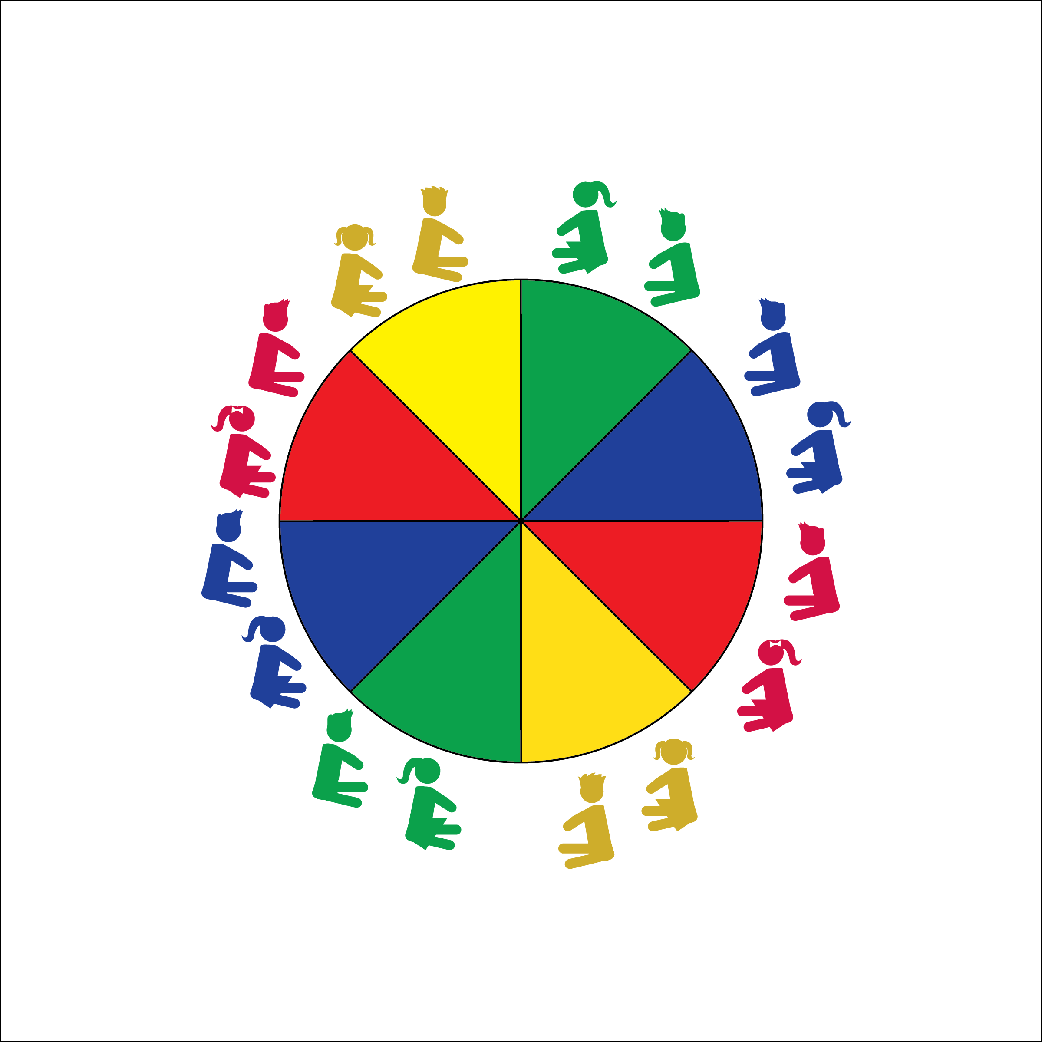

**BALL FUN**

* **Skill:** I will demonstrate control and move the parachute at high, medium, and low levels.
* **Cognitive:** I will describe the difference between using hard or soft force during parachute activities.
* **Fitness:** I will use muscular strength and endurance to perform parachute activities.
* **Personal & Social Responsibility:** I will demonstrate safe and cooperative play during all parachute activities.
* Work Safely
* Listen for Teacher Cues
* Respect Self-Space
* Respect Equipment
* Actively Engage

**Equipment:**

* Large Parachute
* Yarn Balls
* Foam Balls
* Parachute Activity Card: “Ball Fun”

**Set-Up:**

1. Students begin by siting around the outside of the parachute.
2. Teacher has easy access to the Parachute Activity Card.

**Activity Procedures:**

1. Today we’re going to add foam or yarn balls to our parachute. Again, it will be very important for everyone’s safety that we all listen to and follow start and stop signals.
2. Some of the activities will require us to move at just the right time, in a sequence or pattern. Teamwork, cooperation, and control will be very important. The amount of force that we use – either hard or soft – will determine whether or not we will be successful. All parachute activities help us build our muscular strength and endurance.
3. Teachers, use the following activity sequence: 1) Popcorn; 2) Microwave Popcorn; 3) Bounce-Off; 4) Catapult; 5) Roller Ball.

**Grade Level Progression:**

**K:** Reinforce start and stop signals with popcorn activities.

**1st:** Introduce the catapult activity. As student cooperation and coordination increase, add height challenges. Start with an easy challenge (e.g., ball flies over students’ heads). Work toward the ultimate challenge (e.g., ball hits the ceiling).

**2nd:** Roller ball is an advanced activity that requires sequential movement and a lot of teamwork.

**BALL FUN**



Control, Cooperation, Direction, Force, Muscle, Muscular Endurance, Muscular Strength, Teamwork



* **Standard 3 [E2.K-2]** Actively participates in physical education class (K); Actively engages in physical education class (1); Actively engages in physical education class in response to instruction and practice (2).
* **Standard 4 [E1.K-2]** Follows directions in group settings (e.g., safe behaviors, following rules, taking turns) (K); Accepts personal responsibility by using equipment and space appropriately (1); Practices skills with minimal teacher prompting (2).
* **Standard 4 [E4.K-1]** Shares equipment and space with others (K); Works independently with others in a variety of class environments (e.g., small & large groups) (1); Works independently with others in partner environments (2).
* **Standard 4 [E6.K-1, 2b]** Follows teacher directions for safe participation and proper use of equipment with minimal reminders (K); Follows teacher directions for safe participation and proper use of equipment without teacher reminders (1); Works safely with physical education equipment (2b).



* **DOK 1:** How do you recognize hard force? How do you recognize soft force?
* **DOK 2:** What do you know about how to control the force you apply to the parachute?
* **DOK 1:** What is muscular strength?
* **DOK 2:** How does muscular strength affect force?
* **DOK 3:** How is muscular strength related to activities like Catapult?



**Review content**: Review the rules and grips from last class and now practice with objects on the parachute. The review will reinforce the importance of following teacher cues and it will highlight the cumulative nature of each lesson. Students are building up to more complex, and often more interesting activities.



* Use smaller ‘chutes with fewer students working together.
* Use two smaller ‘chutes with one group acting as a model/demonstration ‘chute.
* Provide video demonstrations of each activity.