­­

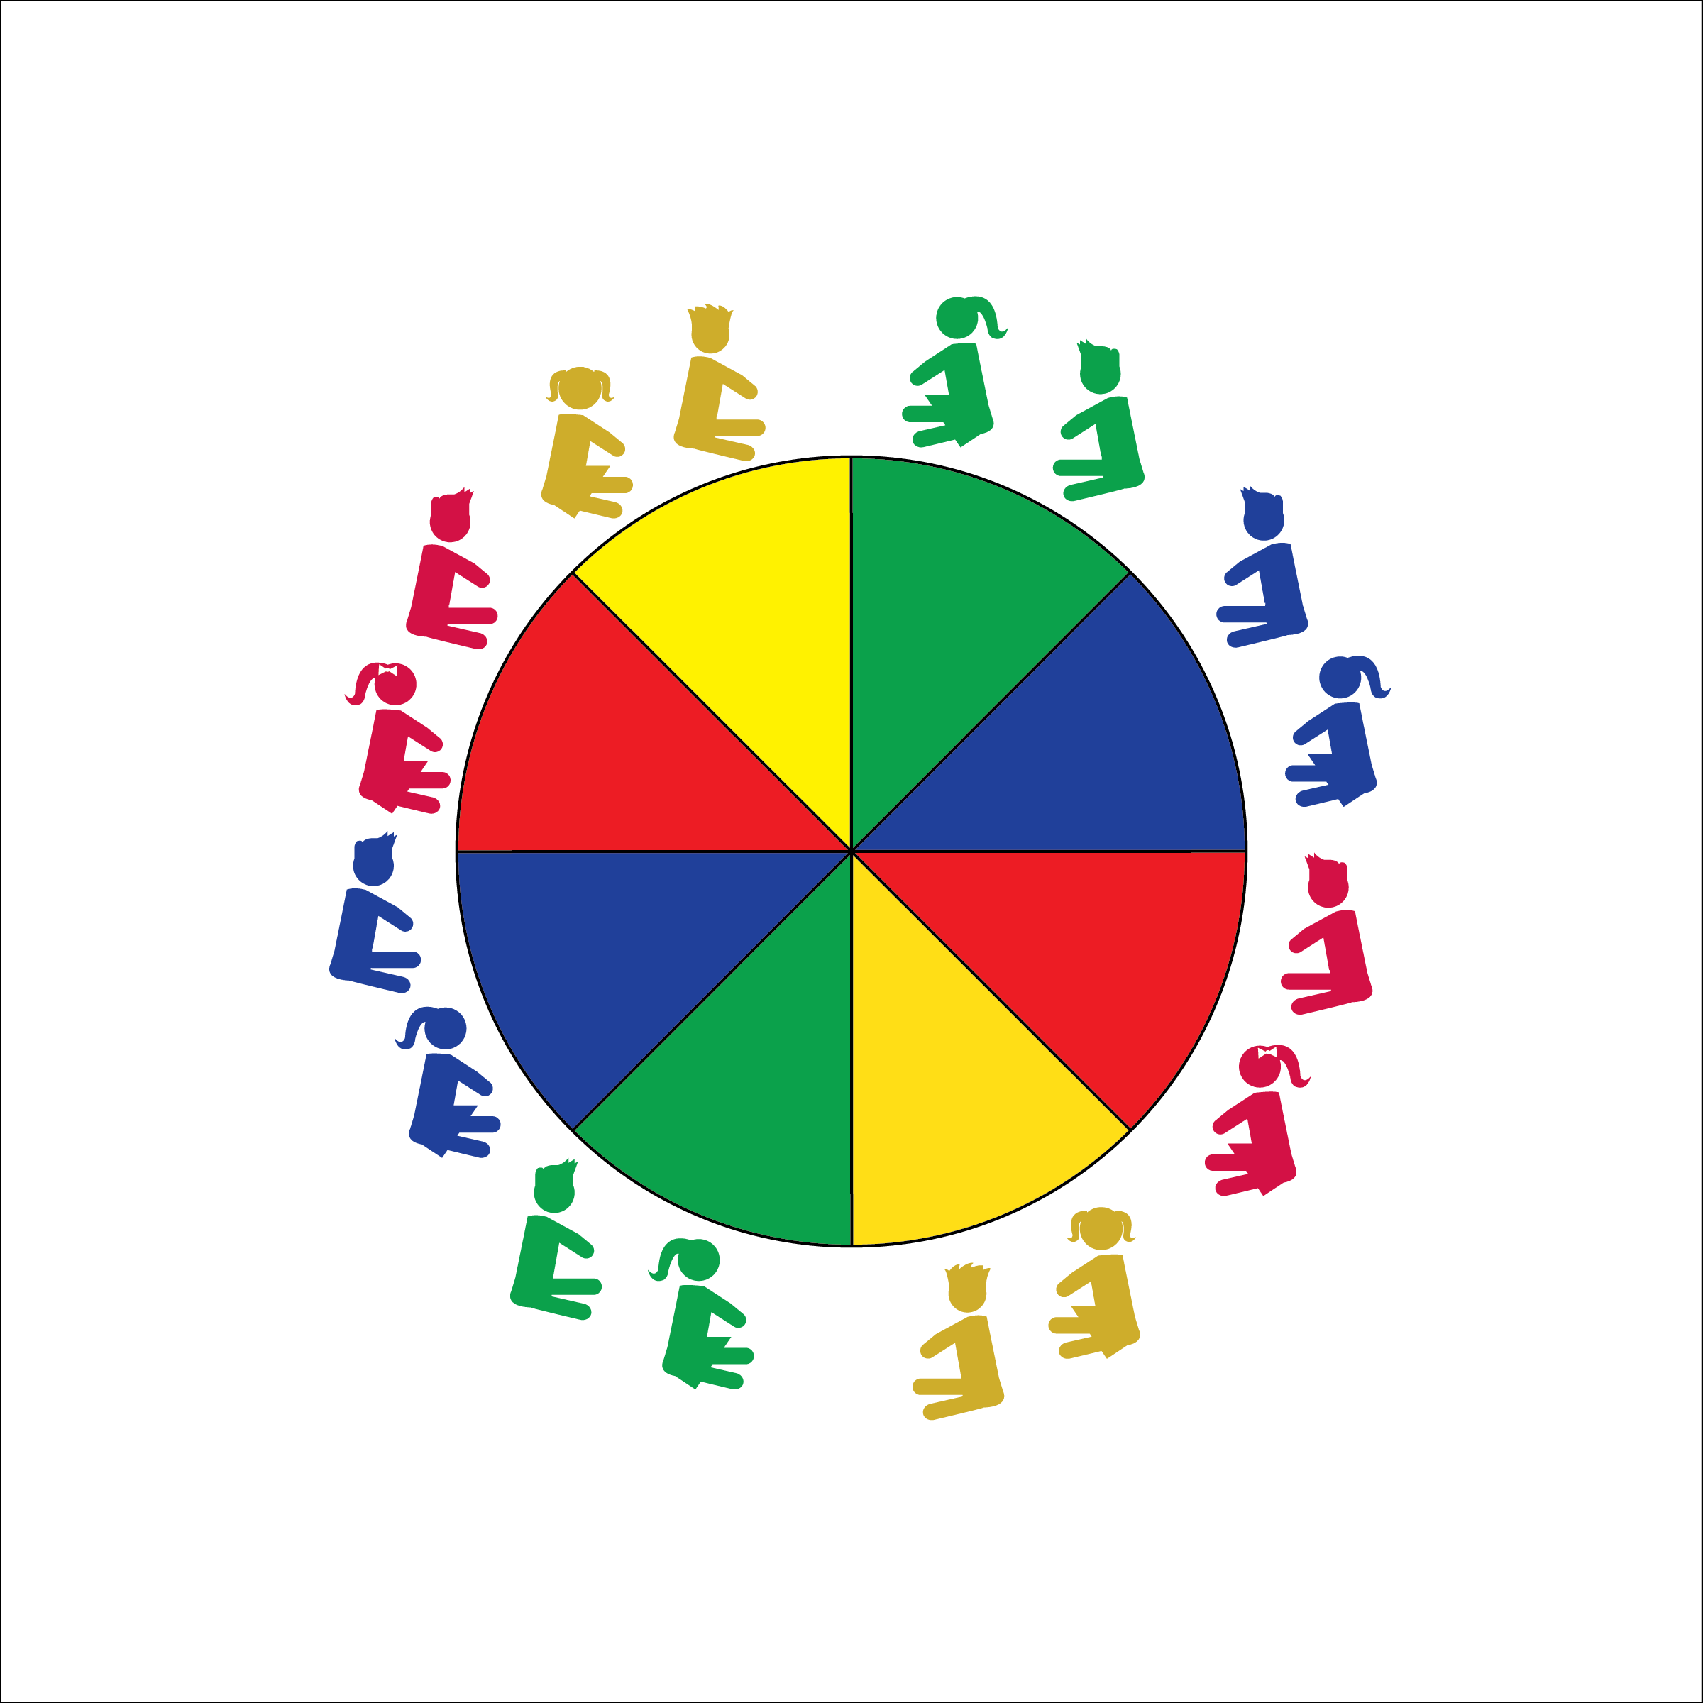

**UNDER THE ‘CHUTE**

* **Skill:** I will use the different grips to perform activities underneath the parachute.
* **Cognitive:** I will discuss the different muscles used during parachute activities.
* **Fitness:** I will use muscular strength and endurance to perform parachute activities.
* **Personal & Social Responsibility:** I will keep my body under control while I’m moving underneath the parachute.
* Work Safely
* Listen for Teacher Cues
* Respect Self-Space
* Respect Equipment
* Actively Engage

**Equipment:**

* Large Parachute
* Parachute Activity Card: “Under the ‘Chute”

**Set-Up:**

1. Students begin by siting around the outside of the parachute.
2. Teacher has easy access to the Parachute Activity Card.

**Activity Procedures:**

1. Today we’re going to work cooperatively while safely exploring space underneath the parachute. We will need to demonstrate teamwork in order to do some really fun activities. Listen carefully for my movement cues.
2. Teachers, use the following activity sequence: 1) Place Change; 2) Windy Day; 3) The Tent; 4) Washing Machine; 5) Igloo; 6) Bear in the Woods; 7) Big Turtle; 8) Headless Horseman

**Grade Level Progression:**

**K through 1st:** Perform the activities as listed on the Activity Card.

**2nd:** Choose students who have demonstrated excellent behavior to be activity leaders. She/he will call out the commands to complete tent formations.

**UNDER THE ‘CHUTE**



Cooperation, Coordination, Muscular Endurance, Muscular Strength, Personal Responsibility, Trust



* **Standard 3 [E2.K-2]** Actively participates in physical education class (K); Actively engages in physical education class (1); Actively engages in physical education class in response to instruction and practice (2).
* **Standard 4 [E1.K-2]** Follows directions in group settings (e.g., safe behaviors, following rules, taking turns) (K); Accepts personal responsibility by using equipment and space appropriately (1); Practices skills with minimal teacher prompting (2).
* **Standard 4 [E4.K]** Follows teacher directions for safe participation and proper use of equipment with minimal reminders (K).



* **DOK 1:** How many muscles can you name?
* **DOK 2:** What do you know about how muscles work?
* **DOK 1:** What does control mean?
* **DOK 2:** What are different ways to apply control to parachute games?
* **DOK 3:** How is control related to safety?



* Use smaller ‘chutes with fewer students working together.
* Use two smaller ‘chutes with one group acting as a model/demonstration ‘chute.
* Provide video demonstrations of each activity.