­­



**PARACHUTE GAMES**

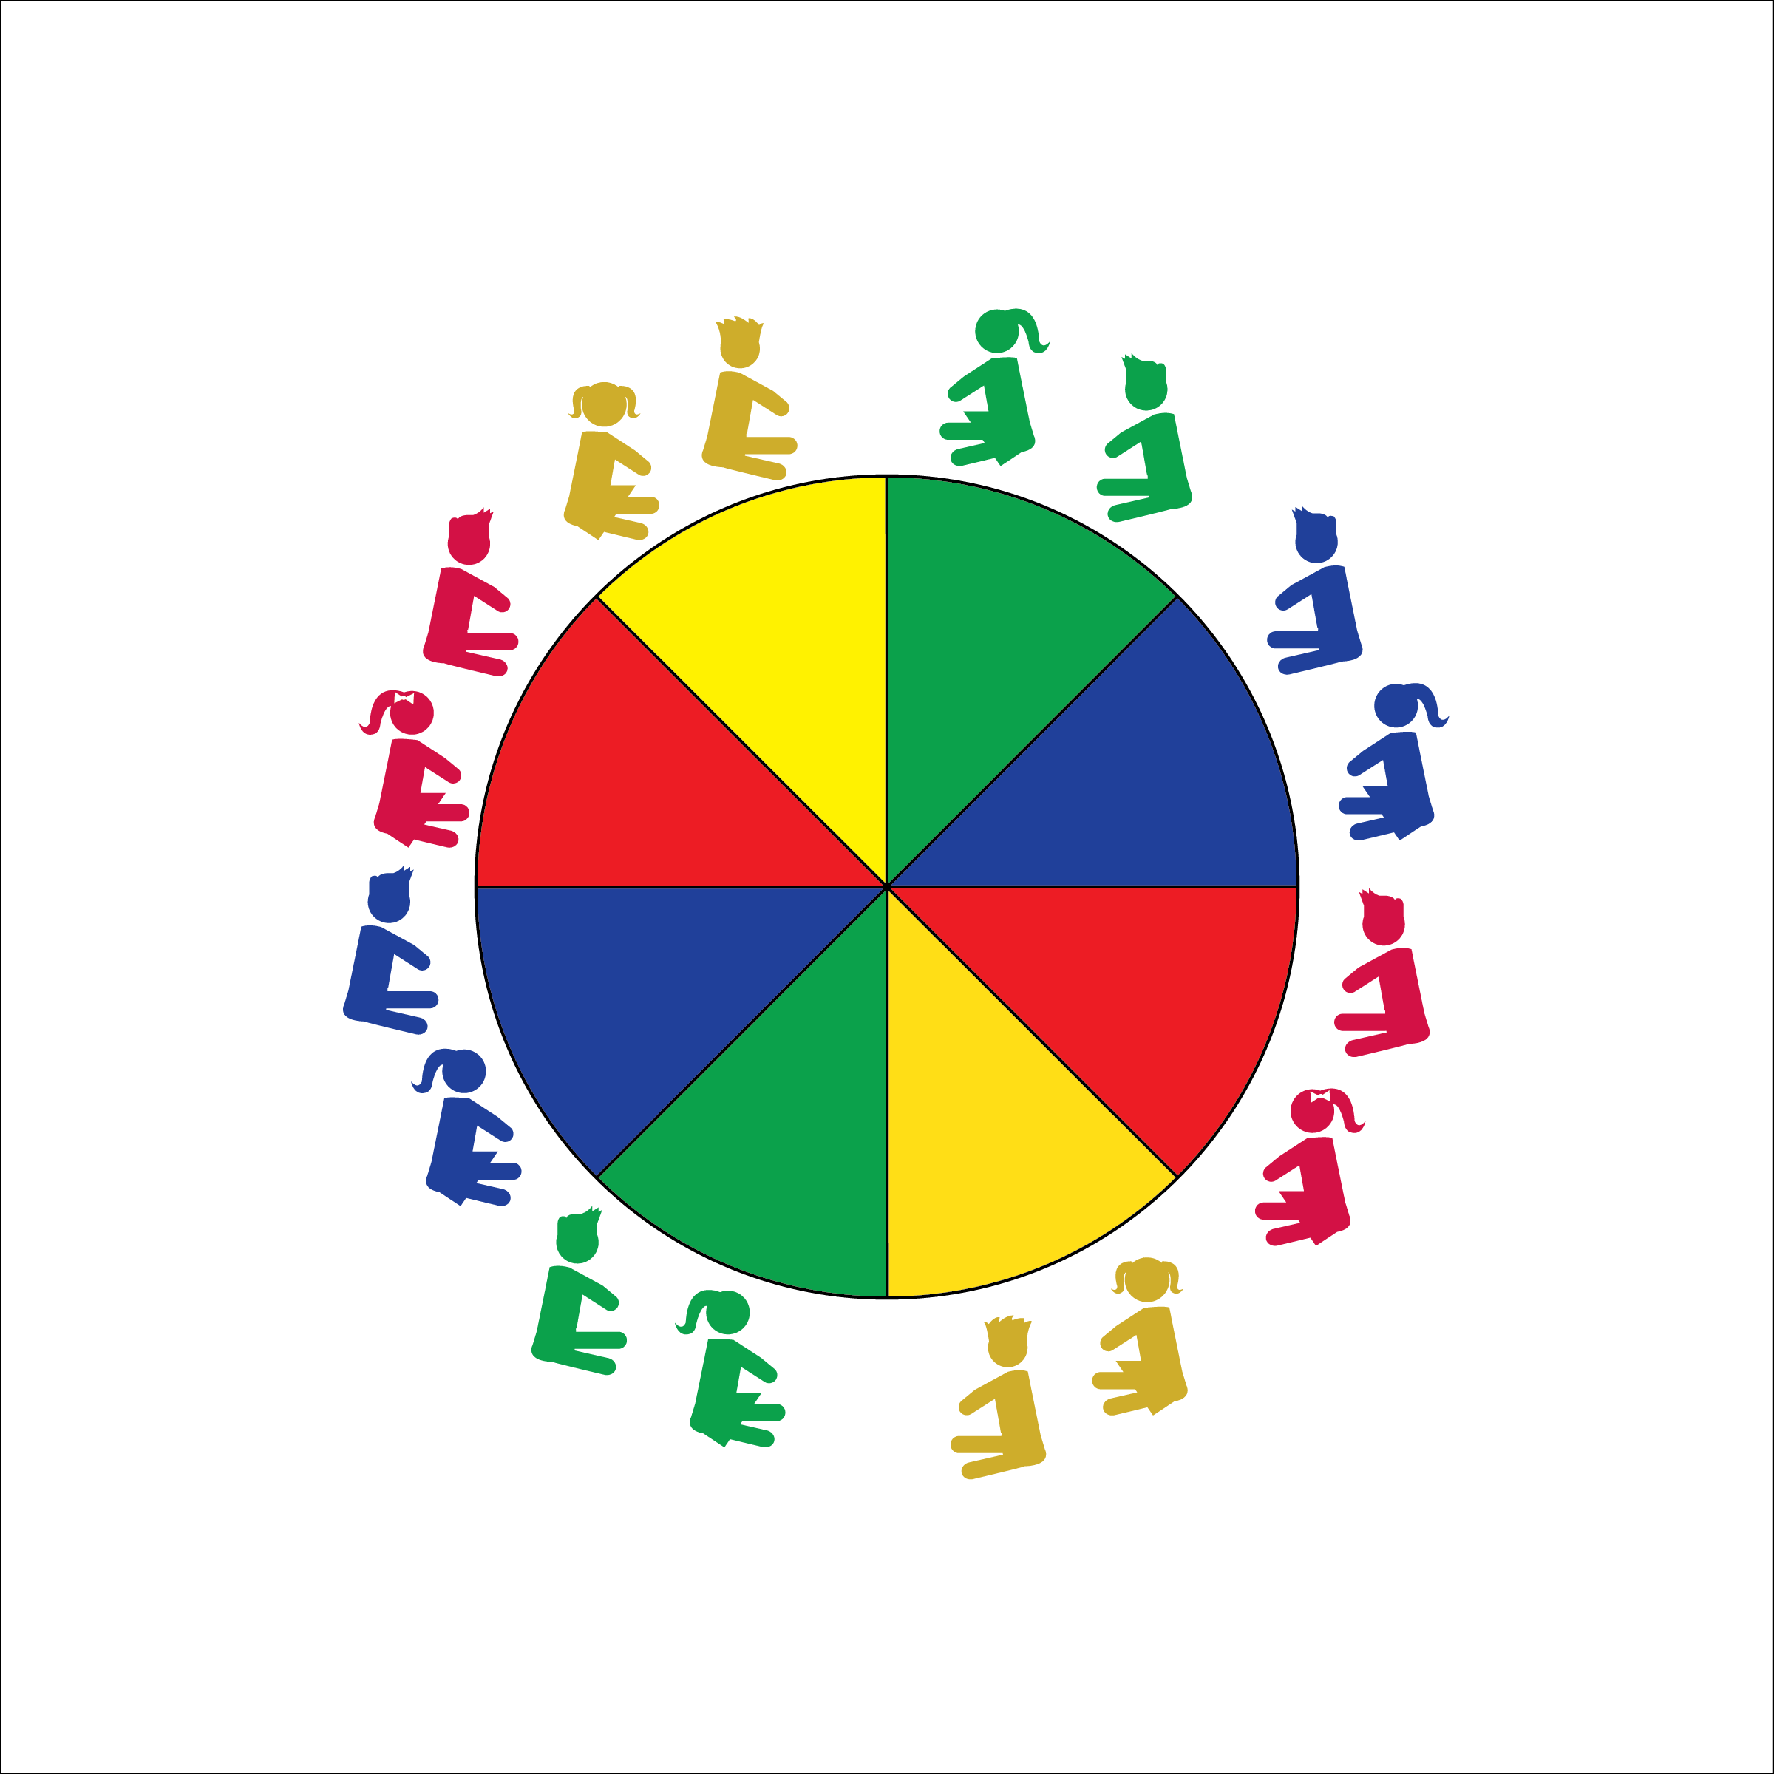

* **Skill:** I will practice a variety of parachute skills using the teacher’s cues.
* **Cognitive:** I will discuss why it’s important to follow the rules of each parachute game.
* **Fitness:** I will stay actively engaged during all activities.
* **Personal & Social Responsibility:** I will demonstrate proper etiquette by following the rules for each game.
* Work Safely
* Listen for Teacher Cues
* Respect Self-Space
* Respect Equipment
* Actively Engage

**Equipment:**

* Parachute
* 1 Foam Ball
* 12 or more bean bags or yarn balls
* Parachute Activity Card: “Parachute Games”

**Set-Up:**

1. Students begin by siting around the outside of the parachute.
2. Teacher has easy access to the Parachute Activity Card.

**Activity Procedures:**

1. During this class and the next we are going to play fun cooperative games with the parachute. It will be important for everyone in the class to follow all rules and directions.
2. Teachers, use as many classes as necessary to teach and participate in each of the following games:  
   Hot Potato, Mousetrap, Shark Attack, Superman’s Cape, Mindfully Floating on Clouds.
3. Important note: some students may not feel comfortable working under the parachute during games like Mousetrap and Shark Attack. Working under the parachute should be voluntary.

**Grade Level Progression:**

**K through 1st:** Try all activities with the exception of Superman’s Cape.

**2nd:** Add Superman’s cape.

**PARACHUTE GAMES**



Control, Etiquette, Mindful, Relaxation



* **Standard 3 [E2.K-2]** Actively participates in physical education class (K); Actively engages in physical education class (1); Actively engages in physical education class in response to instruction and practice (2).
* **Standard 4 [E1.K-2]** Follows directions in group settings (e.g., safe behaviors, following rules, taking turns) (K); Accepts personal responsibility by using equipment and space appropriately (1); Practices skills with minimal teacher prompting (2).
* **Standard 4 [E2.K-2]** Acknowledges responsibility for behavior when prompted (K); Follows the rules/ parameters of the learning environment (1); Accepts responsibility for class protocols with behavior and performance actions (2).
* **Standard 4 [E4.K-2]** Shares equipment and space with others (K); Works independently with others in a variety of class environments (e.g., small & large groups) (1); Works independently with others in partner environments (2);
* **Standard 4 [E6.K-1, 2b]** Follows teacher directions for safe participation and proper use of equipment with minimal reminders (K); Follows teacher directions for safe participation and proper use of equipment without teacher reminders (1); Works safely with physical education equipment (2b).



* **DOK 1:** Can you remember the parachute rules?
* **DOK 1:** What does the word mindful mean?
* **DOK 2:** How does being mindful affect your ability to follow rules?
* **DOK 3:** How is being mindful related to safety?



**Help students elaborate on content:** The excitement of the parachute can often override a child’s desire to please the teacher and follow behavior rules. Take time to pause the action, ask guiding questions, and allow students to elaborate on their thinking.



* Use smaller ‘chutes with fewer students working together.
* Use two smaller ‘chutes with one group acting as a model/demonstration ‘chute.
* Provide video demonstrations of each activity.