­­

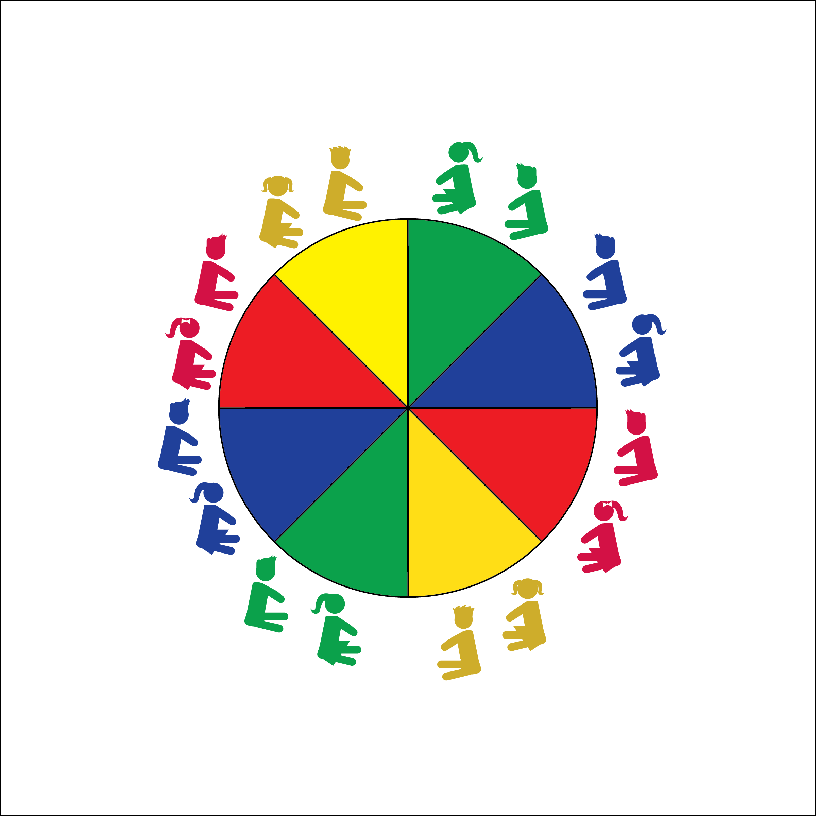

**PARACHUTE FITNESS**

* **Skill:** I will properly demonstrate each fitness activity using the cues the teacher provides.
* **Cognitive:** I will point to and identify different muscles when asked by the teacher.
* **Fitness:** I will actively engage in all fitness activities.
* **Personal & Social Responsibility:** I will understand and discuss that some activities are more challenging than others.
* Work Safely
* Listen for Teacher Cues
* Respect Self-Space
* Respect Equipment
* Actively Engage

**Equipment:**

* Large Parachute
* Parachute Activity Card: “Parachute Fitness”
* Elementary Anatomy Chart

**Set-Up:**

1. Students begin by siting around the outside of the parachute.
2. Teacher has easy access to the Parachute Activity Card.

**Activity Procedures:**

1. This activity is called Parachute Fitness.
2. The object of the activity is to focus on building muscular strength and endurance while playing with the parachute. During each activity we’ll talk about and identify the muscles that we’re using.
3. Teachers, use the following activity sequence: 1) Hands on the Wheel; 2) Parachute Sit-ups; 3) Squat Washers; 4) Biceps Curl; 5) Plank to T Workout.

**Grade Level Progression:**

**K through 1st:** Reinforce controlled movements.

**2nd:** Create and practice a variety of plank-based exercises. Allow students to explore muscular tension created during different body positions.

**PARACHUTE FITNESS**



Challenge, Fitness, Muscular Endurance, Muscular Strength



* **Standard 3 [E2.K-2]** Actively participates in physical education class (K); Actively engages in physical education class (1); Actively engages in physical education class in response to instruction and practice (2).
* **Standard 4 [E1.K-2]** Follows directions in group settings (e.g., safe behaviors, following rules, taking turns) (K); Accepts personal responsibility by using equipment and space appropriately (1);Practices skills with minimal teacher prompting (2).
* **Standard 4 [E4.K-2]** Shares equipment and space with others (K); Works independently with others in a variety of class environments (e.g., small & large groups). (1); Works independently with others in partner environments (2).



* **DOK 1:** Point to the correct muscle as I call out muscle names.
* **DOK 2:** What do you notice about your muscles during parachute fitness activities?
* **DOK 3:** How is muscular endurance related to parachute activities?



**Help students process content**: Parachute activities provide students with a relatable experience with respect to the way that their muscles work. They can feel and see their muscles in action. Engage students in discussion about what they’re seeing and feeling.



* Use smaller ‘chutes with fewer students working together.
* Use two smaller ‘chutes with one group acting as a model/demonstration ‘chute.
* Provide video demonstrations of each activity.