­­­

* Appropriate
* Overhand Grip
* Underhand Grip
* Mixed Grip
* Cooperate
* Teamwork

­

* **Skill:** I will demonstrate the basic overhand, underhand, and mixed grips.
* **Cognitive:** I will discuss parachute safety rules.
* **Fitness:** I will stay actively engaged during all activities.
* **Personal & Social Responsibility:** I will work cooperatively with my classmates and use the parachute appropriately.
* **Standard 1** **[E1.K-2]** Performs locomotor skills (hopping, galloping, running, sliding, skipping) while maintaining balance (K); Hops, gallops, jogs, and slides using a mature pattern (1); Skips using a mature pattern (2).
* **Standard 4 [E1.K-2]** Follows directions in group settings (e.g., safe behaviors, following rules, taking turns) (K); Accepts personal responsibility by using equipment and space appropriately (1); Practices skills with minimal teacher prompting (2).
* **Standard 4 [E4.K-1, 2b]** Follows teacher directions for safe participation and proper use of equipment with minimal reminders (K); Follows teacher directions for safe participation and proper use of equipment without teacher reminders (1); Works safely with physical education equipment (2b).
* Self-Assessment

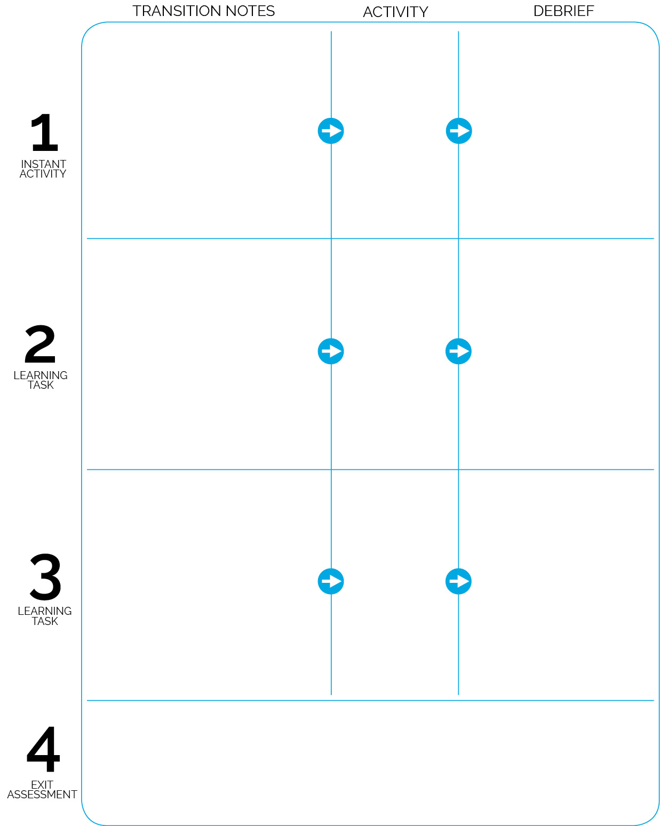

**DOK 1:** Can you remember all of the parachute rules?

**DOK 2:** How does following rules affect safety during parachute activities?

**DOK 3:** How is safety related to learning?

Merry-Go-Round

One-Hand Jog

Color Race

The Wave

**DOK 1:** Can you show me each parachute grip?

**DOK 2:** Which grip did you prefer to use during the Storm Bringer activity?

Get a Grip & Storm Bringer

Pick A Card

(Instant

Activity Module)

Students enter the activity area and sit around the perimeter of the parachute. Prompt students to stand 3 to 5 feet away from the ‘chute. Complete Pick-A-Card activities incorporating nutrition concepts.

**Parachute Self-Assessment (Start/Stop Signals)**

Assessment stations are set up on open sidelines. Each includes 4 piles of

worksheets and 4 boxes of crayons. When I say “GO,” move to an assessment station. Collect a worksheet and crayon. When finished filling it out, give your worksheet to me and then line up.

**DOK 1:** What are the 5 food groups?  
**DOK 2:** Who can tell the class why it’s important to eat foods from the different food groups throughout the day?

Students now sit right at the edge of the parachute. Stay seated to practice each grip.

After practicing each grip, stand and begin Storm Bringer. Practice each grip during the Storm Bringer activity.

Perform the next four activities with a focus on control and safety.