­­

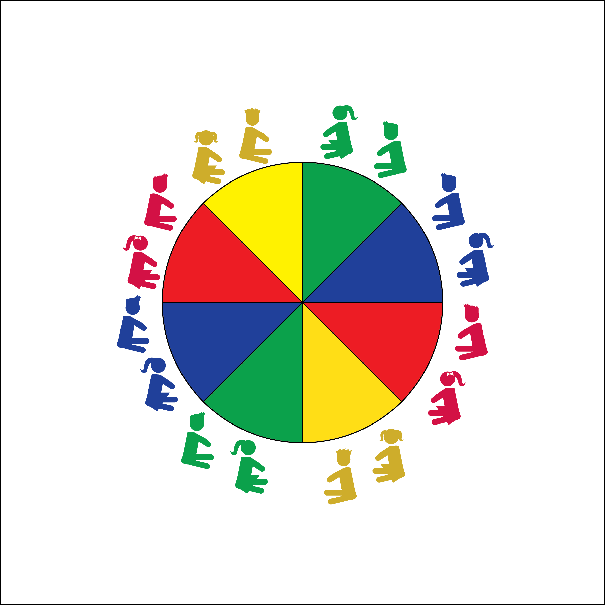

**ACTIVITY NAME**

**Equipment:**

* Equip 1
* Equip 2
* Equip 3

**Set-Up:**

1. Equipment Set Up
2. Student Set Up

* **Skill:** I will…
* **Cognitive:** I will…
* **Fitness:** I will…
* **Personal & Social Responsibility:** I will…
* Cue
* Cue
* Cue

**Activity Procedures:**

1. Today’s activity is…
2. The main objective is…
3. More instructions here…

**Grade Level Progression:**

**K:** K Progression

**1st:** 1 Progression

**2nd:** 2 Progression

**THE BASICS**



* **DOK 1:** Q
* **DOK 2:** Q
* **DOK 3:** Q



* **Standard #** **[E#.K-2]** Text here…
* **Standard #** **[E#.K-2]** Text here…
* **Standard #** **[E#.K-2]** Text here…



Words, Words, Words



* UDA1
* UDA2
* UDA3



**Strategy Title**: Strategy Text