­­­

* Words
* Words
* Words

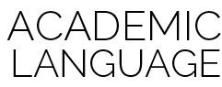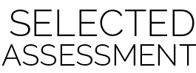­

* **Skill:** I will…
* **Cognitive:** I will…
* **Fitness:** I will…
* **Personal & Social Responsibility:** I will…
* **Standard #** **[E#.K-2]** Text here…
* **Standard #** **[E#.K-2]** Text here…
* **Standard #** **[E#.K-2]** Text here…
* Assessment Name

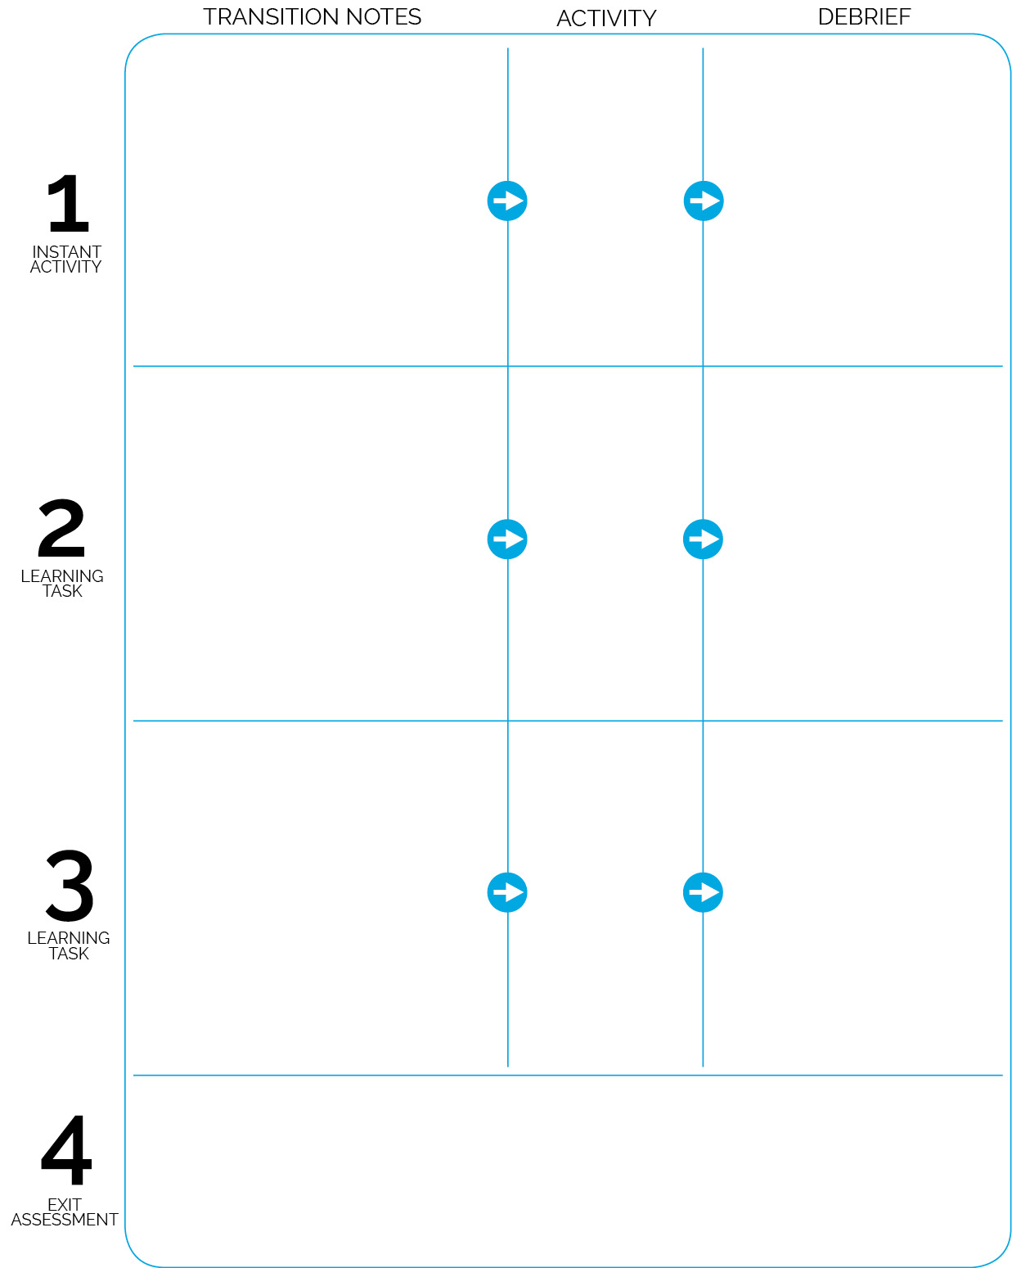

**DOK 1:** Q  
**DOK 2:** Q

**DOK 3:** Q

Activity Name

**DOK 1:** Q  
**DOK 2:** Q

**DOK 3:** Q

Activity Name

Activity Name

Students enter…

**Assessment Name (Details)**

Managing the assessment text…

**DOK 1:** Q  
**DOK 2:** Q

**DOK 3:** Q

Transition text..

Transition text…