­­

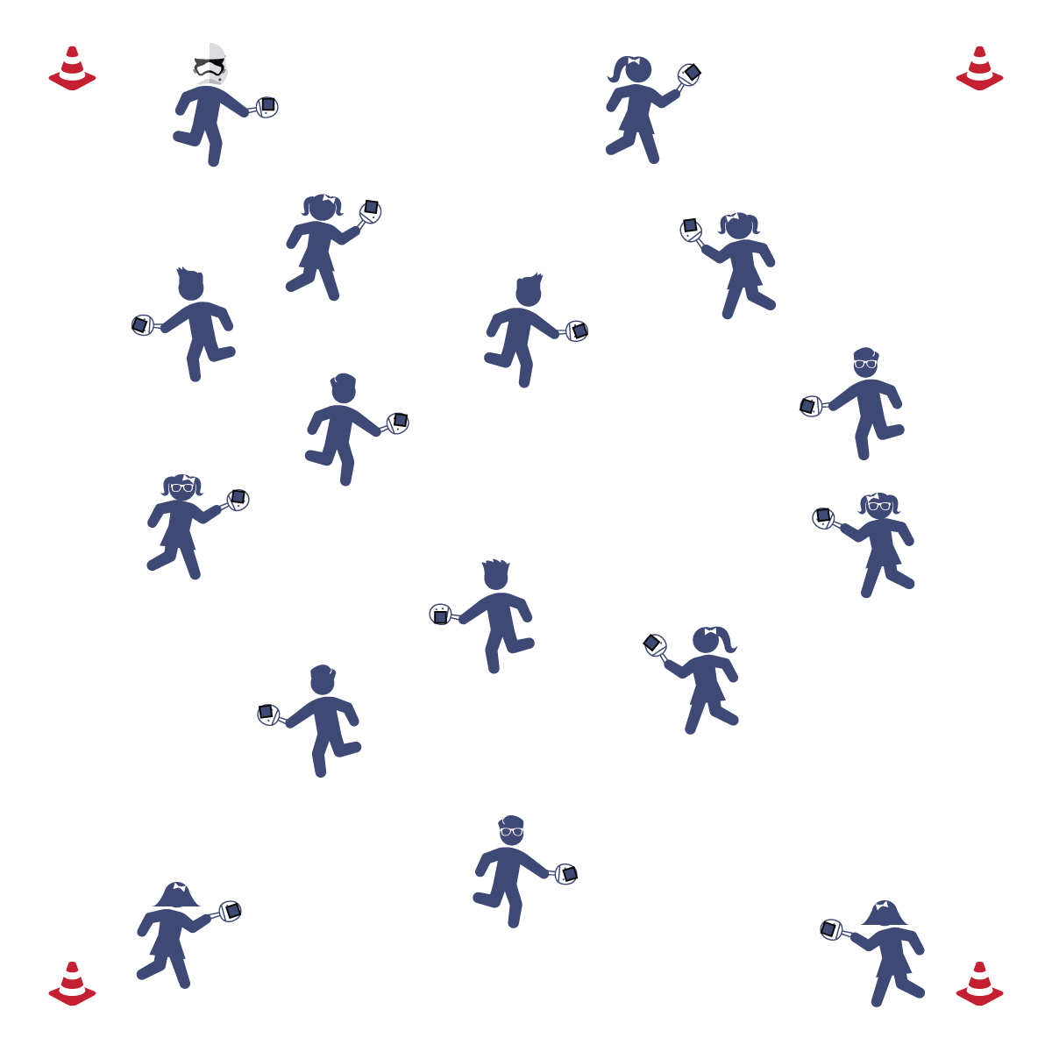

**Equipment:**

* 4 low profile cones
* 1 paddle per student
* 1 bean bag per student

**Set-Up:**

1. Use cones to designate a large activity area.
2. Place paddles throughout the activity area. 1 bean bag on top of each paddle.
3. Each student standing/sitting next to a paddle.

**HELLO PADDLE**

* **Skill:** I will balance a beanbag on my paddle while walking.
* **Cognitive:** I will be able to recite the cues for gripping the paddle.
* **Fitness:** I will actively engage in physical education class without a reminder from the teacher.
* **Personal & Social Responsibility:** I will move carefully and safely in open space while balancing the bean bag.

Paddle Grip

* Shake Hands with the Paddle
* Soft Squeeze
* Lock Wrist

**Activity Procedures:**

1. Today’s activity is called Hello Paddle. We are going to practice handling the paddle by balancing the bean bag on top of it.
2. When I say “GO,” begin walking around the activity area while you balance the bean bag on the paddle. Be careful that you don’t bump into anyone else so that everyone stays safe. Freeze when you hear the stop signal.
3. Repeat the activity using additional locomotor movements (e.g., skipping, galloping).

**Grade Level Progression:**

**3rd:** Play the activity as described above.

**4th:** Students see how many peers they can low-five without dropping the bean bag off the paddle.

**5th:** Students attempt to switch bean bags with as many classmates as they can by tossing and catching while remaining in control.

**HELLO PADDLE**



* **DOK 1:** Can you remember the cues for gripping the paddle?
* **DOK 2:** How does the grip affect your ability to keep the beanbag balanced?
* **DOK 3:** How would you adapt this activity to make it more difficult? Make it easier?



Balance, Catch, Etiquette, Open Space, Personal Responsibility, Toss, Strike



* **Standard** **1 [E6.4]:** Combines traveling with manipulative skills of dribbling, throwing, catching, and striking in teacher- and/or student-designed small-sided practice tasks (4).
* **Standard 2 [E1.3-4]:** Recognizes the concept of open spaces in a movement context (3); Applies the concept of open spaces to combination skills involving traveling (e.g., dribbling and traveling) (4a).
* **Standard 3 [E2.3-5]:** Engages in the activities of physical education class without teacher prompting (3); Actively engages in the activities of physical education class, both teacher-directed and independent (4); Actively engages in all the activities of physical education (5).
* **Standard 4 [E5.3-4]:** Recognizes the role of rules and etiquette in physical activity with peers (3); Exhibits etiquette and adherence to rules in a variety of physical activities (4).
* **Standard 4 [E5.3-5]** Works independently and safely in physical activity settings (3); Works safely with peers and equipment in physical activity settings (4); Applies safety principles with age-appropriate physical activities (5).



* **Adaptation:** Slow students down: tell them that their feet are super heavy and they must move in slow motion.
* **Extension:** Have students use multiple locomotor movements, change speeds, or change levels.

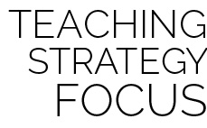

**Identify critical content:** Establish critical content for the duration of the module using the Self-Assessment and Holistic Rubric criteria. Take time at the end of the first lesson to go over all of the criteria with your class. This will frame expectations for students and provide purpose for their skill practice and effort.

**PANCAKE FLIPPER**

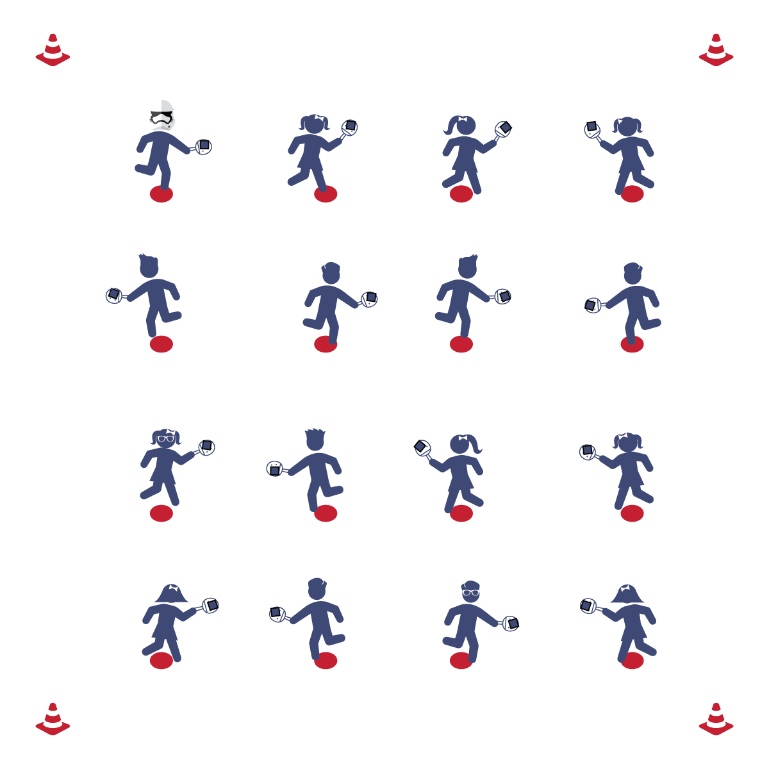

**Activity Procedures:**

1. Today’s activity is called Pancake Flipper. We are going to practice our ability to control the paddle during Pickleminton games.
2. Place the bean bag on your paddle. When I say “GO,” flip the pancake (bean bag) in the air and try to get it to safely land back in its pan (on the paddle) as many times as you can. Freeze when you hear the stop signal.
3. Next, students flip the pancake into the air, catch the pancake with their free hand, toss the pancake back into the air, and then catch the pancake with the pan (paddle) as many times as they can.
4. If students excel in the activities above, play Pancake PIG: students add a twist to the basic tossing and catching by attempting to also perform tricks (e.g., toss and catch behind their back, toss under their leg and catch the bean bag, toss the bean bag and catch on a body part). With students in a group, one student will perform the trick with their pancake and the other students in the group will mimic that trick. If any students in the group cannot do the trick, then they get a letter from the word “PIG” (similar to HORSE in basketball).

**Grade Level Progression:**

**3rd & 4th:** Play the activity as described above.

**5th:** Add Pancake PIG into the activity.

**Equipment:**

* 1 paddle per student
* 1 bean bag per student
* 1 poly spot per student

**Set-Up:**

1. Place the poly spots evenly throughout the activity area.
2. Place a paddle and a bean bag on each poly spot.
3. Each student standing/sitting on a poly spot.

* Balance
* Toss with Control
* Give with the Paddle
* **Skill:** I will catch the beanbag on my paddle after I toss it up in the air.
* **Cognitive:** I will discuss some of the challenges I faced when flipping my paddle to catch the beanbag.
* **Fitness:** I will actively engage in physical education class without a reminder from the teacher.
* **Personal & Social Responsibility:** I will praise others for their success in their movement skills.

**PANCAKE FLIPPER**



* **Standard 2 [E3.3-5]:** Applies the concepts of direction and force when striking an object with a short-handled implement, sending it toward a designated target (4); Analyzes movement situations and applies movement concepts in small-sided practice tasks (5).
* **Standard 4 [E2.3-5]**: Works independently for extended periods of time (3); Reflects on personal social behavior in physical activity (4); Participates with responsible personal behavior in a variety of physical activity contexts, environments, and facilities (5a); Exhibits respect for self with appropriate behavior while engaging in physical activity (5b).



Balance, Direction, Etiquette, Force, Movement Concepts, Open Space,

Personal Responsibility



* **Adaptation:** Provide students with a bigger paddle, or start with a toss and catch without the paddle.
* **Extension:** Have students use their non-dominant hand, increase height of the beanbag when tossed, or incorporate other objects.



* **DOK 1:** What is force?
* **DOK 2:** How did force affect your tossing and catching?
* **DOK 3:** Can you predict how a birdie (or ball) would fly if you were to strike it with hard force? Soft force?



**Help students practice skills:** Pancake Flipper is a fun yet simple activity that gives students the opportunity to explore movement and manipulation with a paddle. Guide student interaction with the paddle and the bean bag, allowing them to struggle at times in order to discover the interaction of force, gravity, and grip-strength on the object they are working to control.

**BIRDIE IN THE CAGE**

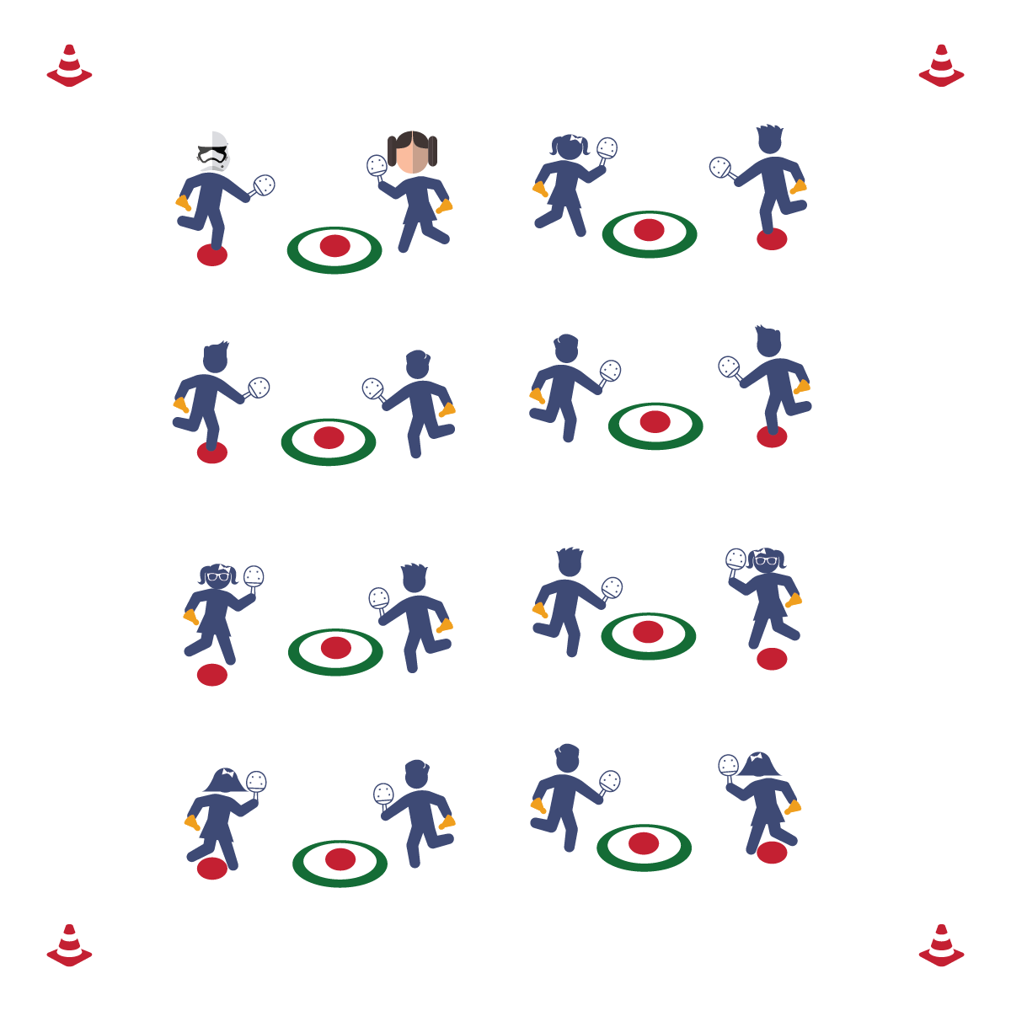

**Activity Procedures:**

1. Today’s activity is called Birdie in the Cage. The object of the activity is to practice our underhand serves and to become more accurate when we serve the birdie.
2. The first partner will stand on the poly spot and serve the birdie with a swing low to high, trying to strike it into the hoop or the poly spot inside of the hoop. The other partner retrieves the birdies.
3. After a set period of time, switch roles.

**Grade Level Progression:**

**3rd & 4th:** Play the activity as described above.

**5th:** Play the activity described above with a time limit: students attempt to maximize the number of accurate serves within the specified time period.

**Equipment:**

* 1 Hula Hoop per 2 students
* 2 poly spots per hoop
* 1 paddle per student
* 1 birdie per student

**Set-Up:**

1. Spread the Hula Hoops throughout the activity area.
2. Place 1 poly spot in the center of each hoop and a poly spot 8-10 feet away from each hoop.
3. Place 2 paddles and 2 birdies at each poly spot.
4. Students in pairs, 1 pair standing at each poly spot.

* **Skill:** I will practice my underhand serve using the skill cues we learned in class.
* **Cognitive:** I will describe the sequence of a proper underhand serve.
* **Fitness:** I will actively participate in the class warm-up to prepare for the activities in physical education class today.
* **Personal & Social Responsibility:** I will exhibit responsible behavior while working independently at the class stations.
* Step in Opposition
* Drop Birdie
* Swing Low to High
* Follow Through

**BIRDIE IN THE CAGE**



* **DOK 1:** What are the cues for an underhand serve?
* **DOK 2:** How can you apply what you’ve learned about force to improve your underhand serve?
* **DOK 3:** Once you’ve mastered this challenge, how would you adapt it to create a task to help you further improve your performance?



**Help students process content:** This activity will be a challenge for most students. Many will have very limited experience with striking skills—especially a serve. It will be important to help students process the result of their performance, specifically when performances are filled with error. Remind students that errors are an important part of the learning process. Thinking about errors with a growth mindset is an important skill that everyone in the class is working to develop.



* **Standard** **1 [E24.3-5]:** Strikes an object with a short-handled implement, sending it forward over a low net or to a wall (3a); Strikes an object with a short-handled implement while demonstrating three of the five critical elements of a mature pattern (3b); Strikes an object with a short-handled implement while demonstrating a mature pattern (4a).
* **Standard 2 [E3.3-4]:** Combines movement concepts (direction, levels, force, time) with skills as directed by the teacher (3); Applies the concepts of direction and force when striking an object with a short-handled implement, sending it toward a designated target (4).
* **Standard 3 [E2.3-5]:** Engages in the activities of physical education class without teacher prompting (3); Actively engages in the activities of physical education class, both teacher-directed and independent (4); Actively engages in all the activities of physical education (5).
* **Standard 4 [E1.4-5]:** Exhibits responsible behavior in independent group situations (4); Engages in physical activity with responsible interpersonal behavior (e.g., peer to peer, student to teacher, student to referee) (5).



Direction, Force, Strike, Serve, Etiquette



* **Adaptation:** Move students closer to the target. Use a foam ball instead of a birdie.
* **Extension:** Continue to move students farther away from the target.

**SPLAT THE SPOT**

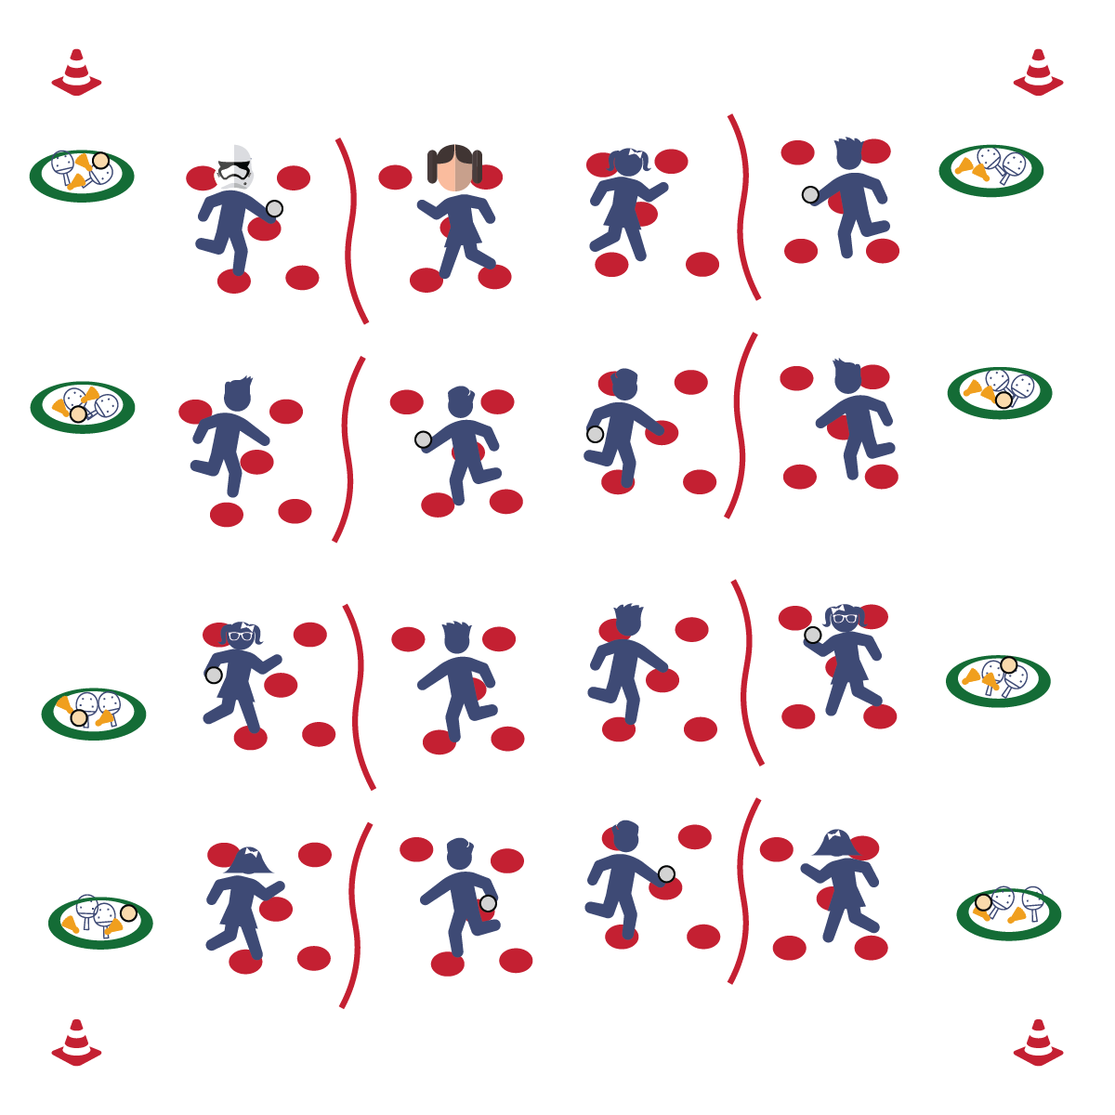

**Activity Procedures:**

1. Today’s activity is called Splat the Spot. The object of the activity is to learn more about the size of the Pickleminton court as we work on force, placement, and accuracy for certain types of shots.
2. When I say “GO,” Partner 1 will pick an object from the pile to start with and then return to their poly spot. Partner 1 will throw the object to Partner 2, and then both partners will quickly move to a new poly spot, and Partner 2 will throw the object back.
3. After 5 throws each, Partner 2 will choose a new object. This will continue until 4 separate objects have been used.
4. Next, Partner 1 will pick up a paddle. Partner 2 will throw the birdie while Partner 1 strikes it using a forehand strike. Partner 2 catches it, both partners move to a new spot, and Partner 2 makes another toss.
5. Make sure you continue moving to different poly spots between each toss. After Partner 1 has gotten 5 hits, Partner 2 will use the paddle and the activity repeats. Next, repeat using backhand strikes.
6. Next, both partners pick up a paddle. Volley the birdie back and forth, doing your best to return it to whichever poly spot your partner is on.

**Grade Level Progression:**

**3rd & 4th:** Play the activity as described above.

**5th:** Add an aerobic activity (e.g., jumping jacks, push-ups) whenever a volley falls.

**Equipment:**

* 1 paddle per student
* 1 birdie per 2 students
* 1 bean bag per 2 students
* 1 Whiffle ball per 2 students
* Various foam balls or other objects
* 1 cone per student
* 1 jump rope per 2 students
* 5 poly spots per student
* 1 Hula Hoop per 2 students

**Set-Up:**

1. Create courts using cones to mark corners and jump ropes as the “nets.” Scatter 5 poly spots on each side of every court.
2. Just off to the side of each court, place 2 paddles and a variety of objects inside 1 hoop.
3. One student on each side of every court, standing on a poly spot.

* **Skill:** I will hit the birdie to my partner with accuracy.
* **Cognitive:** I will describe how force affects accuracy.
* **Fitness:** I will stay actively engaged without reminders from the teacher.
* **Personal & Social Responsibility:** I will use an appropriate amount of force in order to keep my birdie from flying out of control.
* Grip
* Rip
* Follow Through

**SPLAT THE SPOT**



* **DOK 1:** What is accuracy?
* **DOK 2:** What do you know about making an accurate strike with your paddle?
* **DOK 3:** How are the cues for striking related to accuracy?



* **Standard 1 [E24.3-5]:** Strikes an object with a short-handled implement, sending it forward over a low net or to a wall (3a); Strikes an object with a short-handled implement while demonstrating three of the five critical elements of a mature pattern (3b); Strikes an object with a short-handled implement while demonstrating a mature pattern (4a); Strikes an object with a short-handled implement, alternating hits with a partner over a low net or against a wall (4b); Strikes an object consecutively, with a partner, using a short-handled implement, over a net or against a wall, in either a competitive or cooperative game environment (5).
* **Standard 2 [E1.3-4]:** Recognizes the concept of open spaces in a movement context (3); Applies the concept of open spaces to combination skills involving traveling (4a).
* **Standard 2 [E3.3-5]:** Combines movement concepts (direction, levels, force, time) with skills as directed by the teacher (3); Applies the concepts of direction and force when striking an object with a short-handled implement, sending it toward a designated target (4b); Applies movement concepts to strategy in game situations (5a); Analyzes movement situations and applies movement concepts (e.g., force, direction, speed, pathways, extensions) in small-sided practice task/game environments, dance and gymnastics (5c).



Accuracy, Direction, Force, Forehand Strike, Backhand Strike, Open Space, Strike



* **Adaptation:** Have students catch the birdie or object each time before striking the birdie or object back to their partner.
* **Extension:** Have students count how many volleys they can get back and forth.



**Organize students to interact with content:** Splat the Spot is a cooperative skill practice drill that will help students begin to interact with all of the components of a dynamic net game. Students will physically navigate a court and a net while maintaining focus on a manipulative object like a birdie or a ball. Remember that there will be teachable moments with respect to both skill and social development. Help students collaborate in a way that will allow them to interact with the defined outcomes that you have established for the class.

**PEER ASSESSMENT**

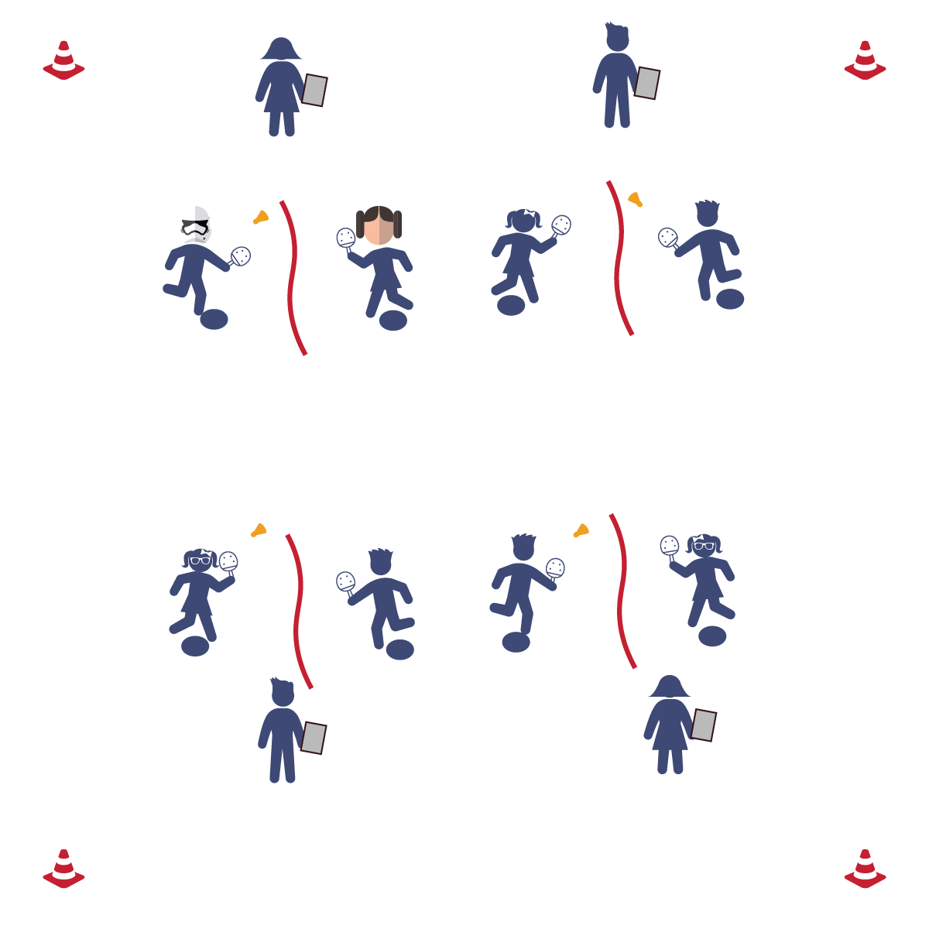

**Equipment:**

* 1 jump rope per 3 students
* 1 birdie per 3 students
* 1 paddle per student
* 1 clipboard per 3 students (optional)
* 1 pencil per 3 students
* 2 poly spots per 3 students
* 1 Pickleminton Peer Assessment per student

**Set-Up:**

1. Set up 1 assessment area per 3 students with a jump rope stretched out as a net and a poly spot on either side (3rd: 12’ apart; 4th: 15’ apart; 5th: 18’ apart).
2. Place 2 paddles, 1 birdie, 1 pencil, and 3 assessment sheets at each assessment area.
3. 3 students at each assessment area, with 2 students striking the birdie and 1 student assessing.

* **Skill:** I will develop and provide constructive feedback to my classmates.
* **Cognitive:** I will identify evidence that supports the constructive feedback I receive.
* **Fitness:** I will remain actively engaged without a reminder from the teacher.
* **Personal & Social Responsibility:** I will be kind and respectful to my classmates when giving them constructive feedback.

**Activity Procedures:**

1. Today’s activity is called Peer Assessment. The object of the activity is to respectfully help one another improve by assessing their performance and giving kind, constructive criticism.
2. Partner 1 and Partner 2 will each complete 15 forehand strikes while Partner 3 peer-assesses Partner 1.
3. Partner 3 and Partner 1 will each complete 15 forehand strikes while Partner 2 peer-assesses Partner 3.
4. Partner 2 and Partner 3 will each complete 15 forehand strikes while Partner 1 peer-assesses Partner 2.
5. After each partner has completed the peer assessment, provide feedback to one another. Next, replay the forehand striking drill. This time, work to improve your performance based on the feedback.

**Grade Level Progression:**

**3rd:** Students perform the drill without a formal, written assessment. However, still allow students to provide feedback based on their observations.

**4th:** Play activity as described above.

**5th:** Add a backhand striking assessment.

* Grip
* Rip
* Follow Through

**PEER ASSESSMENT**



**Help students record and represent knowledge:** At this point in the module you have given students the criteria, cues, and practice time necessary for them to begin to create their own representations and inferences about the skills and skill performances that they are both experiencing personally and seeing from their peers. Peer assessment serves three purposes. First, it provides students with a framework for recording and representing their knowledge of physical education content. Second, it provides a practice environment for them to articulate and express their knowledge and perspective to their peers in a respectful and thoughtful way. Third, it provides an experience in which students must listen to, process, and potentially use feedback given to them by a peer—a lifelong skill that is essential in the 21st century workplace.



* **Standard 1 [E24.3-5]:** Strikes an object with a short-handled implement, sending it forward over a low net or to a wall (3a); Strikes an object with a short-handled implement while demonstrating three of the five critical elements of a mature pattern (3b); Strikes an object with a short-handled implement while demonstrating a mature pattern (4a); Strikes an object with a short-handled implement, alternating hits with a partner over a low net or against a wall (4b); Strikes an object consecutively, with a partner, using a short-handled implement, over a net or against a wall, in either a competitive or cooperative game environment (5).
* **Standard 2 [E3.3-5]:** Combines movement concepts (direction, levels, force, time) with skills as directed by the teacher (3); Applies the concepts of direction and force when striking an object with a short-handled implement, sending it toward a designated target (4b); Applies movement concepts to strategy in game situations (5a); Analyzes movement situations and applies movement concepts...in small-sided practice task/game. (5c).
* **Standard 4 [E3.3-5]:** Accepts and implements specific corrective teacher feedback (3); Listens respectfully to corrective feedback from others (e.g., peers, adults) (4); Gives corrective feedback respectfully to peers (5).



Assessment, Constructive Criticism, Feedback, Forehand Strike, Respect, Strike



* **Adaptation:** Have the student who is being assessed self-toss the birdie and strike it over the net.
* **Extension:** Allow students to use and assess a backhand strike.



* **DOK 1:** How would you describe corrective feedback?
* **DOK 2:** How can you apply what you learned to improve your striking skills?
* **DOK 3:** What facts would you use to support the corrective feedback you received? Can you elaborate on why you chose those facts?

**TIME TO GET SMART**

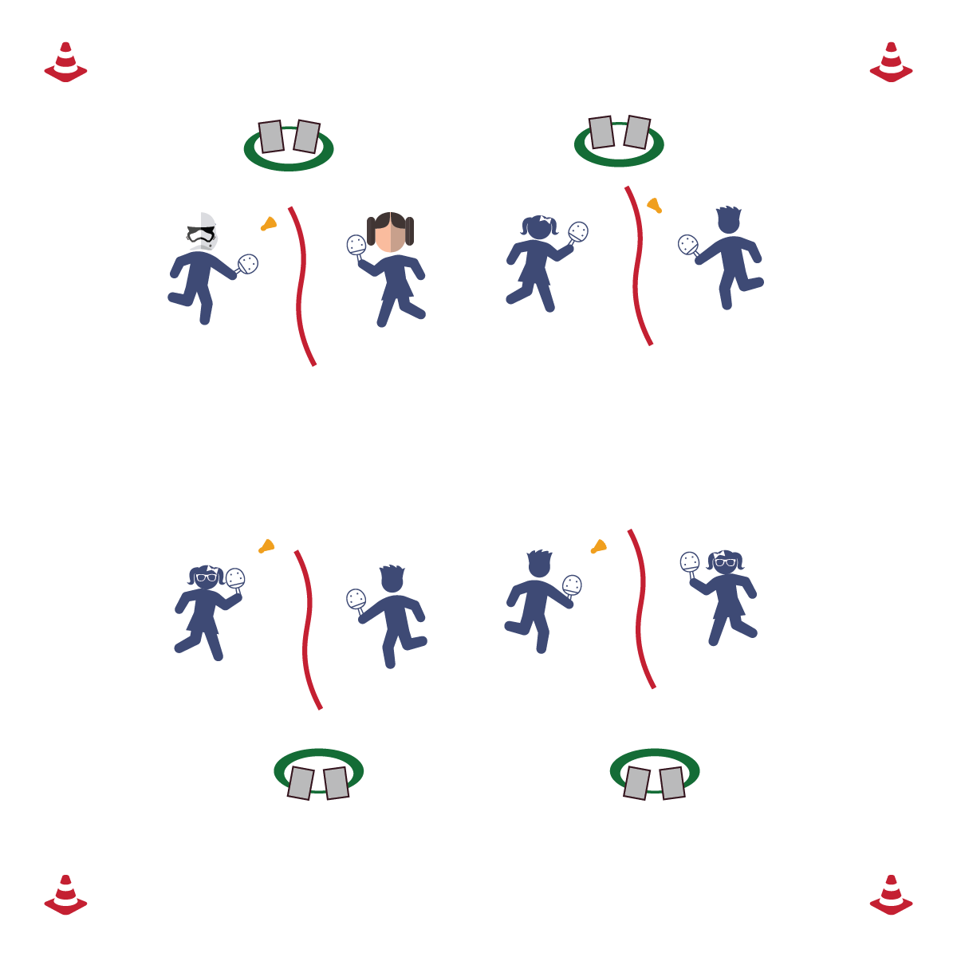

* Find Your Pulse
* Count for 6 Seconds
* Multiply by 10
* **Skill:** I will demonstrate striking skill cues during rapid fire volley sessions.
* **Cognitive:** I will complete a SMART goal sheet carefully and thoughtfully.
* **Fitness:** I will work to increase my heart rate.
* **Personal & Social Responsibility:** I will cooperate with my partner and follow instructions with no reminders.

**Activity Procedures:**

1. Today’s activity is called It's Time to Get SMART. The object of the activity is to track today’s step count and radial and carotid pulse to create a SMART goal for our next class.
2. Have each student put on their pedometer and make sure their step count is accurate.
3. Take both radial and carotid pulse before the activity and write them down on assessment sheet. (Teacher will time students).
4. Students will volley back and forth. The goal is to move your partner across the court. Rapid fire volley for 2 minutes. Re-take/re-record radial and carotid pulses.
5. Students will volley back and forth. The goal is to move your partner across the court. Rapid fire volley for 3 minutes. Re-take/re-record radial and carotid pulses.
6. Students will volley back and forth. The goal is to move your partner across the court. Rapid fire volley for 4 minutes. Re-take/re-record radial and carotid pulses.
7. Check pedometer readings and record them on the assessment sheet. Using the recorded information for each student, create a pedometer and/or heart rate SMART goal for next class.

**Grade Level Progression:**

**3rd-5th:** Play the activity as described above.

**Equipment:**

* 1 pedometer per student
* 1 birdie per 2 students
* 1 paddle per student
* 1 jump rope per 2 students
* 1 pencil per student
* 1 assessment and SMART goal sheet per student
* 1 Hula Hoop per 2 students

**Set-Up:**

1. Using the jump rope as a “net,” set up 1 court for every 2 students in the class.
2. Put 2 paddles, 1 birdie, 2 pedometers, 2 pencils, and 2 assessment/SMART goal sheets in 1 hula hoop off to the side of each court.
3. Students in pairs at each court.

**TIME TO GET SMART**



Accuracy, Assessment, SMART Goals, Heart Rate, Pedometers, Placement, Carotid Pulse, Radial Pulse, Health-Related Fitness, Skill-Related Fitness, Pre-Test, Post-Test, Strategy



**Help students practice strategies and processes:** Working with SMART goals within instructional units like Pickleminton offers students an opportunity to link the goal-setting process to the practical world in which they live. Their skill development is happening in real time. If given the correct lens, students can see and feel learning happening. SMART goals provide that lens and help establish a skillset that will serve all students in all areas of life.



* **DOK 1:** What is a SMART goal?
* **DOK 2:** How would you apply the SMART goal process to your skill improvement?
* **DOK 3:** How are SMART goals related to health-related fitness? Skill-related fitness?



* **Standard 1 [E24.3-5]:** Strikes an object with a short-handled implement, sending it forward over a low net or to a wall (3a); Strikes an object with a short-handled implement while demonstrating three of the five critical elements of a mature pattern (3b); Strikes an object with a short-handled implement while demonstrating a mature pattern (4a); Strikes an object with a short-handled implement, alternating hits with a partner over a low net or against a wall (4b); Strikes an object consecutively, with a partner, using a short-handled implement, over a net or against a wall, in either a competitive or cooperative game environment (5).
* **Standard 3 [E1.3b-4]:** Identifies physical activity benefits as a way to become healthier (3b); Analyzes opportunities for participating in physical activity outside physical education class (4).
* **Standard 3 [E5.3-5]:** Demonstrates, with teacher direction, the health-related fitness components (3); Completes fitness assessments (pre- & post-) (4a); Identifies areas of needed remediation from personal test and, with teacher assistance, identifies strategies for progress in those areas (4b); Analyzes results of fitness assessment (pre- & post-), comparing results to fitness components for good health (5a).



* **Adaptation:** To determine heart rate, time students for the full minute to avoid extra math. Or, provide a pulse bar/pulse tracker for instant heart rate data.
* **Extension:** To determine heart rate, time students for 10 seconds, 15 seconds, or 30 seconds. Then have students do the multiplication to get their heart rate.

**1V1 PICKLEMINTON**

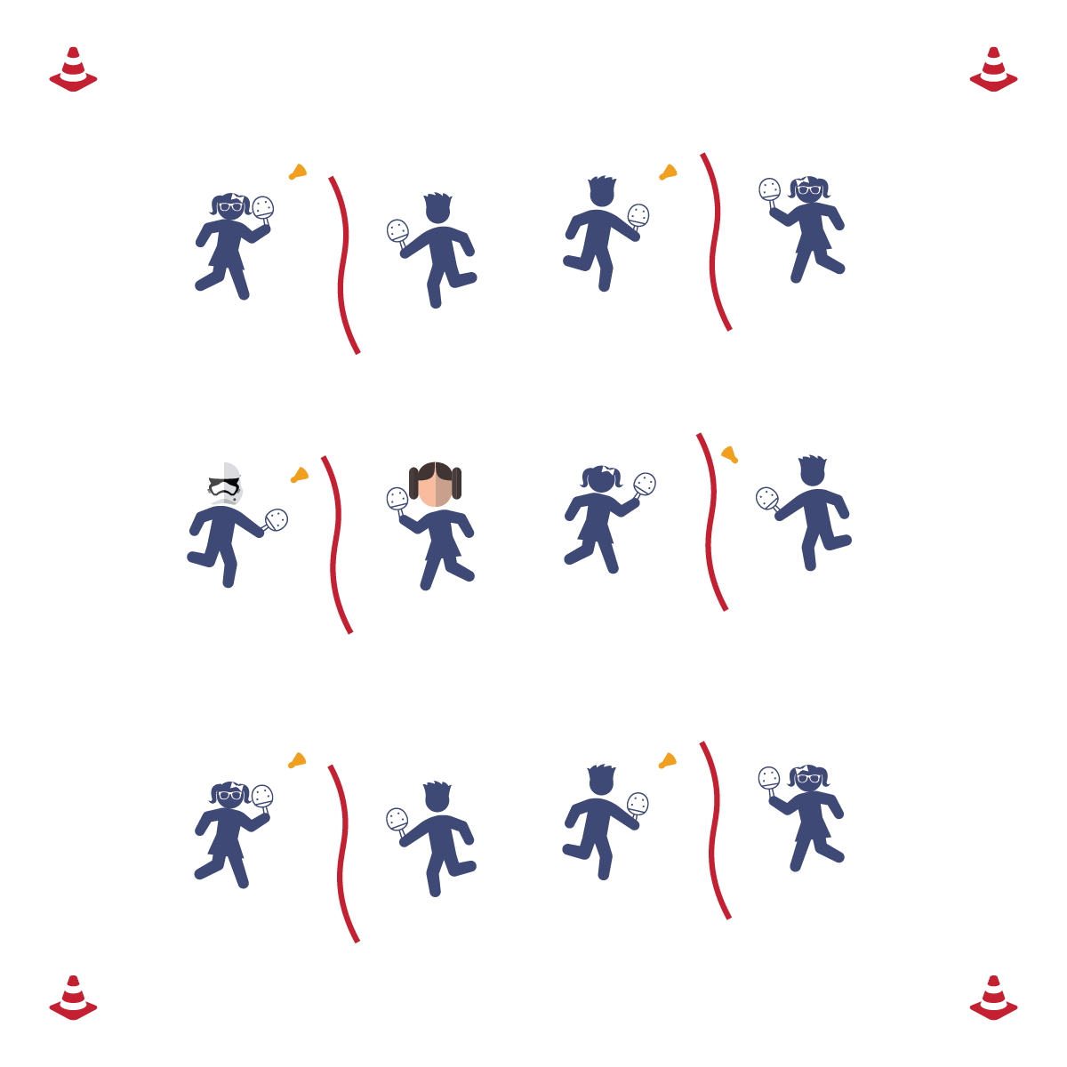

* Play Fair
* Have Fun
* Improve Your Skill

**Equipment:**

* 1 jump rope per 2 students
* 1 paddle per student
* 1 birdie per 2 students

**Set-Up:**

1. Set up the courts, using jump ropes as “nets.”
2. Place a paddle on each side of every court and 1 birdie on every court.
3. Students in pairs at courts.

* **Skill:** I will volley the birdie back and forth with my partner.
* **Cognitive:** I will define the word “etiquette” and relate it to Pickleminton.
* **Fitness:** I will stay actively engaged without reminders from the teacher.
* **Personal & Social Responsibility:** I will follow the safety and etiquette rules that the class creates.

**Activity Procedures:**

1. Today’s activity is 1 v 1 Pickleminton. The object of the activity is to use the basic skills that we’ve practiced to volley the birdie with a partner and attempt to score.
2. Before starting the game, have the class come up with safety rules and consequences if those safety rules are not followed. Have students brainstorm ways they can use integrity and etiquette within their play. Have the students create a plan to resolve any potential conflicts that may arise.
3. Partner 1 starts off with the birdie and serves to Partner 2. The students will volley back and forth until the birdie hits the floor or goes out of bounds.
4. Alternate the serve each time that a point has been scored.

**Grade Level Progression:**

**3rd-5th:** Play the activity as described above.

**1V1 PICKLEMINTON**



**Help students engage in cognitively complex tasks:** At the intermediate grade levels, any competitive physical activity provides layers of complexity that must be unpacked for students to be able to process appropriately. We’re now asking students to select and perform psychomotor skills in a dynamic environment. We’re also asking them to understand that environment in the context of unfamiliar rules. On top of that, we’re insisting that they perform all of this in a way that demonstrates emotional self-control and social etiquette. If that’s not complex, we’re not sure what is. So, it’s important to stop play for teachable moments in all domains. It’s also essential that you frame each day’s performance to foster and reinforce growth mindset and grit.



* **Adaptation:** Allow students to serve a second or third time if they miss their first serve.
* **Extension:** Make the court bigger so the students have more court space to cover.



* **Standard 1 [E6.4]:** Combines traveling with manipulative skill of striking in teacher- and/or student-designed small-sided practice tasks (4).
* **Standard 1 [E24.3-5]:** Strikes an object with a short-handled implement, sending it forward over a low net or to a wall (3a); Strikes an object with a short-handled implement while demonstrating three of the five critical elements of a mature pattern (3b); Strikes an object with a short-handled implement while demonstrating a mature pattern (4a); Strikes an object with a short-handled implement alternating hits with a partner over a low net or against a wall (4b); Strikes an object consecutively, with a partner, using a short-handled implement, over a net or against a wall, in either a competitive or cooperative game environment (5).
* **Standard 2 [E1.3-4]:** Recognizes the concept of open spaces in a movement context (3); Applies the concept of open spaces to combination skills involving traveling (4a).
* **Standard 2 [E3.3-5]:** Combines movement concepts (direction, levels, force, time) with skills as directed by the teacher (3); Applies the concepts of direction and force when striking an object with a short-handled implement, sending it toward a designated target (4b); Applies movement concepts to strategy in game situations (5a); Analyzes movement situations and applies movement concepts in small-sided practice task/game environments (5c).
* **Standard 2 [E5.5]:** Applies basic offensive and defensive strategies/ tactics in net/wall small-sided practice tasks (5b); Recognizes the type of throw, volley, or striking action needed for different games/sports situations (5c).



* **DOK 1:** What is etiquette?
* **DOK 2:** What did you notice about game play when proper etiquette was used?
* **DOK 3:** What is your interpretation of whether or not proper etiquette was used during today’s class? Can you support your interpretation with specific examples?



Etiquette, Integrity, Movement Concepts, Conflict Resolution

**2V2 PICKLEMINTON**

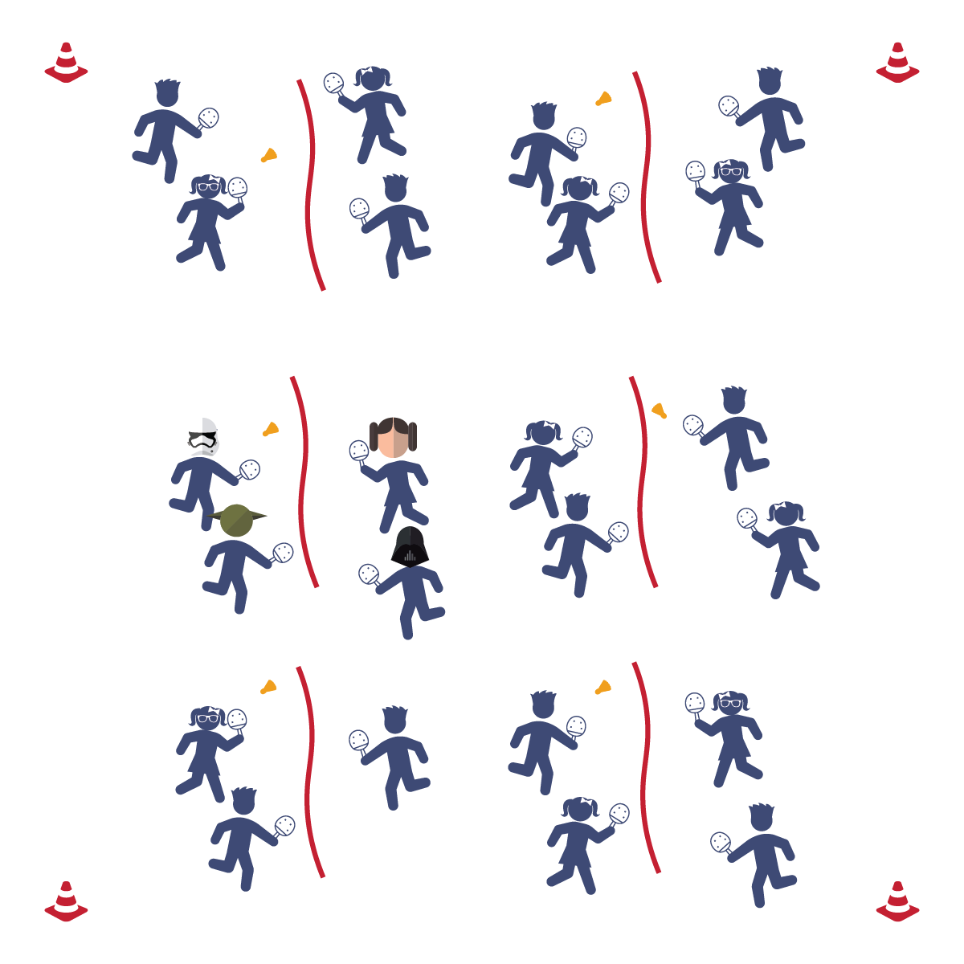

* Play Fair
* Work as a Team
* Improve Your Skill
* **Skill:** I will score a point during game play.
* **Cognitive:** I will define the word “integrity.”
* **Fitness:** I will remain actively involved without reminders from the teacher.
* **Personal & Social Responsibility:** I will play with fairness and integrity to make the game fun for everyone.

**Equipment:**

* 1 jump rope per 4 students
* 1 paddle per student
* 1 birdie per 4 students

**Set-Up:**

1. Set up the courts using jump ropes as “nets.”
2. Place 2 paddles on each side of every court and 1 birdie on each court.
3. Students in groups of 4 at each court.

**Activity Procedures:**

1. Today’s activity is called 2 v 2 Pickleminton. The object of the activity is to use the basic skills that we’ve practiced to volley the birdie against another set of 2 players and attempt to score.
2. Each player on a team will cover either the right or left side of the court, 1 player per side.
3. Group 1 starts off with the birdie and serves to Group 2. The students will volley back and forth until the birdie hits the floor or goes out of bounds.
4. Alternate the serve and server each time that a point has been scored.

**Grade Level Progression:**

**3rd-5th:** Play the activity as described above.

**2V2 PICKLEMINTON**



* **DOK 1:** What is integrity?
* **DOK 2:** How is integrity applied in physical activity/competitive settings?
* **DOK 3:** How is integrity related to the enjoyment of everyone playing a game of Pickleminton?



* **Standard 1 [E6.4]:** Combines traveling with manipulative skill of striking in teacher- and/or student-designed small-sided practice tasks (4).
* **Standard 1 [E24.3-5]:** Strikes an object with a short-handled implement, sending it forward over a low net or to a wall (3a); Strikes an object with a short-handled implement while demonstrating three of the five critical elements of a mature pattern (3b); Strikes an object with a short-handled implement while demonstrating a mature pattern (4a); Strikes an object with a short-handled implement alternating hits with a partner over a low net or against a wall (4b); Strikes an object consecutively, with a partner, using a short-handled implement, over a net or against a wall, in either a competitive or cooperative game environment (5).
* **Standard 2 [E1.3-4]:** Recognizes the concept of open spaces in a movement context (3); Applies the concept of open spaces to combination skills involving traveling (4a).
* **Standard 2 [E3.3-5]:** Combines movement concepts (direction, levels, force, time) with skills as directed by the teacher (3); Applies the concepts of direction and force when striking an object with a short-handled implement, sending it toward a designated target (4b); Applies movement concepts to strategy in game situations (5a); Analyzes movement situations and applies movement concepts in small-sided practice task/game environments (5c).
* **Standard 2 [E5.5]:** Applies basic offensive and defensive strategies/tactics in net/wall small-sided practice tasks (5b); Recognizes the type of throw, volley, or striking action needed for different games/sports situations (5c).



Etiquette, Integrity, Corrective Feedback, Conflict Resolution



* **Adaptation:** Allow students to serve a second or third time if they miss their first serve.
* **Extension:** Make the court bigger so the students have more court space to cover.



**Help students engage in cognitively complex tasks:** See the strategy description for 1v1 Pickleminton—multiply it by 2 (at least) thanks to the cooperative requirements of 2v2.

**STATION DAY**

## 

* Start Activity with Music
* When Music Stops: Clean the Area and Rotate
* **Skill:** I will perform skill assessments to the best of my ability, following as many skills cues as I can.
* **Cognitive**: I will follow the instructions on each station card in order to stay actively engaged with my team.
* **Fitness**: I will find my pulse after each station in order to see if it is beating faster than when I’m sitting or resting.
* **Personal & Social Responsibility**: I will follow the rules and parameters of Station Day.

**Equipment:**

* 24 low profile cones
* Station music and music player
* See station cards for equipment needs

**Set-Up:**

1. Using low profile cones, create 6-10 grids (depending on size of class and activity area).
2. Set station cards up on tall cones in each grid.
3. Set up each station according to its station card.
4. Designate 1 station as an assessment station.
5. Create groups of 2-4 students, each group at a different station.

**Activity Procedures:**

1. Today is a Station Assessment Day. We’ll complete each station for 2 (or 3) minutes. One station is an assessment station where you’ll be given feedback based on your skill performance.
2. *Teacher: Talk through and/or demonstrate each station. Emphasize expectations at the assessment station.*
3. When the music starts, begin working at your station. When it stops, you’ll have 1 minute to clean up the station equipment and rotate to the next station. Wait until the music begins again before you start the activity at the new station.
4. While we’re learning this station format, I’ll pause the music for a longer period of time so that every team is able to clean up their area and rotate.

**Grade Level Progression:**

**3rd-5th:** Play the activity as described above.



* *Select questions from the module you’re teaching or the assessment you’re using.*
* Some students may need step-by-step assistance during clean-up and rotation.
* Pause the music and don’t restart until every group has safely transitioned.
* Provide visual cues and graphics to enhance station instructions.



**STATION DAY**



*Select words from the module that you’re teaching.*



* **Standard 1, 2, 3, 5** [*Select outcomes from the module you’re teaching.*]
* **Standard 4 [E2.3-5]** Works independently for extended periods of time (3); Reflects on personal social behavior in physical activity (4); Participates with responsible personal behavior in a variety of physical activity contexts, environments, and facilities (5a); Exhibits respect for self with appropriate behavior while engaging in physical activity (5b).



**Organizing students to interact with content:** The use of grids to organize students into learning stations is an effective way to manage activity, assessment, and cooperative learning opportunities. Practice using this format several times, especially with young children, before attempting to facilitate an assessment experience. Students need time to master the management aspects of station work. However, once this routine is learned, it often becomes an essential management tool in physical education.