­­

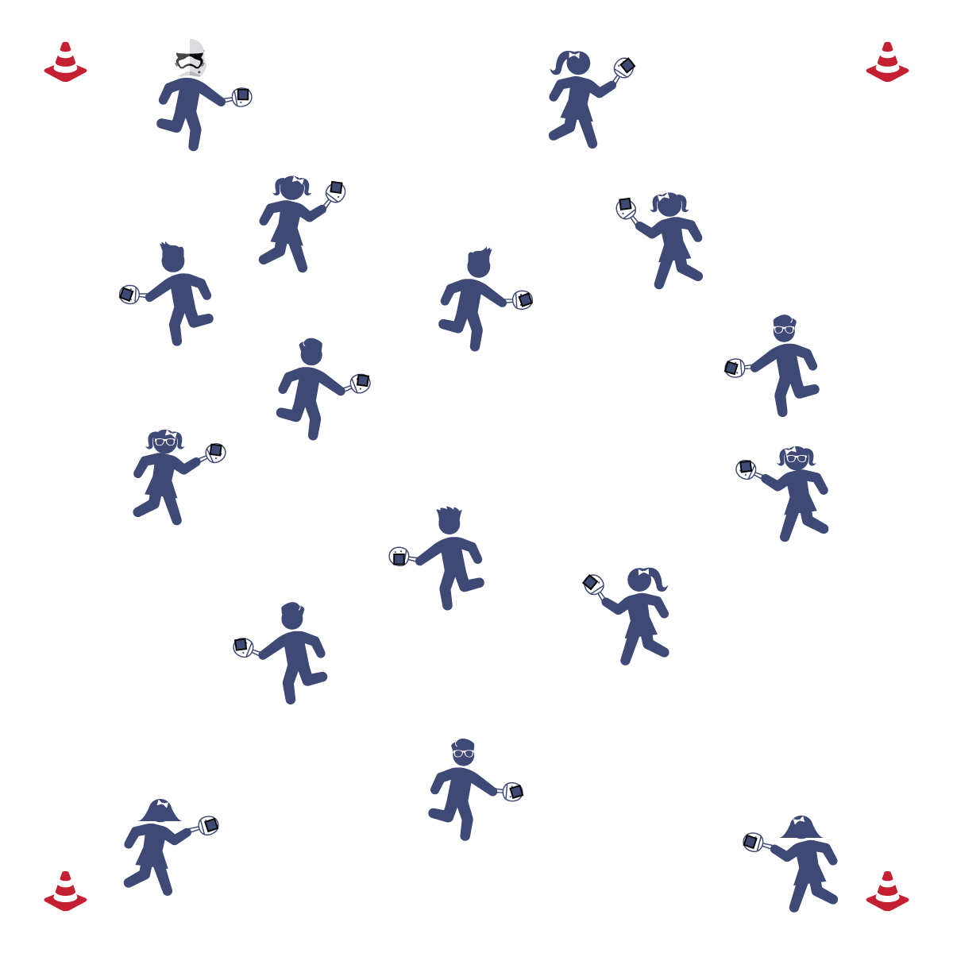

**Equipment:**

* 4 low profile cones
* 1 paddle per student
* 1 bean bag per student

**Set-Up:**

1. Use cones to designate a large activity area.
2. Place paddles throughout the activity area. 1 bean bag on top of each paddle.
3. Each student standing/sitting next to a paddle.

**HELLO PADDLE**

* **Skill:** I will balance a beanbag on my paddle while walking.
* **Cognitive:** I will be able to recite the cues for gripping the paddle.
* **Fitness:** I will actively engage in physical education class without a reminder from the teacher.
* **Personal & Social Responsibility:** I will move carefully and safely in open space while balancing the bean bag.

Paddle Grip

* Shake Hands with the Paddle
* Soft Squeeze
* Lock Wrist

**Activity Procedures:**

1. Today’s activity is called Hello Paddle. We are going to practice handling the paddle by balancing the bean bag on top of it.
2. When I say “GO,” begin walking around the activity area while you balance the bean bag on the paddle. Be careful that you don’t bump into anyone else so that everyone stays safe. Freeze when you hear the stop signal.
3. Repeat the activity using additional locomotor movements (e.g., skipping, galloping).

**Grade Level Progression:**

**3rd:** Play the activity as described above.

**4th:** Students see how many peers they can low-five without dropping the bean bag off the paddle.

**5th:** Students attempt to switch bean bags with as many classmates as they can by tossing and catching while remaining in control.

**HELLO PADDLE**



* **DOK 1:** Can you remember the cues for gripping the paddle?
* **DOK 2:** How does the grip affect your ability to keep the beanbag balanced?
* **DOK 3:** How would you adapt this activity to make it more difficult? Make it easier?



Balance, Catch, Etiquette, Open Space, Personal Responsibility, Toss, Strike



* **Standard** **1 [E6.4]:** Combines traveling with manipulative skills of dribbling, throwing, catching, and striking in teacher- and/or student-designed small-sided practice tasks (4).
* **Standard 2 [E1.3-4]:** Recognizes the concept of open spaces in a movement context (3); Applies the concept of open spaces to combination skills involving traveling (e.g., dribbling and traveling) (4a).
* **Standard 3 [E2.3-5]:** Engages in the activities of physical education class without teacher prompting (3); Actively engages in the activities of physical education class, both teacher-directed and independent (4); Actively engages in all the activities of physical education (5).
* **Standard 4 [E5.3-4]:** Recognizes the role of rules and etiquette in physical activity with peers (3); Exhibits etiquette and adherence to rules in a variety of physical activities (4).
* **Standard 4 [E5.3-5]** Works independently and safely in physical activity settings (3); Works safely with peers and equipment in physical activity settings (4); Applies safety principles with age-appropriate physical activities (5).



* **Adaptation:** Slow students down: tell them that their feet are super heavy and they must move in slow motion.
* **Extension:** Have students use multiple locomotor movements, change speeds, or change levels.

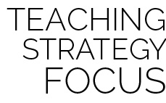

**Identify critical content:** Establish critical content for the duration of the module using the Self-Assessment and Holistic Rubric criteria. Take time at the end of the first lesson to go over all of the criteria with your class. This will frame expectations for students and provide purpose for their skill practice and effort.