­­

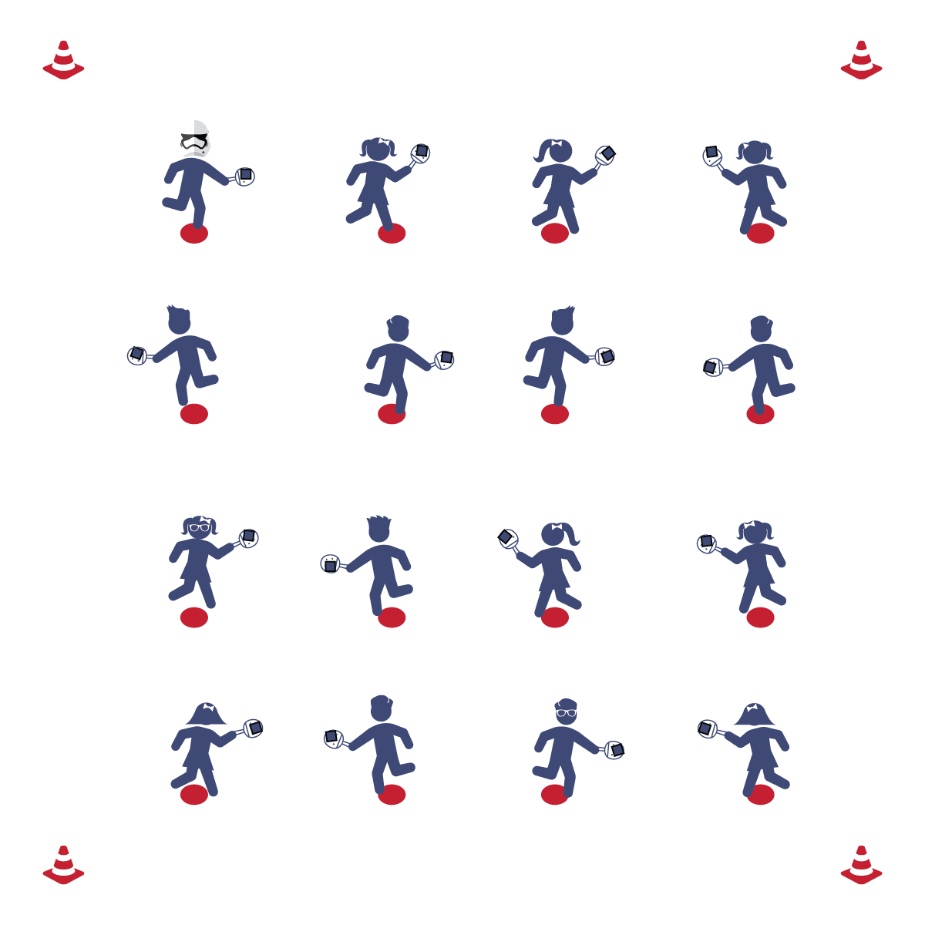

**Activity Procedures:**

1. Today’s activity is called Pancake Flipper. We are going to practice our ability to control the paddle during Pickleminton games.
2. Place the bean bag on your paddle. When I say “GO,” flip the pancake (bean bag) in the air and try to get it to safely land back in its pan (on the paddle) as many times as you can. Freeze when you hear the stop signal.
3. Next, students flip the pancake into the air, catch the pancake with their free hand, toss the pancake back into the air, and then catch the pancake with the pan (paddle) as many times as they can.
4. If students excel in the activities above, play Pancake PIG: students add a twist to the basic tossing and catching by attempting to also perform tricks (e.g., toss and catch behind their back, toss under their leg and catch the bean bag, toss the bean bag and catch on a body part). With students in a group, one student will perform the trick with their pancake and the other students in the group will mimic that trick. If any students in the group cannot do the trick, then they get a letter from the word “PIG” (similar to HORSE in basketball).

**Grade Level Progression:**

**3rd & 4th:** Play the activity as described above.

**5th:** Add Pancake PIG into the activity.

**PANCAKE FLIPPER**

**Equipment:**

* 1 paddle per student
* 1 bean bag per student
* 1 poly spot per student

**Set-Up:**

1. Place the poly spots evenly throughout the activity area.
2. Place a paddle and a bean bag on each poly spot.
3. Each student standing/sitting on a poly spot.

* Balance
* Toss with Control
* Give with the Paddle
* **Skill:** I will catch the beanbag on my paddle after I toss it up in the air.
* **Cognitive:** I will discuss some of the challenges I faced when flipping my paddle to catch the beanbag.
* **Fitness:** I will actively engage in physical education class without a reminder from the teacher.
* **Personal & Social Responsibility:** I will praise others for their success in their movement skills.

**PANCAKE FLIPPER**



* **DOK 1:** What is force?
* **DOK 2:** How did force affect your tossing and catching?
* **DOK 3:** Can you predict how a birdie (or ball) would fly if you were to strike it with hard force? Soft force?

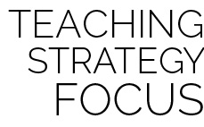

**Help students practice skills:** Pancake Flipper is a fun yet simple activity that gives students the opportunity to explore movement and manipulation with a paddle. Guide student interaction with the paddle and the bean bag, allowing them to struggle at times in order to discover the interaction of force, gravity, and grip-strength on the object they are working to control.



* **Adaptation:** Provide students with a bigger paddle, or start with a toss and catch without the paddle.
* **Extension:** Have students use their non-dominant hand, increase height of the beanbag when tossed, or incorporate other objects.



Balance, Direction, Etiquette, Force, Movement Concepts, Open Space,

Personal Responsibility



* **Standard 2 [E3.3-5]:** Applies the concepts of direction and force when striking an object with a short-handled implement, sending it toward a designated target (4); Analyzes movement situations and applies movement concepts in small-sided practice tasks (5).
* **Standard 4 [E2.3-5]**: Works independently for extended periods of time (3); Reflects on personal social behavior in physical activity (4); Participates with responsible personal behavior in a variety of physical activity contexts, environments, and facilities (5a); Exhibits respect for self with appropriate behavior while engaging in physical activity (5b).



* **DOK 1:** What is force?
* **DOK 2:** How did force affect your tossing and catching?
* **DOK 3:** Can you predict how a birdie (or ball) would fly if you were to strike it with hard force? Soft force?



**Help students practice skills:** Pancake Flipper is a fun yet simple activity that gives students the opportunity to explore movement and manipulation with a paddle. Guide student interaction with the paddle and the bean bag, allowing them to struggle at times in order to discover the interaction of force, gravity, and grip-strength on the object they are working to control.