­­

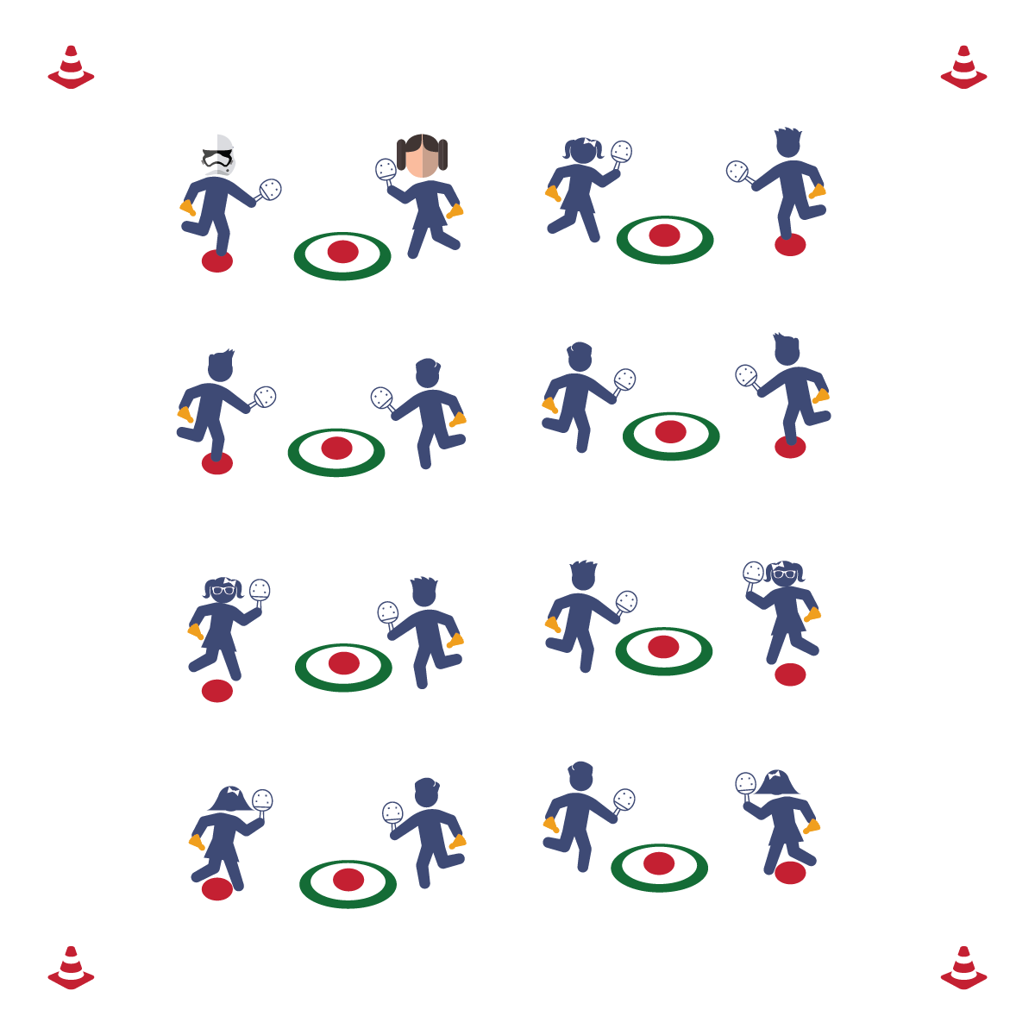

**BIRDIE IN THE CAGE**

* **Skill:** I will practice my underhand serve using the skill cues we learned in class.
* **Cognitive:** I will describe the sequence of a proper underhand serve.
* **Fitness:** I will actively participate in the class warm-up to prepare for the activities in physical education class today.
* **Personal & Social Responsibility:** I will exhibit responsible behavior while working independently at the class stations.
* Step in Opposition
* Drop Birdie
* Swing Low to High
* Follow Through

**Equipment:**

* 1 Hula Hoop per 2 students
* 2 poly spots per hoop
* 1 paddle per student
* 1 birdie per student

**Set-Up:**

1. Spread the Hula Hoops throughout the activity area.
2. Place 1 poly spot in the center of each hoop and a poly spot 8-10 feet away from each hoop.
3. Place 2 paddles and 2 birdies at each poly spot.
4. Students in pairs, 1 pair standing at each poly spot.

**Activity Procedures:**

1. Today’s activity is called Birdie in the Cage. The object of the activity is to practice our underhand serves and to become more accurate when we serve the birdie.
2. The first partner will stand on the poly spot and serve the birdie with a swing low to high, trying to strike it into the hoop or the poly spot inside of the hoop. The other partner retrieves the birdies.
3. After a set period of time, switch roles.

**Grade Level Progression:**

**3rd & 4th:** Play the activity as described above.

**5th:** Play the activity described above with a time limit: students attempt to maximize the number of accurate serves within the specified time period.

**BIRDIE IN THE CAGE**



Direction, Force, Strike, Serve, Etiquette

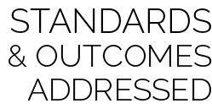

* **Standard** **1 [E24.3-5]:** Strikes an object with a short-handled implement, sending it forward over a low net or to a wall (3a); Strikes an object with a short-handled implement while demonstrating three of the five critical elements of a mature pattern (3b); Strikes an object with a short-handled implement while demonstrating a mature pattern (4a).
* **Standard 2 [E3.3-4]:** Combines movement concepts (direction, levels, force, time) with skills as directed by the teacher (3); Applies the concepts of direction and force when striking an object with a short-handled implement, sending it toward a designated target (4).
* **Standard 3 [E2.3-5]:** Engages in the activities of physical education class without teacher prompting (3); Actively engages in the activities of physical education class, both teacher-directed and independent (4); Actively engages in all the activities of physical education (5).
* **Standard 4 [E1.4-5]:** Exhibits responsible behavior in independent group situations (4); Engages in physical activity with responsible interpersonal behavior (e.g., peer to peer, student to teacher, student to referee) (5).

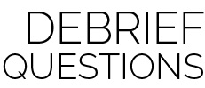

* **DOK 1:** What are the cues for an underhand serve?
* **DOK 2:** How can you apply what you’ve learned about force to improve your underhand serve?
* **DOK 3:** Once you’ve mastered this challenge, how would you adapt it to create a task to help you further improve your performance?

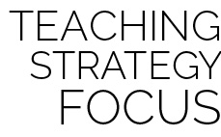

**Help students process content:** This activity will be a challenge for most students. Many will have very limited experience with striking skills—especially a serve. It will be important to help students process the result of their performance, specifically when performances are filled with error. Remind students that errors are an important part of the learning process. Thinking about errors with a growth mindset is an important skill that everyone in the class is working to develop.



* **Adaptation:** Move students closer to the target. Use a foam ball instead of a birdie.
* **Extension:** Continue to move students farther away from the target.