­­

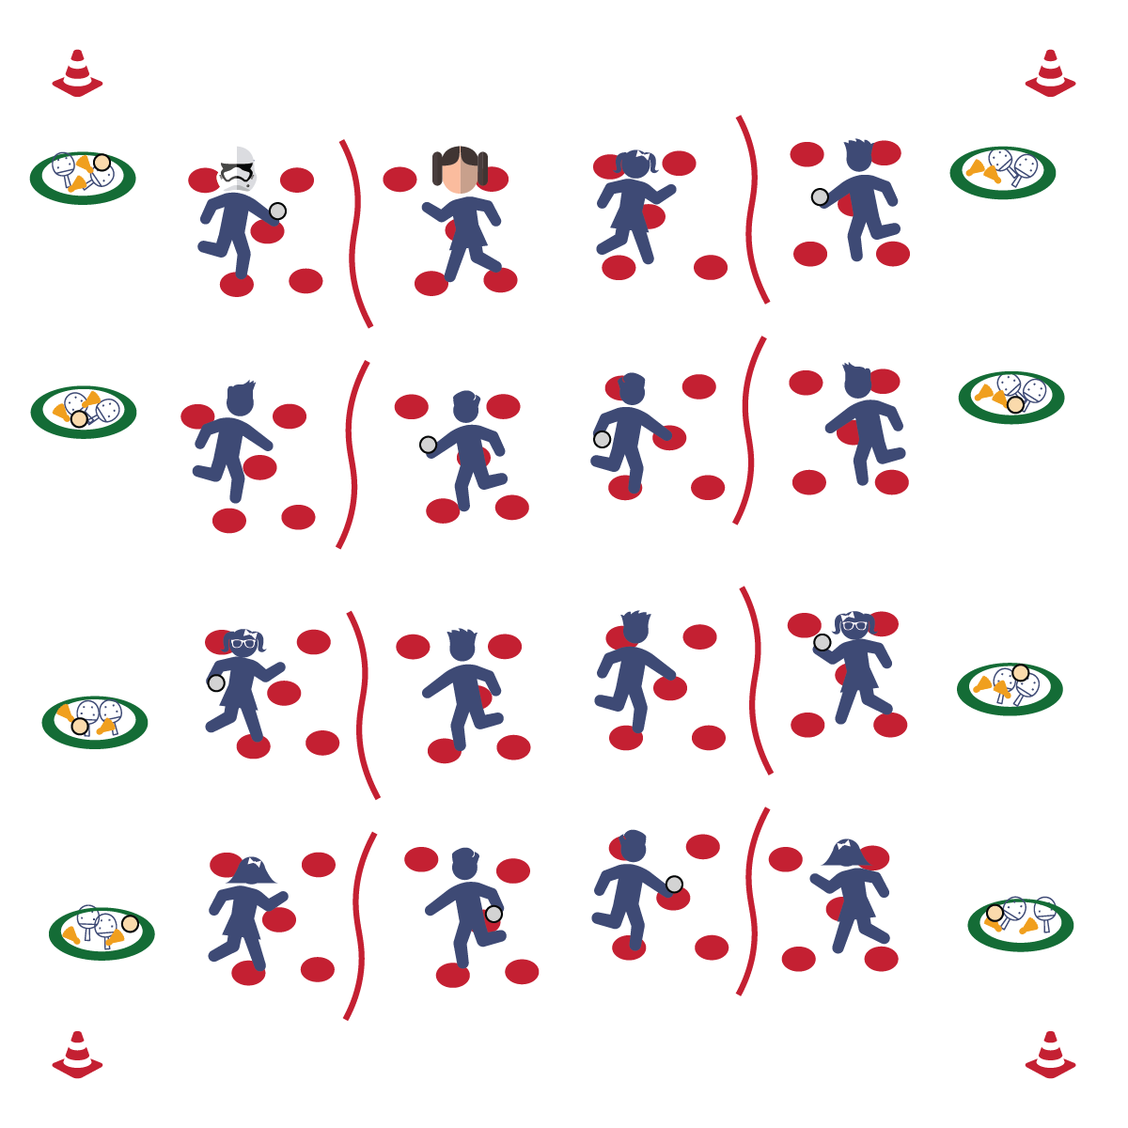



* **Skill:** I will hit the birdie to my partner with accuracy.
* **Cognitive:** I will describe how force affects accuracy.
* **Fitness:** I will stay actively engaged without reminders from the teacher.
* **Personal & Social Responsibility:** I will use an appropriate amount of force in order to keep my birdie from flying out of control.
* Grip
* Rip
* Follow Through

**Equipment:**

* 1 paddle per student
* 1 birdie per 2 students
* 1 bean bag per 2 students
* 1 Whiffle ball per 2 students
* Various foam balls or other objects
* 1 cone per student
* 1 jump rope per 2 students
* 5 poly spots per student
* 1 Hula Hoop per 2 students

**Set-Up:**

1. Create courts using cones to mark corners and jump ropes as the “nets.” Scatter 5 poly spots on each side of every court.
2. Just off to the side of each court, place 2 paddles and a variety of objects inside 1 hoop.
3. One student on each side of every court, standing on a poly spot.

**Activity Procedures:**

1. Today’s activity is called Splat the Spot. The object of the activity is to learn more about the size of the Pickleminton court as we work on force, placement, and accuracy for certain types of shots.
2. When I say “GO,” Partner 1 will pick an object from the pile to start with and then return to their poly spot. Partner 1 will throw the object to Partner 2, and then both partners will quickly move to a new poly spot, and Partner 2 will throw the object back.
3. After 5 throws each, Partner 2 will choose a new object. This will continue until 4 separate objects have been used.
4. Next, Partner 1 will pick up a paddle. Partner 2 will throw the birdie while Partner 1 strikes it using a forehand strike. Partner 2 catches it, both partners move to a new spot, and Partner 2 makes another toss.
5. Make sure you continue moving to different poly spots between each toss. After Partner 1 has gotten 5 hits, Partner 2 will use the paddle and the activity repeats. Next, repeat using backhand strikes.
6. Next, both partners pick up a paddle. Volley the birdie back and forth, doing your best to return it to whichever poly spot your partner is on.

**Grade Level Progression:**

**3rd & 4th:** Play the activity as described above.

**5th:** Add an aerobic activity (e.g., jumping jacks, push-ups) whenever a volley falls.

**SPLAT THE SPOT**

**SPLAT THE SPOT**



Accuracy, Direction, Force, Forehand Strike, Backhand Strike, Open Space, Strike



* **Standard 1 [E24.3-5]:** Strikes an object with a short-handled implement, sending it forward over a low net or to a wall (3a); Strikes an object with a short-handled implement while demonstrating three of the five critical elements of a mature pattern (3b); Strikes an object with a short-handled implement while demonstrating a mature pattern (4a); Strikes an object with a short-handled implement, alternating hits with a partner over a low net or against a wall (4b); Strikes an object consecutively, with a partner, using a short-handled implement, over a net or against a wall, in either a competitive or cooperative game environment (5).
* **Standard 2 [E1.3-4]:** Recognizes the concept of open spaces in a movement context (3); Applies the concept of open spaces to combination skills involving traveling (4a).
* **Standard 2 [E3.3-5]:** Combines movement concepts (direction, levels, force, time) with skills as directed by the teacher (3); Applies the concepts of direction and force when striking an object with a short-handled implement, sending it toward a designated target (4b); Applies movement concepts to strategy in game situations (5a); Analyzes movement situations and applies movement concepts (e.g., force, direction, speed, pathways, extensions) in small-sided practice task/game environments, dance and gymnastics (5c).



* **DOK 1:** What is accuracy?
* **DOK 2:** What do you know about making an accurate strike with your paddle?
* **DOK 3:** How are the cues for striking related to accuracy?

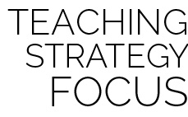

**Organize students to interact with content:** Splat the Spot is a cooperative skill practice drill that will help students begin to interact with all of the components of a dynamic net game. Students will physically navigate a court and a net while maintaining focus on a manipulative object like a birdie or a ball. Remember that there will be teachable moments with respect to both skill and social development. Help students collaborate in a way that will allow them to interact with the defined outcomes that you have established for the class.



* **Adaptation:** Have students catch the birdie or object each time before striking the birdie or object back to their partner.
* **Extension:** Have students count how many volleys they can get back and forth.