­­

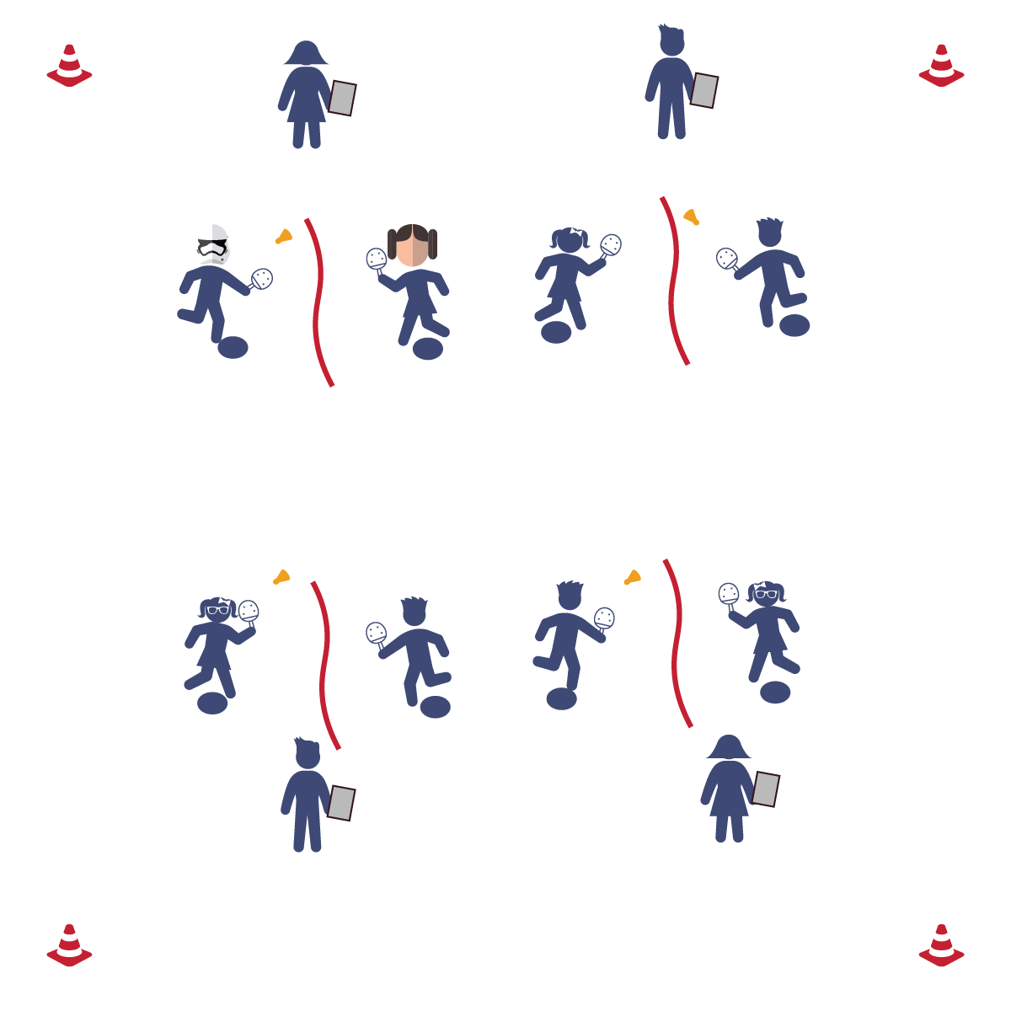

**Equipment:**

* 1 jump rope per 3 students
* 1 birdie per 3 students
* 1 paddle per student
* 1 clipboard per 3 students (optional)
* 1 pencil per 3 students
* 2 poly spots per 3 students
* 1 Pickleminton Peer Assessment per student

**Set-Up:**

1. Set up 1 assessment area per 3 students with a jump rope stretched out as a net and a poly spot on either side (3rd: 12’ apart; 4th: 15’ apart; 5th: 18’ apart).
2. Place 2 paddles, 1 birdie, 1 pencil, and 3 assessment sheets at each assessment area.
3. 3 students at each assessment area, with 2 students striking the birdie and 1 student assessing.

* Grip
* Rip
* Follow Through
* **Skill:** I will develop and provide constructive feedback to my classmates.
* **Cognitive:** I will identify evidence that supports the constructive feedback I receive.
* **Fitness:** I will remain actively engaged without a reminder from the teacher.
* **Personal & Social Responsibility:** I will be kind and respectful to my classmates when giving them constructive feedback.

**Activity Procedures:**

1. Today’s activity is called Peer Assessment. The object of the activity is to respectfully help one another improve by assessing their performance and giving kind, constructive criticism.
2. Partner 1 and Partner 2 will each complete 15 forehand strikes while Partner 3 peer-assesses Partner 1.
3. Partner 3 and Partner 1 will each complete 15 forehand strikes while Partner 2 peer-assesses Partner 3.
4. Partner 2 and Partner 3 will each complete 15 forehand strikes while Partner 1 peer-assesses Partner 2.
5. After each partner has completed the peer assessment, provide feedback to one another. Next, replay the forehand striking drill. This time, work to improve your performance based on the feedback.

**Grade Level Progression:**

**3rd:** Students perform the drill without a formal, written assessment. However, still allow students to provide feedback based on their observations.

**4th:** Play activity as described above.

**5th:** Add a backhand striking assessment.

**PEER ASSESSMENT**

**PEER ASSESSMENT**



* **Adaptation:** Have the student who is being assessed self-toss the birdie and strike it over the net.
* **Extension:** Allow students to use and assess a backhand strike.

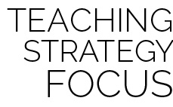

**Help students record and represent knowledge:** At this point in the module you have given students the criteria, cues, and practice time necessary for them to begin to create their own representations and inferences about the skills and skill performances that they are both experiencing personally and seeing from their peers. Peer assessment serves three purposes. First, it provides students with a framework for recording and representing their knowledge of physical education content. Second, it provides a practice environment for them to articulate and express their knowledge and perspective to their peers in a respectful and thoughtful way. Third, it provides an experience in which students must listen to, process, and potentially use feedback given to them by a peer—a lifelong skill that is essential in the 21st century workplace.



* **DOK 1:** How would you describe corrective feedback?
* **DOK 2:** How can you apply what you learned to improve your striking skills?
* **DOK 3:** What facts would you use to support the corrective feedback you received? Can you elaborate on why you chose those facts?



* **Standard 1 [E24.3-5]:** Strikes an object with a short-handled implement, sending it forward over a low net or to a wall (3a); Strikes an object with a short-handled implement while demonstrating three of the five critical elements of a mature pattern (3b); Strikes an object with a short-handled implement while demonstrating a mature pattern (4a); Strikes an object with a short-handled implement, alternating hits with a partner over a low net or against a wall (4b); Strikes an object consecutively, with a partner, using a short-handled implement, over a net or against a wall, in either a competitive or cooperative game environment (5).
* **Standard 2 [E3.3-5]:** Combines movement concepts (direction, levels, force, time) with skills as directed by the teacher (3); Applies the concepts of direction and force when striking an object with a short-handled implement, sending it toward a designated target (4b); Applies movement concepts to strategy in game situations (5a); Analyzes movement situations and applies movement concepts...in small-sided practice task/game. (5c).
* **Standard 4 [E3.3-5]:** Accepts and implements specific corrective teacher feedback (3); Listens respectfully to corrective feedback from others (e.g., peers, adults) (4); Gives corrective feedback respectfully to peers (5).



Assessment, Constructive Criticism, Feedback, Forehand Strike, Respect, Strike