­­

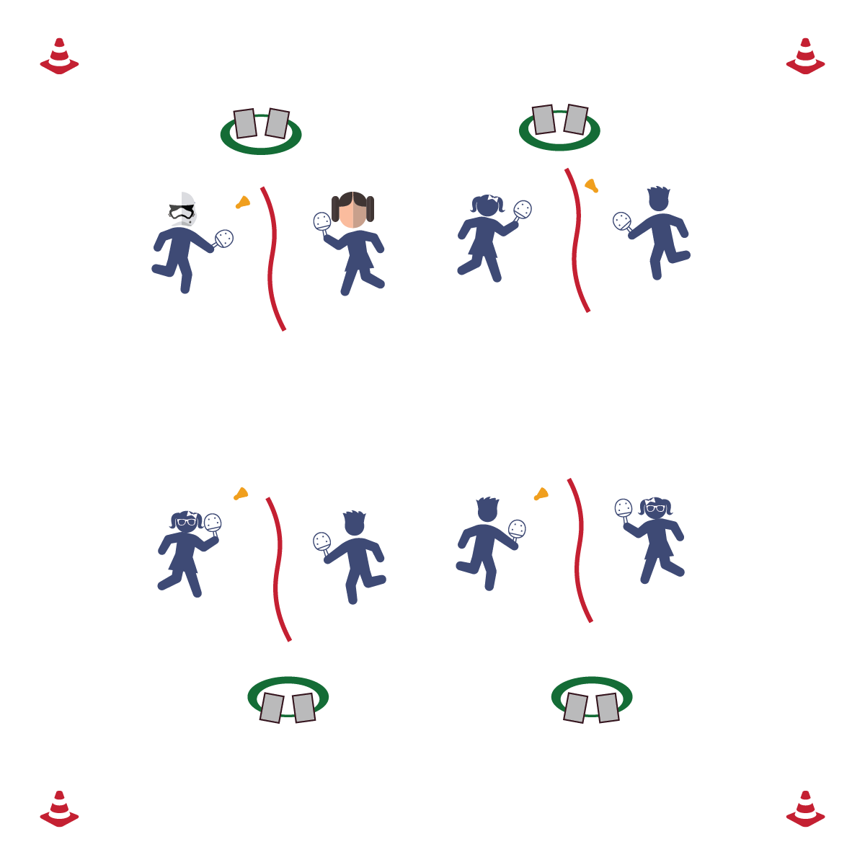

**Activity Procedures:**

1. Today’s activity is called It's Time to Get SMART. The object of the activity is to track today’s step count and radial and carotid pulse to create a SMART goal for our next class.
2. Have each student put on their pedometer and make sure their step count is accurate.
3. Take both radial and carotid pulse before the activity and write them down on assessment sheet. (Teacher will time students).
4. Students will volley back and forth. The goal is to move your partner across the court. Rapid fire volley for 2 minutes. Re-take/re-record radial and carotid pulses.
5. Students will volley back and forth. The goal is to move your partner across the court. Rapid fire volley for 3 minutes. Re-take/re-record radial and carotid pulses.
6. Students will volley back and forth. The goal is to move your partner across the court. Rapid fire volley for 4 minutes. Re-take/re-record radial and carotid pulses.
7. Check pedometer readings and record them on the assessment sheet. Using the recorded information for each student, create a pedometer and/or heart rate SMART goal for next class.

**Grade Level Progression:**

**3rd-5th:** Play the activity as described above.

**Equipment:**

* 1 pedometer per student
* 1 birdie per 2 students
* 1 paddle per student
* 1 jump rope per 2 students
* 1 pencil per student
* 1 assessment and SMART goal sheet per student
* 1 Hula Hoop per 2 students

**Set-Up:**

1. Using the jump rope as a “net,” set up 1 court for every 2 students in the class.
2. Put 2 paddles, 1 birdie, 2 pedometers, 2 pencils, and 2 assessment/SMART goal sheets in 1 hula hoop off to the side of each court.
3. Students in pairs at each court.

* **Skill:** I will demonstrate striking skill cues during rapid fire volley sessions.
* **Cognitive:** I will complete a SMART goal sheet carefully and thoughtfully.
* **Fitness:** I will work to increase my heart rate.
* **Personal & Social Responsibility:** I will cooperate with my partner and follow instructions with no reminders.
* Find Your Pulse
* Count for 6 Seconds
* Multiply by 10

**TIME TO GET SMART**

**TIME TO GET SMART**



Accuracy, Assessment, SMART Goals, Heart Rate, Pedometers, Placement, Carotid Pulse, Radial Pulse, Health-Related Fitness, Skill-Related Fitness, Pre-Test, Post-Test, Strategy



* **Standard 1 [E24.3-5]:** Strikes an object with a short-handled implement, sending it forward over a low net or to a wall (3a); Strikes an object with a short-handled implement while demonstrating three of the five critical elements of a mature pattern (3b); Strikes an object with a short-handled implement while demonstrating a mature pattern (4a); Strikes an object with a short-handled implement, alternating hits with a partner over a low net or against a wall (4b); Strikes an object consecutively, with a partner, using a short-handled implement, over a net or against a wall, in either a competitive or cooperative game environment (5).
* **Standard 3 [E1.3b-4]:** Identifies physical activity benefits as a way to become healthier (3b); Analyzes opportunities for participating in physical activity outside physical education class (4).
* **Standard 3 [E5.3-5]:** Demonstrates, with teacher direction, the health-related fitness components (3); Completes fitness assessments (pre- & post-) (4a); Identifies areas of needed remediation from personal test and, with teacher assistance, identifies strategies for progress in those areas (4b); Analyzes results of fitness assessment (pre- & post-), comparing results to fitness components for good health (5a).



* **DOK 1:** What is a SMART goal?
* **DOK 2:** How would you apply the SMART goal process to your skill improvement?
* **DOK 3:** How are SMART goals related to health-related fitness? Skill-related fitness?



**Help students practice strategies and processes:** Working with SMART goals within instructional units like Pickleminton offers students an opportunity to link the goal-setting process to the practical world in which they live. Their skill development is happening in real time. If given the correct lens, students can see and feel learning happening. SMART goals provide that lens and help establish a skillset that will serve all students in all areas of life.



* **Adaptation:** To determine heart rate, time students for the full minute to avoid extra math. Or, provide a pulse bar/pulse tracker for instant heart rate data.
* **Extension:** To determine heart rate, time students for 10 seconds, 15 seconds, or 30 seconds. Then have students do the multiplication to get their heart rate.