­­



**1V1 PICKLEMINTON**

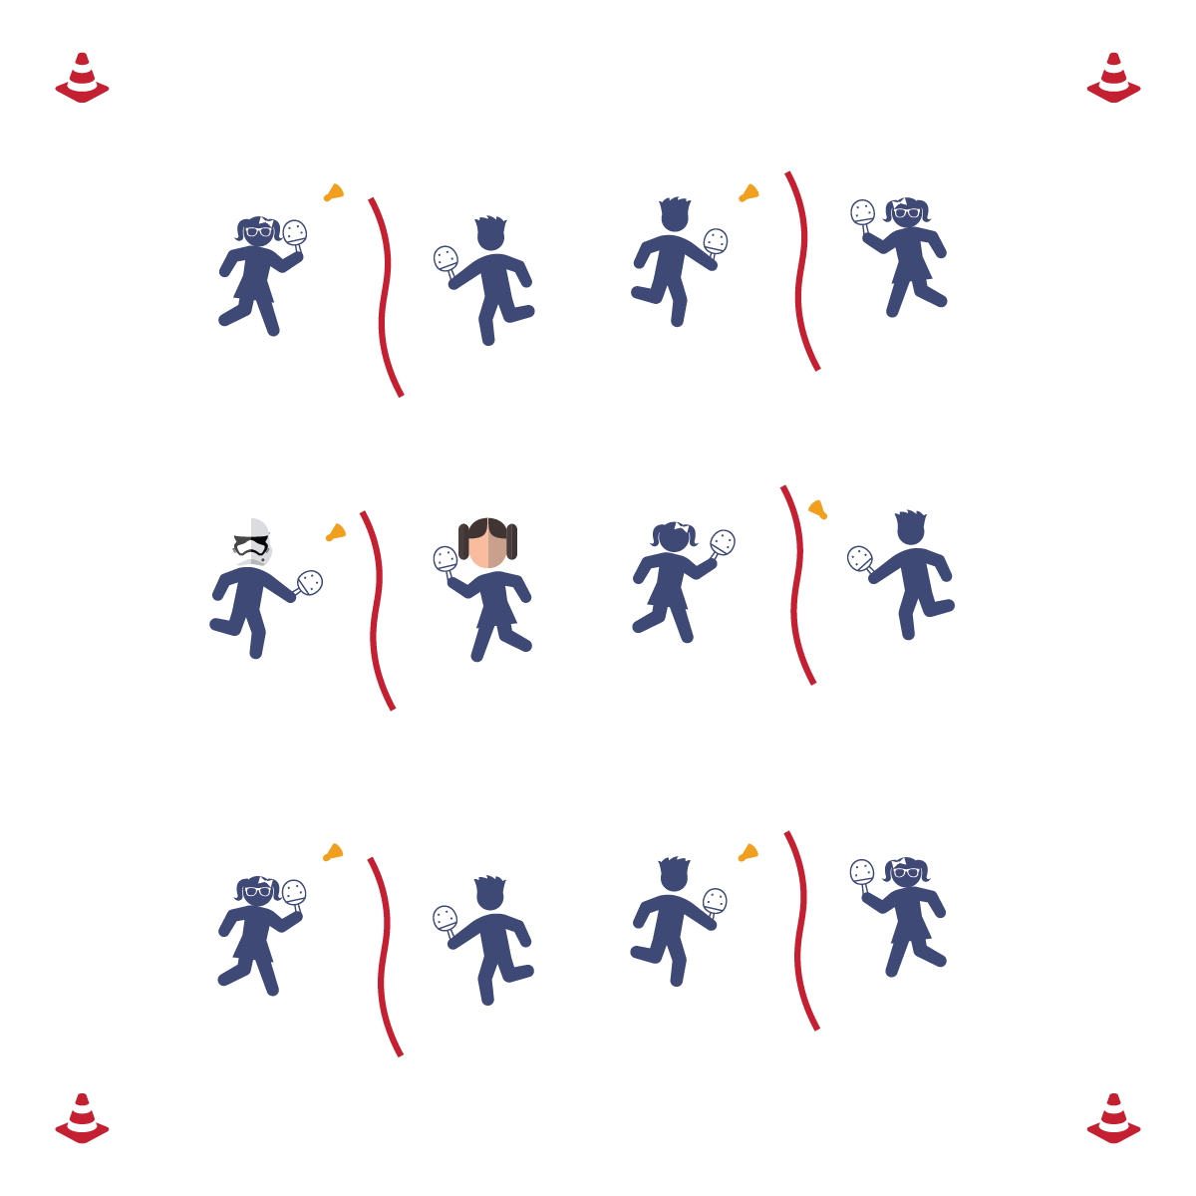

* **Skill:** I will volley the birdie back and forth with my partner.
* **Cognitive:** I will define the word “etiquette” and relate it to Pickleminton.
* **Fitness:** I will stay actively engaged without reminders from the teacher.
* **Personal & Social Responsibility:** I will follow the safety and etiquette rules that the class creates.
* Play Fair
* Have Fun
* Improve Your Skill

**Equipment:**

* 1 jump rope per 2 students
* 1 paddle per student
* 1 birdie per 2 students

**Set-Up:**

1. Set up the courts, using jump ropes as “nets.”
2. Place a paddle on each side of every court and 1 birdie on every court.
3. Students in pairs at courts.

**Activity Procedures:**

1. Today’s activity is 1 v 1 Pickleminton. The object of the activity is to use the basic skills that we’ve practiced to volley the birdie with a partner and attempt to score.
2. Before starting the game, have the class come up with safety rules and consequences if those safety rules are not followed. Have students brainstorm ways they can use integrity and etiquette within their play. Have the students create a plan to resolve any potential conflicts that may arise.
3. Partner 1 starts off with the birdie and serves to Partner 2. The students will volley back and forth until the birdie hits the floor or goes out of bounds.
4. Alternate the serve each time that a point has been scored.

**Grade Level Progression:**

**3rd-5th:** Play the activity as described above.

**1V1 PICKLEMINTON**



Etiquette, Integrity, Movement Concepts, Conflict Resolution



* **Standard 1 [E6.4]:** Combines traveling with manipulative skill of striking in teacher- and/or student-designed small-sided practice tasks (4).
* **Standard 1 [E24.3-5]:** Strikes an object with a short-handled implement, sending it forward over a low net or to a wall (3a); Strikes an object with a short-handled implement while demonstrating three of the five critical elements of a mature pattern (3b); Strikes an object with a short-handled implement while demonstrating a mature pattern (4a); Strikes an object with a short-handled implement alternating hits with a partner over a low net or against a wall (4b); Strikes an object consecutively, with a partner, using a short-handled implement, over a net or against a wall, in either a competitive or cooperative game environment (5).
* **Standard 2 [E1.3-4]:** Recognizes the concept of open spaces in a movement context (3); Applies the concept of open spaces to combination skills involving traveling (4a).
* **Standard 2 [E3.3-5]:** Combines movement concepts (direction, levels, force, time) with skills as directed by the teacher (3); Applies the concepts of direction and force when striking an object with a short-handled implement, sending it toward a designated target (4b); Applies movement concepts to strategy in game situations (5a); Analyzes movement situations and applies movement concepts in small-sided practice task/game environments (5c).
* **Standard 2 [E5.5]:** Applies basic offensive and defensive strategies/ tactics in net/wall small-sided practice tasks (5b); Recognizes the type of throw, volley, or striking action needed for different games/sports situations (5c).



* **DOK 1:** What is etiquette?
* **DOK 2:** What did you notice about game play when proper etiquette was used?
* **DOK 3:** What is your interpretation of whether or not proper etiquette was used during today’s class? Can you support your interpretation with specific examples?

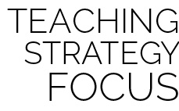

**Help students engage in cognitively complex tasks:** At the intermediate grade levels, any competitive physical activity provides layers of complexity that must be unpacked for students to be able to process appropriately. We’re now asking students to select and perform psychomotor skills in a dynamic environment. We’re also asking them to understand that environment in the context of unfamiliar rules. On top of that, we’re insisting that they perform all of this in a way that demonstrates emotional self-control and social etiquette. If that’s not complex, we’re not sure what is. So, it’s important to stop play for teachable moments in all domains. It’s also essential that you frame each day’s performance to foster and reinforce growth mindset and grit.



* **Adaptation:** Allow students to serve a second or third time if they miss their first serve.
* **Extension:** Make the court bigger so the students have more court space to cover.