­­



**2V2 PICKLEMINTON**

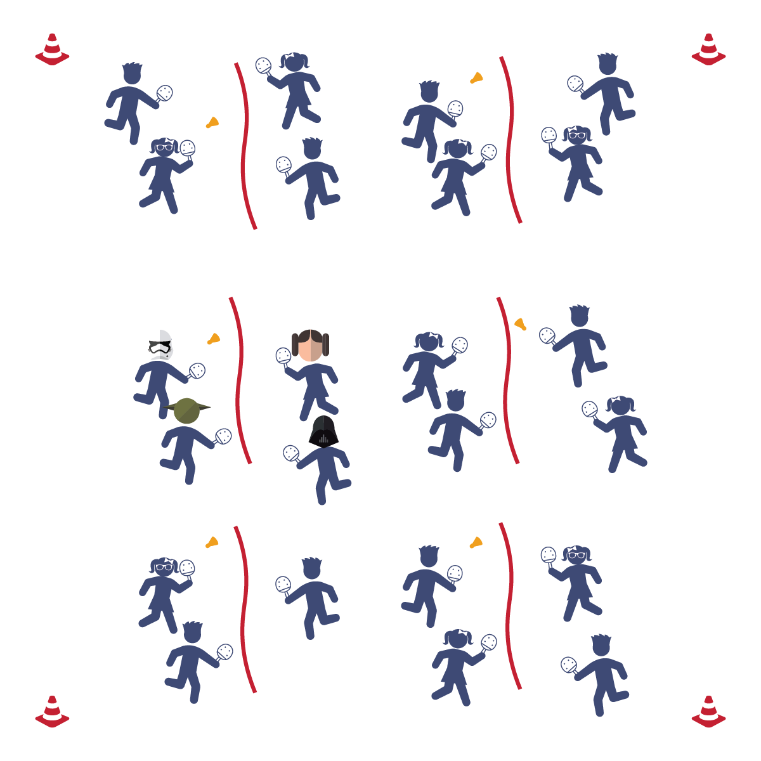

* **Skill:** I will score a point during game play.
* **Cognitive:** I will define the word “integrity.”
* **Fitness:** I will remain actively involved without reminders from the teacher.
* **Personal & Social Responsibility:** I will play with fairness and integrity to make the game fun for everyone.
* Play Fair
* Work as a Team
* Improve Your Skill

**Equipment:**

* 1 jump rope per 4 students
* 1 paddle per student
* 1 birdie per 4 students

**Set-Up:**

1. Set up the courts using jump ropes as “nets.”
2. Place 2 paddles on each side of every court and 1 birdie on each court.
3. Students in groups of 4 at each court.

**Activity Procedures:**

1. Today’s activity is called 2 v 2 Pickleminton. The object of the activity is to use the basic skills that we’ve practiced to volley the birdie against another set of 2 players and attempt to score.
2. Each player on a team will cover either the right or left side of the court, 1 player per side.
3. Group 1 starts off with the birdie and serves to Group 2. The students will volley back and forth until the birdie hits the floor or goes out of bounds.
4. Alternate the serve and server each time that a point has been scored.

**Grade Level Progression:**

**3rd-5th:** Play the activity as described above.

**2V2 PICKLEMINTON**



Etiquette, Integrity, Corrective Feedback, Conflict Resolution



* **Standard 1 [E6.4]:** Combines traveling with manipulative skill of striking in teacher- and/or student-designed small-sided practice tasks (4).
* **Standard 1 [E24.3-5]:** Strikes an object with a short-handled implement, sending it forward over a low net or to a wall (3a); Strikes an object with a short-handled implement while demonstrating three of the five critical elements of a mature pattern (3b); Strikes an object with a short-handled implement while demonstrating a mature pattern (4a); Strikes an object with a short-handled implement alternating hits with a partner over a low net or against a wall (4b); Strikes an object consecutively, with a partner, using a short-handled implement, over a net or against a wall, in either a competitive or cooperative game environment (5).
* **Standard 2 [E1.3-4]:** Recognizes the concept of open spaces in a movement context (3); Applies the concept of open spaces to combination skills involving traveling (4a).
* **Standard 2 [E3.3-5]:** Combines movement concepts (direction, levels, force, time) with skills as directed by the teacher (3); Applies the concepts of direction and force when striking an object with a short-handled implement, sending it toward a designated target (4b); Applies movement concepts to strategy in game situations (5a); Analyzes movement situations and applies movement concepts in small-sided practice task/game environments (5c).
* **Standard 2 [E5.5]:** Applies basic offensive and defensive strategies/tactics in net/wall small-sided practice tasks (5b); Recognizes the type of throw, volley, or striking action needed for different games/sports situations (5c).



* **DOK 1:** What is integrity?
* **DOK 2:** How is integrity applied in physical activity/competitive settings?
* **DOK 3:** How is integrity related to the enjoyment of everyone playing a game of Pickleminton?



**Help students engage in cognitively complex tasks:** See the strategy description for 1v1 Pickleminton—multiply it by 2 (at least) thanks to the cooperative requirements of 2v2.



* **Adaptation:** Allow students to serve a second or third time if they miss their first serve.
* **Extension:** Make the court bigger so the students have more court space to cover.