­­­

* Balance
* Etiquette
* Force
* Personal Responsibility

­

* **Standard 2 [E3.3-5]:** Applies the concepts of direction and force when striking an object with a short-handled implement, sending it toward a designated target (4); Analyzes movement situations and applies movement concepts in small-sided practice tasks (5).
* **Standard 4 [E5.3-5]** Works independently and safely in physical activity settings (3); Works safely with peers and equipment in physical activity settings (4); Applies safety principles with age-appropriate physical activities (5).
* **Skill:** I will catch the beanbag on my paddle after I toss it up in the air.
* **Cognitive:** I will recite the cues for gripping the paddle.
* **Fitness:** I will actively engage in physical education class without a reminder from the teacher.
* **Personal & Social Responsibility:** I will praise others for their success in their movement skills.
* Self-Assessment for Grip

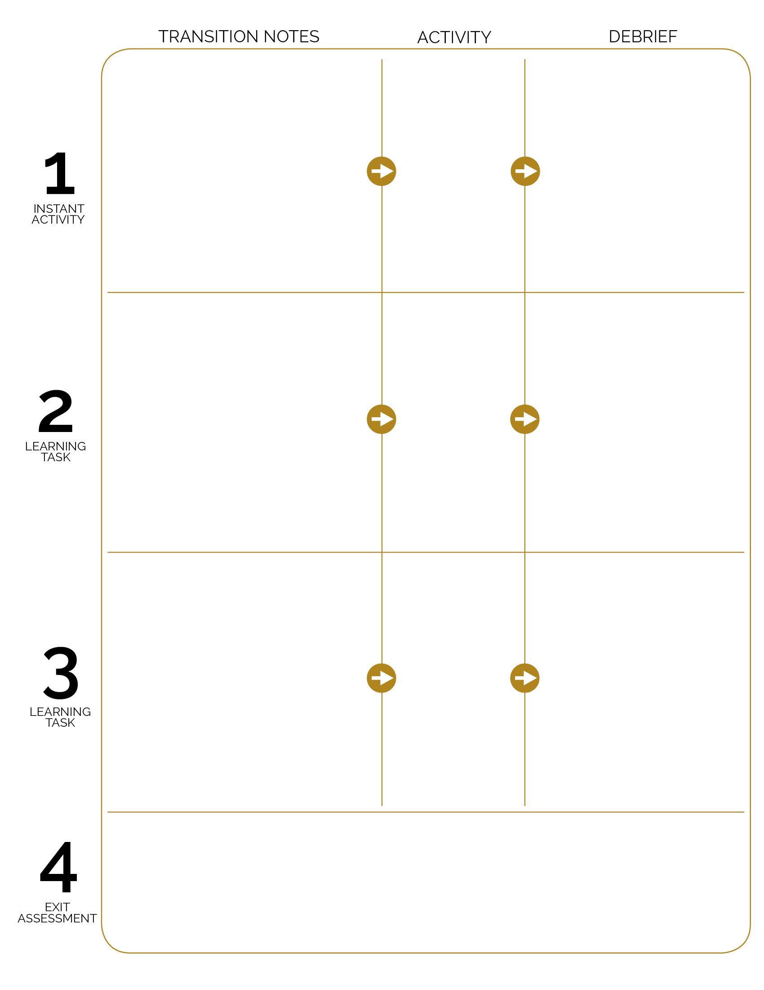

6 assessment stations are set up on the area perimeter. Students move to the area, collect a self-assessment and pencil and complete the pre-assessment for grip.

Flower Power Tag

Pancake Flipper

After Hello Paddle debrief, review grip cues and then transition right into Pancake Flipper with a focus on control.

Hello Paddle

**DOK 1:** There are seeds for flowers, are there any foods that have seed in them?

**DOK 2:** Why is it important to eat a variety of fruits and vegetables?

**DOK 1:** Can you remember the cues for gripping the paddle?

**DOK 2:** How does the grip affect your ability to keep the beanbag balanced?

**DOK 3:** How would you adapt this activity to make it more difficult? Make it easier?

**DOK 1:** What is force?

**DOK 2:** How did force affect your tossing and catching?

**DOK 3:** Can you predict how a birdie (or ball) would fly if you were to strike it with hard force? Soft force?

Students will enter the activity area and receive instruction for Flower Power Tag. Play at a speed walking pace and then increase speed when students demonstrate safe play.

Paddles and beanbags are spread out around the perimeter of the tag area. After Flower Power debrief, students transition to getting a paddle and then moving to find personal space.

Allow students to experiment with paddle grips, then cover the cues.