**HELLO PADDLE**

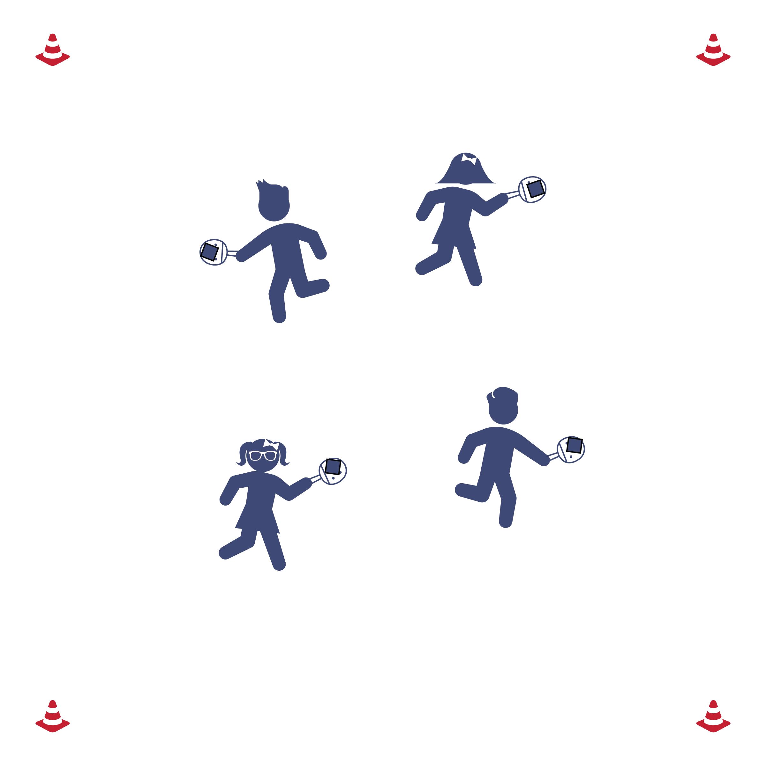

**Set-Up**

* Everyone has a paddle and bean bag.

**Equipment**

* 1 paddle per student
* 1 bean bag per student

**How to play**

1. Walking around the activity area while you balance the bean bag on the paddle.
2. Be careful that you don’t bump into anyone else so that everyone stays safe.
3. Try different locomotor skills (e.g., skipping, galloping, hopping).

**BIRDIE IN THE CAGE**

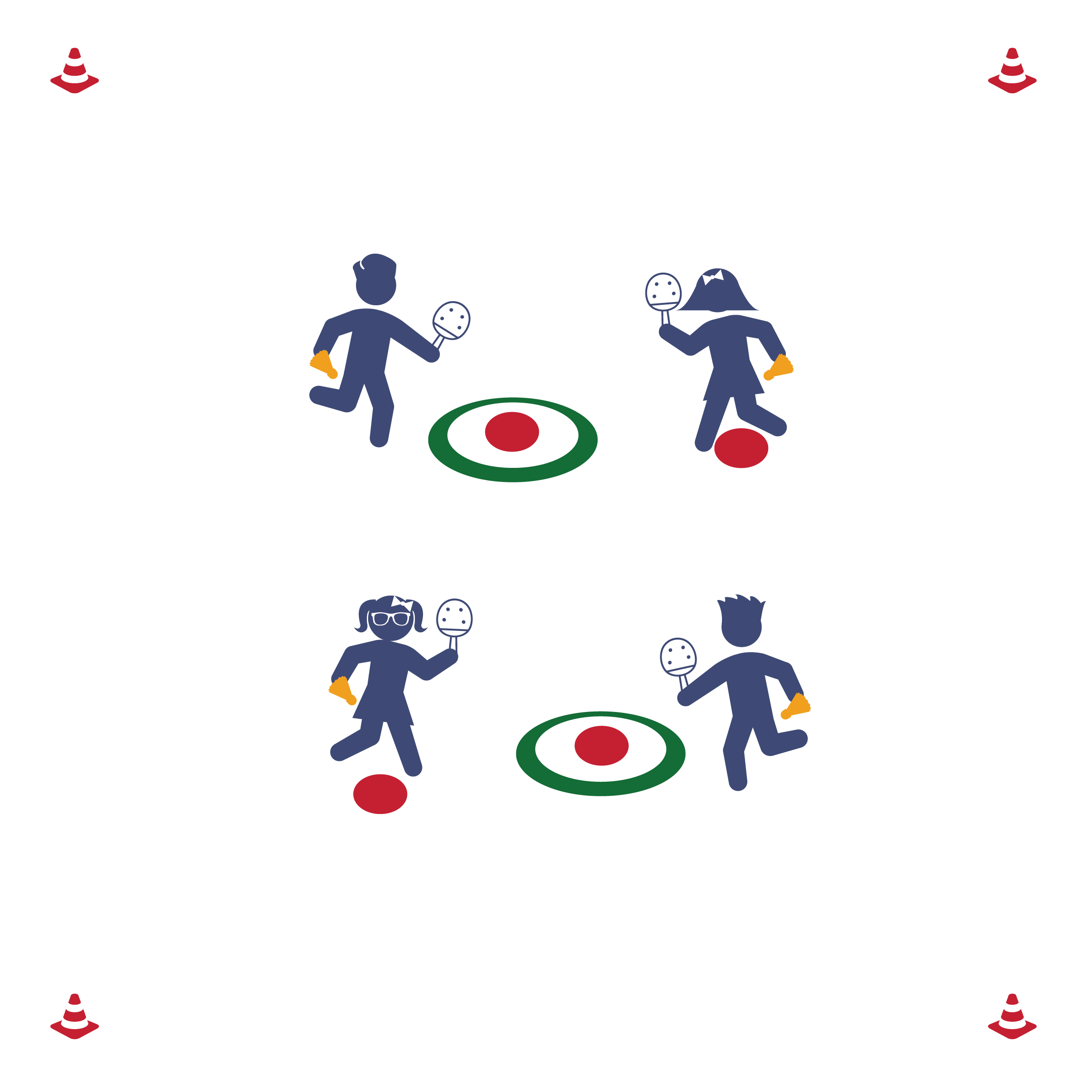

**Equipment**

* 1 Hula hoop and 2 poly spots per pair
* 1 paddle and 1 birdie per student

**Set-up**

* Place 1 poly spot in the center of each hoop and a poly spot 6-8 feet away from each hoop.

**How to play**

1. The first partner will stand on the poly spot and serve the birdie into the hoop. The other partner retrieves the birdies.
2. After 7 serves, switch roles.

**PANCAKE FLIPPER**

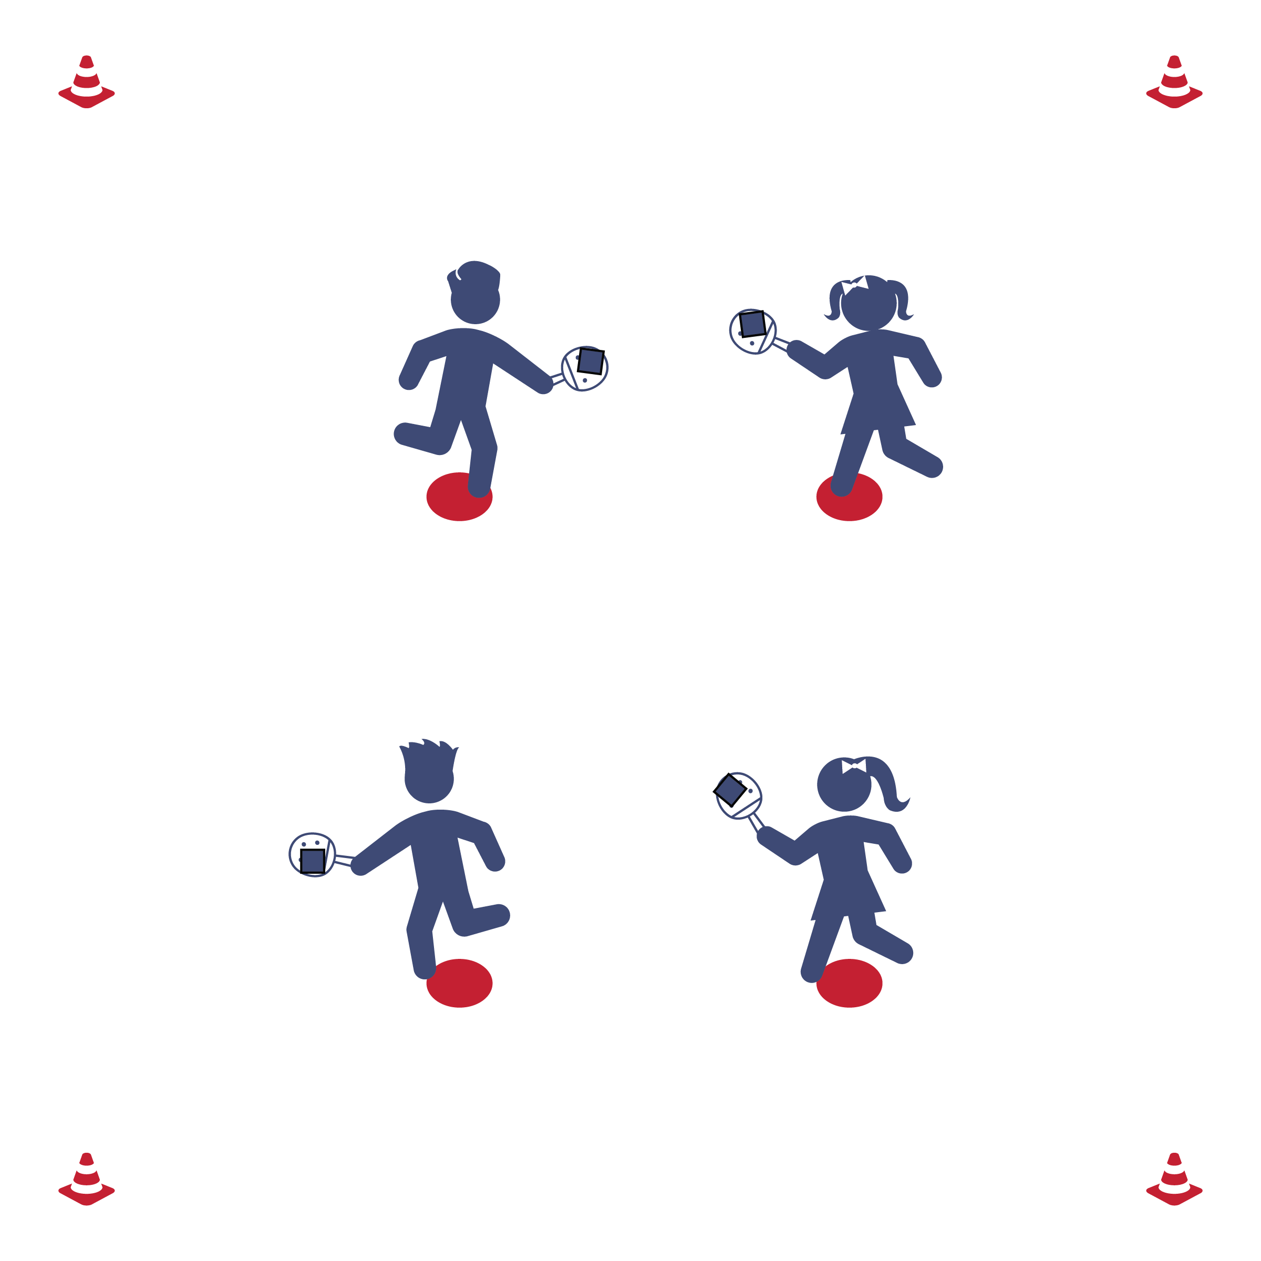

**Equipment**

* 1 paddle, 1 bean bag, and   
  1 poly spot per student

**Set-Up**

* Everyone is on a spot with a paddle and bean bag.

**How to play**

1. Flip the pancake (bean bag) in the air and try to get it to safely land back in its pan (on the paddle).
2. How many times can you safely land a pancake before the stop signal?

**SPLAT THE SPOT**

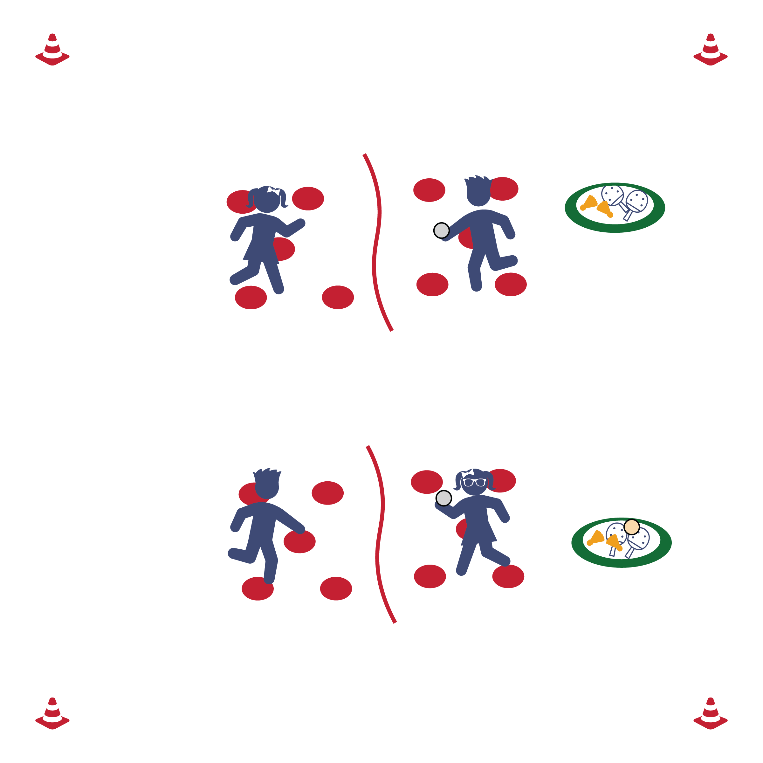

**Equipment**

* 1 rope, 10 poly spots, 2 paddles, and a hoop full of objects.

**Set-Up**

* Create courts using jump ropes as the “nets.” Scatter 5 poly spots on each side of every court.
* Each player with a paddle. Each pair with a hoop-full of objects to strike.

**How to play**

1. Partner 1 will pick an object from the pile to start with and then return to their poly spot.
2. Partner 1 will toss (or serve) the object to Partner 2. Toss (or strike) the objects back-and-forth while quickly moving from spot-to-spot.
3. After 5 tosses (or strikes) each, Partner 2 will choose a new object. Continue until the stop signal.

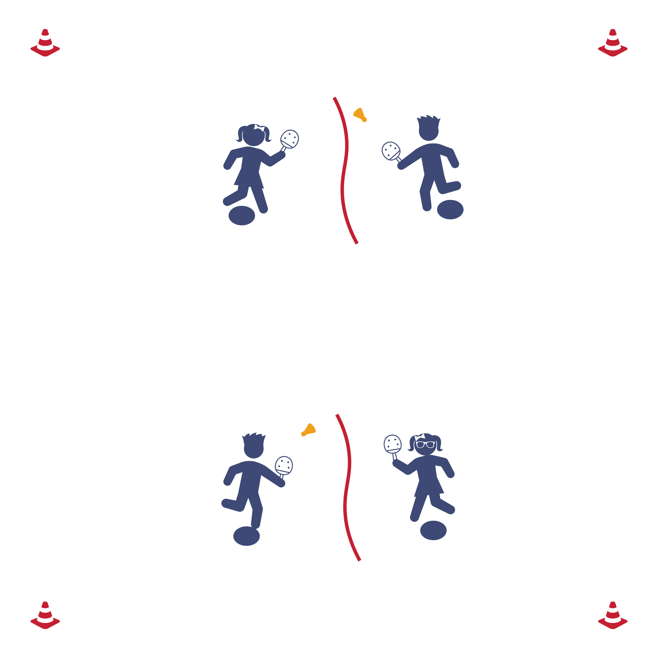

**Equipment**

* 1 rope, 2 spots, 2 paddles, and 1 birdie per pair.

**Set-Up**

* Create courts using jump ropes as the “nets.” One poly spot on each side of every court.
* Each player with a paddle. Each pair with a birdie.

**How to play**

1. Start on a spot.
2. Player 1 serves to player 2.
3. How many times can you and your partner work together to volley the birdie?

**RAPID FIRE VOLLEY**

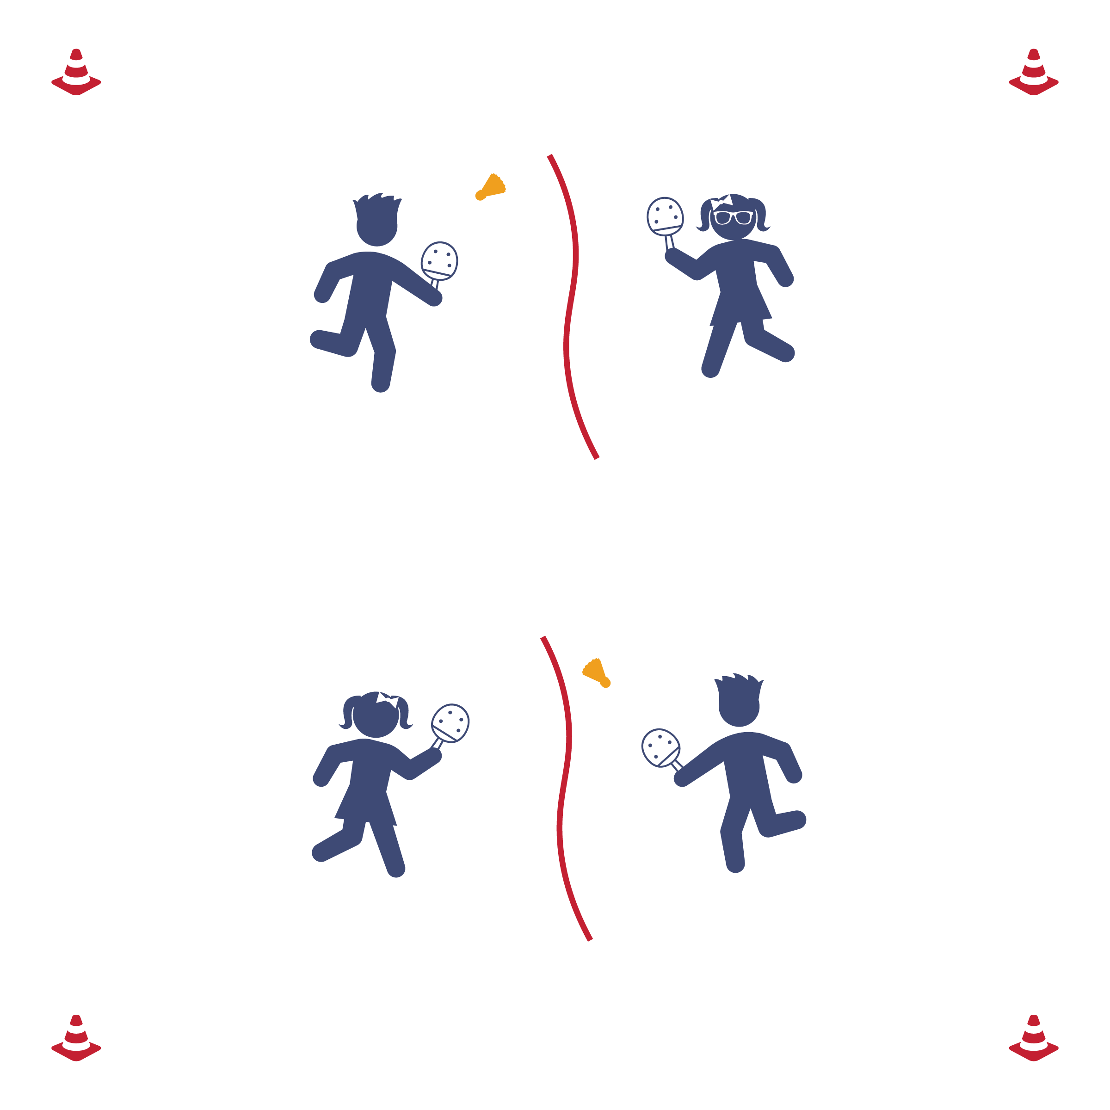

**Equipment**

* 1 rope, 2 paddles, and 1 birdie per pair.

**Set-up**

* Create courts using jump ropes as the “nets.”
* Each player with a paddle. Each pair with a birdie.

**How to play**

1. Play Rock, Paper, Scissors to see who serves first.
2. Play Pickleminton until you hear the stop signal.

**1 V 1 PICKLEMINTON**

**2 V 2 PICKLEMINTON**

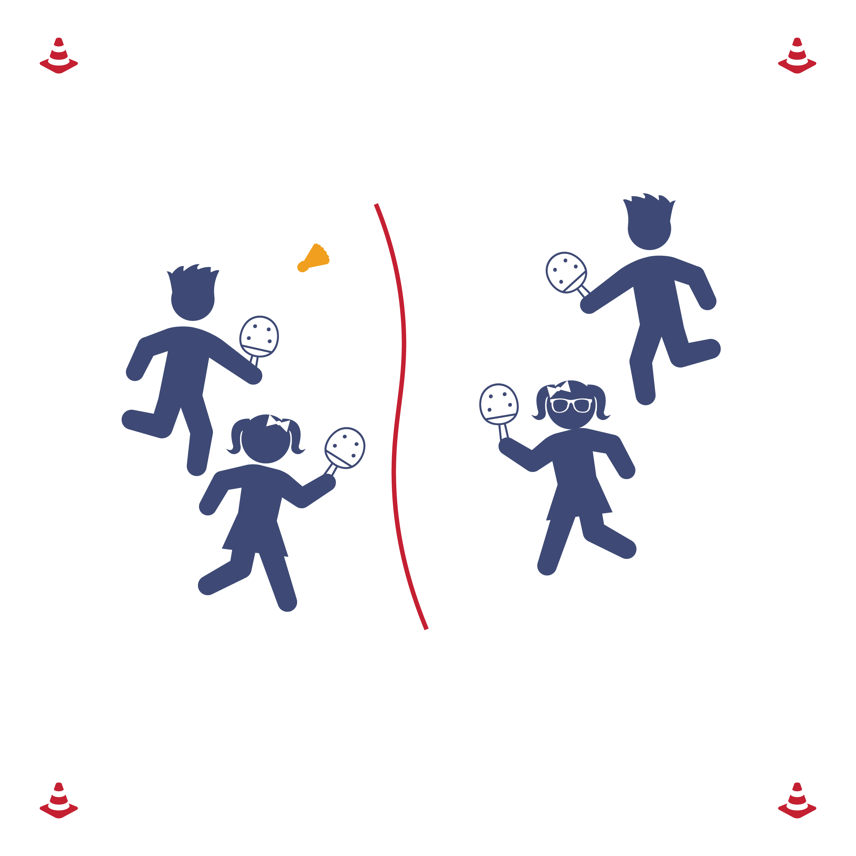

**Equipment**

* 1 rope, 4 paddles, and 1 birdie per group of 4.

**Set-up**

* Create courts using jump ropes as the “nets.”
* Each player with a paddle. Each group with a birdie.

**How to play**

1. Play Rock, Paper, Scissors to see who serves first.
2. Play Pickleminton until you hear the stop signal.



**SELF-ASSESSMENT**

1. Complete the Assessment for Pickleminton Skills.
2. When finished, perform the following exercise sequence until it’s time to rotate to the next station:
   1. 3 push-ups
   2. 11 calf-raises
   3. 33 jumping jacks