­­

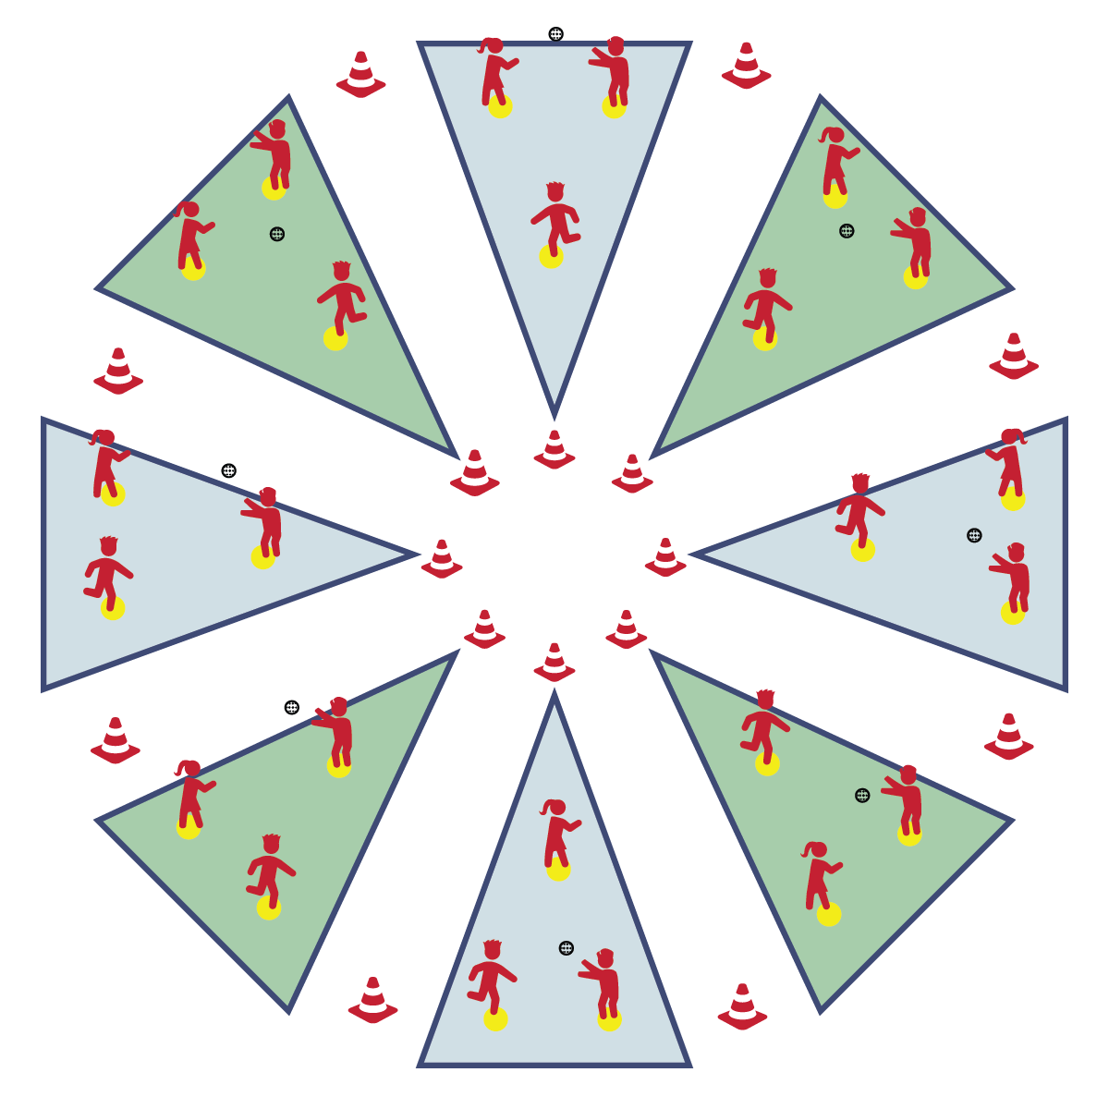

**Equipment:**

* 16 Cones
* 24 Spot Markers
* 8 Plastic Balls

**Set-Up:**

1. Set up Circle Sandlot Formation using cones and 3 spot markers per sandlot area.
2. Separate students into groups of 3, each group with a ball.
3. Send group of 3 to each Circle Sandlot area.

**CATCH ON THE SANDLOT**

* **Skill:** I will throw and catch using skill cues learned in class.
* **Cognitive:** I will discuss safety considerations related to playing catch.
* **Fitness:** I will stay physically active throughout the activity.
* **Personal & Social Responsibility:** I will participate safely and independently with my group members.
* Grip 2 Fingers on Top
* Stand Sideways, Non-Throwing Arm at Target
* Step to Target (Opposition)
* Throwing Arm Way Back
* Follow-Through with Wrist to Opposite Knee

**Activity Procedures:**

1. It’s time to start working in Circle Sandlot Formation with a game of catch. Circle Sandlot Formation is the organization system that we’ll be using for most of our Bat and Ball activities.
2. At each sandlot area there are 3 spot markers set up in a triangle. Each member of your group will move to a spot marker. The player with the ball starts the game by throwing the ball to the player on their left. Throw and catch around your triangle until you hear the stop signal.
3. Now that we understand this formation, we’re going to add some challenges.
4. Ground balls: Player 1 rolls the ball to Player 2, who fields it and throws to Player 3. Player 3 rolls to Player 1, who fields it and throws to Player 2. Continue this pattern until you hear the stop signal.
5. Fly balls: Player 1 tosses a high “pop-fly” to Player 2, who catches it and throws a good overhand throw to Player 3. Player 3 tosses a “pop-fly” to Player 1, who catches it and throws a good overhand throw to Player 2. Continue this pattern until you hear the stop signal.

**Grade Level Progression:**

**3rd:** Focus on throwing and catching with accuracy.

**4th:** Add challenges as described above.

**5th:** Allow students to create their own challenges.

**CATCH ON THE SANDLOT**



Accuracy, Catch, Coordination, Fielding, Follow-Through, Independently, Overhand, Throw



* **Standard** **[E14.3-5b]** Throws overarm, demonstrating three of the five critical elements of a mature pattern, in non-dynamic environments, for distance and/or force (3); Throws overarm using a mature pattern in non-dynamic environments (4a); Throws overarm to a partner or at a target with accuracy at a reasonable distance (4b); Throws (overarm) using a mature pattern in non-dynamic environments, with different sizes and types of objects (5a); Throws (overarm) to a large target with accuracy (5b).
* **Standard 1 [E16.3-5]** Catches a gently tossed hand-sized ball from a partner, demonstrating four of the five critical elements of a mature pattern (3); Catches a thrown ball above the head, at chest/waist level, and below the waist using a mature pattern in a non-dynamic environment (4); Catches a batted ball above the head, at chest/waist level, and along the ground using a mature pattern in a non-dynamic environment (5a); Catches with accuracy, both partners moving (5b); Catches with reasonable accuracy in dynamic, small-sided practice tasks (5c).
* **Standard 4 [E6.3-5]** Works independently and safely in physical activity settings (3); Works safely with peers and equipment in physical activity settings (4); Applies safety principles with age-appropriate physical activities (5).



* **DOK 1:** How can you recognize a safe game of catch?
* **DOK 2:** How would you compare and contrast a safe game with a game that is unsafe?
* **DOK 3:** How is safety related to your ability to learn skills like throwing and catching?



**Identify critical content:** A simple game of catch provides students with explicit opportunities for learning and practicing the skill cues for throwing and catching. Take time to teach, review, and then revisit the cues over and over in order to help students understanding the cues cognitively and feel improvement and success from a motor-learning perspective.



* Change the distance between players to match skill levels.
* Use a variety of different balls, allowing students to select the ball they are most comfortable catching.