­­

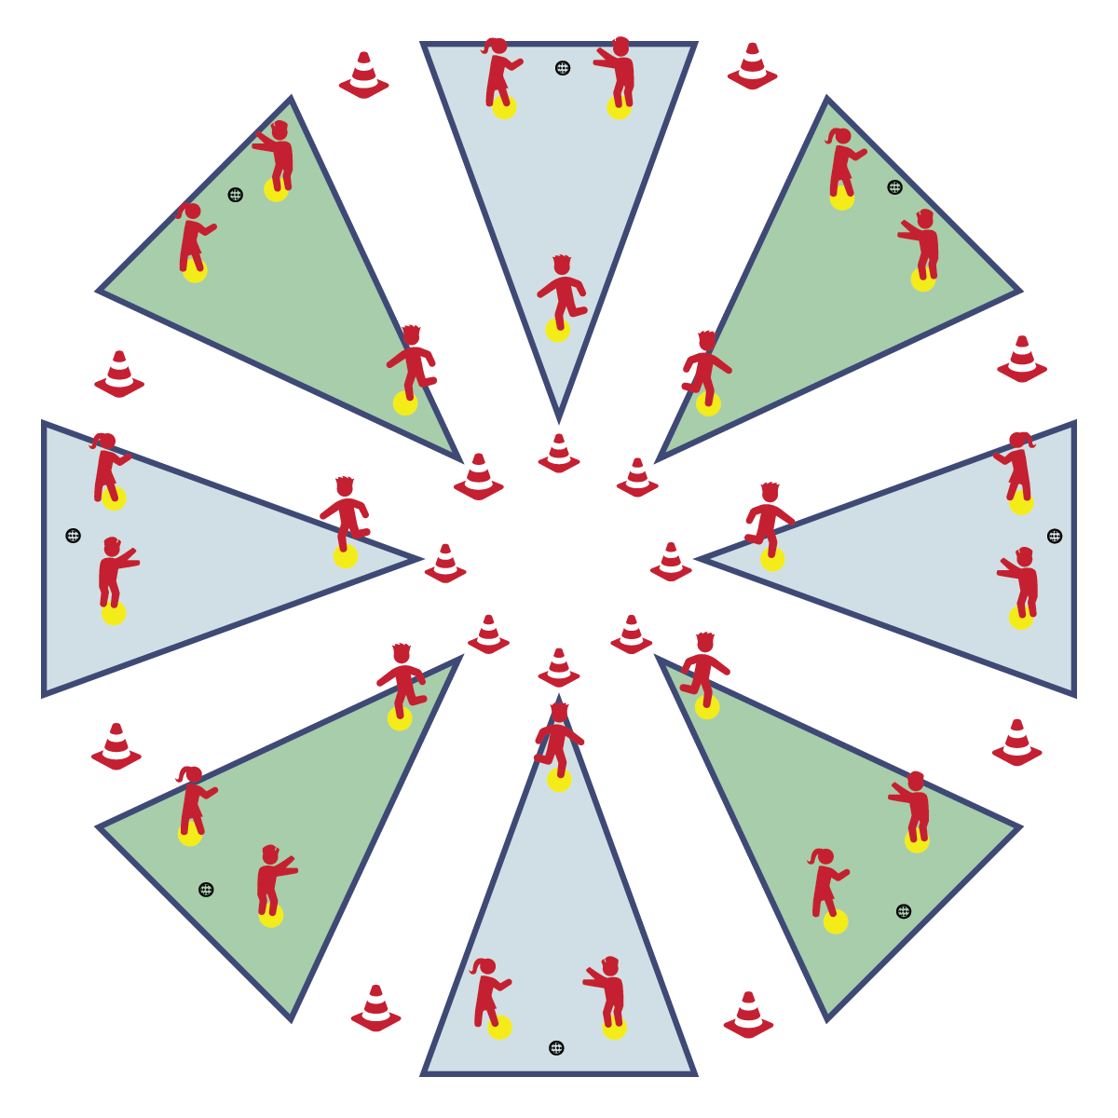

**THROW-RUN DERBY**

* **Skill:** I will use throwing skills cues to throw for distance.
* **Cognitive:** I will discuss the importance of athletic stance when fielding.
* **Fitness:** I will remain actively engaged in this activity.
* **Personal & Social Responsibility:** I will practice safe behaviors in all positions played during this activity.
* Grip 2 Fingers on Top
* Stand Sideways, Non-Throwing Arm at Target
* Step to Target (Opposition)
* Throwing Arm Way Back
* Follow-Through with Wrist to Opposite Knee

**Equipment:**

* 16 Cones
* 24 Spot Markers
* 8 Plastic Balls

**Set-Up:**

1. Set up Circle Sandlot Formation using cones and 3 spot markers per sandlot area.
2. 2 spot markers are fence spots, 1 is a home base spot.
3. Separate students into groups of 3, each group with a ball.
4. Send group of 3 to each Circle Sandlot area.

**Activity Procedures:**

1. Now it’s time for a little Throw-Run Derby. Player 1 is the batter. Players 2 and 3 are outfielders. The object of the game is for the batter to score as many Throw-Runs as possible by landing a ball beyond the fence spots without it being caught by an outfielder. Outfielders will try to catch each throw before the ball hits the ground.
2. After Player 1 takes 3 throws as the batter, rotate so that Player 2 becomes the new batter and Players 1 and 3 are outfielders. On the next rotation, Player 3 becomes the batter. Continue this pattern until you hear the stop signal. Keep track of how many Throw-Runs you score.

**Grade Level Progression:**

**3rd:** Allow throws beyond the fence cones to count as Throw-Runs, even if they are caught.

**4th:** Play the activity as described above.

**5th:** Increase the distance between the batter and the fence cones.

**THROW-RUN DERBY**



Athletic Stance, Fielding, Follow-Through, Overhand, Power, Safety, Throw



* **Standard** **[E1.4-5b]** Uses various locomotor skills in a variety of small-sided practice tasks, dance, and educational gymnastics experiences (4); Demonstrates mature patterns of locomotor skills in dynamic small-sided practice tasks, gymnastics, and dance (5a); Combines locomotor and manipulative skills in a variety of small-sided practice tasks/games environments (5b).
* **Standard 1 [E13.3,5a&b]** Throws underhand to a partner or target with reasonable accuracy (3); Throws (underhand) using a mature pattern in non-dynamic environments, with different sizes and types of objects (5a); Throws (underhand) to a large target with accuracy (5b).
* **Standard 1 [E14.3-5b]** Throws overarm, demonstrating three of the five critical elements of a mature pattern, in non-dynamic environments, for distance and/or force (3); Throws overarm using a mature pattern in non-dynamic environments (4a); Throws overarm to a partner or at a target with accuracy at a reasonable distance (4b); Throws (overarm) using a mature pattern in non-dynamic environments, with different sizes and types of objects (5a); Throws (overarm) to a large target with accuracy (5b).
* **Standard 1 [E16.3-5]** Catches a gently tossed hand-sized ball from a partner, demonstrating four of the five critical elements of a mature pattern (3); Catches a thrown ball above the head, at chest/waist level, and below the waist using a mature pattern in a non-dynamic environment (4); Catches a batted ball above the head, at chest/waist level, and along the ground using a mature pattern in a non-dynamic environment (5a); Catches with accuracy, both partners moving (5b); Catches with reasonable accuracy in dynamic, small-sided practice tasks (5c).



* **DOK 1:** What is athletic stance?
* **DOK 2:** What do you know about athletic stance?
* **DOK 3:** How is athletic stance related to fielding a ball?



**Help students practice skills, strategies, and processes:** Throw-Run Derby is an instructional practice task designed to help teach the directional nature of the sandlot management set-up, as well as the basic rules for the Home-Run Derby. This activity allows students to learn basic safety considerations before adding in the additional safety requirements of using a bat.



* Modify the rules to increase the level of success. For example, any ball thrown in fair territory counts as a Throw-Run.