­­

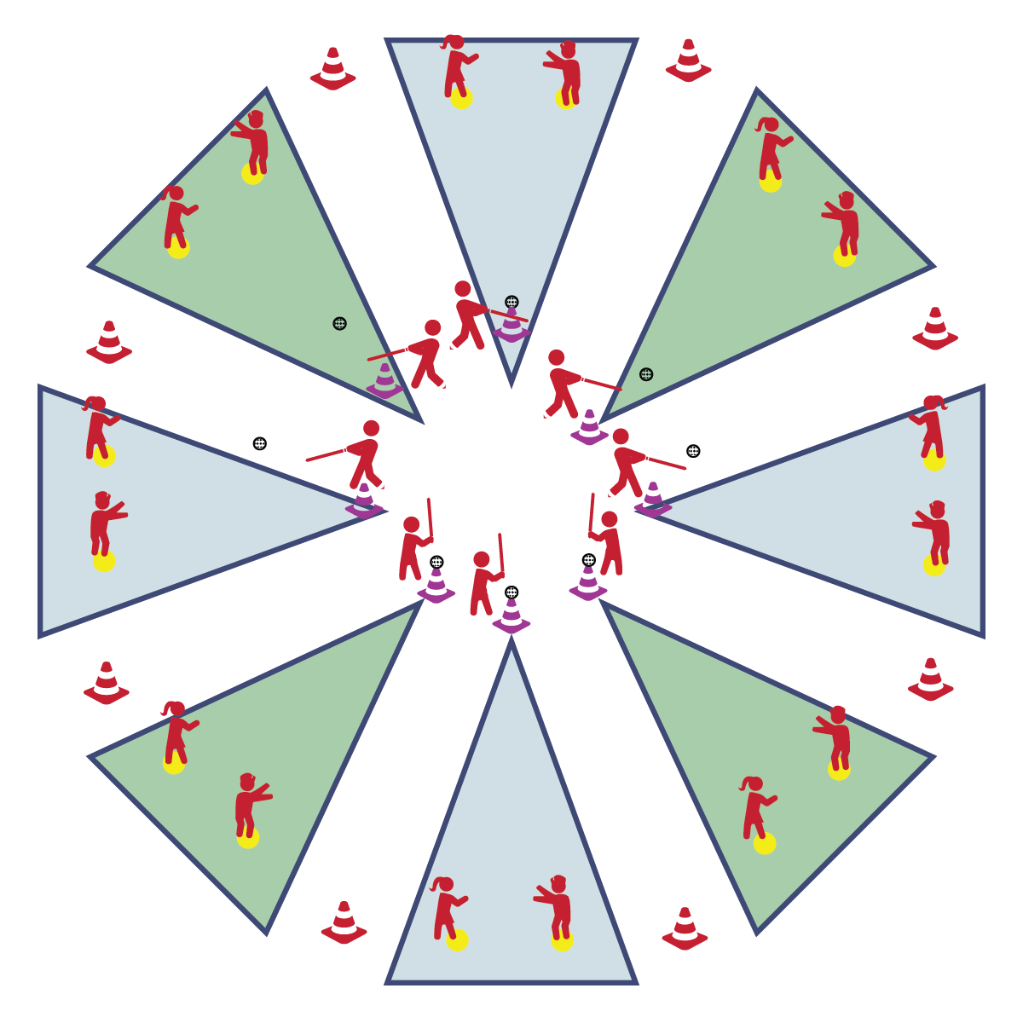

**HOME-RUN DERBY**

* **Skill:** I will use cues for striking while batting the ball.
* **Cognitive:** I will discuss ways to demonstrate responsibility when using a bat.
* **Fitness:** I will remain actively engaged in this activity.
* **Personal & Social Responsibility:** I will use all equipment in a safe and appropriate manner.
* Everyone 25’ from Batter
* Athletic Stance
* Grip Together, Line of Knuckles
* Bat Up, Grip at Armpit
* See Ball from Start to Finish
* Rotate Hips; Drive Body Through the Ball

**Equipment:**

* 8 Cones
* 8 Spot Markers
* 8 Plastic Balls
* 8 Bats
* 8 Tees (or cones)

**Set-Up:**

1. Set up Circle Sandlot Formation using one bat, one cone, one tee and one spot marker.
2. Students will be separated into groups of 3, each group with a ball.
3. Send group of 3 to each Circle Sandlot area.

**Activity Procedures:**

1. Let’s take it to the next level with a Home-Run Derby. Player 1 is the batter. Players 2 and 3 are outfielders. The object of the game is for the batter to score as many Home Runs as possible by hitting the ball off the cone (tee) and landing it beyond the fence cones without being caught by an outfielder. Outfielders will try to catch each hit before the ball touches the ground.
2. After Player 1 hits 3 balls as the batter, rotate so that Player 2 becomes the new batter and Players 1 and 3 are outfielders. On the next rotation, Player 3 becomes the batter. Continue this pattern until you hear the stop signal. Keep track of how many Home Runs you score.

**Grade Level Progression:**

**3rd:** Students hit exclusively off a cone/tee.

**4th- 5th:** Allow students to attempt to hit 3 pitched balls before hitting off of the tee.

**HOME-RUN DERBY**



Athletic Stance, Balance, Critical Elements, Coordination, Fielding, Responsibility, Safety, Strike



* **Standard** **1 [E16.3-5]** Catches a gently tossed hand-sized ball from a partner, demonstrating four of the five critical elements of a mature pattern (3); Catches a thrown ball above the head, at chest/waist level, and below the waist using a mature pattern in a non-dynamic environment (4); Catches a batted ball above the head, at chest/waist level, and along the ground using a mature pattern in a non-dynamic environment (5a); Catches with accuracy, both partners moving (5b); Catches with reasonable accuracy in dynamic, small-sided practice tasks (5c).
* **Standard 1 [E25.3-5b]** Strikes a ball with a long-handled implement, sending it forward, while using proper grip for the implement (e.g., hockey stick, bat, golf club). Note: Use batting tee or ball tossed by teacher for batting (3); Strikes an object with a long-handled implement (e.g., hockey stick, golf club, bat, tennis/badminton racket), while demonstrating three of the five critical elements of a mature pattern for the implement (grip, stance, body orientation, swing plane, and follow-through) (4); Strikes a pitched ball with a bat using a mature pattern (5a); Combines striking with a long implement with receiving and traveling skills in a small-sided game (5b).
* **Standard 2 [E5.5c]** Recognizes the type of throw, volley, or striking action needed for different games/sports situations (5c).



* **DOK 1:** What would you include on a list about playing a game with a bat?
* **DOK 2:** How does responsibility apply to using a bat?
* **DOK 3:** What facts would you choose to support an assertion that someone demonstrated responsibility during bat and ball games? Can you elaborate on why you chose those facts?



**Identify critical content:** Safely and effectively striking a ball with a bat is foundational to participation in any bat and ball game. Home-Run Derby allows both teachers and students to focus on this critical content in a fun, small-sided game designed to provide low-pressure repetitions for both batting and fielding.



* Provide bat of different sizes, shapes, and weights. Large barrel bats, or those with flat striking surfaces can increase the rate of success.