­­



**BASEBALL TAG**

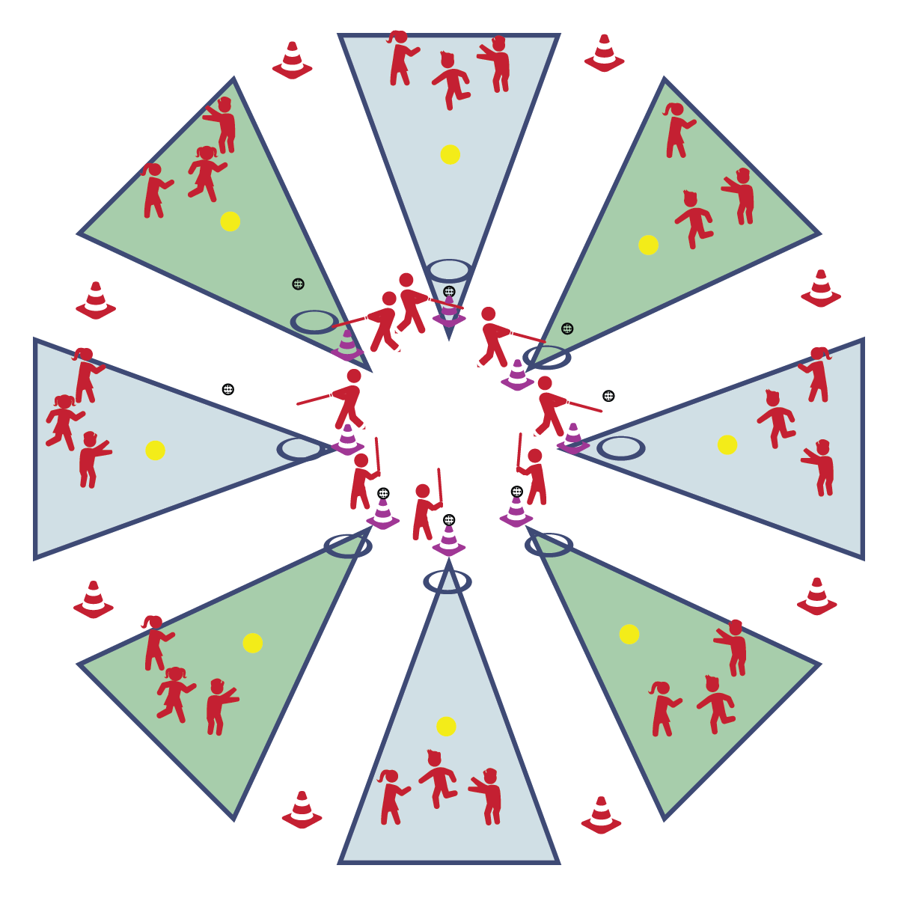

* **Skill:** I will safely transition from batting to running.
* **Cognitive:** I will discuss the components of fitness that are related to bat and ball games.
* **Fitness:** I will remain actively engaged in this activity.
* **Personal & Social Responsibility:** I will demonstrate responsible behaviors throughout this activity.
* Grip the Bat
* Hit the Ball
* Drop Bat in Hoop

**Equipment:**

* 1 Spot Marker
* 1 Plastic Ball
* 1 Bat
* 1 Tee (or cone)

**Set-Up:**

1. Set up 1 spot marker at the center of the playing space.
2. Place 1 plastic ball, 1 bat, and 1 tee at the front of the area.
3. Place a hoop just in front of the tee (cone) as the batter’s hoop.
4. 1 student will bat first.
5. The rest of the students will spread out in open space and act as the fielders.

**Activity Procedures:**

1. It’s time to increase our aerobic benefits with a game of Baseball Tag. The object of the game is for the batter to tag as many players as she/he can before the fielders make an out.
2. On the start signal the batter will hit the ball off of the cone (tee). As soon as the ball is hit, the batter will place the bat in the batter’s hoop and begin chasing fielders. For each fielder that is tagged, a run is scored.
3. While the batter is tagging fielders, the fielders are working to make an out. This is done by getting the ball and making good relay throws to the pitcher’s mound (spot marker). Fielders may not run with the ball. It must be thrown from player to player until it is cleanly caught on the mound. If tagged, fielders with the ball are worth 2 runs.

**Grade Level Progression:**

**3rd:** Provide a hoop in which students must place the bat after hitting and before moving to tag fielders.

**4th- 5th:** Allow students to attempt to hit 3 pitched balls before hitting off of the tee.

**BASEBALL TAG**



Fitness, Health-Related Fitness, Personal Responsibility, Skill-Related Fitness



* **Standard 1 [E25.3-5b]** Strikes a ball with a long-handled implement, sending it forward, while using proper grip for the implement (e.g., hockey stick, bat, golf club). Note: Use batting tee or ball tossed by teacher for batting (3); Strikes an object with a long-handled implement (e.g., hockey stick, golf club, bat, tennis/badminton racket), while demonstrating three of the five critical elements of a mature pattern for the implement (grip, stance, body orientation, swing plane, and follow-through) (4); Strikes a pitched ball with a bat using a mature pattern (5a); Combines striking with a long implement with receiving and traveling skills in a small-sided game (5b).
* **Standard 2 [E3.3&5a-c]** Combines movement concepts (direction, levels, force, time) with skills as directed by the teacher (3); Applies movement concepts to strategy in game situations (5a); Applies the concepts of direction and force to strike an object with a long-handled implement (5b); Analyzes movement situations and applies movement concepts (e.g., force, direction, speed, pathways, extensions) in small-sided practice task/game environments, dance and gymnastics (5c).
* **Standard 4 [E1.3-5]** Exhibits personal responsibility in teacher-directed activities (3); Exhibits responsible behavior in independent group situations (4); Engages in physical activity with responsible interpersonal behavior (e.g., peer to peer, student to teacher, student to referee) (5).



* **DOK 1:** What is health-related fitness? What is skill-related fitness?
* **DOK 1:** Which ones would we include on a list of fitness components related to bat and ball games?
* **DOK 2:** What do you know about the skills and activities required for participation in bat and ball games?
* **DOK 3:** Choose a component and describe how that component relates to bat and ball games.



**Help students process content:** The concept of moving the ball quickly around the ball field with accurate throws is an essential part of defensive play in most bat and ball games. However, it’s not necessarily an intuitive concept for young students. Baseball tag creates an environment to help students process and practice this concept.



* Allow fielders to run with the ball to the pitcher’s mound.
* Add tag-teamers to help the batter successful tag fielders.