­­



**BRANNBOLL**

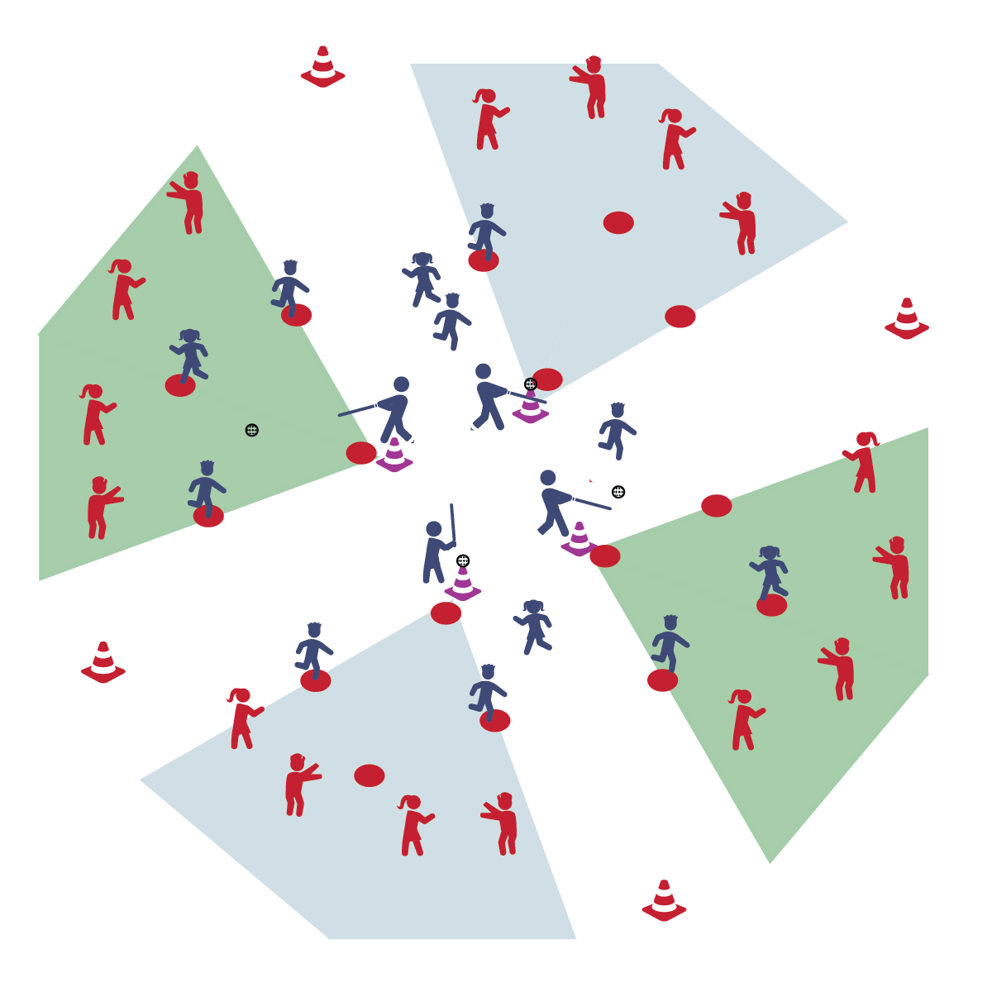

* **Skill:** I will safely transition from batting to running.
* **Cognitive:** I will discuss the skill cues for throwing, catching, and batting.
* **Fitness:** I will remain actively engaged in the activity.
* **Personal & Social Responsibility:** I will demonstrate responsible behaviors while working with my classmates.
* Everyone 25’ from Batter
* Athletic Stance
* Grip Together, Line of Knuckles
* Bat Up, Grip at Armpit
* See Ball from Start to Finish
* Rotate Hips; Drive Body Through the Ball

**Equipment:**

* 5 Spot Markers
* 1 Plastic Ball
* 1 Tee (or cone)

**Set-Up:**

1. Set up 5 spot markers in a diamond shape, 1 for each base (1st, 2nd, 3rd, home)
2. Class will be split into even teams of at least 4 players: batters and fielders.
3. Batters will wait to bat first and fielders will scatter in open space throughout the playing area.

**Activity Procedures:**

1. It’s time to play modified Brannboll (bren:bul). This is a Swedish tee-ball game played by children and adults. The object for the batting team is to score points by reaching a base successfully and trying to work around the bases, back to home base. Each base is worth 1 point.
2. The object for the fielding team is catch base-runners in between bases by fielding, throwing, and catching the ball on the Outing Base (hoop). The fielding team scores a point for each base-runner caught in between bases. If caught, base-runners go back to the last base they touched. There is no limit to the number of base-runners per base.
3. If the batting team fails to bring a base-runner back to home base to hit (all players are stuck on bases), then the team is “caught out” and teams switch (i.e., fielders to batters, batters to the field). Teachers may also choose to switch sides after the batting team scores 10 runs.
4. Batters have 3 swings to hit a ball into fair territory and past the Outing Base. If a batter fails to hit a fair ball, he/she moves to first base as a new base-runner (no point awarded and no other runners advance).
5. Play continues for a set period of time. When time expires, the game is over.

**Grade Level Progression:**

**3rd:** Students hit exclusively off a cone/tee.

**4th- 5th:** Allow students to attempt to hit 3 self-tossed balls before hitting off of the tee.

**5th:** Allow students to attempt to hit 3 pitched, or self-tossed balls before hitting off of the tee.

**BRANNBOLL**



Fielding, Mature Skill Pattern, Participation, Safety, Strike, Throw



* **Standard** **1 [E14.3-5b]** Throws overarm, demonstrating three of the five critical elements of a mature pattern, in non-dynamic environments, for distance and/or force (3); Throws overarm using a mature pattern in non-dynamic environments (4a); Throws overarm to a partner or at a target with accuracy at a reasonable distance (4b); Throws (overarm) using a mature pattern in non-dynamic environments, with different sizes and types of objects (5a); Throws (overarm) to a large target with accuracy (5b).
* **Standard 1 [E25.3-5b]** Strikes a ball with a long-handled implement, sending it forward, while using proper grip for the implement (e.g., hockey stick, bat, golf club). Note: Use batting tee or ball tossed by teacher for batting (3); Strikes an object with a long-handled implement (e.g., hockey stick, golf club, bat, tennis/badminton racket), while demonstrating three of the five critical elements of a mature pattern for the implement (grip, stance, body orientation, swing plane, and follow-through) (4); Strikes a pitched ball with a bat using a mature pattern (5a); Combines striking with a long implement with receiving and traveling skills in a small-sided game (5b).
* **Standard 1 [E26.4]** Combines traveling with the manipulative skills of dribbling, throwing, catching, and striking in teacher- and/or student-designed small-sided practice task environments (4).
* **Standard 2 [E3.3&5a-c]** Combines movement concepts (direction, levels, force, time) with skills as directed by the teacher (3); Applies movement concepts to strategy in game situations (5a); Applies the concepts of direction and force to strike an object with a long-handled implement (5b); Analyzes movement situations and applies movement concepts (e.g., force, direction, speed, pathways, extensions) in small-sided practice task/game environments, dance and gymnastics (5c).
* **Standard 4 [E1.3-5]** Exhibits personal responsibility in teacher-directed activities (3); Exhibits responsible behavior in independent group situations (4); Engages in physical activity with responsible interpersonal behavior (e.g., peer to peer, student to teacher, student to referee) (5).



* **DOK 1:** Can you remember the skill cues for each of the skills that we’ve used in bat and ball activities?
* **DOK 2:** From the start of this module until today, what have you noticed about your ability to perform the skills using the cues correctly?
* **DOK 3:** How is practice related to your improvements? Can you support your answer with examples from this module?



**Review content:** Brannboll is a great game for bringing together all of the skills and concepts taught cumulatively throughout the module. Take time to review the skill cues and concepts before starting the activity, and find teachable moments within the game to highlight, reinforce, or correct aspects of student performances.



* Use larger-sized bats and/or balls.
* Use larger bases, either closer or farther apart.