­­

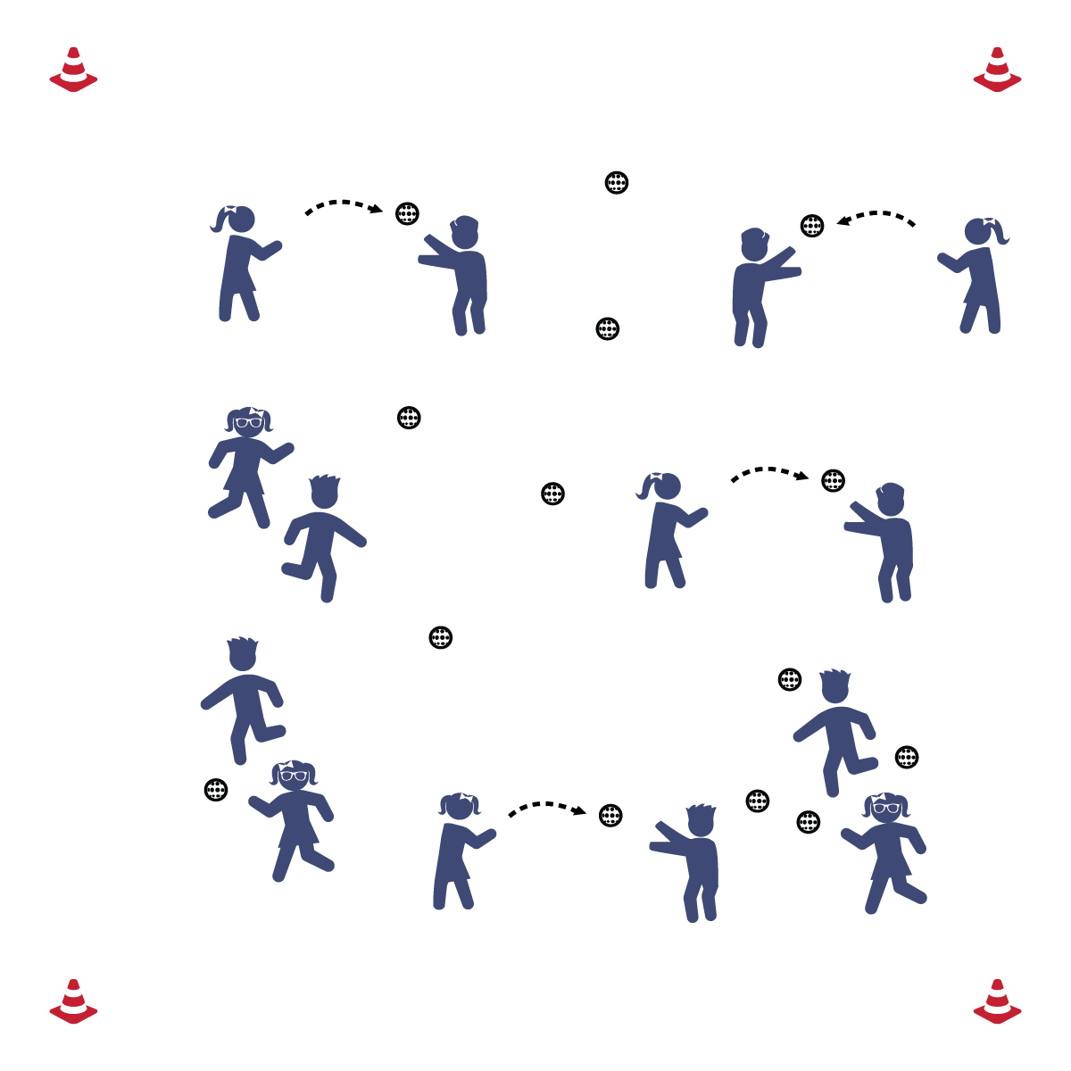

**TWO BALL TOSSERS**

* Eyes on the Ball
* Hands a Target
* Thumbs Together  
  (Chest or Above)
* Pinkies Together  
  (Below the Chest)
* Two Hands Absorb the Ball

**Equipment:**

* 1 ball per 2 students

**Set-Up:**

1. Balls will be scattered around the gym.
2. Pair students; each pair with a ball.

* **Skill:** I will accurately throw the ball to my partner.
* **Cognitive:** I will recite the cues for catching a ball at different heights.
* **Fitness:** I will stay physically active throughout the activity.
* **Personal & Social Responsibility:** I will work cooperatively with my partner to make good throws and catches.

**Activity Procedures:**

1. Today we’re going to work on our throwing and catching skills with a game called Two Ball Tossers. The object of the game is for you and your partner to accurately throw and catch as many plastic softballs as you can before the time is up.
2. On the start signal you’ll move to a ball, pick it up and make a good throw to your partner. Your partner will then throw the ball back to you, and you’ll put it back on the ground while your partner moves to a new ball.
3. Your partner will then pick up the new ball and make a good throw to you. You’ll throw back to your partner and then move to a new ball. Continue until you hear the stop signal.

**Grade Level Progression:**

**3rd:** Focus on underhand throwing.

**4th:** Review underhand throwing and move to overhand throws.

**5th:** Prompt students to remain moving while throwing and catching. They must pick the ball up, move during both throws and catches, and then place the ball in a new part of the activity area.

**TWO BALL TOSSERS**



* Use a variety of different balls, allowing students to select the ball they are most comfortable catching.



* **Standard** **[E1.4-5b]** Uses various locomotor skills in a variety of small-sided practice tasks, dance, and educational gymnastics experiences (4); Demonstrates mature patterns of locomotor skills in dynamic small-sided practice tasks, gymnastics, and dance (5a); Combines locomotor and manipulative skills in a variety of small-sided practice tasks/games environments (5b).
* **Standard 1 [E13.3,5a&b]** Throws underhand to a partner or target with reasonable accuracy (3); Throws (underhand) using a mature pattern in non-dynamic environments, with different sizes and types of objects (5a); Throws (underhand) to a large target with accuracy (5b).
* **Standard 1 [E14.3-5b]** Throws overarm, demonstrating three of the five critical elements of a mature pattern, in non-dynamic environments, for distance and/or force (3); Throws overarm using a mature pattern in non-dynamic environments (4a); Throws overarm to a partner or at a target with accuracy at a reasonable distance (4b); Throws (overarm) using a mature pattern in non-dynamic environments, with different sizes and types of objects (5a); Throws (overarm) to a large target with accuracy (5b).
* **Standard 1 [E16.3-5]** Catches a gently tossed hand-sized ball from a partner, demonstrating four of the five critical elements of a mature pattern (3); Catches a thrown ball above the head, at chest/waist level, and below the waist using a mature pattern in a non-dynamic environment (4); Catches a batted ball above the head, at chest/waist level, and along the ground using a mature pattern in a non-dynamic environment (5a); Catches with accuracy, both partners moving (5b); Catches with reasonable accuracy in dynamic, small-sided practice tasks (5c).



* **DOK 1:** Can you remember the cues for throwing (underhand/overhand)? How about catching?
* **DOK 2:** How does where you catch the ball (high/low) affect how you catch it?
* **DOK 3:** How is throwing related to sports like softball and baseball? How is catching related?

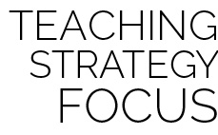

**Organize students to interact with content:** The game of Two Ball Tossers is designed to provide a large number of touches for each student. In other words, the pace and organization of this game provides many opportunities for each student to both throw and catch a ball. At the same time, students are required to demonstrate cooperation and personal responsibility.



Accuracy, Actively Engage, Catch, Manipulative Skill, Overhand, Throw, Underhand

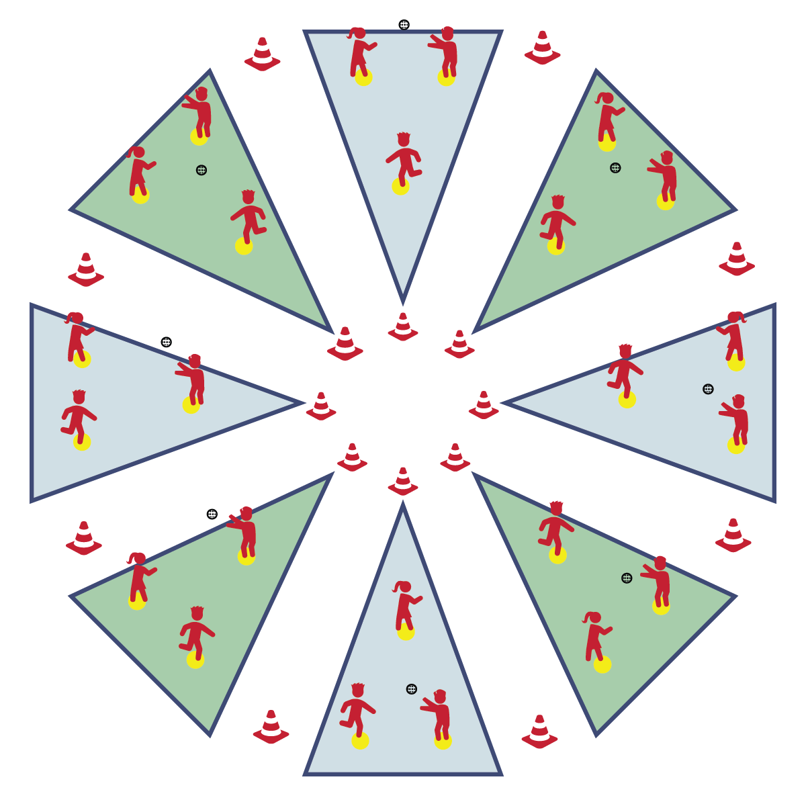

**CATCH ON THE SANDLOT**

**Equipment:**

* 16 Cones
* 24 Spot Markers
* 8 Plastic Balls

**Set-Up:**

1. Set up Circle Sandlot Formation using cones and 3 spot markers per sandlot area.
2. Separate students into groups of 3, each group with a ball.
3. Send group of 3 to each Circle Sandlot area.

* **Skill:** I will throw and catch using skill cues learned in class.
* **Cognitive:** I will discuss safety considerations related to playing catch.
* **Fitness:** I will stay physically active throughout the activity.
* **Personal & Social Responsibility:** I will participate safely and independently with my group members.
* Grip 2 Fingers on Top
* Stand Sideways, Non-Throwing Arm at Target
* Step to Target (Opposition)
* Throwing Arm Way Back
* Follow-Through with Wrist to Opposite Knee

**Activity Procedures:**

1. It’s time to start working in Circle Sandlot Formation with a game of catch. Circle Sandlot Formation is the organization system that we’ll be using for most of our Bat and Ball activities.
2. At each sandlot area there are 3 spot markers set up in a triangle. Each member of your group will move to a spot marker. The player with the ball starts the game by throwing the ball to the player on their left. Throw and catch around your triangle until you hear the stop signal.
3. Now that we understand this formation, we’re going to add some challenges.
4. Ground balls: Player 1 rolls the ball to Player 2, who fields it and throws to Player 3. Player 3 rolls to Player 1, who fields it and throws to Player 2. Continue this pattern until you hear the stop signal.
5. Fly balls: Player 1 tosses a high “pop-fly” to Player 2, who catches it and throws a good overhand throw to Player 3. Player 3 tosses a “pop-fly” to Player 1, who catches it and throws a good overhand throw to Player 2. Continue this pattern until you hear the stop signal.

**Grade Level Progression:**

**3rd:** Focus on throwing and catching with accuracy.

**4th:** Add challenges as described above.

**5th:** Allow students to create their own challenges.

**CATCH ON THE SANDLOT**



* **DOK 1:** How can you recognize a safe game of catch?
* **DOK 2:** How would you compare and contrast a safe game with a game that is unsafe?
* **DOK 3:** How is safety related to your ability to learn skills like throwing and catching?



* Change the distance between players to match skill levels.
* Use a variety of different balls, allowing students to select the ball they are most comfortable catching.



* **Standard** **1 [E14.3-5b]** Throws overarm, demonstrating three of the five critical elements of a mature pattern, in non-dynamic environments, for distance and/or force (3); Throws overarm using a mature pattern in non-dynamic environments (4a); Throws overarm to a partner or at a target with accuracy at a reasonable distance (4b); Throws (overarm) using a mature pattern in non-dynamic environments, with different sizes and types of objects (5a); Throws (overarm) to a large target with accuracy (5b).
* **Standard 1 [E16.3-5]** Catches a gently tossed hand-sized ball from a partner, demonstrating four of the five critical elements of a mature pattern (3); Catches a thrown ball above the head, at chest/waist level, and below the waist using a mature pattern in a non-dynamic environment (4); Catches a batted ball above the head, at chest/waist level, and along the ground using a mature pattern in a non-dynamic environment (5a); Catches with accuracy, both partners moving (5b); Catches with reasonable accuracy in dynamic, small-sided practice tasks (5c).
* **Standard 4 [E6.3-5]** Works independently and safely in physical activity settings (3); Works safely with peers and equipment in physical activity settings (4); Applies safety principles with age-appropriate physical activities (5).



Accuracy, Catch, Coordination, Fielding, Follow-Through, Independently, Overhand, Throw



**Identify critical content:** A simple game of catch provides students with explicit opportunities for learning and practicing the skill cues for throwing and catching. Take time to teach, review, and then revisit the cues over and over in order to help students understanding the cues cognitively and feel improvement and success from a motor-learning perspective.

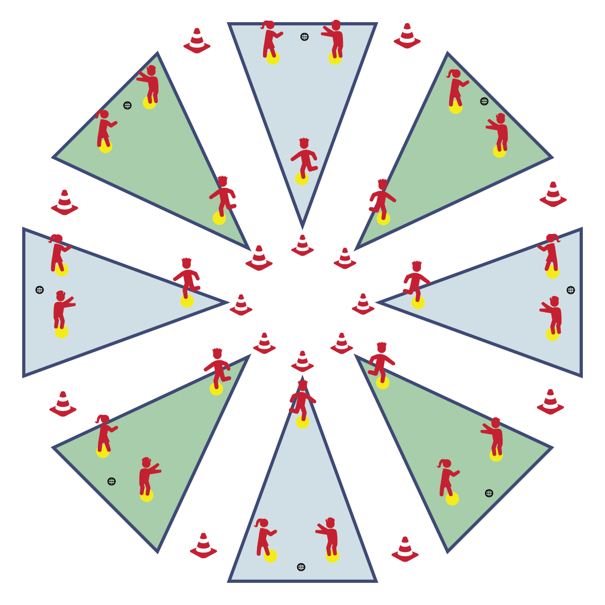

**THROW-RUN DERBY**

* **Skill:** I will use throwing skills cues to throw for distance.
* **Cognitive:** I will discuss the importance of athletic stance when fielding.
* **Fitness:** I will remain actively engaged in this activity.
* **Personal & Social Responsibility:** I will practice safe behaviors in all positions played during this activity.
* Grip 2 Fingers on Top
* Stand Sideways, Non-Throwing Arm at Target
* Step to Target (Opposition)
* Throwing Arm Way Back
* Follow-Through with Wrist to Opposite Knee

**Equipment:**

* 16 Cones
* 24 Spot Markers
* 8 Plastic Balls

**Set-Up:**

1. Set up Circle Sandlot Formation using cones and 3 spot markers per sandlot area.
2. 2 spot markers are fence spots, 1 is a home base spot.
3. Separate students into groups of 3, each group with a ball.
4. Send group of 3 to each Circle Sandlot area.

**Activity Procedures:**

1. Now it’s time for a little Throw-Run Derby. Player 1 is the batter. Players 2 and 3 are outfielders. The object of the game is for the batter to score as many Throw-Runs as possible by landing a ball beyond the fence spots without it being caught by an outfielder. Outfielders will try to catch each throw before the ball hits the ground.
2. After Player 1 takes 3 throws as the batter, rotate so that Player 2 becomes the new batter and Players 1 and 3 are outfielders. On the next rotation, Player 3 becomes the batter. Continue this pattern until you hear the stop signal. Keep track of how many Throw-Runs you score.

**Grade Level Progression:**

**3rd:** Allow throws beyond the fence cones to count as Throw-Runs, even if they are caught.

**4th:** Play the activity as described above.

**5th:** Increase the distance between the batter and the fence cones.

**THROW-RUN DERBY**



* Modify the rules to increase the level of success. For example, any ball thrown in fair territory counts as a Throw-Run.



* **Standard** **[E1.4-5b]** Uses various locomotor skills in a variety of small-sided practice tasks, dance, and educational gymnastics experiences (4); Demonstrates mature patterns of locomotor skills in dynamic small-sided practice tasks, gymnastics, and dance (5a); Combines locomotor and manipulative skills in a variety of small-sided practice tasks/games environments (5b).
* **Standard 1 [E13.3,5a&b]** Throws underhand to a partner or target with reasonable accuracy (3); Throws (underhand) using a mature pattern in non-dynamic environments, with different sizes and types of objects (5a); Throws (underhand) to a large target with accuracy (5b).
* **Standard 1 [E14.3-5b]** Throws overarm, demonstrating three of the five critical elements of a mature pattern, in non-dynamic environments, for distance and/or force (3); Throws overarm using a mature pattern in non-dynamic environments (4a); Throws overarm to a partner or at a target with accuracy at a reasonable distance (4b); Throws (overarm) using a mature pattern in non-dynamic environments, with different sizes and types of objects (5a); Throws (overarm) to a large target with accuracy (5b).
* **Standard 1 [E16.3-5]** Catches a gently tossed hand-sized ball from a partner, demonstrating four of the five critical elements of a mature pattern (3); Catches a thrown ball above the head, at chest/waist level, and below the waist using a mature pattern in a non-dynamic environment (4); Catches a batted ball above the head, at chest/waist level, and along the ground using a mature pattern in a non-dynamic environment (5a); Catches with accuracy, both partners moving (5b); Catches with reasonable accuracy in dynamic, small-sided practice tasks (5c).



* **DOK 1:** What is athletic stance?
* **DOK 2:** What do you know about athletic stance?
* **DOK 3:** How is athletic stance related to fielding a ball?



Athletic Stance, Fielding, Follow-Through, Overhand, Power, Safety, Throw



**Help students practice skills, strategies, and processes:** Throw-Run Derby is an instructional practice task designed to help teach the directional nature of the sandlot management set-up, as well as the basic rules for the Home-Run Derby. This activity allows students to learn basic safety considerations before adding in the additional safety requirements of using a bat.

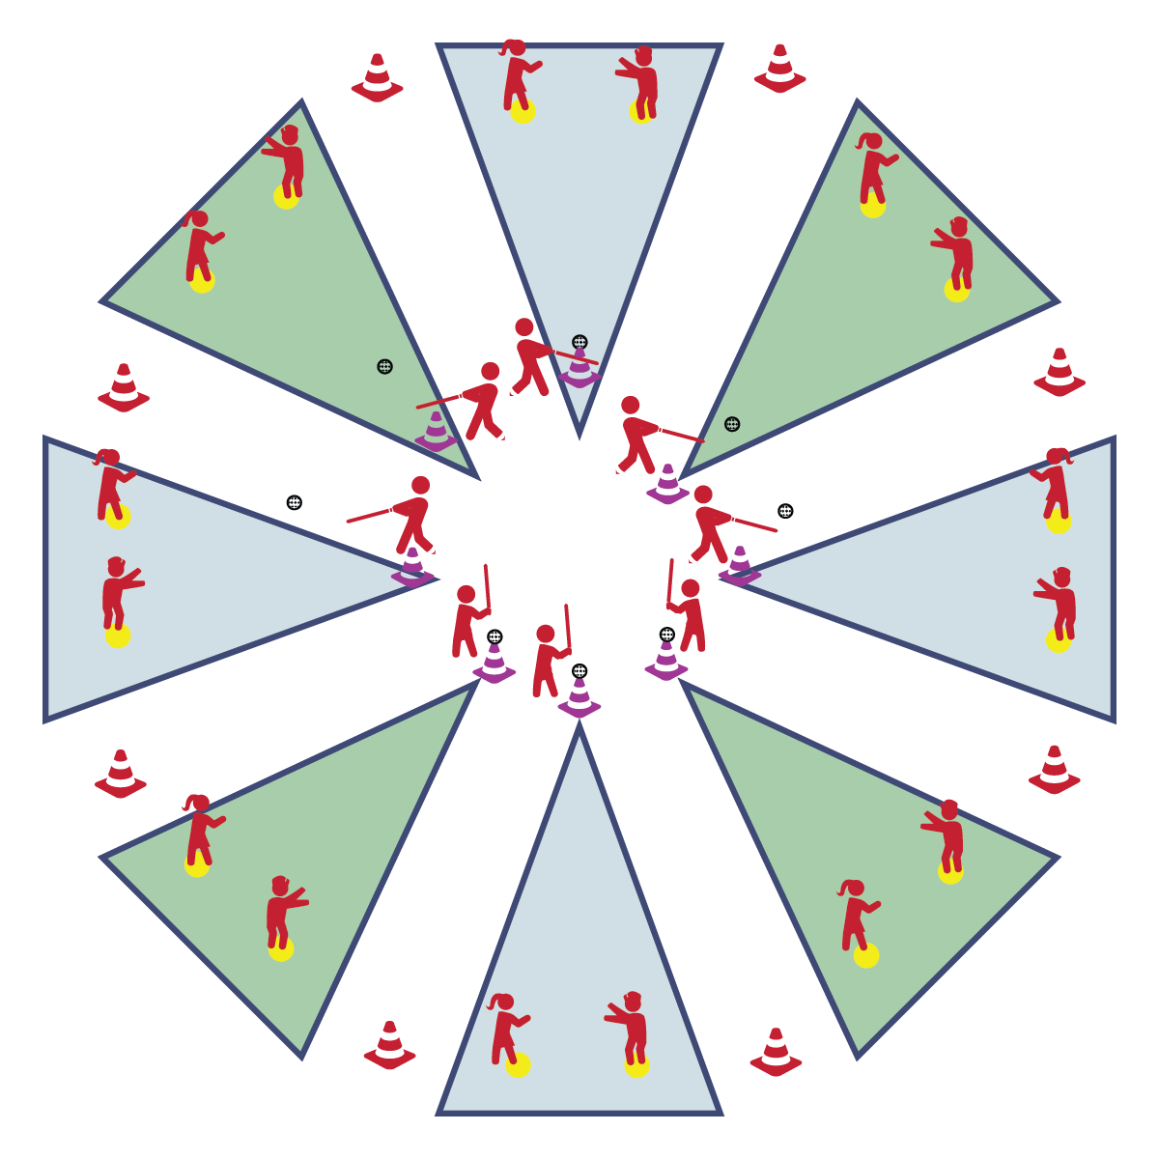

**HOME-RUN DERBY**

* Everyone 25’ from Batter
* Athletic Stance
* Grip Together, Line of Knuckles
* Bat Up, Grip at Armpit
* See Ball from Start to Finish
* Rotate Hips; Drive Body Through the Ball
* **Skill:** I will use cues for striking while batting the ball.
* **Cognitive:** I will discuss ways to demonstrate responsibility when using a bat.
* **Fitness:** I will remain actively engaged in this activity.
* **Personal & Social Responsibility:** I will use all equipment in a safe and appropriate manner.

**Equipment:**

* 8 Cones
* 8 Spot Markers
* 8 Plastic Balls
* 8 Bats
* 8 Tees (or cones)

**Set-Up:**

1. Set up Circle Sandlot Formation using one bat, one cone, one tee and one spot marker.
2. Students will be separated into groups of 3, each group with a ball.
3. Send group of 3 to each Circle Sandlot area.

**Activity Procedures:**

1. Let’s take it to the next level with a Home-Run Derby. Player 1 is the batter. Players 2 and 3 are outfielders. The object of the game is for the batter to score as many Home Runs as possible by hitting the ball off the cone (tee) and landing it beyond the fence cones without being caught by an outfielder. Outfielders will try to catch each hit before the ball touches the ground.
2. After Player 1 hits 3 balls as the batter, rotate so that Player 2 becomes the new batter and Players 1 and 3 are outfielders. On the next rotation, Player 3 becomes the batter. Continue this pattern until you hear the stop signal. Keep track of how many Home Runs you score.

**Grade Level Progression:**

**3rd:** Students hit exclusively off a cone/tee.

**4th- 5th:** Allow students to attempt to hit 3 pitched balls before hitting off of the tee.

**HOME-RUN DERBY**



* Provide bat of different sizes, shapes, and weights. Large barrel bats, or those with flat striking surfaces can increase the rate of success.



* **Standard** **1 [E16.3-5]** Catches a gently tossed hand-sized ball from a partner, demonstrating four of the five critical elements of a mature pattern (3); Catches a thrown ball above the head, at chest/waist level, and below the waist using a mature pattern in a non-dynamic environment (4); Catches a batted ball above the head, at chest/waist level, and along the ground using a mature pattern in a non-dynamic environment (5a); Catches with accuracy, both partners moving (5b); Catches with reasonable accuracy in dynamic, small-sided practice tasks (5c).
* **Standard 1 [E25.3-5b]** Strikes a ball with a long-handled implement, sending it forward, while using proper grip for the implement (e.g., hockey stick, bat, golf club). Note: Use batting tee or ball tossed by teacher for batting (3); Strikes an object with a long-handled implement (e.g., hockey stick, golf club, bat, tennis/badminton racket), while demonstrating three of the five critical elements of a mature pattern for the implement (grip, stance, body orientation, swing plane, and follow-through) (4); Strikes a pitched ball with a bat using a mature pattern (5a); Combines striking with a long implement with receiving and traveling skills in a small-sided game (5b).
* **Standard 2 [E5.5c]** Recognizes the type of throw, volley, or striking action needed for different games/sports situations (5c).



* **DOK 1:** What would you include on a list about playing a game with a bat?
* **DOK 2:** How does responsibility apply to using a bat?
* **DOK 3:** What facts would you choose to support an assertion that someone demonstrated responsibility during bat and ball games? Can you elaborate on why you chose those facts?



**Identify critical content:** Safely and effectively striking a ball with a bat is foundational to participation in any bat and ball game. Home-Run Derby allows both teachers and students to focus on this critical content in a fun, small-sided game designed to provide low-pressure repetitions for both batting and fielding.



Athletic Stance, Balance, Critical Elements, Coordination, Fielding, Responsibility, Safety, Strike

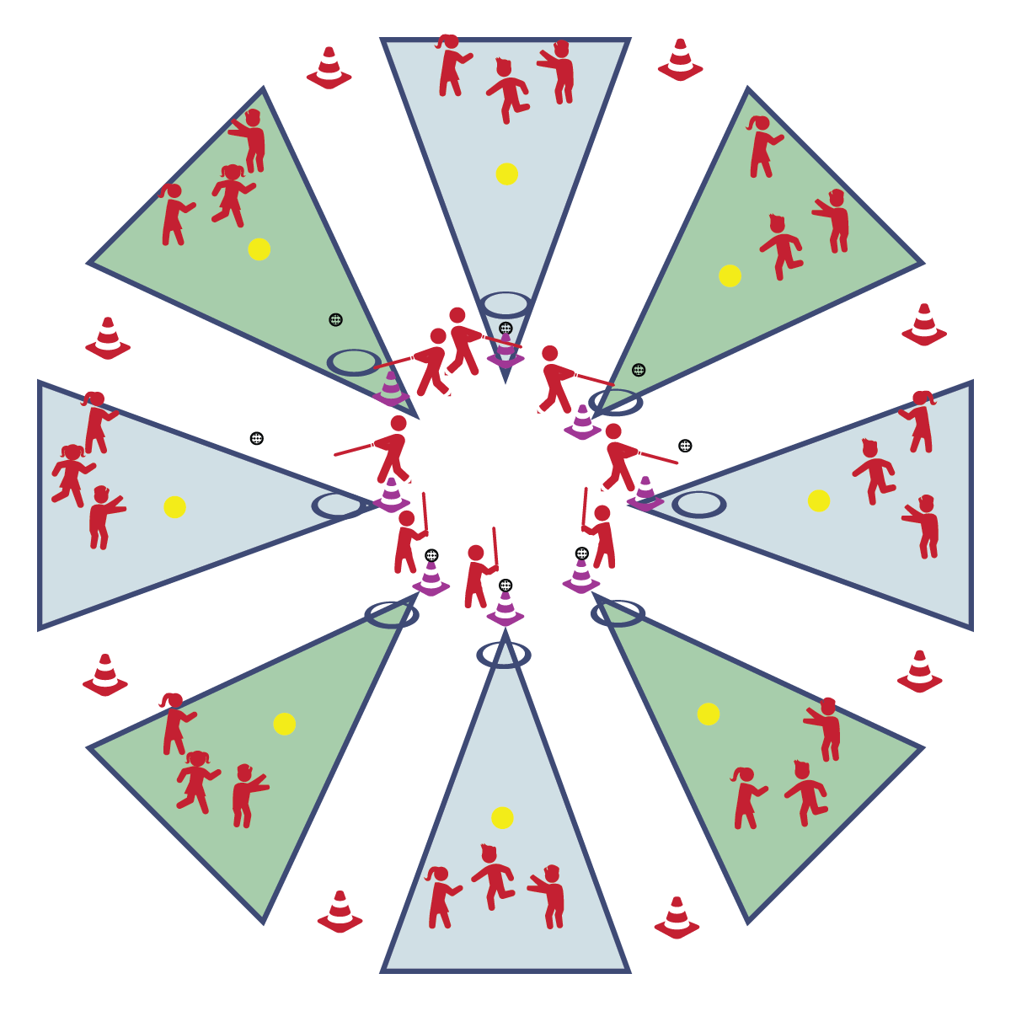

**Equipment:**

* 1 Spot Marker
* 1 Hoop
* 1 Plastic Ball
* 1 Bat
* 1 Tee (or cone)

**Set-Up:**

1. Set up 1 spot marker at the center of the playing space.
2. Place 1 plastic ball, 1 bat, and 1 tee at the front of the area.
3. Place a hoop just in front of the tee (cone) as the batter’s hoop.
4. 1 student will bat first.
5. The rest of the students will spread out in open space and act as the fielders.

**BASEBALL TAG**

* Grip the Bat
* Hit the Ball
* Drop Bat in Hoop
* **Skill:** I will safely transition from batting to running.
* **Cognitive:** I will discuss the components of fitness that are related to bat and ball games.
* **Fitness:** I will remain actively engaged in this activity.
* **Personal & Social Responsibility:** I will demonstrate responsible behaviors throughout this activity.

**Activity Procedures:**

1. It’s time to increase our aerobic benefits with a game of Baseball Tag. The object of the game is for the batter to tag as many players as she/he can before the fielders make an out.
2. On the start signal the batter will hit the ball off of the cone (tee). As soon as the ball is hit, the batter will place the bat in the batter’s hoop and begin chasing fielders. For each fielder that is tagged, a run is scored.
3. While the batter is tagging fielders, the fielders are working to make an out. This is done by getting the ball and making good relay throws to the pitcher’s mound (spot marker). Fielders may not run with the ball. It must be thrown from player to player until it is cleanly caught on the mound. If tagged, fielders with the ball are worth 2 runs.

**Grade Level Progression:**

**3rd:** Provide a hoop in which students must place the bat after hitting and before moving to tag fielders.

**4th- 5th:** Allow students to attempt to hit 3 pitched balls before hitting off of the tee.

**BASEBALL TAG**



* **DOK 1:** What is health-related fitness? What is skill-related fitness?
* **DOK 1:** Which ones would we include on a list of fitness components related to bat and ball games?
* **DOK 2:** What do you know about the skills and activities required for participation in bat and ball games?
* **DOK 3:** Choose a component and describe how that component relates to bat and ball games.



* **Standard 1 [E25.3-5b]** Strikes a ball with a long-handled implement, sending it forward, while using proper grip for the implement (e.g., hockey stick, bat, golf club). Note: Use batting tee or ball tossed by teacher for batting (3); Strikes an object with a long-handled implement (e.g., hockey stick, golf club, bat, tennis/badminton racket), while demonstrating three of the five critical elements of a mature pattern for the implement (grip, stance, body orientation, swing plane, and follow-through) (4); Strikes a pitched ball with a bat using a mature pattern (5a); Combines striking with a long implement with receiving and traveling skills in a small-sided game (5b).
* **Standard 2 [E3.3&5a-c]** Combines movement concepts (direction, levels, force, time) with skills as directed by the teacher (3); Applies movement concepts to strategy in game situations (5a); Applies the concepts of direction and force to strike an object with a long-handled implement (5b); Analyzes movement situations and applies movement concepts (e.g., force, direction, speed, pathways, extensions) in small-sided practice task/game environments, dance and gymnastics (5c).
* **Standard 4 [E1.3-5]** Exhibits personal responsibility in teacher-directed activities (3); Exhibits responsible behavior in independent group situations (4); Engages in physical activity with responsible interpersonal behavior (e.g., peer to peer, student to teacher, student to referee) (5).



**Help students process content:** The concept of moving the ball quickly around the ball field with accurate throws is an essential part of defensive play in most bat and ball games. However, it’s not necessarily an intuitive concept for young students. Baseball tag creates an environment to help students process and practice this concept.



Fitness, Health-Related Fitness, Personal Responsibility, Skill-Related Fitness



* Allow fielders to run with the ball to the pitcher’s mound.
* Add tag-teamers to help the batter successful tag fielders.

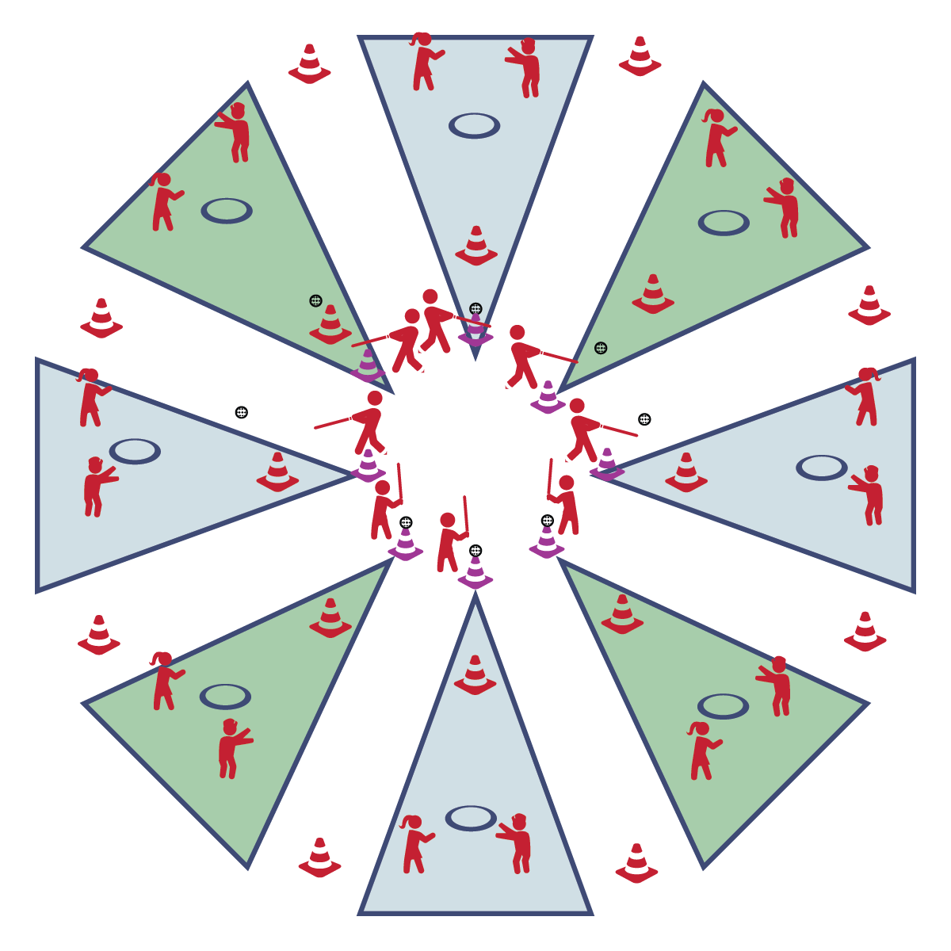

**SANDLOT BASEBALL**

* **Skill:** I will demonstrate skill cues while throwing and batting.
* **Cognitive:** I will discuss movement concepts related to baseball/softball.
* **Fitness:** I will discuss skill-related fitness components related to sandlot baseball.
* **Personal & Social Responsibility:** I will demonstrate responsible behavior in a team setting.
* Everyone 25’ from Batter
* Athletic Stance
* Grip Together, Line of Knuckles
* Bat Up, Grip at Armpit
* See Ball from Start to Finish
* Rotate Hips; Drive Body Through the Ball

**Equipment:**

* 8 Hula Hoops
* 8 Cones
* 8 Plastic Balls
* 8 Tees (or cones)

**Set-Up:**

1. Set up Circle Sandlot Formation using 1 bat, 1 cone, 1 tee, 1 hoop, and 1 spot marker.
2. Students will be separated into groups of 3, each group with a ball.
3. Send a group of 3 to each Circle Sandlot area.

**Activity Procedures:**

1. It’s time for some Sandlot Baseball! The object of the game is for the batter to score as many runs as possible by running back and forth from the tee-cone to the base-cone. Touch the base-cone = 1 run. Make it back to the tee-cone = 2 runs.
2. Fielders work to get the batter out. One fielder fields the ball while the other runs to the hoop. The ball must be thrown to and caught in the hoop. When the ball is caught by the fielder inside the hoop, the fielder yells, “OUT!” and the batter stops running.
3. Each batter bats for 3 outs and then all switch places.

**Grade Level Progression:**

**3rd:** Students hit exclusively off a cone/tee.

**4th- 5th:** Allow students to attempt to hit 3 pitched balls before hitting off of the tee.

**SANDLOT BASEBALL**



**Organize students to interact with content:** This sandlot baseball instructional format and game provides students with a dynamic and fun environment for practicing the fundamental skills and concepts required for future participation in baseball, softball, and cricket.



* **DOK 1:** Can you remember the components of skill-related fitness?
* **DOK 2**: What do you know about the components that are related to this game of Sandlot Baseball?
* **DOK 3:** How would you adapt this game to focus on different components of skill-related fitness?



* **Standard** **1 [E14.3-5b]** Throws overarm, demonstrating three of the five critical elements of a mature pattern, in non-dynamic environments, for distance and/or force (3); Throws overarm using a mature pattern in non-dynamic environments (4a); Throws overarm to a partner or at a target with accuracy at a reasonable distance (4b); Throws (overarm) using a mature pattern in non-dynamic environments, with different sizes and types of objects (5a); Throws (overarm) to a large target with accuracy (5b).
* **Standard 1 [E25.3-5b]** Strikes a ball with a long-handled implement, sending it forward, while using proper grip for the implement (e.g., hockey stick, bat, golf club). Note: Use batting tee or ball tossed by teacher for batting (3); Strikes an object with a long-handled implement (e.g., hockey stick, golf club, bat, tennis/badminton racket), while demonstrating three of the five critical elements of a mature pattern for the implement (grip, stance, body orientation, swing plane, and follow-through) (4); Strikes a pitched ball with a bat using a mature pattern (5a); Combines striking with a long implement with receiving and traveling skills in a small-sided game (5b).
* **Standard 1 [E26.4]** Combines traveling with the manipulative skills of dribbling, throwing, catching, and striking in teacher- and/or student-designed small-sided practice task environments (4).
* **Standard 2 [E3.3&5a-c]** Combines movement concepts (direction, levels, force, time) with skills as directed by the teacher (3); Applies movement concepts to strategy in game situations (5a); Applies the concepts of direction and force to strike an object with a long-handled implement (5b); Analyzes movement situations and applies movement concepts (e.g., force, direction, speed, pathways, extensions) in small-sided practice task/game environments, dance and gymnastics (5c).
* **Standard 4 [E1.3-5]** Exhibits personal responsibility in teacher-directed activities (3); Exhibits responsible behavior in independent group situations (4); Engages in physical activity with responsible interpersonal behavior (e.g., peer to peer, student to teacher, student to referee) (5).



Fielding, Mature Skill Pattern, Participation, Safety, Strike, Throw



* Use larger-sized bats and/or balls.
* Use larger bases, either closer or farther apart.
* Allow students to run (rather than throw) the ball into the hoop.

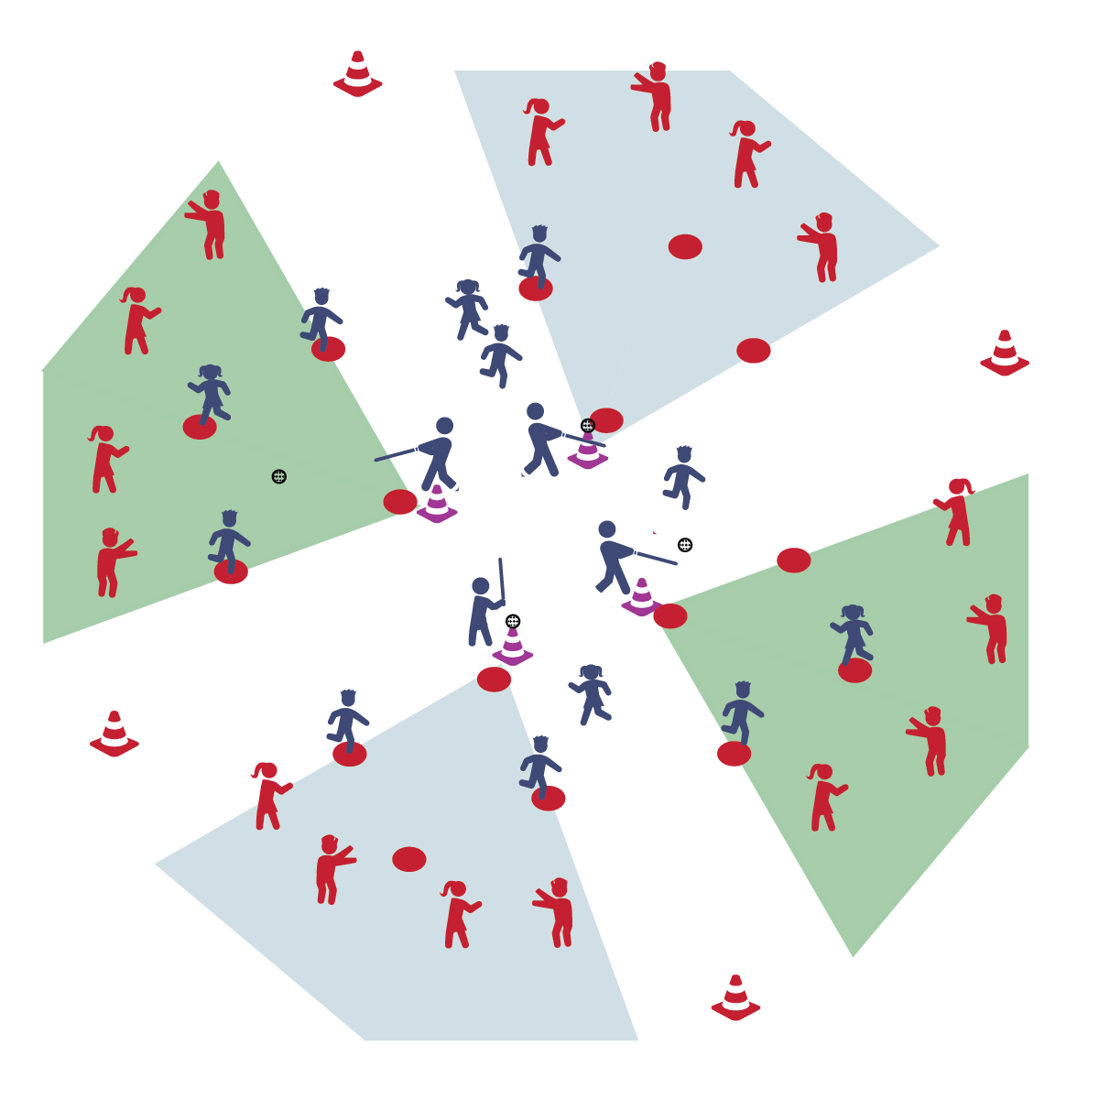

**BRANNBOLL**

* Everyone 25’ from Batter
* Athletic Stance
* Grip Together, Line of Knuckles
* Bat Up, Grip at Armpit
* See Ball from Start to Finish
* Rotate Hips; Drive Body Through the Ball

**Activity Procedures:**

1. It’s time to play modified Brannboll (bren:bul). This is a Swedish tee-ball game played by children and adults. The object for the batting team is to score points by reaching a base successfully and trying to work around the bases, back to home base. Each base is worth 1 point.
2. The object for the fielding team is catch base-runners in between bases by fielding, throwing, and catching the ball on the Outing Base (hoop). The fielding team scores a point for each base-runner caught in between bases. If caught, base-runners go back to the last base they touched. There is no limit to the number of base-runners per base.
3. If the batting team fails to bring a base-runner back to home base to hit (all players are stuck on bases), then the team is “caught out” and teams switch (i.e., fielders to batters, batters to the field). Teachers may also choose to switch sides after the batting team scores 10 runs.
4. Batters have 3 swings to hit a ball into fair territory and past the Outing Base. If a batter fails to hit a fair ball, he/she moves to first base as a new base-runner (no point awarded and no other runners advance).
5. Play continues for a set period of time. When time expires, the game is over.

**Grade Level Progression:**

**3rd:** Students hit exclusively off a cone/tee.

**4th- 5th:** Allow students to attempt to hit 3 self-tossed balls before hitting off of the tee.

**5th:** Allow students to attempt to hit 3 pitched, or self-tossed balls before hitting off of the tee.

* **Skill:** I will safely transition from batting to running.
* **Cognitive:** I will discuss the skill cues for throwing, catching, and batting.
* **Fitness:** I will remain actively engaged in the activity.
* **Personal & Social Responsibility:** I will demonstrate responsible behaviors while working with my classmates.

**Equipment:**

* 5 Spot Markers
* 1 Plastic Ball
* 1 Tee (or cone)

**Set-Up:**

1. Set up 5 spot markers in a diamond shape, 1 for each base (1st, 2nd, 3rd, home)
2. Class will be split into even teams of at least 4 players: batters and fielders.
3. Batters will wait to bat first and fielders will scatter in open space throughout the playing area.

**BRANNBOLL**



* **DOK 1:** Can you remember the skill cues for each of the skills that we’ve used in bat and ball activities?
* **DOK 2:** From the start of this module until today, what have you noticed about your ability to perform the skills using the cues correctly?
* **DOK 3:** How is practice related to your improvements? Can you support your answer with examples from this module?



**Review content:** Brannboll is a great game for bringing together all of the skills and concepts taught cumulatively throughout the module. Take time to review the skill cues and concepts before starting the activity, and find teachable moments within the game to highlight, reinforce, or correct aspects of student performances.



* **Standard** **1 [E14.3-5b]** Throws overarm, demonstrating three of the five critical elements of a mature pattern, in non-dynamic environments, for distance and/or force (3); Throws overarm using a mature pattern in non-dynamic environments (4a); Throws overarm to a partner or at a target with accuracy at a reasonable distance (4b); Throws (overarm) using a mature pattern in non-dynamic environments, with different sizes and types of objects (5a); Throws (overarm) to a large target with accuracy (5b).
* **Standard 1 [E25.3-5b]** Strikes a ball with a long-handled implement, sending it forward, while using proper grip for the implement (e.g., hockey stick, bat, golf club). Note: Use batting tee or ball tossed by teacher for batting (3); Strikes an object with a long-handled implement (e.g., hockey stick, golf club, bat, tennis/badminton racket), while demonstrating three of the five critical elements of a mature pattern for the implement (grip, stance, body orientation, swing plane, and follow-through) (4); Strikes a pitched ball with a bat using a mature pattern (5a); Combines striking with a long implement with receiving and traveling skills in a small-sided game (5b).
* **Standard 1 [E26.4]** Combines traveling with the manipulative skills of dribbling, throwing, catching, and striking in teacher- and/or student-designed small-sided practice task environments (4).
* **Standard 2 [E3.3&5a-c]** Combines movement concepts (direction, levels, force, time) with skills as directed by the teacher (3); Applies movement concepts to strategy in game situations (5a); Applies the concepts of direction and force to strike an object with a long-handled implement (5b); Analyzes movement situations and applies movement concepts (e.g., force, direction, speed, pathways, extensions) in small-sided practice task/game environments, dance and gymnastics (5c).
* **Standard 4 [E1.3-5]** Exhibits personal responsibility in teacher-directed activities (3); Exhibits responsible behavior in independent group situations (4); Engages in physical activity with responsible interpersonal behavior (e.g., peer to peer, student to teacher, student to referee) (5).



Fielding, Mature Skill Pattern, Participation, Safety, Strike, Throw



* Use larger-sized bats and/or balls.
* Use larger bases, either closer or farther apart.

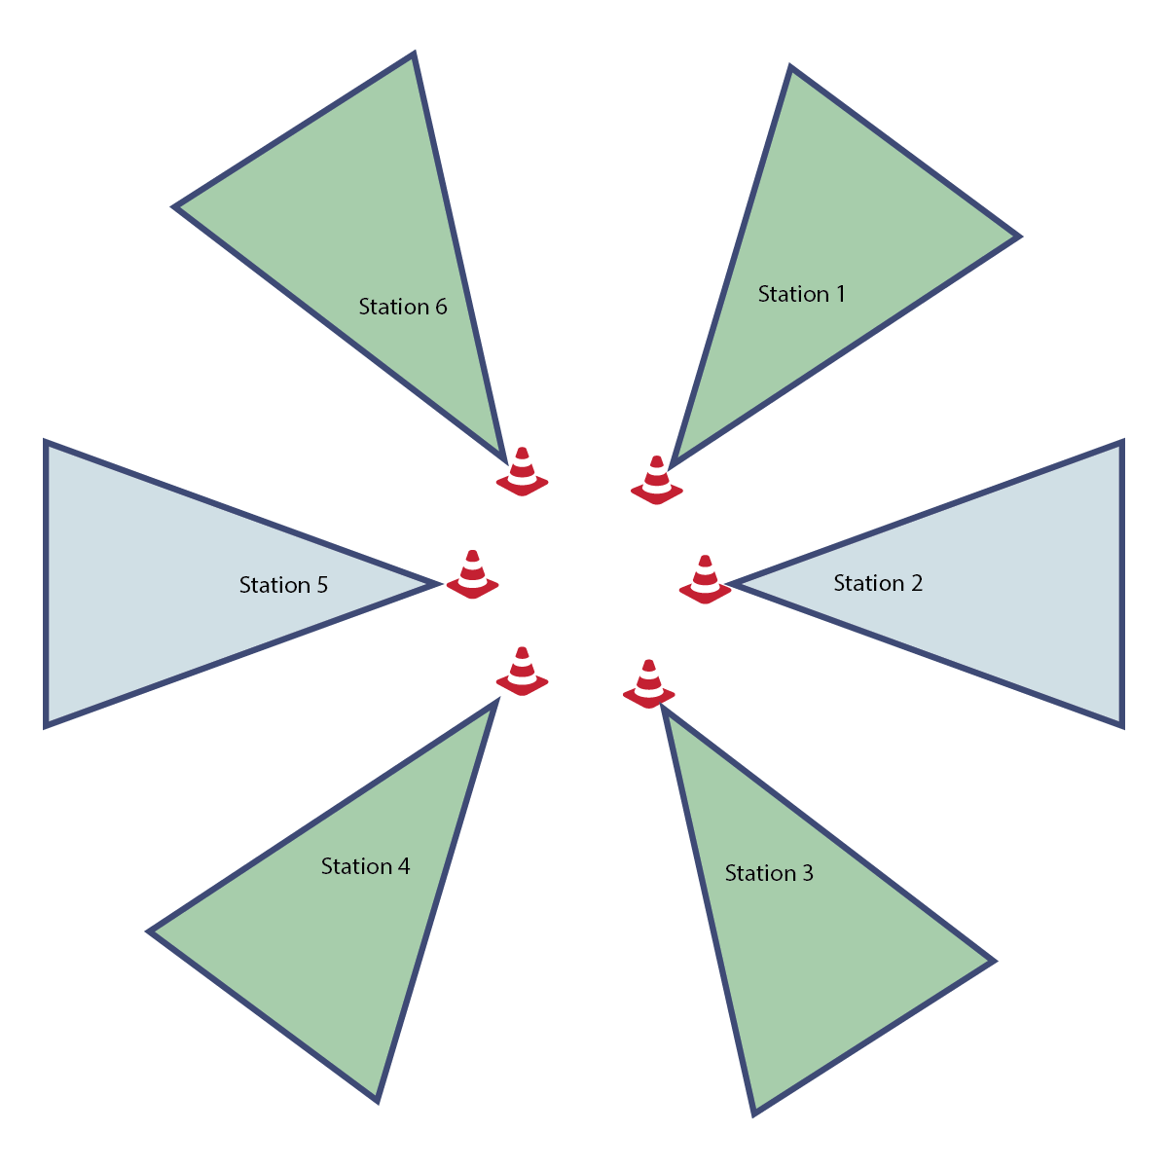

**CIRCLE SANDLOT STATIONS**

* Start Activity with Music
* When Music Stops: Clean the Area and Rotate
* **Skill:** I will perform skill assessments to the best of my ability, following as many skills cues as I can.
* **Cognitive**: I will follow the instructions on each station card in order to stay actively engaged with my team.
* **Fitness**: I will find my pulse after each station in order to see if it is beating faster than when I’m sitting or resting.
* **Personal & Social Responsibility**: I will follow the rules and parameters of Station Day.

**Equipment:**

* 5-8 station cards
* 5-8 tall cones
* See station cards for equipment needs
* Station music and music player

**Set-Up:**

1. Set up Circle Sandlot Formation using station cards and cones.
2. Set up each station according to each station card.
3. Send group of 4 to each station.

**Activity Procedures:**

1. Today is a Station Assessment Day. We’ll complete each station for 2 (or 3) minutes. One station is an assessment station where you’ll be given feedback based on your skill performance.
2. *Teacher: Talk through and/or demonstrate each station. Emphasize expectations at the assessment station.*
3. When the music starts, begin working at your station. When it stops, you’ll have 1 minute to clean up the station equipment and rotate to the next station. Wait until the music begins again before you start the activity at the new station.
4. While we’re learning this station format, I’ll pause the music for a longer period of time so that every team is able to clean up their area and rotate.

**Grade Level Progression:**

**3rd-5th:** Play the activity as described above.

**CIRCLE SANDLOT STATIONS**



* **Standard** **1, 2, 3, 5** [*Select outcomes from the module you’re teaching.*]
* **Standard 4 [E2.3-5]** Works independently for extended periods of time (3); Reflects on personal social behavior in physical activity (4); Participates with responsible personal behavior in a variety of physical activity contexts, environments, and facilities (5a); Exhibits respect for self with appropriate behavior while engaging in physical activity (5b).



* Some students may need step-by-step assistance during clean-up and rotation.
* Pause the music and don’t restart until every group has safely transitioned.
* Provide visual cues and graphics to enhance station instructions.



*Select words from earlier activities.*



* *Select questions from earlier activities that need to be reviewed.*



**Organizing students to interact with content:** The use of set areas to organize students into learning stations is an effective way to manage activity, assessment, and cooperative learning opportunities. Practice using this format several times, especially with young children, before attempting to facilitate an assessment experience. Students need time to master the management aspects of station work. However, once this routine is learned, it often becomes an essential management tool in physical education.