­­­

­

* Self-Assessment: Throwing & Catching
* Accuracy
* Catch
* Follow-Through
* Overhand
* Throw
* **Skill:** I will throw and catch using skill cues learned in class.
* **Cognitive:** I will discuss safety considerations related to playing catch.
* **Fitness:** I will stay physically active throughout the activity.
* **Personal & Social Responsibility:** I will work cooperatively with my partner to make good throws and catches.
* **Standard 1 [E14.3-5b]** Throws overarm, demonstrating three of the five critical elements of a mature pattern, in non-dynamic environments, for distance and/or force (3); Throws overarm using a mature pattern in non-dynamic environments (4a); Throws overarm to a partner or at a target with accuracy at a reasonable distance (4b); Throws (overarm) using a mature pattern in non-dynamic environments, with different sizes and types of objects (5a); Throws (overarm) to a large target with accuracy (5b).
* **Standard 1 [E16.3-5]** Catches a gently tossed hand-sized ball from a partner, demonstrating four of the five critical elements of a mature pattern (3); Catches a thrown ball above the head, at chest/waist level, and below the waist using a mature pattern in a non-dynamic environment (4); Catches a batted ball above the head, at chest/waist level, and along the ground using a mature pattern in a non-dynamic environment (5a); Catches with accuracy, both partners moving (5b); Catches with reasonable accuracy in dynamic, small-sided practice tasks (5c).

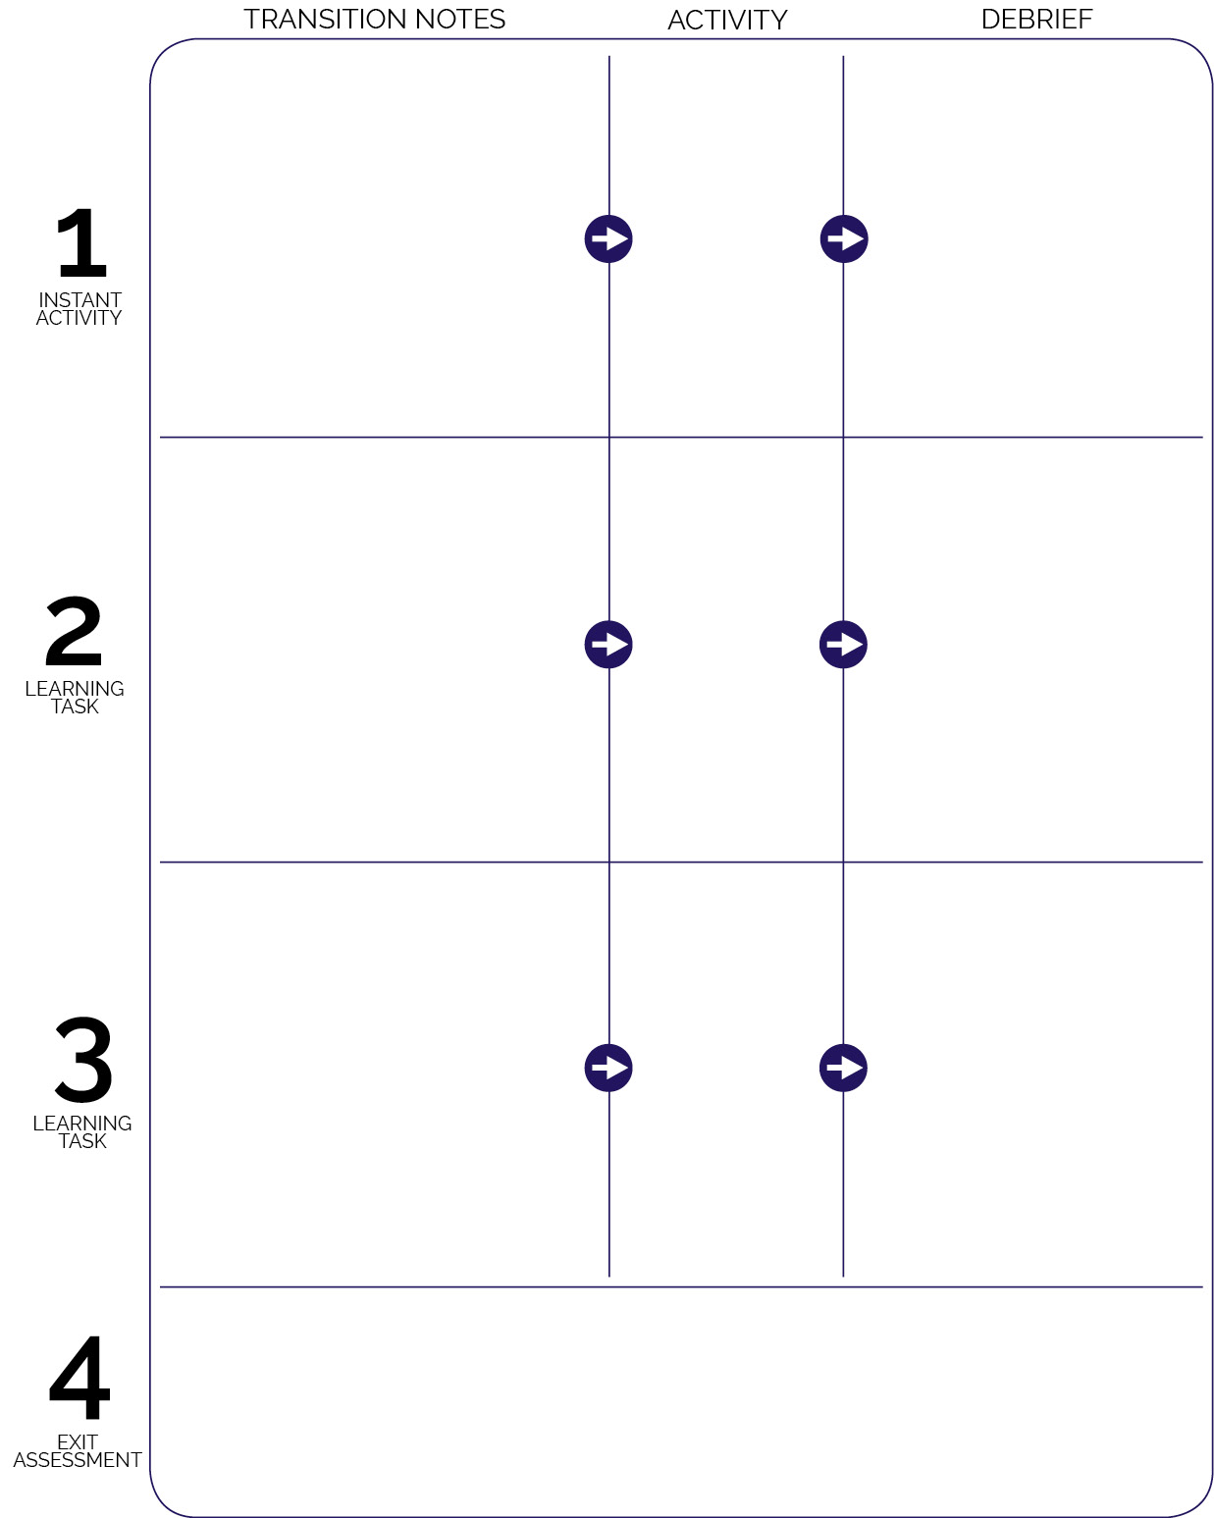

**DOK 1:** How can you recognize a safe game of catch?

**DOK 2:** How would you compare and contrast a safe game with a game that is unsafe?

**DOK 3:** How is safety related to your ability to learn skills like throwing and catching?

**DOK 1:** What are the cues for catching a ball above your head?  
**DOK 2:** How does this compare to catching a ball at your waist?  
**DOK 3:** How could we adapt this game to help us practice for different sports?

Center Field Relay

Two Ball Tossers

Catch on the Sandlot

Students move to assessment stations with self-assessment pages and pencils available. Students complete the pre- and goal-assessment for Throwing and Catching.

**DOK 1:** Can you remember the cues for throwing? How about catching?

**DOK 2:** How does where you catch the ball (high/low) affect how you catch it?

**DOK 3:** How is throwing related to sports like softball and baseball? How is catching related?

As students enter the activity area they pair-up with a partner and begin Center Field Relay activities.

Students transition from debrief area to large activity areas with plastic softballs scattered.

Group students into teams of 3. Sandlot formation is set-up apart from the Two Ball Tossers activity area. Move students into the Sandlot with one group as a demonstration group.