**TWO BALL TOSSERS**

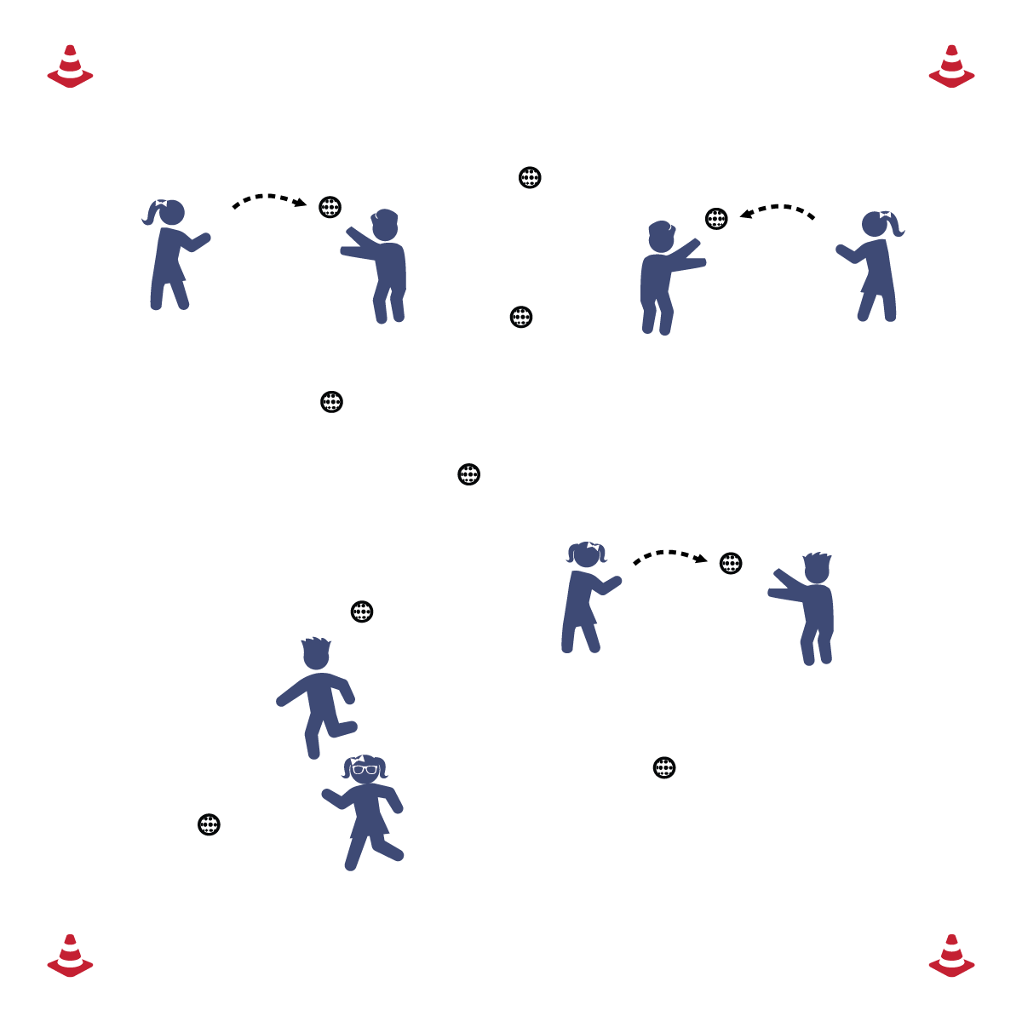

**Set-Up**

* Balls are scattered in station area.
* Work with a partner.

**Equipment**

* 2 balls per student

**How to play**

1. The object of this game is for you and your partner to throw and catch as many plastic softballs as you can before the station time is up.
2. Start at one ball, pick it up and throw it to your partner, who will then throw it back to you.
3. Your partner moves to a new ball, turns and throws it to you.
4. Throw it back, then move to a new ball.

**GAME OF CATCH**

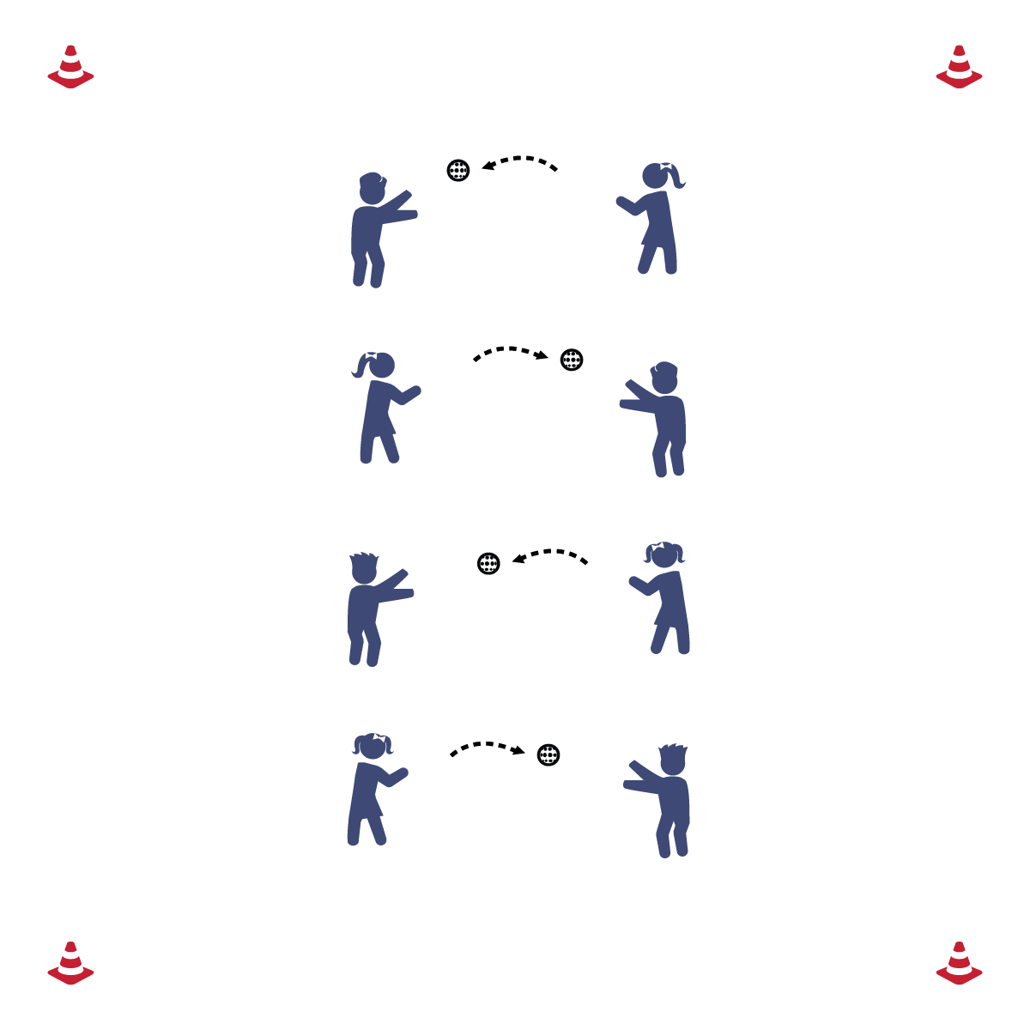

**Equipment**

* 1 ball per pair

**Set-up**

* Stand across from your partner with a ball.
* Be sure that all pairs are throwing in the same direction.

**How to play**

1. Throw & catch with your partner.
2. After 10 throws each, practice ground balls. Roll to your partner, she/he throws back to you. Each partner takes 5 ground balls then switch.
3. Next, practice pop-flies.

**THROW-RUN DERBY**

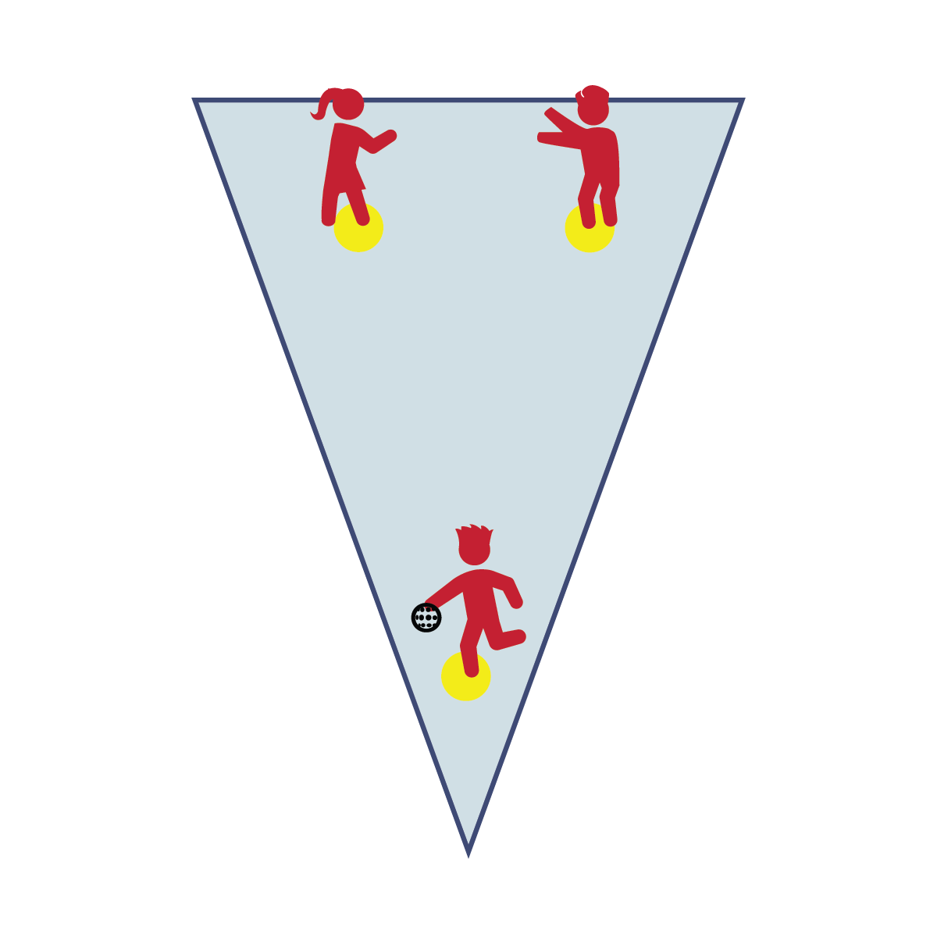

**Equipment**

* 1 ball per group
* 3 spot markers per group

**Set-Up**

* 2 spot markers are the “fence spots” and 1 spot marker is home base.
* 1 player is on home base. The other players scatter behind the fence spots.

**How to play**

1. The player on home base tries to throw a home-run beyond the fence spots without the ball being caught.
2. Take 3 throws and then rotate to a new batter.

**HOME-RUN DERBY**

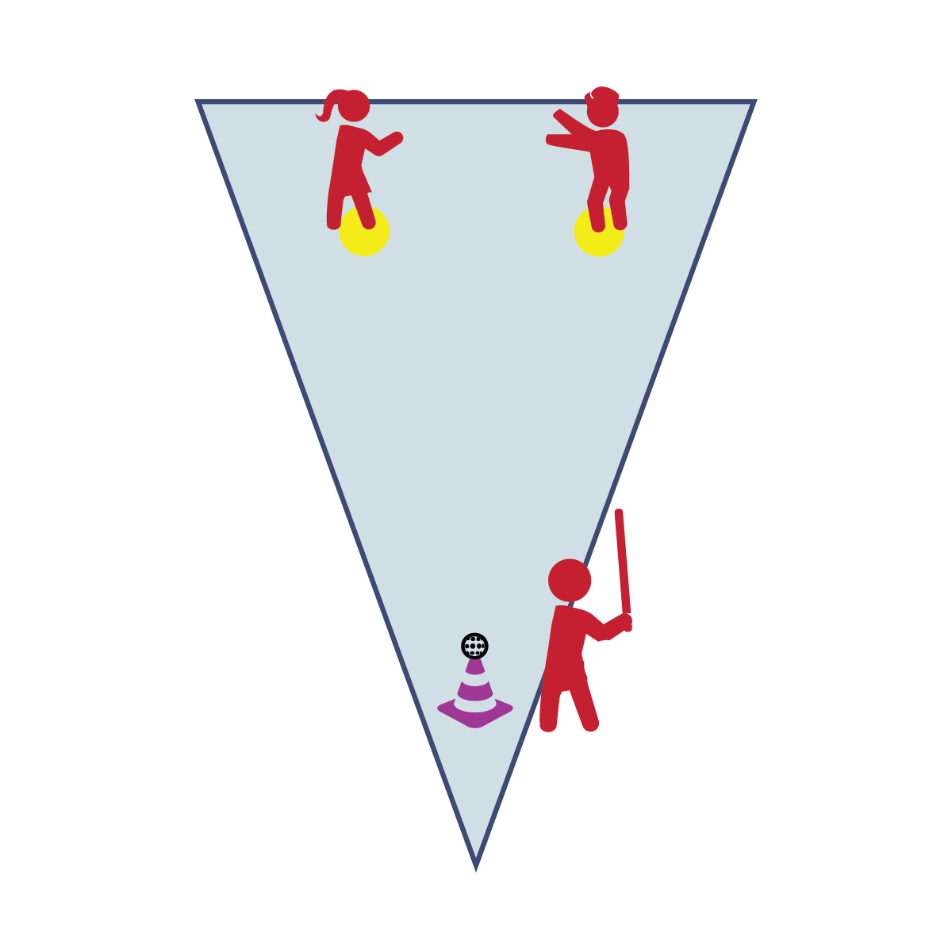

**Equipment**

* 1 tall cone, 1 ball, 1 bat, and  
  2 spot markers per group.

**Set-Up**

* 2 spot markers are the “fence spots” and the tall cone is home base.
* 1 player is the batter. The other players scatter behind the fence spots.

**How to play**

1. The batter at home base tries to hit a ball off of the cone for a home-run beyond the fence spots without the ball being caught.
2. Take 3 hits off of the cone and then rotate to a new batter.

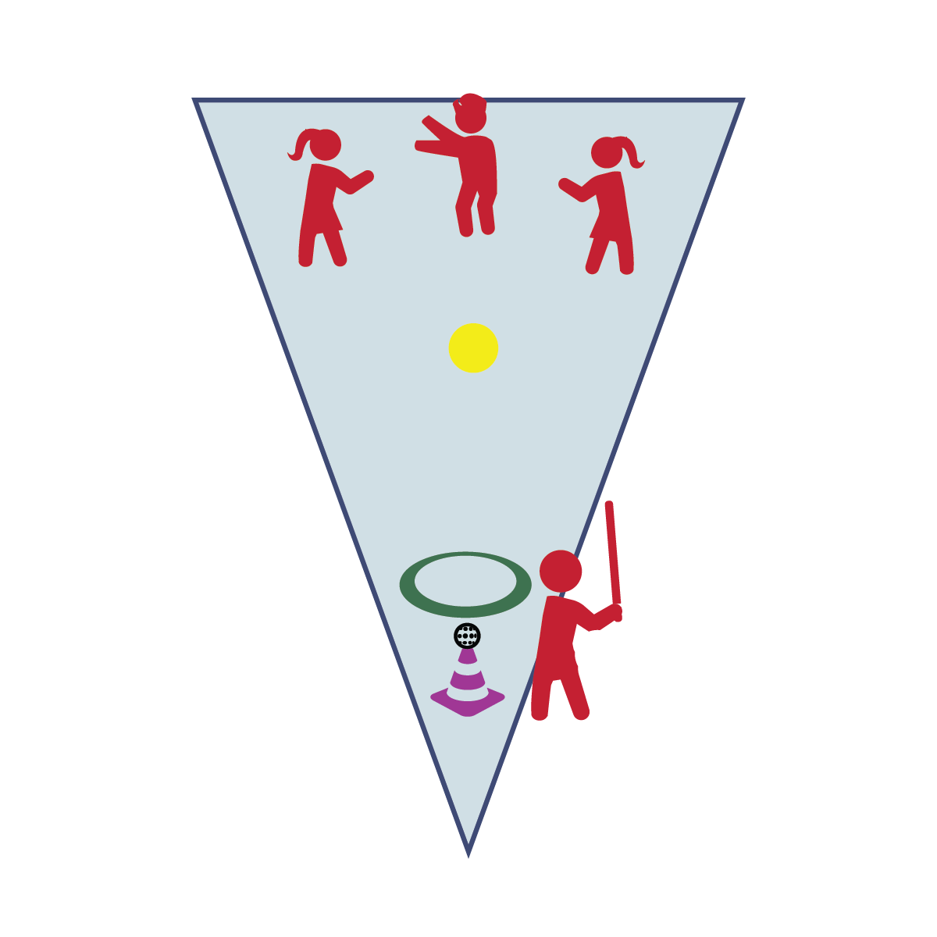

**Equipment**

* 1 tall cone, 1 ball, 1 bat, 1 hoop and1 spot marker per group.

**Set-Up**

* Place a spot marker at the center of the station area.
* Place ball, bat, and tall cone at the front of the area. Place a hoop in front of the cone.
* 1 player is the batter. The other players scatter behind the spot.

**How to play**

1. The batter hit the ball, places the bat in the hoop, and then runs to tag as many fielders as possible.
2. Each tag = 1 run.
3. Fielders make an out by getting the ball and making good relay throws to the spot marker.

**BASEBALL TAG**

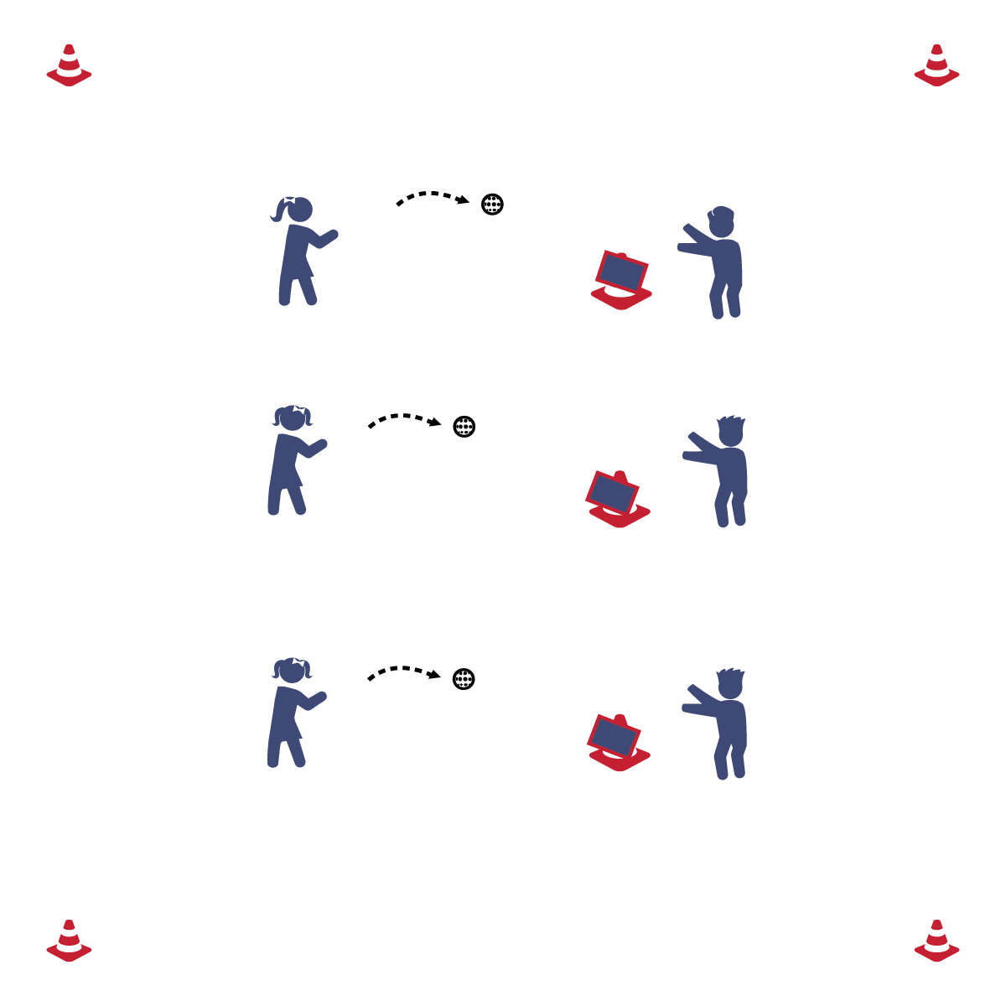

**Set-up**

* Cones are in a line so that all pairs are throwing in the same direction. 1 task tent hangs from each cone.
* 1 partner 30-40 ft. from the cone.
* The other partner next to the cone.

**How to play**

1. One partner is the pitcher and tries to throw the ball and hit the task tent.
2. The other partner stand behind the cone and throws the ball back after each pitch.
3. Change roles after 10 pitches.

**Equipment**

* 1 ball, 1 tall cone, and 1 task tent cone per pair.

**PITCHING PRACTICE**

**BATTING PRACTICE**

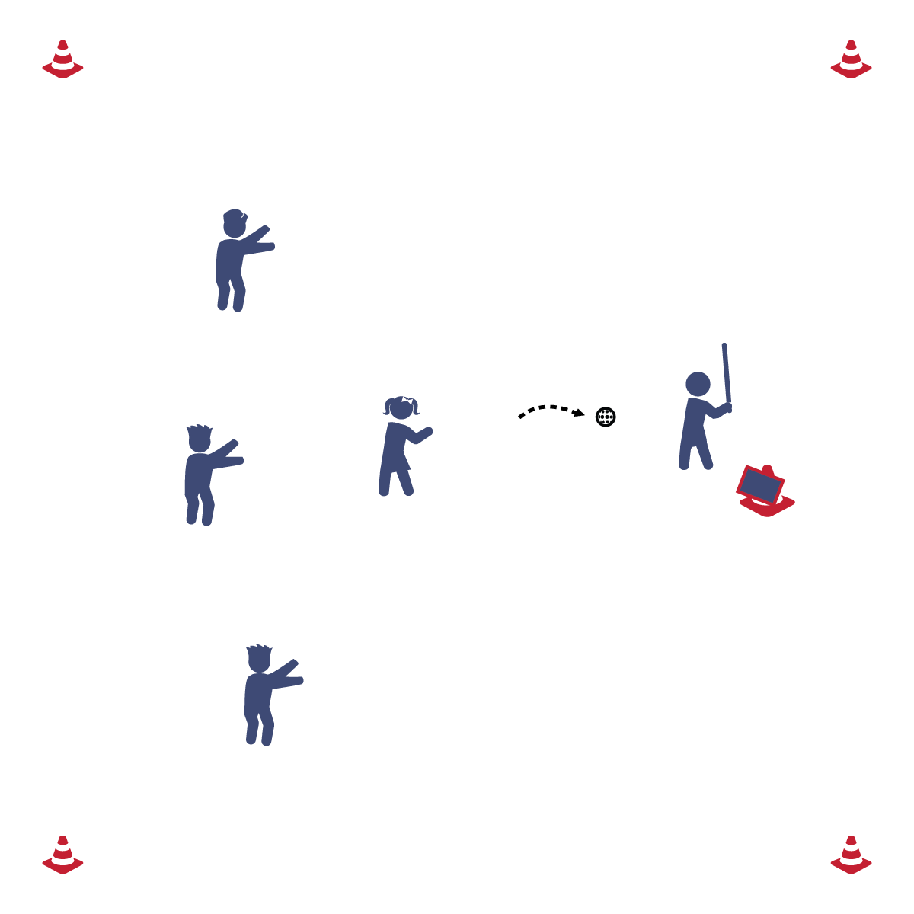

**Equipment**

* 1 ball, 1 bat, 1 tall cone, and 1 task tent.

**Set-up**

* 1 Cone is set up at the front of the area with a task tent over the top.
* 1 pitcher 30-40 ft. from the cone.
* 1 batter in front of and to the side of the cone. The cone creates a strike zone.
* Other players scattered in the field.

**How to play**

1. The Pitcher tries to throw strikes while the batter tries to hit strikes.
2. Each batter gets 3 strikes.
3. If the batter hits the ball, she/he gets to hit again.
4. After 3 strikes or 3 hits, rotate batters.



**SELF-ASSESSMENT**

1. Complete the Assessment for Bat and Ball Skills.
2. When finished, perform the following exercise sequence until it’s time to rotate to the next station:
   1. 3 push-ups
   2. 11 calf-raises
   3. 33 jumping jacks