­­

**TABATA WARM-UP**



* **Skill:** I will demonstrate fitness activities with proper form and attention to safety.
* **Cognitive:** I will answer questions related to safe participation in fitness activities.
* **Fitness:** I will pace my activity so that I increase my heart rate and warm up my muscles.
* **Personal & Social Responsibility:** I will work independently.

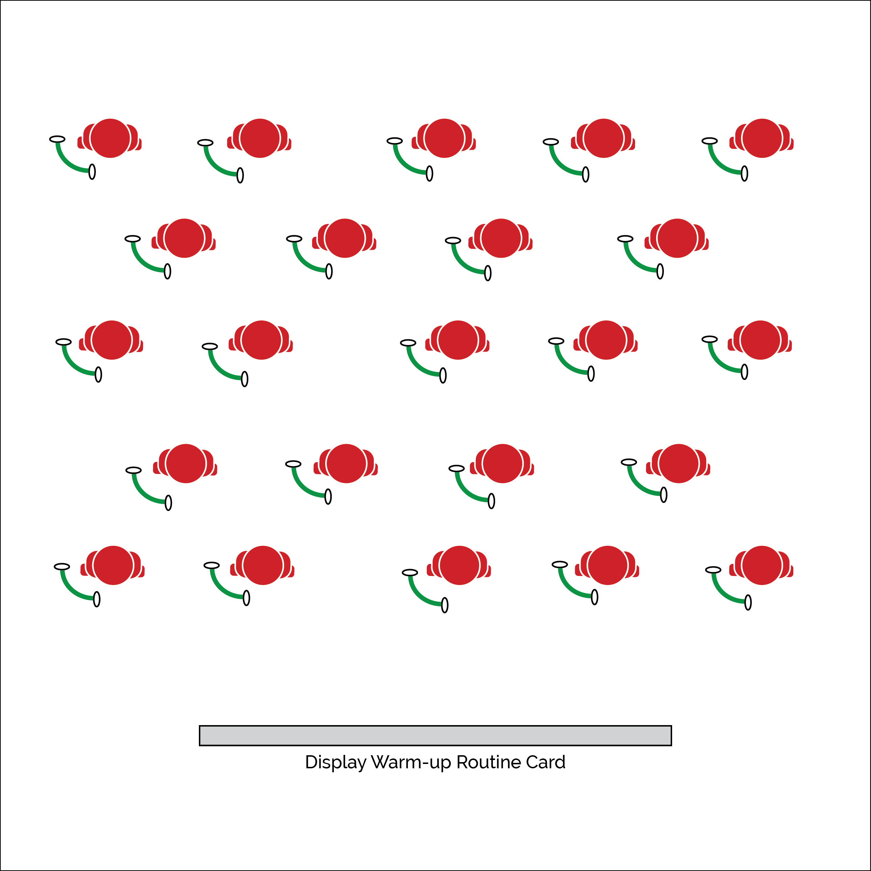

**Equipment:**

* Tabata Warm-Up Routine Card(s)
* 1 exercise resistance band per student
* Tabata audio cues (Tabata timer app)

**Set-Up:**

1. Set up a large activity area using cones or floor lines.
2. Place Tabata Warm-Up Routine Cards in task tents or display using a projector.
3. Scatter students in view of the Routine Cards and with enough personal space for safe movement.
4. Prepare Tabata audio cues using music player and/or a Tabata timer app.

**Activity Procedures:**

1. Each day of our Tabata module will begin with a 4-minute warm-up routine using an exercise resistance band. Tabata training was created by a Japanese scientist named Dr. Izumi Tabata. True Tabata workouts combine 20 seconds of vigorous activity with 10 seconds of rest in between each set. We may adjust our timing and intensity throughout the module, but it’s important to understand the history behind our workouts. Dr. Tabata’s research showed that even 4-minute workouts using his timing formula can have positive results on a person’s overall fitness.
2. On the start signal we’ll begin following the Tabata Warm-Up Routine Card that is displayed. On the stop signal, begin 10 seconds of rest and prepare for the next exercise on the routine card.
3. When the 4-minute routine is over, return your resistance band to the equipment storage area and get ready for our next activity.

**Grade Level Progression:**

**6 & 7:** Perform the warm-up as described above.

**8:** Allow students to create their own warm-up routines using the blank Tabata Routine Card.

* Follow Exercise Cues
* Listen for Start/Stop Signals
* Pace Your Activity to Warm-Up Your Muscles

**TABATA WARM-UP**



**Identify Critical Content:** Safe and appropriate participation is absolutely essential for the success of fitness instruction. By starting the Tabata module with a focus on safe participation, students will understand baseline expectations for their behavior and performance.



* **DOK 1:** How can you recognize appropriate and safe fitness participation?
* **DOK 2:** How do exercise/activity cues affect safe participation?
* **DOK 3:** How is appropriate behavior related to independent participation?



* Pair students to provide a guide for those who require assistance.
* Provide fitness activities at various levels of intensity and difficulty. Allow students to choose their level of participation.



* **Standard 3 [M1.6-8]** Describes how being physically active leads to a healthy body (6); Identifies barriers related to maintaining a physically active lifestyle and seeks solutions for eliminating those barriers (7); Identifies the five components of health-related fitness (muscle strength, muscle endurance, flexibility, cardiovascular endurance, and body composition) and explains the connections between fitness and overall physical and mental health (8).
* **Standard 3 [M6.6-8]** Participates in moderate to vigorous aerobic physical activity that includes intermittent or continuous aerobic physical activity of both moderate and vigorous intensity for at least 60 minutes per day (6); Participates in moderate to vigorous muscle- and bone-strengthening physical activity at least three times a week (7); Participates in moderate to vigorous aerobic and/or muscle- and bone-strengthening physical activity for at least 60 minutes per day at least five times a week (8).
* **Standard 4 [M7.6-8]** Uses physical activity and fitness equipment appropriately and safely, with the teacher’s guidance (6); Independently uses physical activity and exercise equipment appropriately and safely (7); Independently uses physical activity and fitness equipment appropriately and identifies specific safety concerns associated with the activity (8).



Appropriate, Equipment, Guidance, Identify, Independent, Safe, Safety Concerns, Set, Specific, Vigorous