­­

**FLIP FLOP DON’T STOP**

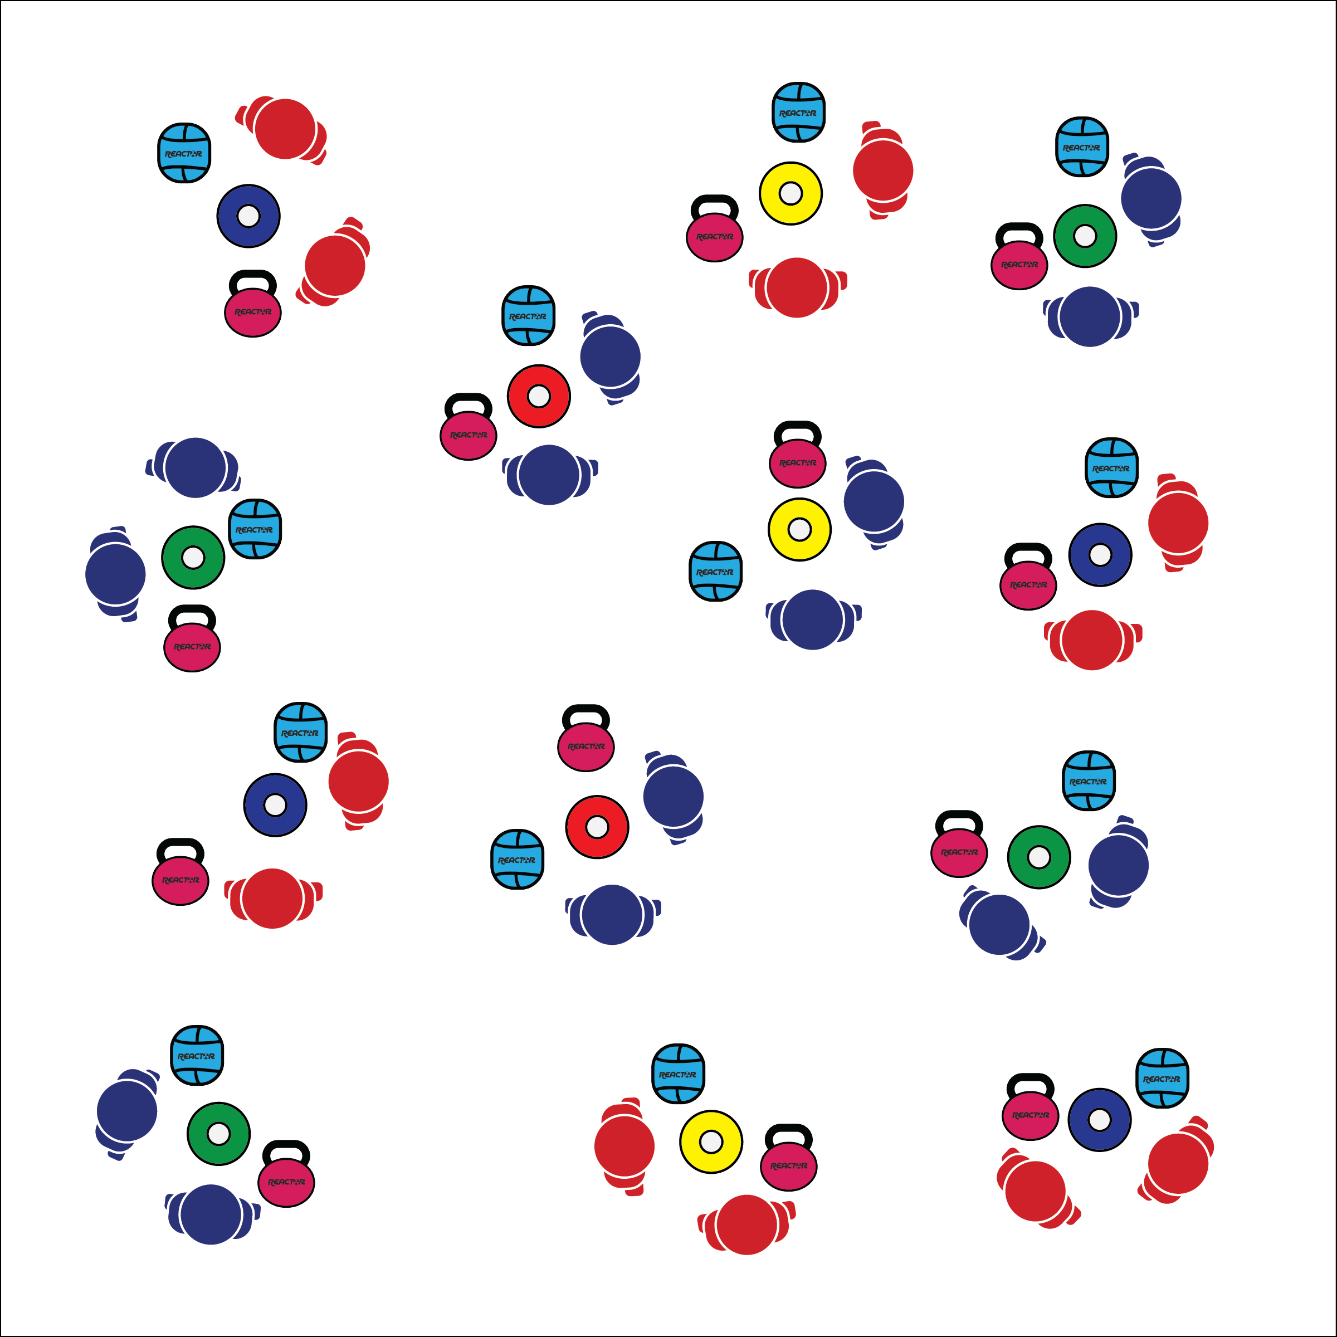

**Activity Procedures:**

1. Today’s Tabata workout is called Flip Flop Don’t Stop. Before we begin, you and your partner will create a short “Don’t Stop” handshake that you’ll be able to perform during each rest interval. This handshake has to have 2 components (e.g., a fist-bump and then a high-5) and also a short, encouraging phrase (e.g., “We won’t stop!).
2. On the start signal, 1 partner will begin with 1 piece of equipment and the other partner will use the other piece. Perform the 1st exercise on the Routine Card.
3. On the 10-second rest signal, quickly perform your handshake and then flip-flop (switch) equipment. Perform the 2nd exercise on the Routine Card.
4. Continue this interval pattern for an 8-minute Tabata workout.

**Grade Level Progression:**

**6:** Perform the activity as described above.

**7 & 8:** Provide blank Flip Flop Routine Cards. Allow pairs to create and perform their own routines.

* **Skill:** I will perform exercises with proper form and a focus on safety.
* **Cognitive:** I will discuss major muscles and body systems involved in performing this Tabata routine.
* **Fitness:** I will identify muscles used in each exercise interval.
* **Personal & Social Responsibility:** I will use encouraging language with my partner during each rest interval.

**Equipment:**

* 1 low profile cone per 2 students
* 2 different pieces of fitness equipment per pair of students (e.g., 1 medicine ball & 1 fitness band)
* Tabata audio cues (Tabata timer app)
* 1 8-Minute Tabata Flip Flop Routine Card
* 1 body systems assessment per pair of students
* Heart rate monitors (optional)

**Set-Up:**

1. Provide a home base using 1 low profile cone for each pair of students. Scatter home bases throughout the activity area.
2. Distribute fitness equipment according to class routine.

* Focus on Form and Safety
* Use Encouraging Language
* Have Fun

**FLIP FLOP DON’T STOP**



**Help students practice skills, strategies, and processes:** Tabata Flip Flop Routines provide a rich environment for practicing skills, strategies, and processes that are essential for lifelong fitness participation. First, students are performing fitness exercises in an encouraging setting where they can get feedback on form and safety. Next, they are practicing positive social interactions in a physical activity setting and learning the value of being active with a friend. Finally, they are working through the process of designing and performing their own Tabata routines.



* **DOK** **1:** How do you recognize the major muscles used in an exercise?
* **DOK 2:** What do you notice about how the muscles perform during an exercise?
* **DOK 3:** How is the respiratory system related to muscle performance?
* **DOK 4:** Design a Tabata Flip Flop Routine that includes exercises that work at least 4 major muscle groups.



* **Standard 3 [M14.6-8]** Identifies major muscles used in selected physical activities (6); Describes how muscles pull on bones to create movement in pairs by relaxing and contracting (7); Explains how body systems interact with one another (e.g., blood transports nutrients from the digestive system, oxygen from the respiratory system) during physical activity (8).
* **Standard 5 [M6.6-8]** Demonstrates respect for self and others in activities and games by following the rules, encouraging others, and playing within the spirit of the game or activity (6); Demonstrates the importance of social interaction by helping and encouraging others, avoiding trash talk, and providing support to classmates (7); Demonstrates respect for self by asking for help and helping others in various physical activities (8).



Muscle, Body Systems, Encourage, Positive Talk



* Provide a variety of equipment and exercises to match students’ abilities.
* Provide visual cues and demonstrations of each exercise.