­­

**TABATA WARM-UP**



* **Skill:** I will demonstrate fitness activities with proper form and attention to safety.
* **Cognitive:** I will answer questions related to safe participation in fitness activities.
* **Fitness:** I will pace my activity so that I increase my heart rate and warm up my muscles.
* **Personal & Social Responsibility:** I will work independently.

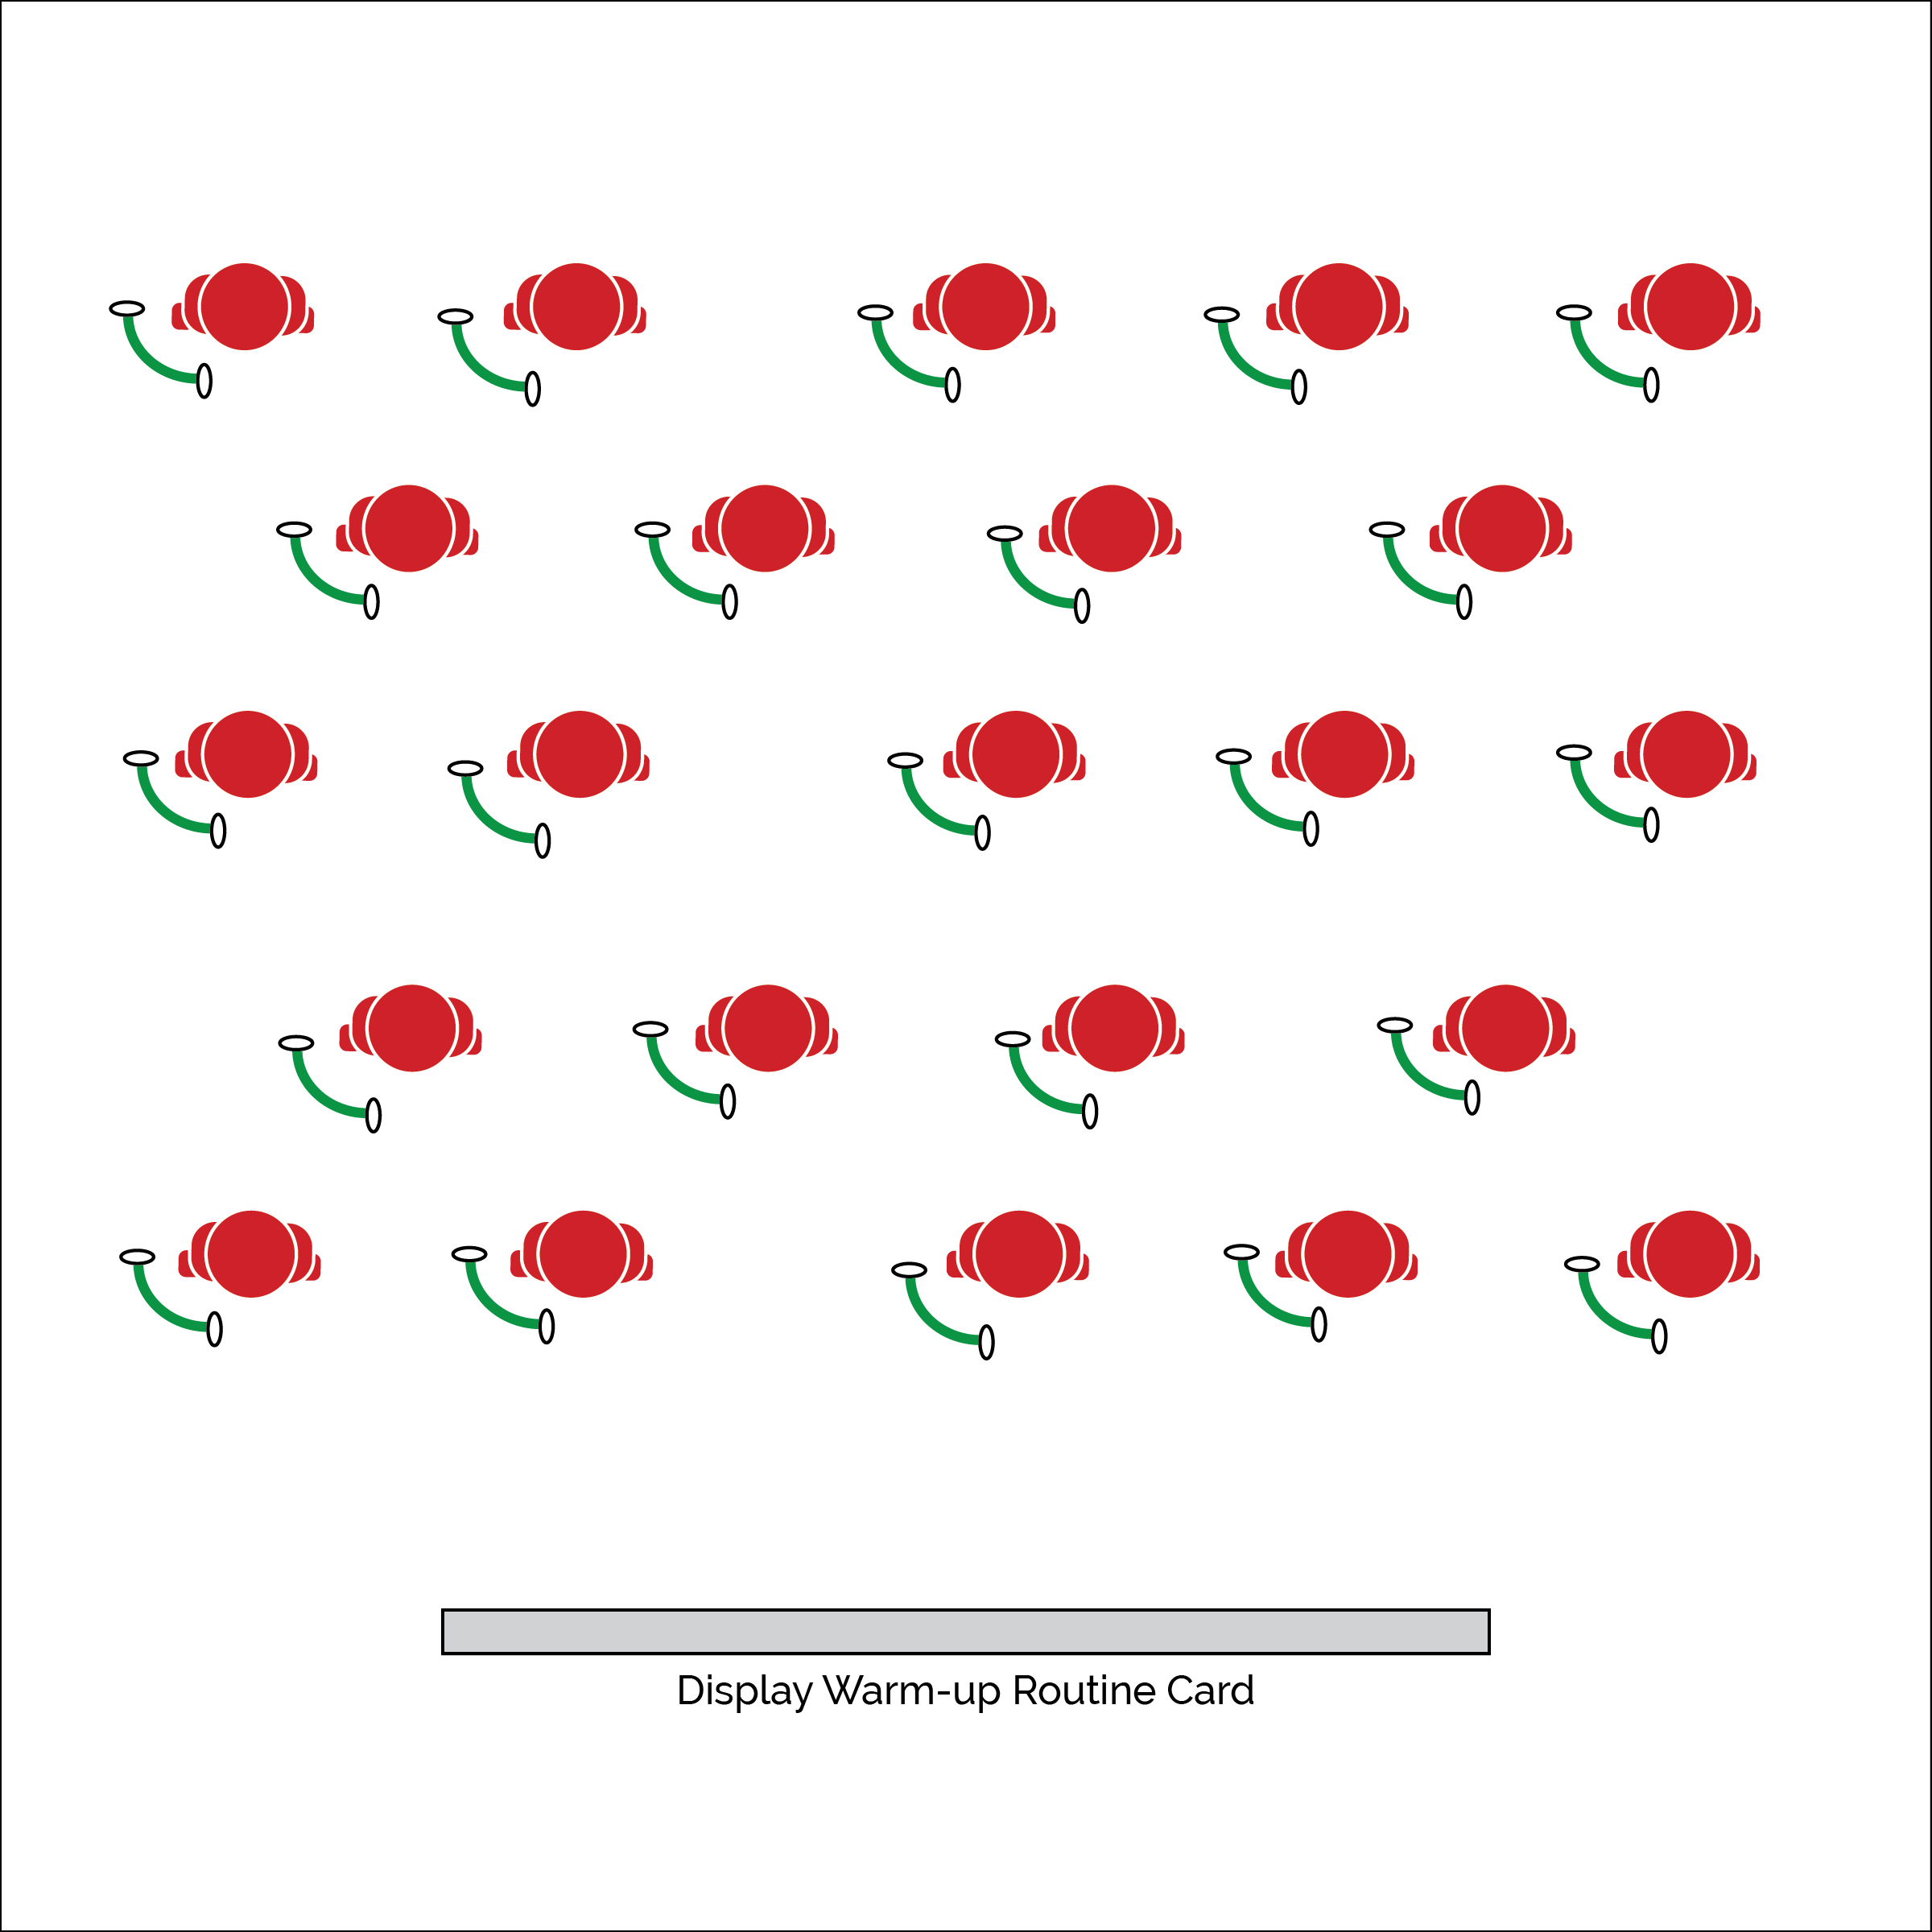

**Equipment:**

* Tabata Warm-Up Routine Card(s)
* 1 exercise resistance band per student
* Tabata audio cues (Tabata timer app)

**Set-Up:**

1. Set up a large activity area using cones or floor lines.
2. Place Tabata Warm-Up Routine Cards in task tents or display using a projector.
3. Scatter students in view of the Routine Cards and with enough personal space for safe movement.
4. Prepare Tabata audio cues using music player and/or a Tabata timer app.

**Activity Procedures:**

1. Each day of our Tabata module will begin with a 4-minute warm-up routine using an exercise resistance band. Tabata training was created by a Japanese scientist named Dr. Izumi Tabata. True Tabata workouts combine 20 seconds of vigorous activity with 10 seconds of rest in between each set. We may adjust our timing and intensity throughout the module, but it’s important to understand the history behind our workouts. Dr. Tabata’s research showed that even 4-minute workouts using his timing formula can have positive results on a person’s overall fitness.
2. On the start signal we’ll begin following the Tabata Warm-Up Routine Card that is displayed. On the stop signal, begin 10 seconds of rest and prepare for the next exercise on the routine card.
3. When the 4-minute routine is over, return your resistance band to the equipment storage area and get ready for our next activity.

**Grade Level Progression:**

**6 & 7:** Perform the warm-up as described above.

**8:** Allow students to create their own warm-up routines using the blank Tabata Routine Card.

* Follow Exercise Cues
* Listen for Start/Stop Signals
* Pace Your Activity to Warm-Up Your Muscles

**TABATA WARM-UP**



**Identify Critical Content:** Safe and appropriate participation is absolutely essential for the success of fitness instruction. By starting the Tabata module with a focus on safe participation, students will understand baseline expectations for their behavior and performance.



* **DOK 1:** How can you recognize appropriate and safe fitness participation?
* **DOK 2:** How do exercise/activity cues affect safe participation?
* **DOK 3:** How is appropriate behavior related to independent participation?



* Pair students to provide a guide for those who require assistance.
* Provide fitness activities at various levels of intensity and difficulty. Allow students to choose their level of participation.



* **Standard 3 [M1.6-8]** Describes how being physically active leads to a healthy body (6); Identifies barriers related to maintaining a physically active lifestyle and seeks solutions for eliminating those barriers (7); Identifies the five components of health-related fitness (muscle strength, muscle endurance, flexibility, cardiovascular endurance, and body composition) and explains the connections between fitness and overall physical and mental health (8).
* **Standard 3 [M6.6-8]** Participates in moderate to vigorous aerobic physical activity that includes intermittent or continuous aerobic physical activity of both moderate and vigorous intensity for at least 60 minutes per day (6); Participates in moderate to vigorous muscle- and bone-strengthening physical activity at least three times a week (7); Participates in moderate to vigorous aerobic and/or muscle- and bone-strengthening physical activity for at least 60 minutes per day at least five times a week (8).
* **Standard 4 [M7.6-8]** Uses physical activity and fitness equipment appropriately and safely, with the teacher’s guidance (6); Independently uses physical activity and exercise equipment appropriately and safely (7); Independently uses physical activity and fitness equipment appropriately and identifies specific safety concerns associated with the activity (8).



Appropriate, Equipment, Guidance, Identify, Independent, Safe, Safety Concerns, Set, Specific, Vigorous

## 

**Activity Procedures:**

1. It’s time to do another Tabata-style workout using a One & Done Routine Card.
2. Every routine card gives a list of exercises/activities to be completed during each set of the Tabata workout. This is called “one & done” because each exercise is only done 1 time during the routine.
3. The 1st card we are going to complete is the health-related routine. Listen to the start/stop signals to complete each exercise Tabata-style.
4. The 2nd card to complete is the skill-related routine. Again, use the start/stop signals to make your way through the routine.
5. When both routines are complete, write your name on an activity log sheet and begin completing your log.

**Grade Level Progression:**

**6:** Perform the activity as described above.

**7 & 8:** Allow students to create their own skill- and health-related routines using the blank Tabata Routine Card.

**Equipment:**

* 5 cones with task tents
* 5 Tabata One & Done Health-Related Routine Cards
* 5 Tabata One & Done Skill-Related Routine Cards
* See routine cards for equipment needed
* 1 physical activity log sheet per student
* Tabata audio cues (Tabata timer app)

**Set-Up:**

1. Place cones around the perimeter of the activity area with space for students to exercise safely.
2. Place Health-Related Routine Cards in the front side of each task tent.
3. Place Skill-Related Routine Cards in the back side of each task tent.
4. Place activity log sheets under each cone.

* **Skill:** I will demonstrate fitness activities with proper form and attention to safety.
* **Cognitive:** I will identify and discuss the components of heath- and skill-related fitness.
* **Fitness:** I will maintain a physical activity log for the duration of this Tabata module.
* **Personal & Social Responsibility:** I will focus on safe and appropriate participation.
* Follow Exercise Cues
* Listen for Start/Stop Signals
* Maintain Exercise Intensity

**ONE AND DONE**

**ONE AND DONE**



**Organize students to interact with content:** Identifying, distinguishing, comparing, and contrasting are all tasks that are cognitive in nature. Organizing students so that they experience the relevance of health- and skill-related fitness within a physical activity context will help them process the experience in order to successfully complete cognitive tasks.



* Modify routine cards and exercises to meet the needs of all students.
* Decrease the intensity of this activity by providing a longer rest interval.



* **Standard 3 [M6.6-8]** Participates in moderate to vigorous aerobic physical activity that includes intermittent or continuous aerobic physical activity of both moderate and vigorous intensity for at least 60 minutes per day (6); Participates in moderate to vigorous muscle- and bone-strengthening physical activity at least three times a week (7); Participates in moderate to vigorous aerobic and/or muscle- and bone-strengthening physical activity for at least 60 minutes per day at least five times a week (8).
* **Standard 3 [M7.6-8]** Identifies the components of skill- related fitness (6); Distinguishes between health-related and skill-related fitness (7); Compares and contrasts health-related fitness components (8).
* **Standard 3 [M16.6-8]** Maintains a physical activity log for at least two weeks and reflects on activity levels as documented in the log (6); Maintains a physical activity and nutrition log for at least two weeks and reflects on activity levels and nutrition as documented in the log (7); Designs and implements a program to improve levels of health-related fitness and nutrition (8).
* **Standard 4 [M7.6-8]** Uses physical activity and fitness equipment appropriately and safely, with the teacher’s guidance (6); Independently uses physical activity and exercise equipment appropriately and safely (7); Independently uses physical activity and fitness equipment appropriately and identifies specific safety concerns associated with the activity (8).



* **DOK 1:** What is skill-related fitness? What is health-related fitness?
* **DOK 2:** What is the difference between health-related and skill-related fitness?
* **DOK 3:** How is skill-related fitness related to health-related fitness?
* **DOK 4:** Work with a partner to develop a new Tabata routine that focuses on health-related fitness. Next develop a routine with a focus on skill-related fitness.



Compare, Contrast, Distinguish, Health-Related Fitness, Skill-Related Fitness

­­

**DOUBLE OR NOTHING**

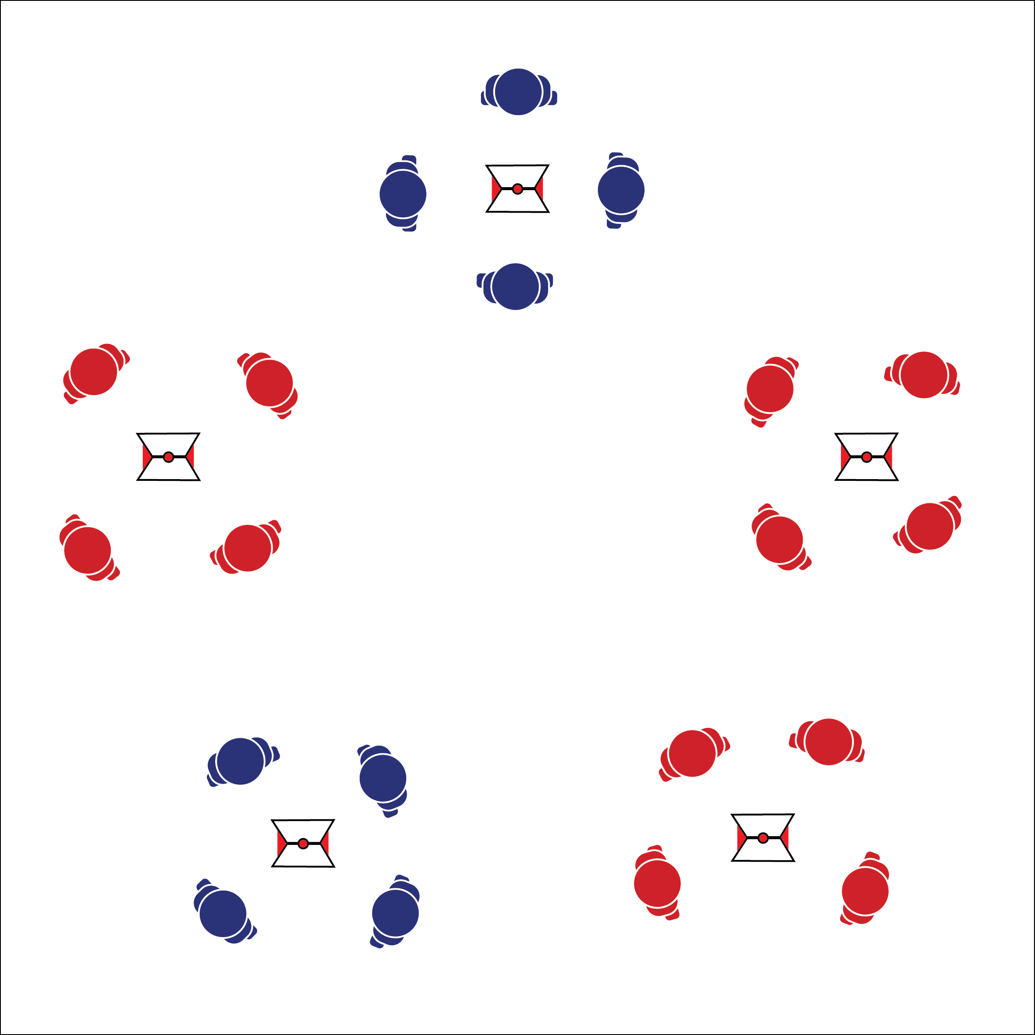

* **Skill:** I will demonstrate fitness activities with proper form and attention to safety.
* **Cognitive:** I will identify and discuss major muscles and body systems as they relate to Tabata workouts.
* **Fitness:** I will maintain a physical activity log for the duration of this Tabata Module.
* **Personal & Social Responsibility:** I will focus on safe and appropriate participation.
* Follow Exercise Cues
* Listen for Start/Stop Signals
* Maintain Exercise Intensity

**Equipment:**

* 5 (or more) cones with task tents
* 5 (or more) Tabata Double or Nothing Routine Cards
* See routine cards for equipment needed
* 1 physical activity log sheet per student
* Tabata audio cues (Tabata timer app)

**Set-Up:**

1. Place cones around the perimeter of the activity area with space for students to exercise safely.
2. Place Double or Nothing Routine Cards in the front side of each task tent.
3. Place activity log sheets in an area accessible to students.

**Activity Procedures:**

1. It’s time for a Tabata-style workout called Double or Nothing.
2. Each routine card gives a list of exercises/activities to be completed during each set of the Tabata workout. This is called “Double or Nothing” because every exercise is done twice in a row. Keep track of how many repetitions you complete in the 1st set of each exercise. Then, on the 2nd set, try to increase or sustain that number while also maintaining perfect exercise form.
3. Listen to the start/stop signals to complete each exercise Tabata-style. After completing a full routine card, we’ll rotate to a new card and begin again.
4. When both routines are complete, find your activity log sheet from previous lessons and continue completing your log.

**Grade Level Progression:**

**6:** Perform the activity as described above.

**7 & 8:** Allow students to create their own Double or Nothing routines using the blank Tabata Routine Card.

**DOUBLE OR NOTHING**



* Provide various routine cards and exercises to meet the needs of all students.
* Decrease the intensity of this activity by providing a longer rest interval.



* **Standard 3 [M14.6-8]** Identifies major muscles used in selected physical activities (6); Describes how muscles pull on bones to create movement in pairs by relaxing and contracting (7); Explains how body systems interact with one another (e.g., blood transports nutrients from the digestive system, oxygen from the respiratory system) during physical activity (8).
* **Standard 4 [M7.6-8]** Uses physical activity and fitness equipment appropriately and safely, with the teacher’s guidance (6); Independently uses physical activity and exercise equipment appropriately and safely (7); Independently uses physical activity and fitness equipment appropriately and identifies specific safety concerns associated with the activity (8).
* **Standard 5 [M1.6-8]** Describes how being physically active leads to a healthy body (6); Identifies different types of physical activities and describes how each exerts a positive impact on health (7); Identifies the five components of health-related fitness (muscle strength, muscle endurance, flexibility, cardiovascular endurance, and body composition) and explains the connections between fitness and overall physical and mental health (8).



* **DOK 1:** What are body systems?
* **DOK 2:** What do you know about different body systems?
* **DOK 3:** How is exercise related to different body systems? (Choose a system and discuss that system’s relationship to exercise.)
* **DOK 4:** What information can you gather to support your ideas about exercise and body systems? (Teachers can assign this question as an internet scavenger hunt.)



**Manage response rates with tiered questioning techniques:** Teachers’ use of the DOK question set above provides the class with purposeful discussion prompts that ascend in cognitive complexity in order to push students to deepen their thinking about the content presented. Use a “turn-and-talk” strategy to ensure that all students discuss the topic. Next, “cold call” on students without asking for volunteers. This will allow you to hear from students who might not otherwise present if given the choice. Finally, be sure that all answers are supported by evidence and/or contain details. One- and two-word answers are not acceptable.



Major Muscles, Muscle, Bone, Relax, Contract, Body Systems, Interact, Blood, Nutrients, Digestive System, Oxygen, Respiratory System

## 

**Activity Procedures:**

1. It’s time for a cooperative Tabata-style workout called Mirror-Mirror.
2. Each exercise card gives a list of exercises/activities that can be completed during 1 set of the Tabata workout. This is called “Mirror-Mirror” because Partner A will choose an exercise during the 1st set, and Partner B will “mirror” her/his movements. When the music stops and starts again, Partner B will choose an exercise, and Partner A will “mirror” her/his movements. (Complete one 4-minute Tabata workout using this format.)
3. Next we’ll repeat this activity, but Partner A will complete muscle-strengthening exercises, and Partner B will complete bone-strengthening exercises. Keep in mind that some exercises may be both (bone- and muscle-strengthening).
4. Now that we’ve completed two 4-minute routines, find your activity log sheet from previous lessons and continue completing your log.

**Grade Level Progression:**

**6:** Perform the activity as described above.

**7 & 8:** Allow students to create their own list of bone- and muscle-strengthening exercises.

**Equipment:**

* 5 (or more) cones with task tents
* 5 (or more) Mirror-Mirror Exercise Cards
* See exercise cards for equipment needed
* 1 physical activity log sheet per student
* Tabata audio cues (Tabata timer app)

**Set-Up:**

1. Place cones around the perimeter of the activity area with space for students to exercise safely.
2. Place Mirror-Mirror Cards in the front side of each task tent or display them using a projector that can be seen by all students.
3. Place activity log sheets in an area accessible to students.

* **Skill:** I will demonstrate fitness activities with proper form and attention to safety.
* **Cognitive:** I will identify exercises that work to improve both muscle and bone strength.
* **Fitness:** I will perform exercises that work to improve both muscle and bone strength.
* **Personal & Social Responsibility:** I will focus on safe and appropriate participation.
* Demonstrate Exercise Cues
* Listen for Start/Stop Signals
* Maintain Exercise Intensity

**MIRROR-MIRROR**

**MIRROR-MIRROR**



* Decrease the intensity of this activity by providing a longer rest interval.
* Don’t limit exercise choices to bone- and muscle-strengthening options. Give other options that meet the needs of your students.



* **DOK 1:** How can you recognize a bone-strengthening exercise? A muscle-strengthening exercise?
* **DOK 2:** How would you compare and/or contrast bone-strengthening with muscle-strengthening exercises?
* **DOK 3:** How are muscle- and bone-strengthening exercises related to a physically active lifestyle?
* **DOK 4:** Develop a comprehensive exercise program that will help you incorporate muscle- and bone-strengthening activity into your weekly routine at least 5 times per week.



Aerobic Activity, Bone-Strengthening Exercise, Continuous, Intermittent, Moderate Intensity, Muscle-Strengthening Exercise, Physically Active Lifestyle, Program, Vigorous Intensity



* **Standard 3 [M6.6-8]** Participates in moderate to vigorous aerobic physical activity that includes intermittent or continuous aerobic physical activity of both moderate and vigorous intensity for at least 60 minutes per day (6); Participates in moderate to vigorous muscle- and bone-strengthening physical activity at least three times a week (7); Participates in moderate to vigorous aerobic and/or muscle- and bone-strengthening physical activity for at least 60 minutes per day at least five times a week (8).
* **Standard 3 [M7.6-8]** Identifies the components of skill- related fitness (6); Distinguishes between health-related and skill-related fitness (7); Compares and contrasts health-related fitness components (8).
* **Standard 4 [M7.6-8]** Uses physical activity and fitness equipment appropriately and safely, with the teacher’s guidance (6); Independently uses physical activity and exercise equipment appropriately and safely (7); Independently uses physical activity and fitness equipment appropriately and identifies specific safety concerns associated with the activity (8).



**Help students examine similarities and differences:** Muscle- and bone-strengthening exercises are essential for good physical health across a person’s lifespan. However, many programs fail to help students classify activities for future lifestyle planning. Deeply discussing these elements of good health allows students to examine the concepts as well as their current and future activity choices with the skills and knowledge needed to make appropriate lifestyle choices.

­­

**FLIP FLOP DON’T STOP**

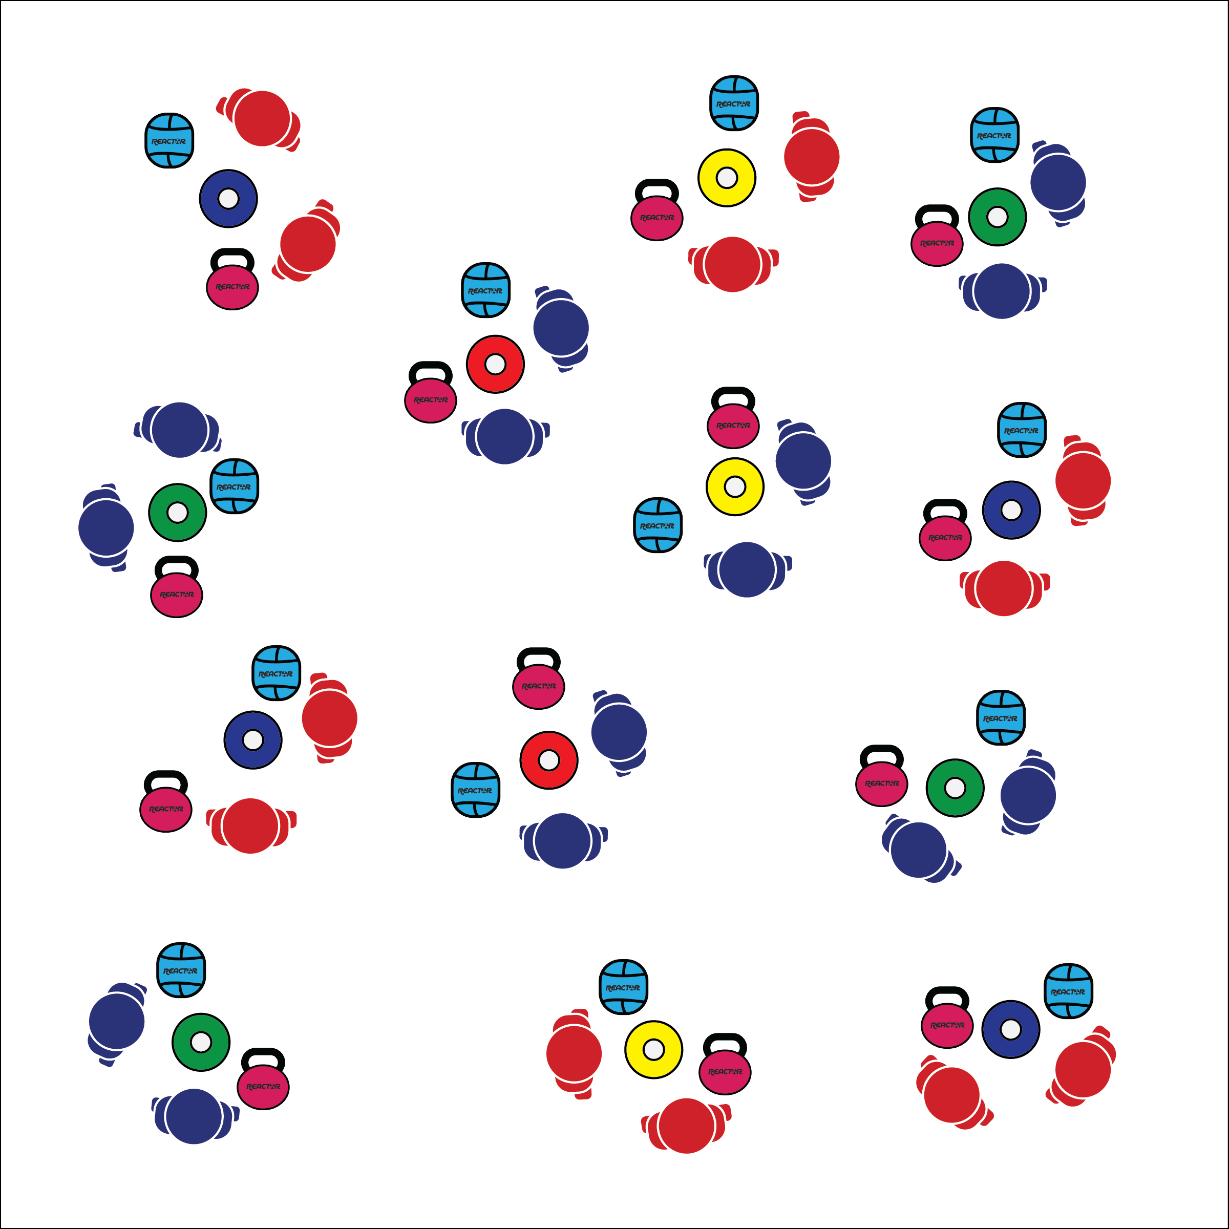

**Activity Procedures:**

1. Today’s Tabata workout is called Flip Flop Don’t Stop. Before we begin, you and your partner will create a short “Don’t Stop” handshake that you’ll be able to perform during each rest interval. This handshake has to have 2 components (e.g., a fist-bump and then a high-5) and also a short, encouraging phrase (e.g., “We won’t stop!).
2. On the start signal, 1 partner will begin with 1 piece of equipment and the other partner will use the other piece. Perform the 1st exercise on the Routine Card.
3. On the 10-second rest signal, quickly perform your handshake and then flip-flop (switch) equipment. Perform the 2nd exercise on the Routine Card.
4. Continue this interval pattern for an 8-minute Tabata workout.

**Grade Level Progression:**

**6:** Perform the activity as described above.

**7 & 8:** Provide blank Flip Flop Routine Cards. Allow pairs to create and perform their own routines.

* **Skill:** I will perform exercises with proper form and a focus on safety.
* **Cognitive:** I will discuss major muscles and body systems involved in performing this Tabata routine.
* **Fitness:** I will identify muscles used in each exercise interval.
* **Personal & Social Responsibility:** I will use encouraging language with my partner during each rest interval.

**Equipment:**

* 1 low profile cone per 2 students
* 2 different pieces of fitness equipment per pair of students (e.g., 1 medicine ball & 1 fitness band)
* Tabata audio cues (Tabata timer app)
* 1 8-Minute Tabata Flip Flop Routine Card
* 1 body systems assessment per pair of students
* Heart rate monitors (optional)

**Set-Up:**

1. Provide a home base using 1 low profile cone for each pair of students. Scatter home bases throughout the activity area.
2. Distribute fitness equipment according to class routine.

* Focus on Form and Safety
* Use Encouraging Language
* Have Fun

**FLIP FLOP DON’T STOP**



**Help students practice skills, strategies, and processes:** Tabata Flip Flop Routines provide a rich environment for practicing skills, strategies, and processes that are essential for lifelong fitness participation. First, students are performing fitness exercises in an encouraging setting where they can get feedback on form and safety. Next, they are practicing positive social interactions in a physical activity setting and learning the value of being active with a friend. Finally, they are working through the process of designing and performing their own Tabata routines.



* **DOK** **1:** How do you recognize the major muscles used in an exercise?
* **DOK 2:** What do you notice about how the muscles perform during an exercise?
* **DOK 3:** How is the respiratory system related to muscle performance?
* **DOK 4:** Design a Tabata Flip Flop Routine that includes exercises that work at least 4 major muscle groups.



* **Standard 3 [M14.6-8]** Identifies major muscles used in selected physical activities (6); Describes how muscles pull on bones to create movement in pairs by relaxing and contracting (7); Explains how body systems interact with one another (e.g., blood transports nutrients from the digestive system, oxygen from the respiratory system) during physical activity (8).
* **Standard 5 [M6.6-8]** Demonstrates respect for self and others in activities and games by following the rules, encouraging others, and playing within the spirit of the game or activity (6); Demonstrates the importance of social interaction by helping and encouraging others, avoiding trash talk, and providing support to classmates (7); Demonstrates respect for self by asking for help and helping others in various physical activities (8).



Muscle, Body Systems, Encourage, Positive Talk



* Provide a variety of equipment and exercises to match students’ abilities.
* Provide visual cues and demonstrations of each exercise.

**TABATA INTERVAL STATIONS**

## 

**Activity Procedures:**

1. It’s time for Tabata interval training. Today’s workout will be a full 16 minutes. We’ll work to pace our activity so that we maintain a heart rate in our target zone.
2. Prepare to begin the exercise designated for your row of spot markers. Start when the music begins. On the signal, stop your exercise and move to the spot to your left. Prepare to start the new exercise and begin on the signal. The station on the far left will move quickly around the circuit to the spots on the far right.
3. Again, pace your movement so that you stay in the target heart rate zone.

**Grade Level Progression:**

**6-8:** Perform the activity as described above.

**Equipment:**

* 1 spot marker per student
* 6 cones with task tents (use 6-color set if available)
* Interval Station Cards
* Equipment specific to each station card
* Tabata audio cues (Tabata timer app)
* Heart rate monitors (optional)

**Set-Up:**

1. Place cones in a line along 1 side of the activity area.
2. Place Interval Station Cards in task tents on each cone.
3. Distribute spot markers in a line behind each cone with space for safe movement. Color-coordinate spots with cones if possible.
4. Distribute station equipment at corresponding spots.

* Move Safely
* Rotate Quickly
* Keep Your Pace
* **Skill:** I will adjust exercise intensity in order to work in my target zone.
* **Cognitive:** I will discuss best safety practices in exercise environments.
* **Fitness:** I will increase my heart rate into a target zone.
* **Personal & Social Responsibility:** I will work in self-space with awareness of and respect for others.



Blood, Body Systems, Contract, Interact, Nutrients, Oxygen, Relax, Respiratory System, Type



* **DOK 1:** What would you in include on a list about how being physically active leads to a health body?
* **DOK 2:** How can different types of activities have positive impacts on your health?
* **DOK 3:** Can you formulate a theory for the positive impacts of different activities on health? How would you test/prove your theory to be correct?
* **DOK 4:** Analyze the consequences of past behavior with respect to lifestyle and physical activity. How have your choices and behaviors either enhanced or hindered your health? Why?



* Change the duration of work and rest intervals.
* Provide modifications at each station and allow students to work at the level of their choice.



* **Standard 3 [M6.6-8]** Participates in moderate to vigorous aerobic physical activity that includes intermittent or continuous aerobic physical activity of both moderate and vigorous intensity for at least 60 minutes per day (6); Participates in moderate to vigorous muscle- and bone-strengthening physical activity at least three times a week (7); Participates in moderate to vigorous aerobic and/or muscle- and bone-strengthening physical activity for at least 60 minutes per day at least five times a week (8).
* **Standard 3 [M16.6-8]** Maintains a physical activity log for at least two weeks and reflects on activity levels as documented in the log (6); Maintains a physical activity and nutrition log for at least two weeks and reflects on activity levels and nutrition as documented in the log (7); Designs and implements a program to improve levels of health-related fitness and nutrition (8).
* **Standard 4 [M7.6-8]** Uses physical activity and fitness equipment appropriately and safely, with the teacher’s guidance (6); Independently uses physical activity and exercise equipment appropriately and safely (7); Independently uses physical activity and fitness equipment appropriately and identifies specific safety concerns associated with the activity (8).
* **Standard 5 [M1.6-8]** Describes how being physically active leads to a healthy body (6); Identifies different types of physical activities and describes how each exerts a positive impact on health (7); Identifies the five components of health-related fitness (muscle strength, muscle endurance, flexibility, cardiovascular endurance, and body composition) and explains the connections between fitness and overall physical and mental health (8).



**Help students elaborate on content:** The debrief question set above requires students to make inferences about the information presented in class as it relates to prior experiences and past behavior. Allow students to explore these inferences through focused discussion, prompting them to give evidence and context to support their thinking.

**TABATA INTERVAL STATIONS**