­­­

­

* **Standard 3 [M1.6-8]** Describes how being physically active leads to a healthy body (6); Identifies barriers related to maintaining a physically active lifestyle and seeks solutions for eliminating those barriers (7); Identifies the five components of health-related fitness (muscle strength, muscle endurance, flexibility, cardiovascular endurance, and body composition) and explains the connections between fitness and overall physical and mental health (8).
* **Standard 4 [M7.6-8]** Uses physical activity and fitness equipment appropriately and safely, with the teacher’s guidance (6); Independently uses physical activity and exercise equipment appropriately and safely (7); Independently uses physical activity and fitness equipment appropriately and identifies specific safety concerns associated with the activity (8).
* **Skill:** I will demonstrate fitness activities with proper form and attention to safety.
* **Cognitive:** I will answer questions related to safe participation in fitness activities.
* **Fitness:** I will pace my activity so that I increase my heart rate and warm up my muscles.
* **Personal & Social Responsibility:** I will work independently.
* Appropriate
* Equipment
* Independent
* Safety Concerns
* Health-Related Fitness
* Skill-Related Fitness
* Physical Activity Log Sheets

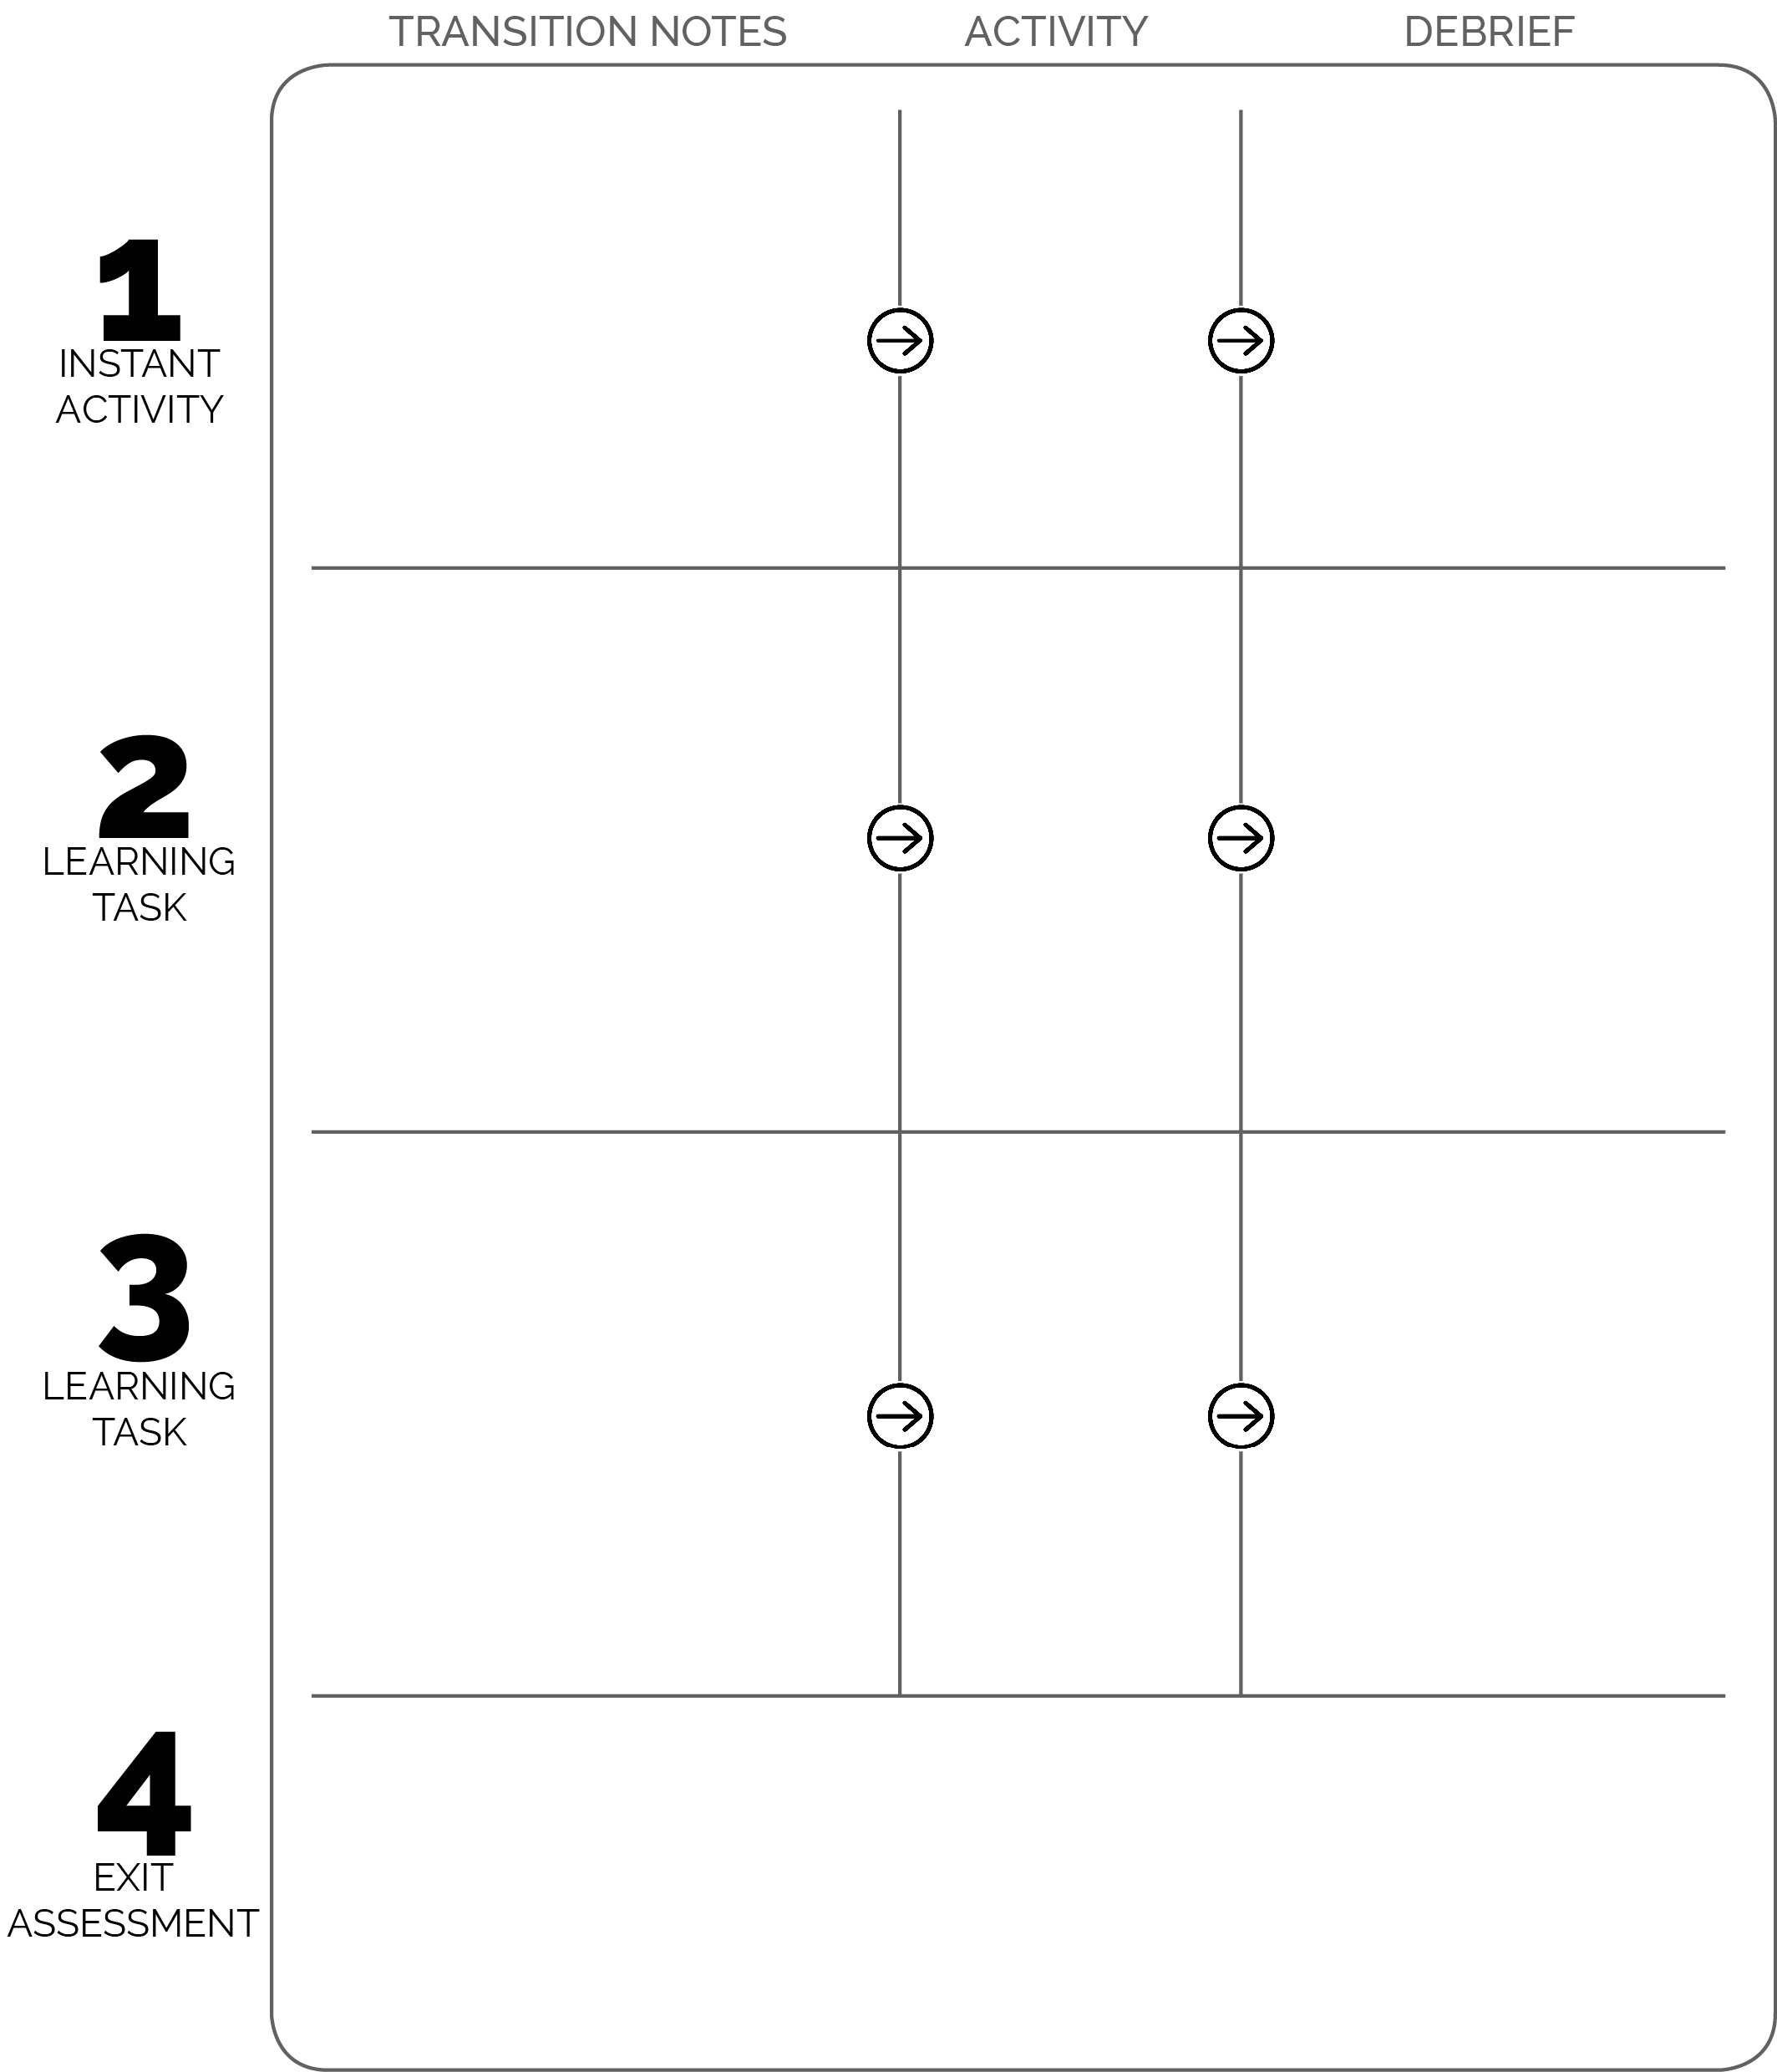

**DOK 1:** What are the components of skill-related fitness?  
**DOK 2:** How does skill-related fitness affect your ability to reach goals?  
**DOK 3:** How are the components of skill-related fitness related to Empire Tag?

**DOK 1:** How can you recognize appropriate and safe fitness participation?

**DOK 2:** How do exercise/activity cues affect safe participation?

**DOK 3:** How is appropriate behavior related to independent participation?

Students complete physical activity log sheets immediately after the One and Done Tabata session. They’ll collect the sheets from Task Tent stations and will then place completed work in the student work folder placed by the locker room door.

Students are provided an appropriate amount of time to complete the logs. Next, students help clear Tabata stations and equipment in preparation for Empire Tag (secondary instant activity).

Empire Tag

**Use debrief time to introduce student activity logs.**

One and Done

After warm-up debrief is done, students have 30 seconds to walk the perimeter and choose a One and Done routine to complete. All choices will be based on their routine preference or social groups. Complete health-related routine first, then complete skill-related card.

Tabata Warm-Up

Students enter the activity area to see a warm-up routine posted on the wall via a computer and projector. As students enter, they read the exercises and practice each. If a student does not know the exercise, she/he can ask a classmate. When all students arrive, begin warm-up.