

**SPEED**

**ROPE**

Jump Rope





**UPRIGHT ROWS**



Resistance Band



Medicine Ball



**HALF-JACK MED-BALL SQUEEZE**

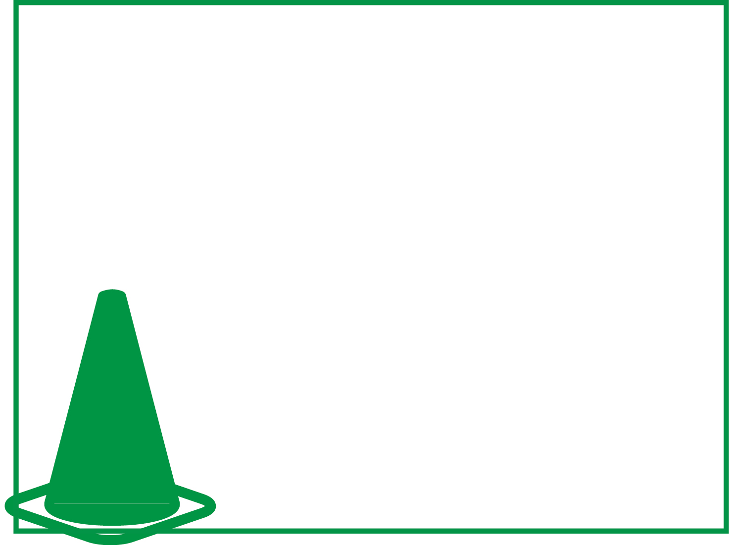

**KB SQUATS**

Kettle Bell





**PLANK ARM RAISES**

No Equipment





**BASIC CRUNCH**

Exercise Ball