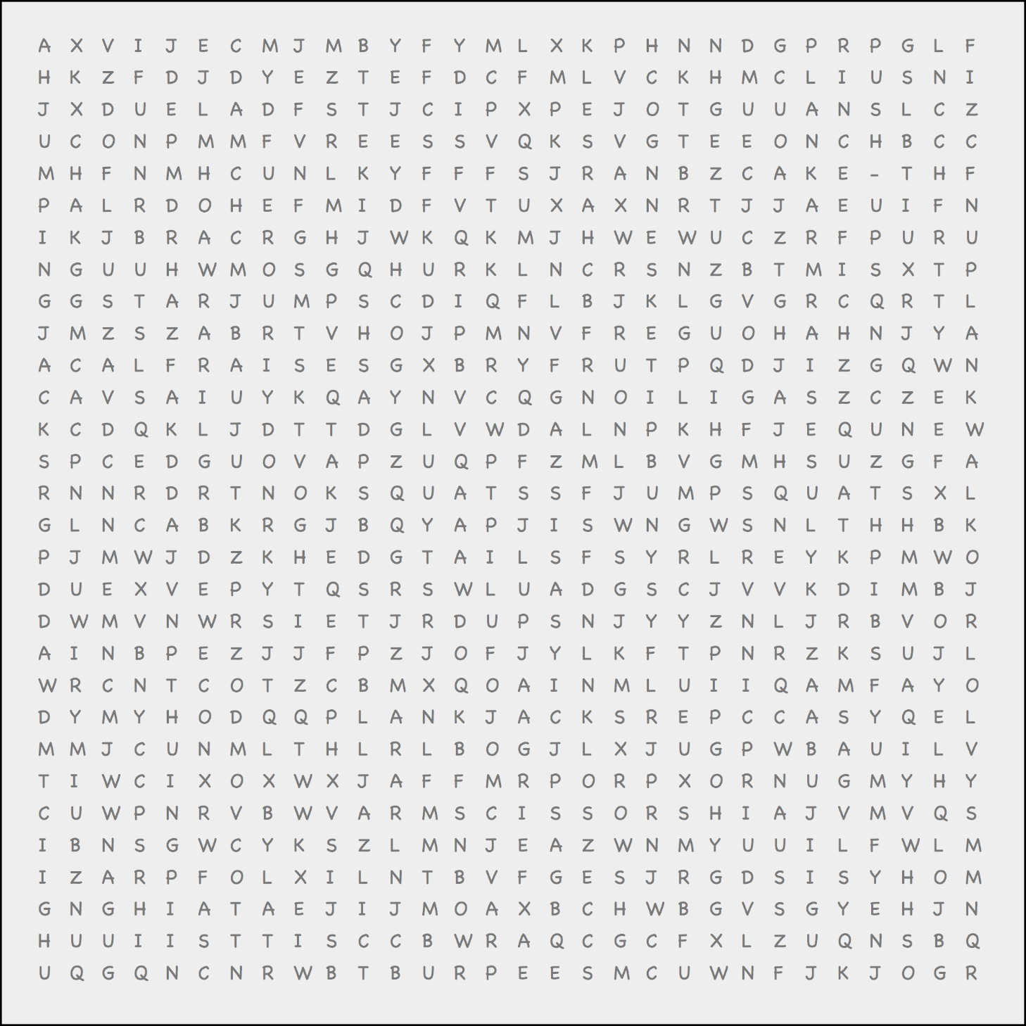

**Muscle-Strengthening Exercises**

PUSH-UPS, LUNGES, PLANK LEG RAISES, ARM SCISSORS,

PLANK ARM RAISES, CALF RAISES, ARM CIRCLES, SQUATS

**Bone-Strengthening Exercises**

STAR JUMPS, JUMP SQUATS, PLANK JACKS,

JUMPING JACKS, BURPEES, PLANK WALK, JOG

**Name:** _____________________________________________________________________________

Find and circle the exercises from each category.