­­­

* Word 1
* Word 2
* Word 3

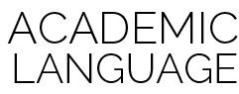­

* **Skill:** I will…
* **Cognitive:** I will…
* **Fitness:** I will…
* **Personal & Social Responsibility:** I will…
* **Standard Info Here**
* **Standard Info Here**
* Assessment 1
* Assessment 2

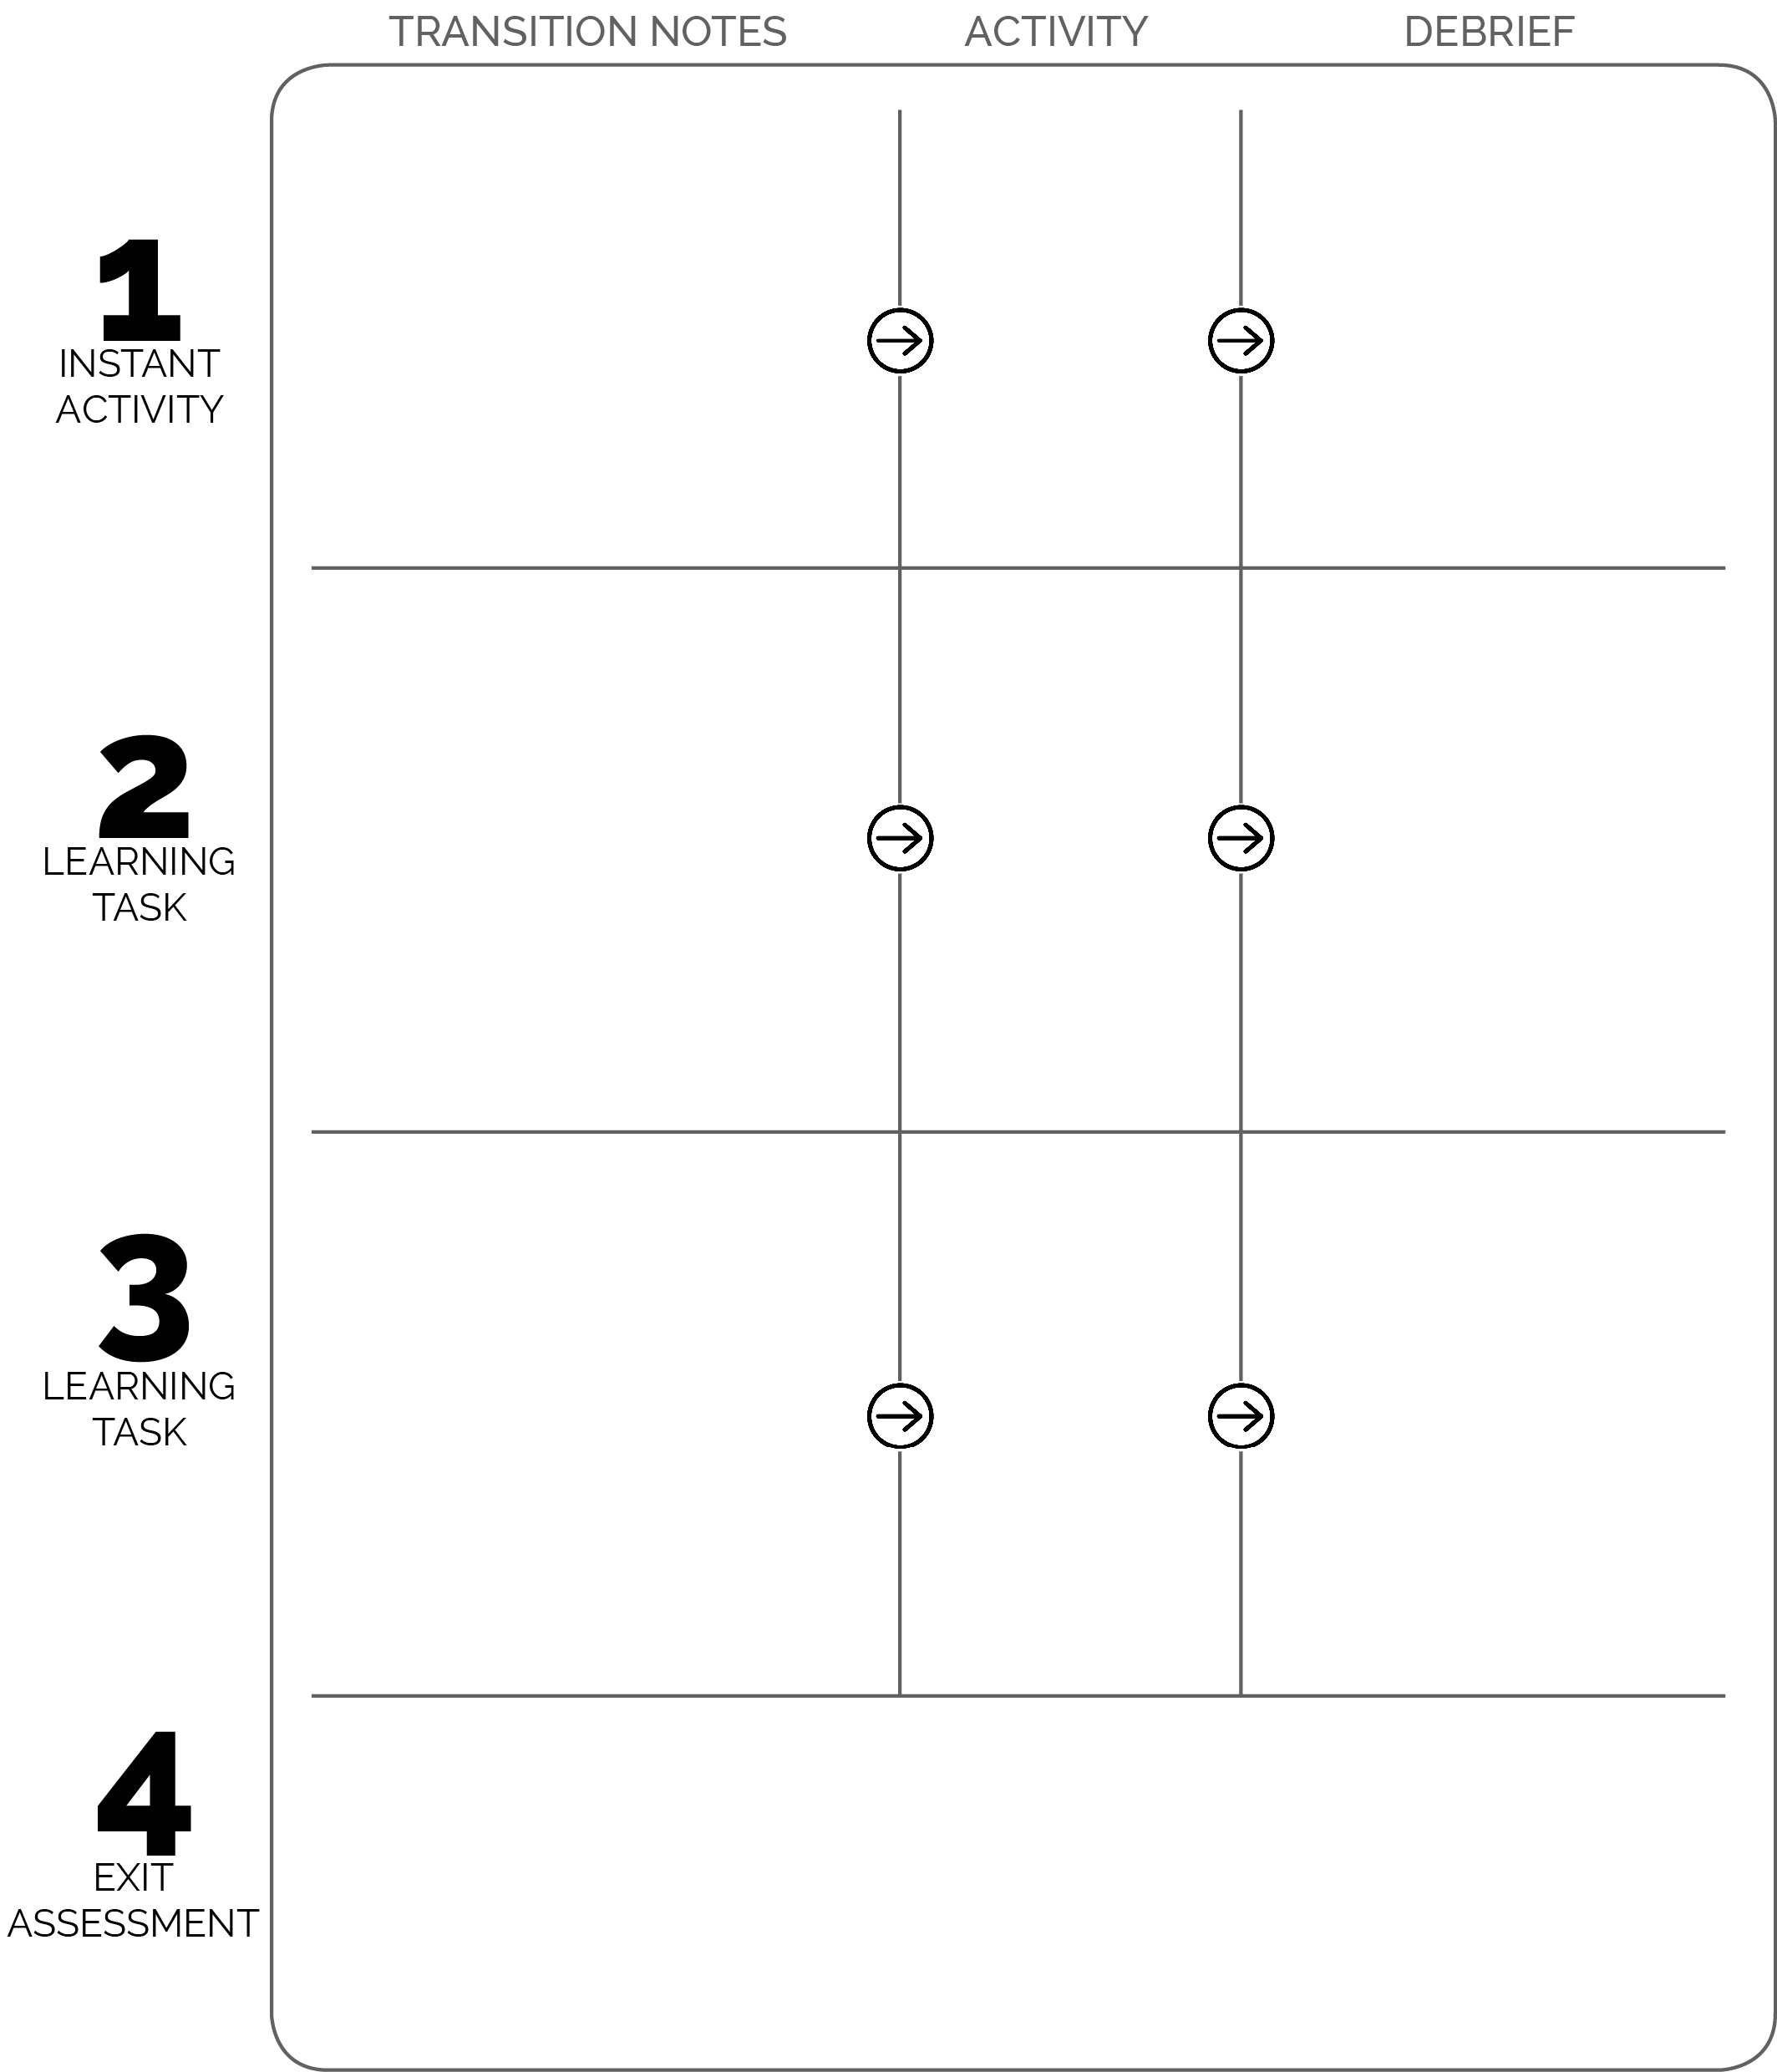

**DOK 1:** Q…?

**DOK 2:** Q…?

**DOK 3:** Q…?

Describe assessment…

Students transition…

Activity 3

**DOK 1:** Q…?

**DOK 2:** Q…?

**DOK 3:** Q…?

**DOK 1:** Q…?

**DOK 2:** Q…?

**DOK 3:** Q…?

Activity 2

Students transition…

Activity 1

Students enter the activity area…