­­

**12 HOOPS of Fitness**



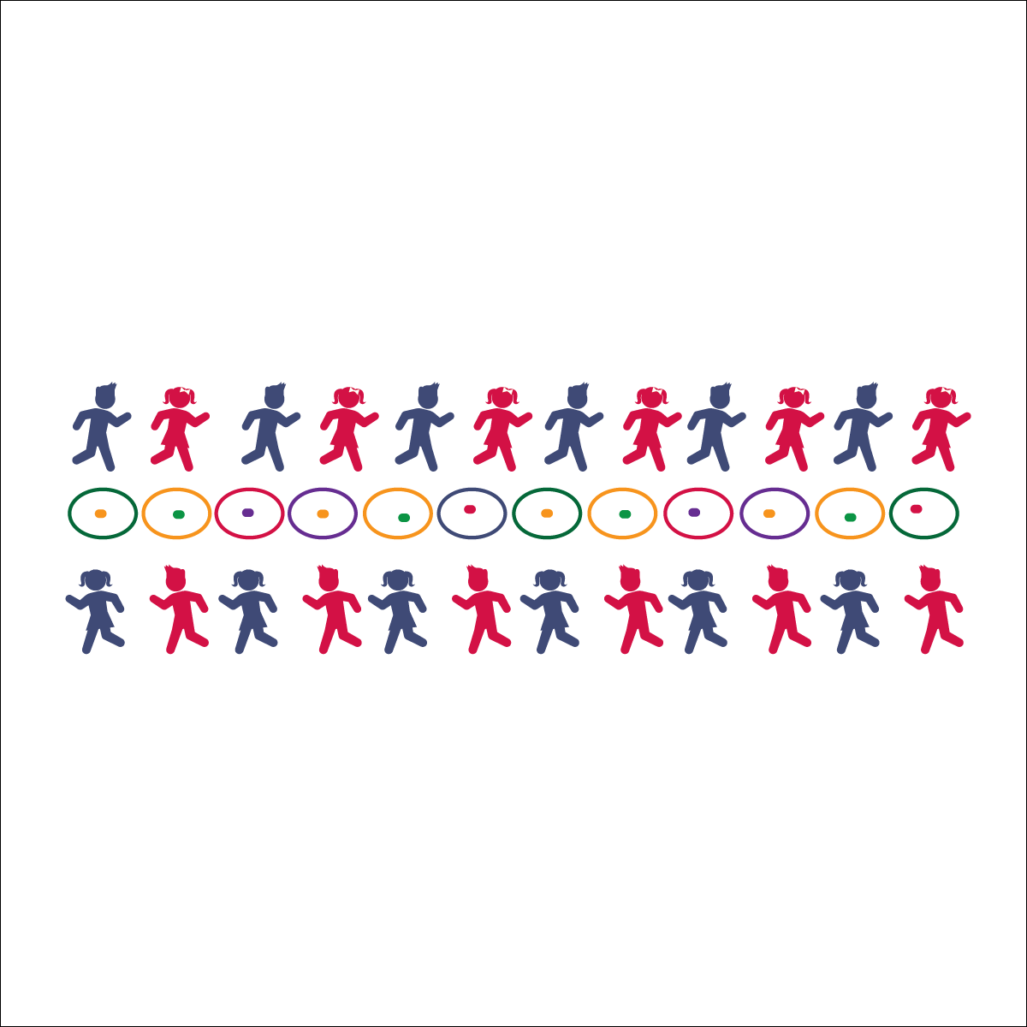

**Equipment:**

* 12 hula hoops
* 1 tossable item in each hoop (bean bag, foam ball, etc.)

**Set-Up:**

1. Create a single line of hula hoops with at least 3 feet of space in between each hoop.
2. Place 1 tossable piece of equipment in each hoop.
3. Pair students. Space them 10–20 feet apart, facing each other with a hoop centered between them.



* **DOK 1:** What is health-related fitness? What is skill-related fitness?
* **DOK 2:** What did you notice about your heart during this activity?
* **DOK 3:** How is this activity related to health- and/or skill-related fitness?



* **Standard 3 [E3.K-5]** Recognizes that when you move fast, your heart beats faster and you breathe faster (K); Identifies the heart as a muscle that grows stronger w/exercise, play & physical activity (1); Uses own body as resistance (e.g., holds plank position, animal walks) for developing strength (2a); Identifies physical activities that contribute to fitness (2b); Describes the concept of fitness and provides examples of activity to enhance fitness (3); Identifies the components of health-related fitness (4); Differentiates between skill-related and health-related fitness (5).

**Activity Procedures:**

1. Today we’re going to practice tossing, catching, locomotor skills, sharing, and listening! Our activity is called the 12 Hoops of Fitness.
2. On the start signal, pick up the piece of equipment in your hoop and begin tossing it back and forth with you partner. On the stop signal, freeze. (Allow students to toss for 30–45 seconds.)
3. After you freeze, I’ll ask the partner with the equipment to place it back in the hoop. Next, I’ll give you a traveling instruction and a direction. For example, “gallop clockwise.” When I say, “Travel!” everyone will move as instructed until you hear the stop signal.
4. On the stop signal, you’ll freeze next to a new hoop with a new partner. On the start signal, you’ll begin tossing the piece of equipment in your hoop. How many good tosses and catches can you make before you hear the stop signal?

**Grade Level Progression:**

**K–2nd:** Focus on locomotor skills and pacing. Add animal movements when appropriate.

**3rd–5th:** Add fitness activities as the form of travel (e.g., plank walks, bear walks, walking lunges).

Toss

* Tick-Tock Swing, Step to Target
* Release to Target, Follow Through

Catch

* Watch, Stand Ready
* Pinkies or Thumbs, Soft Hands

Cooperative Fitness

* **Skill:** I will perform skills and movements at the right time.
* **Cognitive:** I will discuss health- and skill-related fitness.
* **Fitness:** I will perform activities and skills that will enhance my fitness.
* **PSR:** I will cooperate with my partner.