­­

**TEAM REP Time**



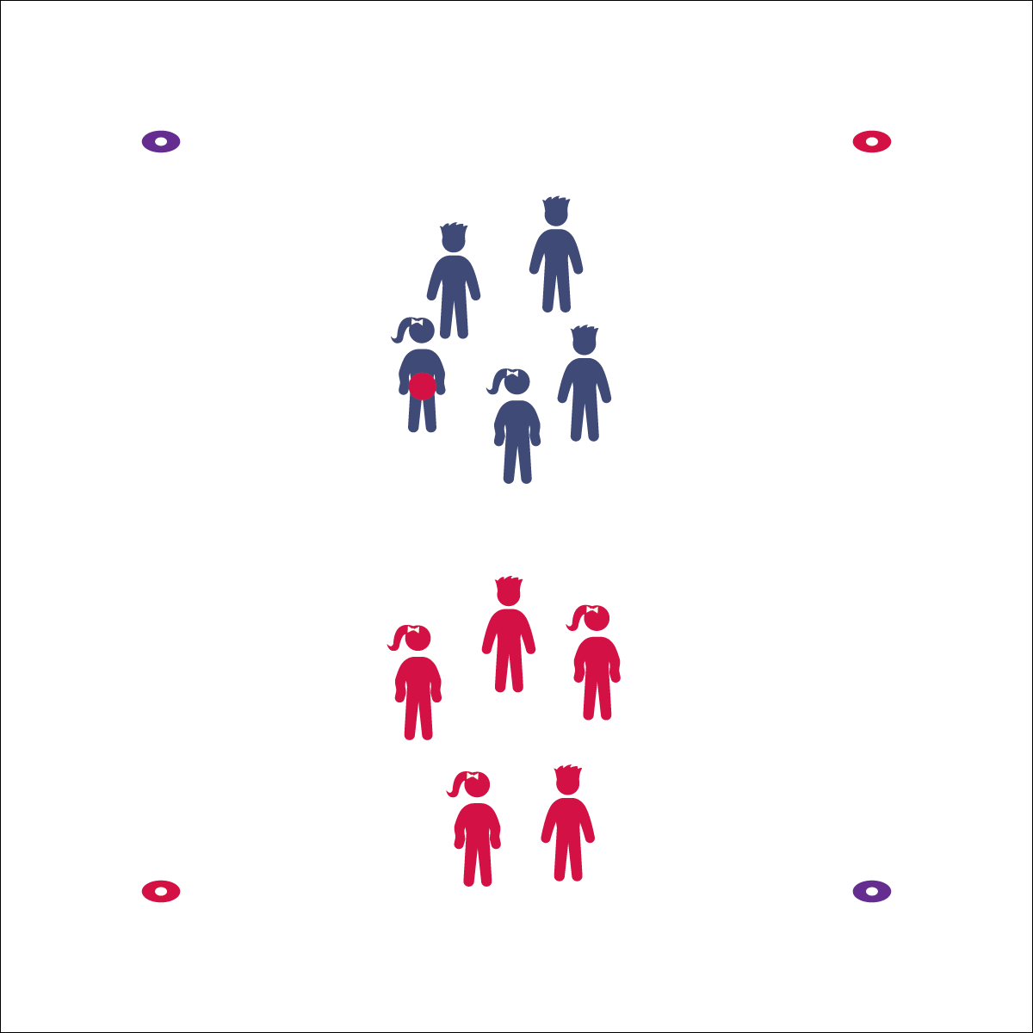



* **Standard 5 [E1.K-5]** Recognizes that physical activity is important for good health (K); Identifies physical activity as a component of good health (1); Recognizes the value of “good health balance” (2); Discusses the relationship between physical activity and good health (3); Examines the health benefits of participating in physical activity (4); Compares the health benefits of participating in selected physical activities (5).

**Equipment:**

* 1 foam ball per 2 teams
* 4 low-profile cones per 2 teams

**Set-Up:**

1. Create a large grid with 1 section of the grid for 2 teams.
2. Create equal teams of 5–7 students; 2 teams per section, 1 ball per 2 teams.



* **DOK 1:** What is physical activity?
* **DOK 2:** What do you know about physical activity and good health?
* **DOK 3:** What facts would you select to support the importance of physical activity? Why did you choose those facts?
* **Skill:** I will perform exercises with perfect form.
* **Cognitive:** I will discuss the benefits of being active.
* **Fitness:** I will discuss the benefits of the exercises we perform.
* **PSR:** I will cooperate with my team and follow all rules.

**Activity Procedures:**

1. It’s time to exercise our bodies while we play a game called Team Rep Time. The object of the game is to score points by completing as many repetitions of each exercise as possible.
2. Each team forms a circle with enough space to safely perform exercises. Offense starts with the ball, and the other team is defense. A player on the offense throws the ball high in the air so it lands within the cones. If the ball is thrown out of bounds, the team loses its turn and cannot score points.
3. When the ball is thrown, offense begins the set exercise (e.g., jumping jacks). Defense retrieves the ball and hands it off behind them in an over/under pattern. When everyone on defense has held the ball, the final player yells, “STOP!” Offense scores a point for each repetition complete before the stop signal is made. Offense and defense switch roles. 1 round is complete when both teams have had an opportunity to score. Play for 3–5 rounds and then find a new team to compete against.

**Grade Level Progression:**

**K–2nd:** Use simple exercises like jumping jacks, marching knees, star jumps, and plank shoulder taps.

**3rd–5th:** Add exercises like burpees, plank jacks, and push-ups.

Cooperative Fitness

* Follow Rules
* Demonstrate Perfect Form
* Work Hard
* Have Fun