­­

**Healthy Choice Tag**



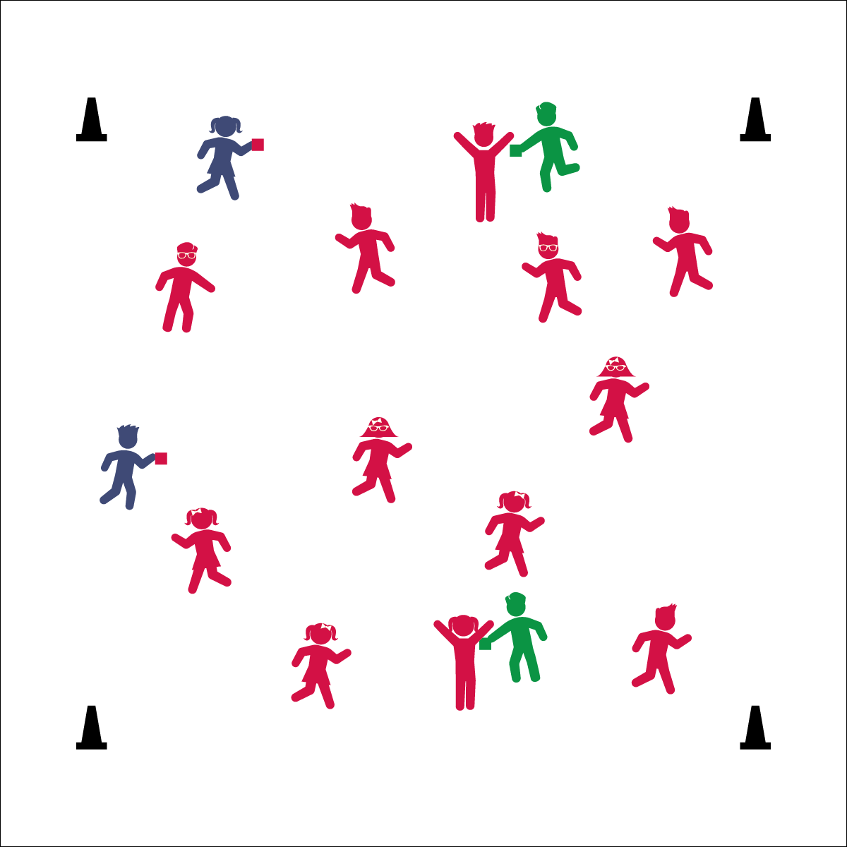

**Activity Procedures:**

1. It’s time for Healthy Choice Tag. When I say, “GO!” the game begins at a speed-walking pace.
2. To start, all taggers will do 5 jumping jacks to give the other players time to get away from them. Then the Unhealthy Choice Taggers will attempt to safely tag others with their red bean bags.
3. If you’re tagged, freeze, do 5 jumping jacks, and then put your hands above your head and repeat, “I need help!” The red bean bags symbolize unhealthy choices. In real life—and in this game—if you make an unhealthy choice, it’s important to stop the behavior, make a healthy choice (like exercise), and ask for help.
4. To be freed, a Healthy Choice Tagger must come and tag you with a green bean bag. The green bean bags symbolize healthy choices and allow you to return to the game. Unhealthy Choice Taggers may not tag Healthy Choice Taggers (and vice versa).
5. Everyone freeze on the stop signal.

**Grade Level Progression:**

**K–2nd:** Use simple exercises like jumping jacks, marching knees, star jumps, and plank shoulder taps.

**3rd–5th:** Add exercises like burpees, plank jacks, and push-ups.

**Equipment:**

* 1–3 red bean bags
* 1–3 green bean bags
* 4 low-profile cones

**Set-Up:**

1. Use cones to create a large activity area.
2. Give red bean bags to 1–3 Unhealthy Choice Taggers and green bean bags to 1–3 Healthy Choice Taggers.
3. Students scattered in the activity area.



* **DOK 1:** How can you recognize a healthy choice?
* **DOK 2:** How would you compare andcontrast healthy and unhealthy choices?
* **DOK 3:** How can you help friends or family members make healthy choices? How can you help them if they make unhealthy choices?
* **Skill:** I will practice safe tagging techniques.
* **Cognitive:** I will identify and discuss healthy choices.
* **Fitness:** I will stay active in order to increase my heart rate.
* **PSR:** I will help others when they are frozen by tagging them with a green bean bag.



* **Standard 5 [E1.K-5]** Recognizes that physical activity is important for good health (K); Identifies physical activity as a component of good health (1); Recognizes the value of “good health balance” (2); Discusses the relationship between physical activity and good health (3); Examines the health benefits of participating in physical activity (4); Compares the health benefits of participating in selected physical activities (5).

Cooperative Fitness

* Eyes Up
* Be Aware of your Surroundings
* Safe Tagging