­­

**Johnny on the spot**

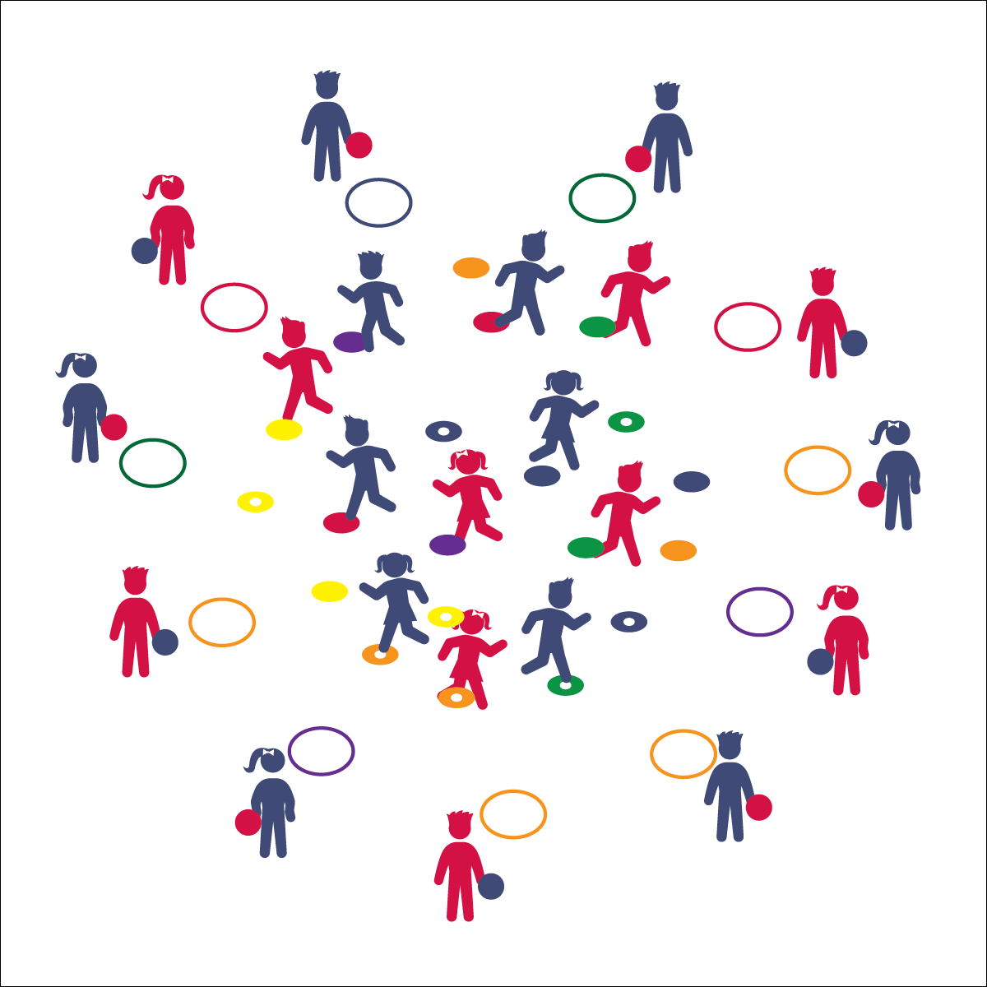

* **Skill:** I will follow skill cues when I throw and catch the ball.
* **Cognitive:** I will discuss skills cues for throwing and catching.
* **Fitness:** I will stay active to collect as many spots as I can.
* **PSR:** I will cooperate with my partner to make accurate throws and successful catches.

**Activity Procedures:**

1. We’re going practice our throwing and catching with a game called Johnny on the Spot. The object is to collect as many spots as you can by making a clean catch while standing on a spot.
2. On the start signal, the partner with the ball stays in the home hoop while the other partner travels safely to any spot.
3. The partner in the hoop will throw the ball to the partner on the spot. If she/he catches it, she/he’ll throw it back to the hoop partner.
4. If both partners catch the ball, they get to keep the spot. Pick it up and place it in your home hoop, abd then change roles and continue playing, working to collect as many spots as possible.

**Grade Level Progression:**

**K–2nd:** Start with underhand throws, progressing to overhand throws.

**3rd–5th:** Expand the distance between spots and hoops to make the game more challenging.



* **Standard 1 [E16.1-5]** Catches various sizes of balls self-tossed/tossed by a skilled thrower (1b); Catches a self-tossed or well-thrown large ball with hands, not trapping or cradling against the body (2); catches a gently tossed hand-sized ball from a partner, demonstrating four of the five critical elements of a mature pattern (3); Catches a thrown ball above the head, at chest/waist level, and below the waist using a mature pattern in a non-dynamic environment. (4); Catches with reasonable accuracy in dynamic, small-sided practice tasks (5c).



* **DOK 1:** Show me how you would perform a catch above your shoulders? Below your waist?
* **DOK 2:** How was throwing and catching in this game similar to throwing and catching in other games we’ve played? How was it different?
* **DOK 3:** How could we change this game to make it easier? More difficult?

**Equipment:**

* 1 foam ball per 2 students
* 1 hula hoop per 2 students
* 12–24 spot markers or low-profile cones

**Set-Up:**

1. Use 12+ hoops to create a large activity circle.
2. Scatter spots/low-profile cones inside the circle.
3. Pair students, each pair at a hoop with a ball.

* Look & Get Ready
* Pinkies Together or  
  Thumbs Together
* Soft Hands

Fielding Games