­­

**Strike zone fielding**

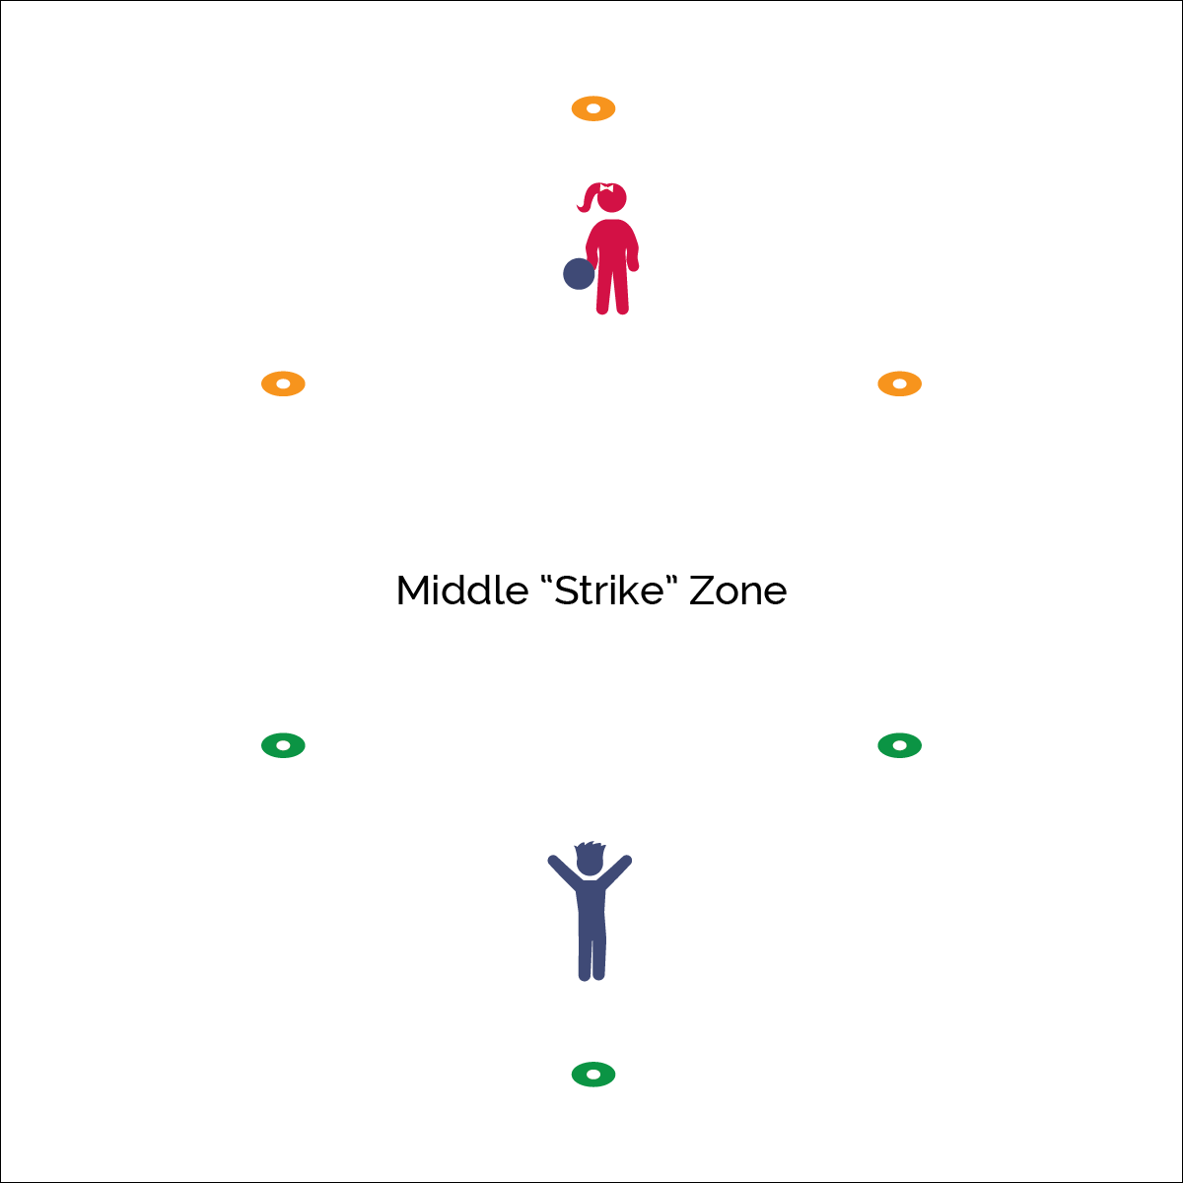

* **Skill:** I will follow skill cues when I catch the ball.
* **Cognitive:** I will discuss why it’s important to practice skills that are difficult.
* **Fitness:** I will actively participate in Strike Zone Fielding.
* **PSR:** I will accept feedback and use it to help improve my catching skills.

**Equipment:**

* 1 playground or foam ball per 2 students
* 6 spot markers or low-profile cones per 2 students

**Set-Up:**

1. Use 4 cones/spots to create a rectangle approximately 10 feet deep, which will become the middle zone.
2. Form a triangular zone on each side by centering 1 cone 6–8 feet behind each side of the middle zone.
3. One pair at each playing area with a ball.



* **Standard 1 [E16.1-5]** Catches various sizes of balls self-tossed/tossed by a skilled thrower (1b); Catches a self-tossed or well-thrown large ball with hands, not trapping or cradling against the body (2); catches a gently tossed hand-sized ball from a partner, demonstrating four of the five critical elements of a mature pattern (3); Catches a thrown ball above the head, at chest/waist level, and below the waist using a mature pattern in a non-dynamic environment. (4); Catches with reasonable accuracy in dynamic, small-sided practice tasks (5c).



* **DOK 1:** Show me how you would perform a catch above your shoulders? Below your waist?
* **DOK 2:** What did you notice about your ability to catch balls coming into your field? What is challenging about it?
* **DOK 3:** How is practice related to learning skills that are challenging?

**Activity Procedures:**

1. It’s time to practice catching and fielding during a game of Strike Zone Fielding. The object of the game is to score runs by bouncing the ball in the other player’s field, past the middle zone lines. Fielding players are trying to catch the ball in the air before it can bounce.
2. The player with the ball is “at bat.” The batter tosses the ball into the fielder’s area so it flies over the middle zone. If it lands in the middle zone or out of bounds, it’s a strike—3 strikes equal an out.
3. If the ball bounces on the ground in the fielder’s area before the fielder can catch it, it’s a run for the batter. If the ball is caught before it bounces, the batter is out. Change roles after 3 outs.

**Grade Level Progression:**

**K–2nd:** Allow students to roll and field rolling balls. Any ball that is missed or bobbled is a run. Adjust the size of the play area to match skill levels.

**3rd–5th:** Expand the play area and play with ghost bases. If a fielder does not catch the ball, each bounce is a base (i.e. 1 bounce = single, 2 bounces = double, 3 bounces = triple, 4 bounces = home run).

* Look & Get Ready
* Pinkies Together or  
  Thumbs Together
* Soft Hands

Fielding Games