­­

**Race Base Kickball**



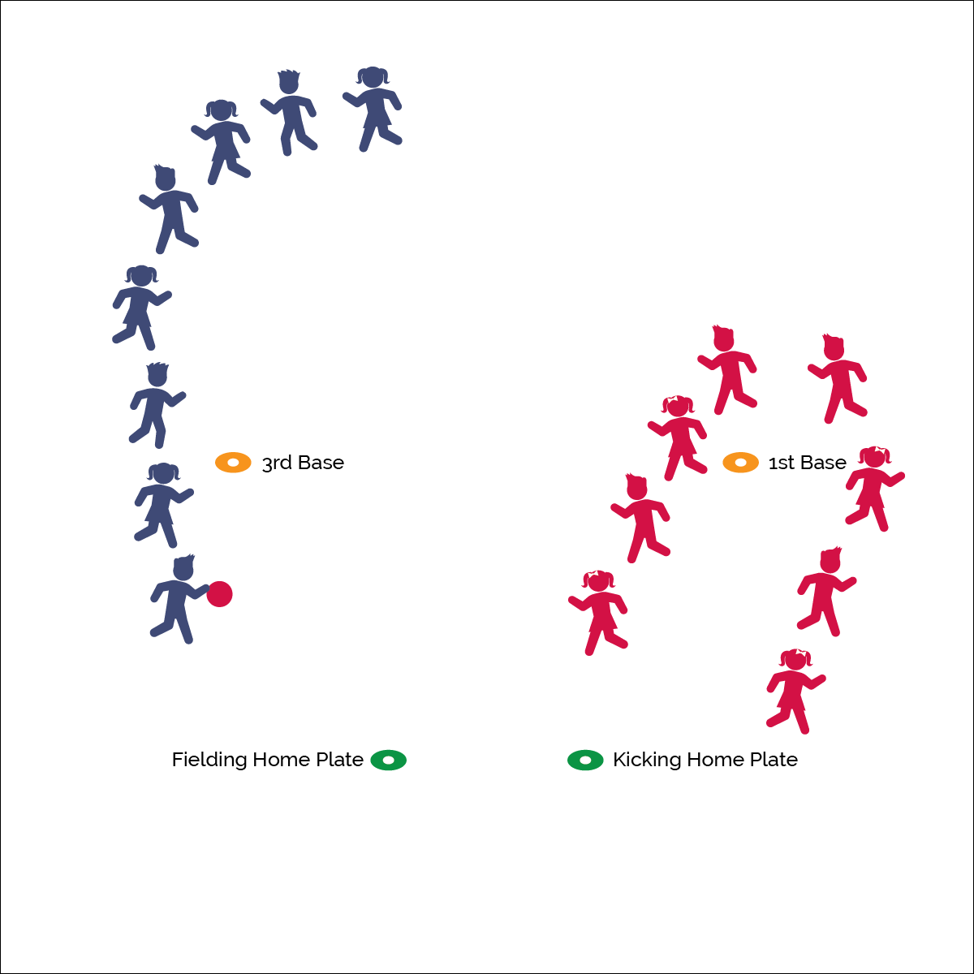

* Plant Foot
* Lean In
* Shoelaces
* Swing Through

**Activity Procedures:**

1. It’s time to play Race Base Kickball! We’ll play Rock, Paper, Scissors to see who is the home team. Visiting team kicks first. The object of this game is to score as many runs as you can by having all your teammates run around 1st base and back to the kicking home plate, before the fielding team gets the ball and all has all their teammates run around 3rd base and the fielding home plate.
2. Kicking teams use their own pitchers. Kicker 1 kicks the ball into fair territory. Then the kicker leads the entire team in a straight line to first base and back to home plate. 1 point is scored for each team member who makes it across home plate before the opposing team can make an “out.”
3. To make an out, the fielding team retrieves the ball and the player with the ball leads the team around 3rd base to the fielding home plate. Once all the fielding team players make it past home, it’s an out.
4. Caught fly balls are not automatic outs; both teams must run no matter what.

**Grade Level Progression:**

**K–2nd:** Start with students kicking a stationary ball.Teams use different locomotor skills to travel.

**3rd–5th:** All or nothing: kicking teams must get everyone across home plate to score 1 run.

**Equipment:**

* 1 kickball
* 4 bases (low profile cones or spot markers)

**Set-Up:**

1. In a large activity area, place 2 home plates 20 feet apart from one another.
2. Align 1st and 3rd base with each other, placed 40 feet from each home plate.
3. Divide students into 2 equal teams.



* **DOK 1:** What are the cues for kicking a ball?
* **DOK 2:** How does each cue affect the accuracy of a kick?
* **DOK 3:** How is purposeful practice related to skill cues?



* **Standard 1 [E21.K-2]** Kicks a stationary ball from a stationary position, demonstrating two of the five elements of a mature kicking pattern (K); Approaches a stationary ball and kicks it forward, demonstrating two of the five critical elements of a mature pattern (1); Uses a continuous running approach and kicks a moving ball, demonstrating three of the five critical elements of a mature pattern (2); Uses a continuous running approach and intentionally performs a kick along the ground and a kick in the air, demonstrating four of the five critical elements of a mature pattern for each (3a).

Fielding Games

* **Skill:** I will kick the ball into fair territory.
* **Cognitive:** I will discuss the cues for kicking a ball.
* **Fitness:** I will stay active throughout the activity.
* **P&S Responsibility:** I will follow the rules and etiquette of Race Base Kickball.