­­

**KICKBALL TAG**

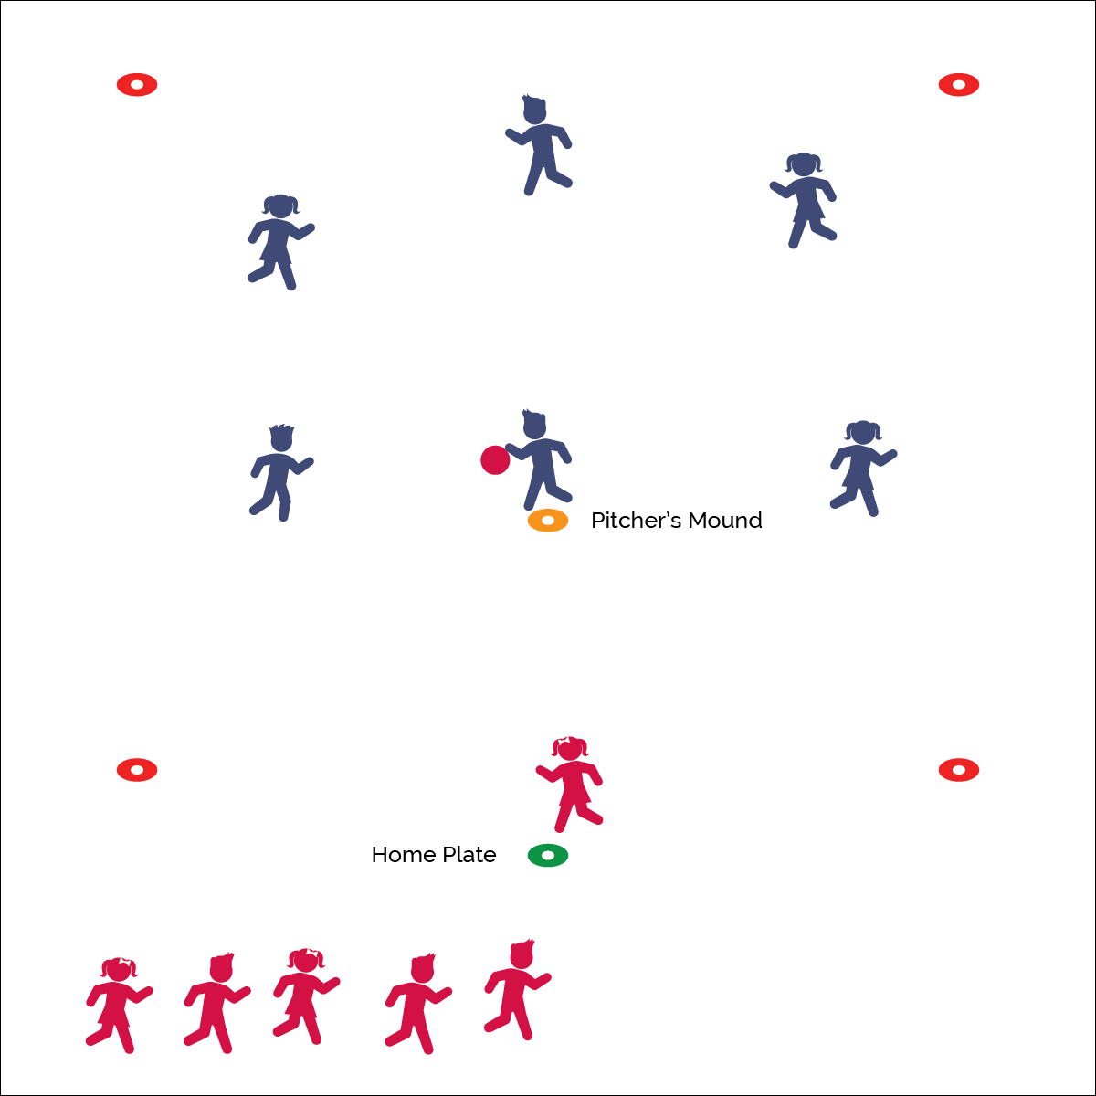



* **Standard 1 [E21.K-5]** Kicks a stationary ball from a stationary position, demonstrating 2/5 elements of a mature kicking pattern (K); Approaches a stationary ball and kicks it forward, demonstrating 2/5 critical elements of a mature pattern (1); Uses a continuous running approach and kicks a moving ball, demonstrating 3/5 critical elements (2); Uses a continuous running approach and intentionally performs a kick along the ground and a kick in the air, demonstrating 4/5 critical elements (3a); Uses a continuous running approach and kicks a stationary ball for accuracy (3b); Kicks along the ground and in the air using mature patterns (4); Demonstrates mature patterns in kicking in small-sided practice task environments (5).

**Activity Procedures:**

1. It’s time to play Kickball Tag! The object is for the kicker to score runs by tagging as many fielding players and she/he can before an out is made.
2. As soon as the ball is kicked into fair territory, the kicker will chase and attempt to tag the fielding players. At the same time, fielding players will make at least 3 passes to get the ball to the pitcher’s mound. Fielders cannot run with the ball—it must advance through accurate passes. As soon as the ball reaches the pitcher’s mound, the fielding team yells, “OUT!”
3. Switch sides after each player on the kicking team has a chance to kick.

**Grade Level Progression:**

**K–2nd:** Kickers kick a stationary ball.

**3rd–5th:** Kickers kick a pitched ball. Increase the number of passes required for an out.



* **DOK 1:** What would you include on a list about kicking a ball?
* **DOK 2:** What did you notice about your kicks when you used good form? When you did not use good form?
* **DOK 3:** How is good kicking form related to accuracy? How is it related to power?

Kick

* Plant Foot
* Lean In
* Shoelaces
* Swing Through
* **Skill:** I will kick the ball into fair territory.
* **Cognitive:** I will discuss the importance of cooperation in team games.
* **Fitness:** I will actively participate in Kickball Tag.
* **PSR:** I will cooperate with my teammates to make outs while we are playing as the fielding team.

**Equipment:**

* 1 playground or foam ball
* 2 spot makers (home base & pitcher’s mound)
* 4 low profile cones to mark area boundaries

**Set-Up:**

1. Use 4 cones/spots to create an extra-large activity area.
2. Place 1 spot maker as home base and 1 as the pitcher’s mound.

Fielding Games