­­

**Chariot Race**

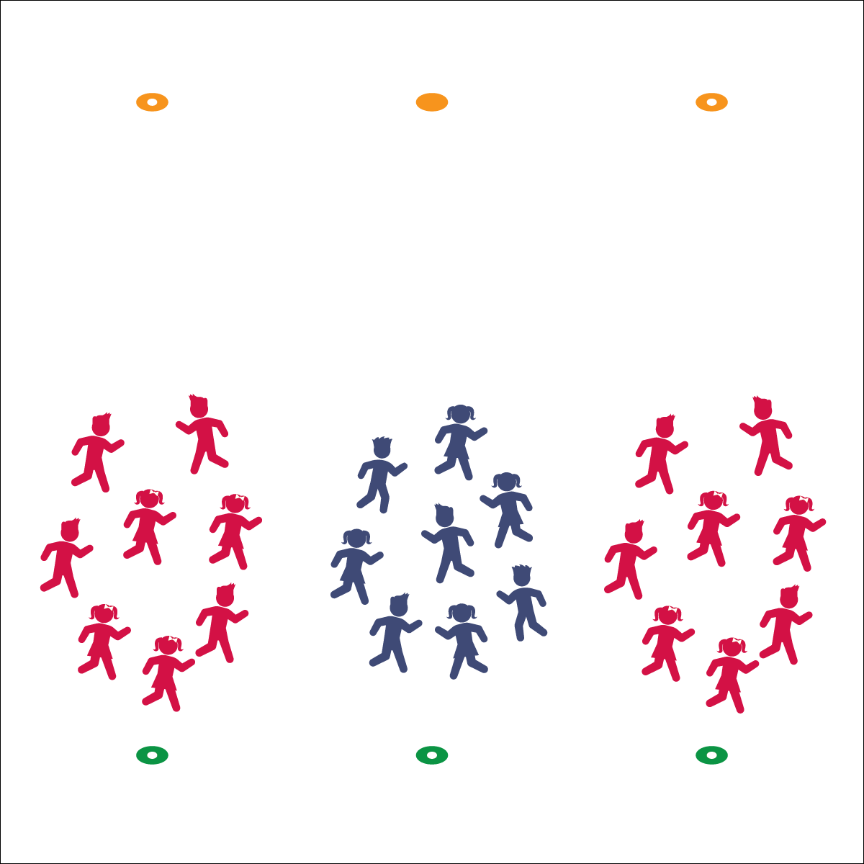

* **Skill:** I will safely pace my movements to match my teammates.
* **Cognitive:** I will find opportunities to praise the performance of my teammates.
* **Fitness:** I will stay active throughout each chariot race.
* **P&S Responsibility:** I will accept all my teammates  
  and recognize their contributions to our team.



* **Standard 4 [E4.K-5]** Shares equipment and space with others (K); Works independently with others in a variety of class environments (e.g., small and large groups) (1); Works independently with others in partner environments (2); Works cooperatively with others (3a); Praises others for their success in movement performance (3b); Praises the movement performance of others both more and less-skilled (4a); Accepts “players” of all skill levels into the physical activity (4b); Accepts, recognizes, and actively involves others with both higher and lower skill abilities into physical activities and group projects (5).



* **DOK 1:** How can you recognize good effort and good performance?
* **DOK 2:** How would you praise good effort? How would you praise good performance?
* **DOK 3:** How is praise related to feeling accepted by your teammates?

**Activity Procedures:**

1. It’s time for our Chariot Races! The object of the game is for each team to take their chariot past the cone on the opposite side of the activity area.
2. On the start signal, each team will form a circle around the first person in line. Hold hands (or lock elbows) to keep the circle together. Then start walking (jogging, skipping, galloping, etc.) as a group to the opposite cone. (Stop on the other side and reset with a new “chariot rider” and then start again.
3. Now that you’re really good at racing your chariots, we’ll begin our marathon races. On the start signal, the first rider will ride the chariot to the opposite cone. As soon as you’re past the cone, change riders and quickly cross the activity area again. Continue changing riders until everyone has had a turn.

**Grade Level Progression:**

**K–2nd:** Focus on controlled locomotor skills with safe pacing.

**3rd–5th:** Add fitness and challenges like bear walks, crab walk, soccer dribbles, etc.

**Equipment:**

* 2 low-profile cones per group of 6–10 students

**Set-Up:**

1. Use low-profile cones to create 2 parallel lines on opposite sides of the activity area.
2. Create equal groups of 6–10 students.
3. Each group starts behind their own cone, facing the cone on the other side of the area.

* Move Together, Stay Together
* Praise Good Effort
* Keep a Good Attitude

Personal/Social Responsibility