­­

**Soccer Spots**



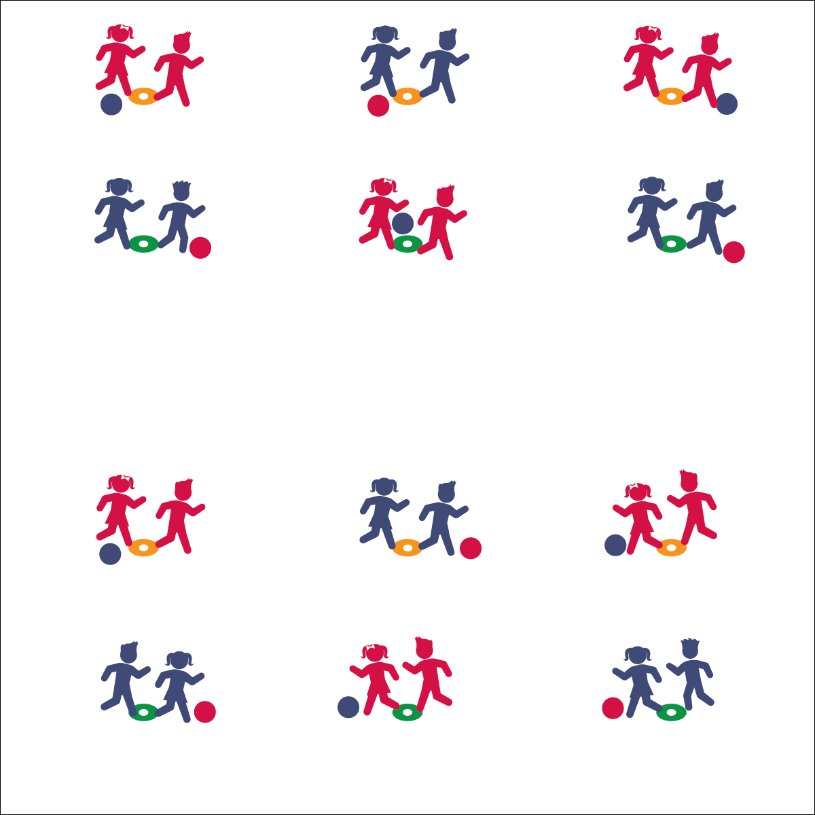



* **DOK 1:** What is social behavior?
* **DOK 2:** What do you know about social behaviors in physical education class?
* **DOK 3:** How are social behaviors related to fun?



* **Standard 4 [E2.K-5]** Acknowledges responsibility for behavior when prompted (K); Follows the rules/parameters of the learning environment (1); Accepts responsibility for class protocols with behavior and performance actions (2); Works independently for extended periods of time (3); Reflects on personal social behavior in physical activity (4); Participates with responsible personal behavior in a variety of physical activity contexts, environments, and facilities (5a); Exhibits respect for self with appropriate behavior while engaging in physical activity (5b).

**Equipment:**

* 1 spot marker per group of 2–3 students
* 1 foam ball per group of 2–3 students

**Set-Up:**

1. Create 1 safe activity area per 2 groups.
2. In each area, place 2 spot markers 10–20 feet apart.
3. Create groups of 2–3 students, with 2 groups at each activity area.
4. Each team with a ball.

**Activity Procedures:**

1. It’s time to challenge another team to Soccer Spots. We will focus on fair play and sportsmanship. The object of the game is to touch the other team’s spot marker with the ball before they can touch yours.
2. Each player starts with one foot on their home spot marker. On the signal, begin dribbling and passing to your partner while avoiding the other team. The first team to touch the opposing team’s spot scores a point. Then the game resets, and teams turn around to aim at the other spot. After both teams have reset and taken the starting position (1 foot on their new home spot), the team who just scored a point will make the next start signal.
3. After 3–4 minutes, each team will find a new team to challenge.

**Grade Level Progression:**

**K–2nd:** Play without allowing any defensive plays. Limit team size to 2 students with a focus on dribbling.

**3rd–5th:** Allow teams to attempt to intercept passes and use other defensive plays. Body contact is not allowed and results in an automatic score for the team that is fouled.

Personal/Social Responsibility

* **Skill:** I will follow the rules and parameters of Soccer Spots.
* **Cognitive:** I will discuss my social behavior.
* **Fitness:** I will stay actively engaged during all activities.
* **PSR:** I will respect my self and others by behaving appropriately and following all rules.
* Keep Ball Close
* Tap with Both Feet
* Eyes Up