­­

**Leaning Tower**



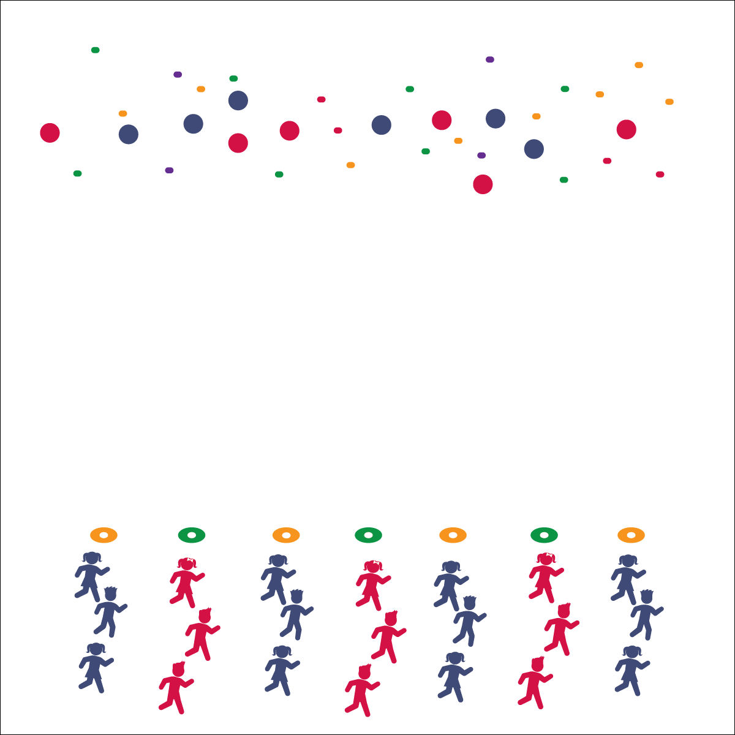



* **Standard 4 [E4.K-5]** Shares equipment/space with others (K); Works independently with others in a variety of environments (e.g., small and large groups) (1); Works independently with others in partner environments (2); Works cooperatively with others (3a); Praises others for success in movement performance (3b); Praises the movement performance of others both more & less-skilled (4a); Accepts “players” of all skill levels (4b); Accepts, recognizes, and actively involves others with both higher and lower skill abilities into physical activities and group projects (5).

**Equipment:**

* 1 low-profile cone per group of 3–4 students
* 1 foam ball per group of 3–4 students
* 36+ bean bags

**Set-Up:**

1. Space low-profile cones in a line along 1 side of the activity area.
2. Scatter foam balls and bean bags on the opposite side of the play area.
3. Create groups of 3–4 students; 1 group at each cone.



* **DOK 1:** What does cooperation mean?
* **DOK 2:** What do you know about cooperation?
* **DOK 3:** How is cooperation related to success?

**Activity Procedures:**

1. The name of this cooperative challenge is Leaning Tower. The object of the game is for each team to create a tower on top of your cone using a foam ball and at least 3 bean bags.
2. On the start signal, everyone on your team will move together to pick up a foam ball. Each player must be touching the ball as you travel back to place the ball on the cone.
3. In the same way, your team will then travel to pick up one bean bag, and then return to place the bean bag on top of the foam ball. Continue until your tower is built 3 or more bean bags high.
4. If your tower falls at any time, you must return all materials back to the opposite sideline and start over with a foam ball.

**Grade Level Progression:**

**K–2nd:** Make the challenge easier by using only bean bags (no foam ball).

**3rd–5th:** Challenge students to use 1 finger or an elbow to pick up and transport objects. Add a fitness activity if a team’s tower falls (i.e., the team must do 10 jumping jacks before rebuilding).

Personal/Social Responsibility

* **Skill:** I will cooperate with my teammates to build a tower.
* **Cognitive:** I will discuss the importance of cooperation.
* **Fitness:** I will stay actively engaged during all activities.
* **PSR:** I will share equipment and space and work cooperatively.
* Move Together
* Listen to Teammates
* Use Positive Words